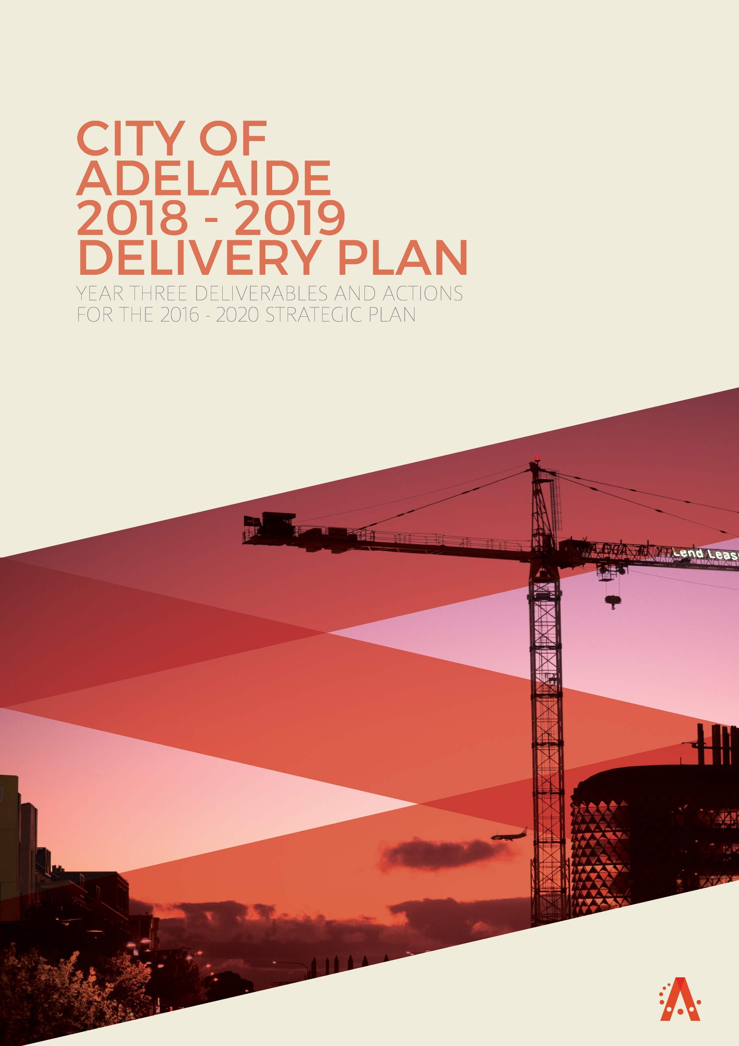

Frequently used acronyms in this document:
ACB Adelaide Convention Bureau
APLA Adelaide Park Lands Authority
APLEMP Adelaide Park Lands Event Management Plan
APLMS Adelaide Park Lands Management Strategy
CNA Carbon Neutral Adelaide
GAP Glenelg to Adelaide Pipeline
NAIDOC National Aboriginal and Islanders Day Observance Committee
ORAH Old Royal Adelaide Hospital (now Lot 14)

INTRODUCTION

The City of Adelaide 2016-2020 Strategic Plan sets Council's vision for the City:

Adelaide is a welcoming and dynamic City full of rich and diverse experiences.

To realise this vision Council has a primary goal to:

Strengthen the City economy by growing the number of people living,
working, playing, visiting and studying in the City every day

This document sets out the deliverables for 2018-19 that further the achievement of the 110 Actions in the City of Adelaide Strategic Plan 2016-2020. This is not a progress report.

Progress on Strategic Plan Actions is reported quarterly.

CONTENTS

SMART THEME UPDATE
Objectives & Projects
Deliverables

GREEN THEME UPDATE
Objectives & Projects
Deliverables

LIVEABLE THEME UPDATE
Objectives & Projects
Deliverables

CREATIVE THEME UPDATE
Objectives & Projects
Deliverables

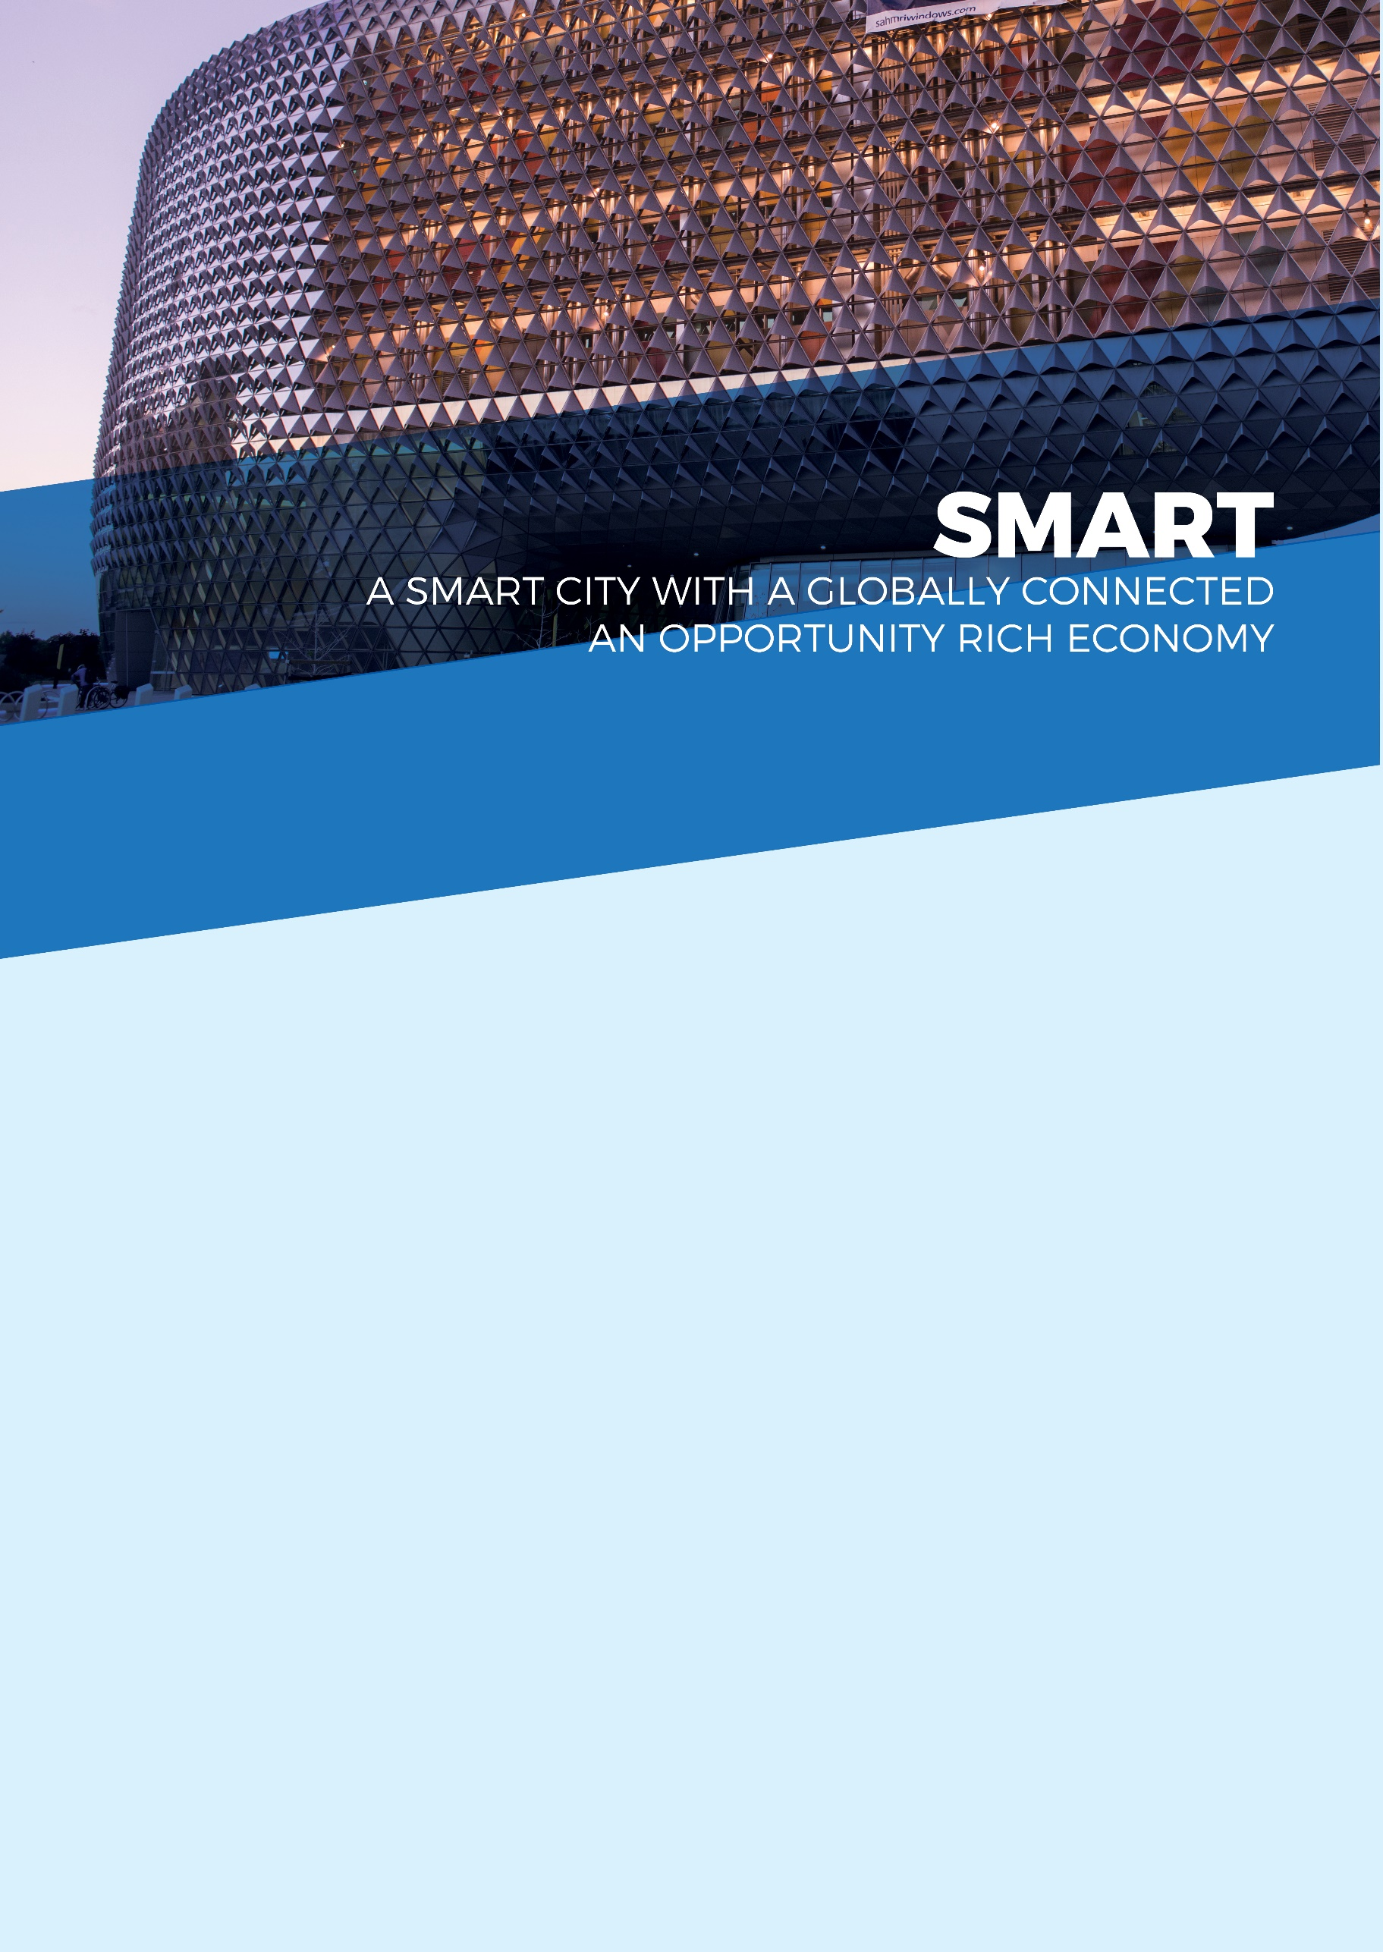

OBJECTIVES
- By 2020, our city’s economy will be growing faster than the Australian economy
- Total businesses in the city will grow from 5,000 to over 5,300 and workers on any given day from 89,000 to 94,000 by 2020
- Workers in professional and technical services, education, finance, telecommunications, creative and media sectors will have grown from 41,000 to over 49,000 by 2020
- By 2020, the number of students in the city on any given day of the week will increase from 39,000 to 41,000

STRATEGIC PLAN ACTIONS
The Smart theme has 26 actions to be progressed during the life of the 2016-2020 Strategic Plan. The actions focus on growing the city economy through the adoption of smart technologies, business growth, support for start-ups and entrepreneurs, trade and investment, and building on the city’s strong entrepreneurial, creative, education and heritage base.  2018 - 2019 DELIVERABLES  The following deliverables were planned for 2018-19. They align to the actions under the Smart theme of the City of Adelaide 2016-2020 Strategic Plan.  Given the passage of time, some deliverables for 2018-19 will have already been progressed at the time Council receives this document. | - Expansion of Connected Council Initiative  - City and Corporation Brand  - Adelaide Living Magazine  - Brand marketing and campaign execution  - Market segmentation and consumer profiling  - Provide base funding to the existing Precinct Groups.  - Mainstreets pilot programs including advancement grants and district management pilot  - Community Engagement Review  - Digitisation of building plans and development applications  - Transforming services: w-planning  - Deliver the Online Forms project  - Implementation of the Permit Review  - City Parking Experience - Embed Smart Parking  - 10 Gigabit City  - Provide input to the future of Lot14 (ORAH)  - Support co-working space and network and explore opportunities  - International relations  - Investment attraction and trade  - International Relations Strategy  - Showcase the City - heritage tourism market  - Adelaide Alliance Network (International Alumni student program)  - Retail strategy  - Vogue Festival | - Gawler Place Redevelopment  - Market to Riverbank Laneways Upgrade  - Laneways activation  - Economic Insights Dashboard  - Business Growth and Capability Building  - Connect businesses to information, events and opportunities  - Investment attraction case management  - Renew Adelaide funding  - Talent and business attraction  - Entrepreneur support initiatives  - Adelaide Smart City Studio  - Educational sector stakeholder management and support  - Study Adelaide funding

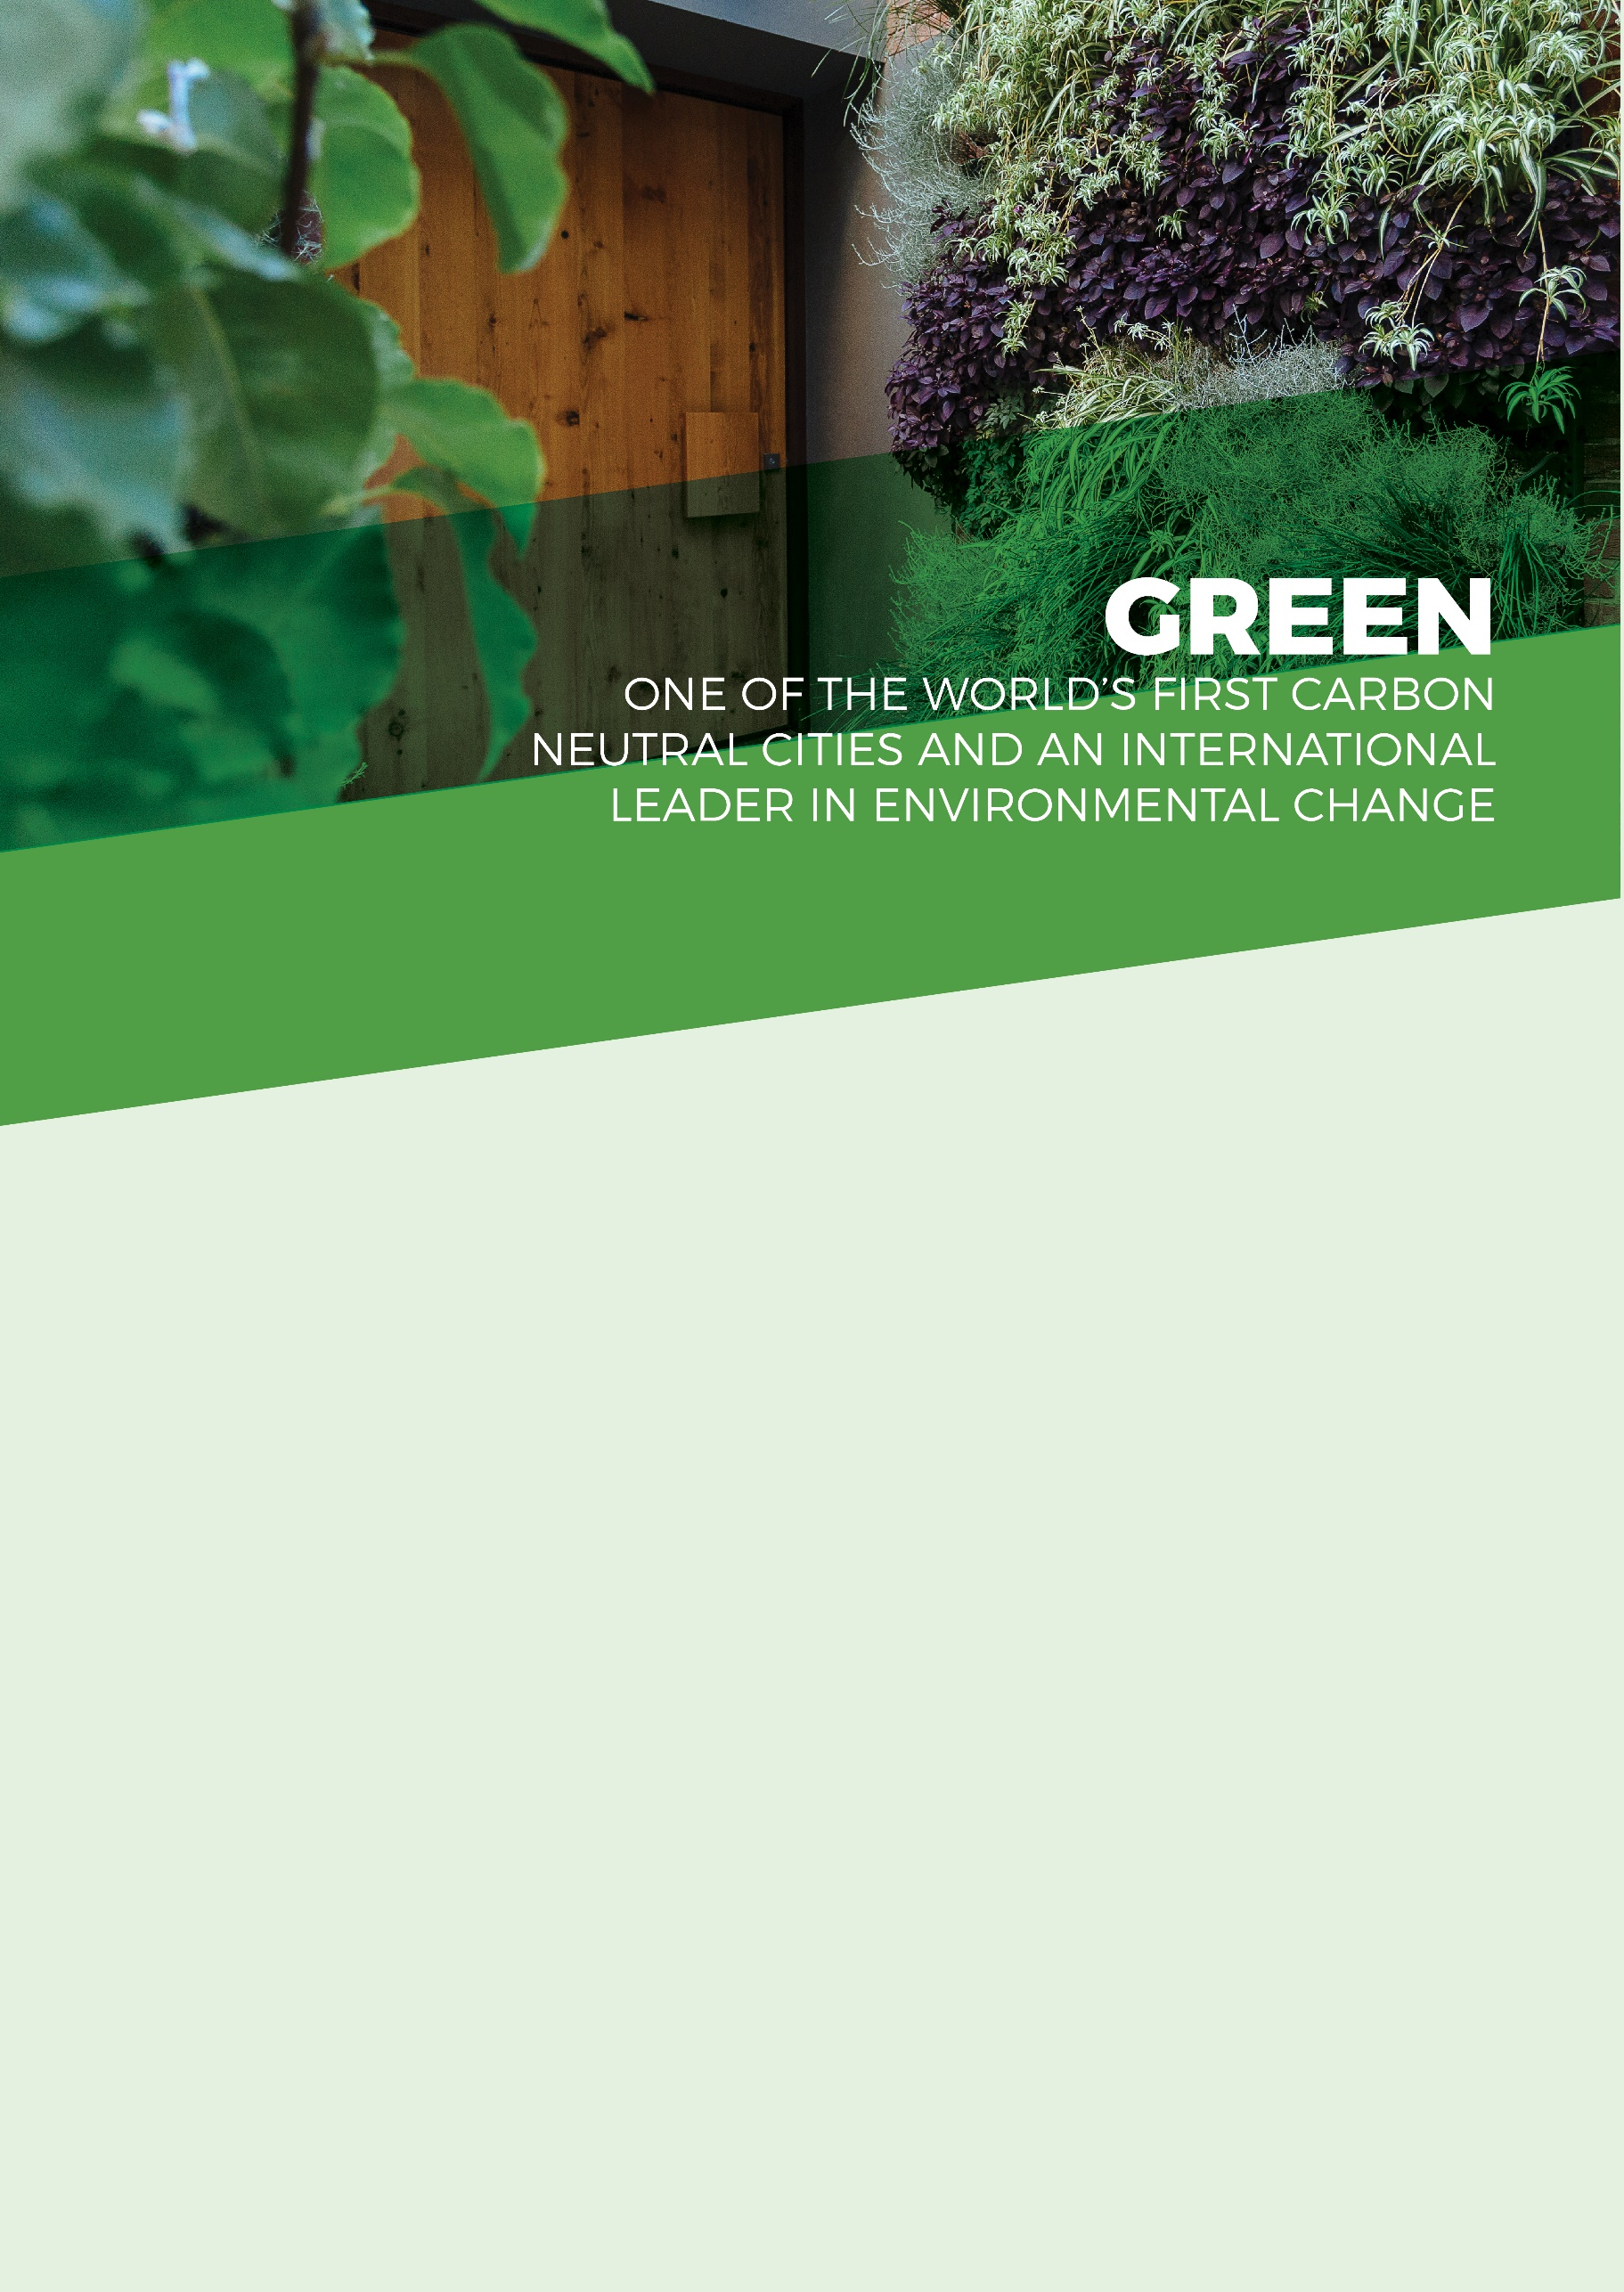

OBJECTIVES
- City carbon emissions will be reduced by 35% from the 2006-07 baseline by 2020
- Green space and greenery in the built-up areas of the city will have increased by 100,000 square metres by 2020
- By 2020, Aquatic native plants on the Torrens Lake floor will have increased from almost zero to 7,500 square metres
- A detailed measure of reduction in kerbside and general waste will have been developed and influences our work
- A comprehensive integrated water management measure will have been developed and influences our work

STRATEGIC PLAN ACTIONS
The Green theme has 28 actions to be progressed during the life of the 2016-2020 Strategic Plan. The actions focus on carbon neutrality, improving energy performance, incentivising sustainable practices, enhancing biodiversity, water quality, waste reduction and recycling, and increasing green space and greenery in the city.  2018 - 2019 DELIVERABLES  The following deliverables were planned for 2018-19. They align to the actions under the Green theme of the City of Adelaide 2016-2020 Strategic Plan.  Given the passage of time, some deliverables for 2018-19 will have already been progressed at the time Council receives this document. | - Carbon Neutral Adelaide (CNA) - Partnership Framework  - CNA - Green Buildings (Council): Carbon Neutral Council Roadmap  - CNA - Green Buildings (Privately Owned): Solar Savers & City Switch and Building Upgrade Finance  - CNA - Green Buildings (Council Energy)  - CNA Action Plan (Planning and Development Actions)  - CNA – Sustainability Incentives Scheme  - City Bikeways - construct North-South Bikeway  - LED lights and smart lighting for Council assets  - Smart City – Electric Vehicles  - Green procurement – evaluation criteria  - Deliver summits and forums that connect with the Strategic Plan and engage key stakeholders in developing the City’s future  - Biodiversity and Water Quality Management Action Plan  - Sustainability themed future accelerator program and green investment  - Adelaide city experiences that highlight our green and clean attributes and reputation.  - Green the City Plan  - Review of open space provision with development  - Prioritise greening in Council’s design and delivery projects  - Powerline undergrounding (PLEC) | - Improve the ecological value of watercourses and biodiversity in the Park Lands  - Brown Hill Keswick Creek Storm Water Management and Governance  - Stormwater management - water asset management plan implementation and Water Sensitive Urban Design  - Waste services transition  - Waste management (public)  - Events waste minimisation  - Adelaide Park Land Event Management Plan (APLEMP) Project 9 - Carbon neutrality and sustainable resource use  - Sustainable waste management practices  - GAP irrigation  - Water sensitive urban design  - Reduce stormwater and other pollutants in the Torrens River catchment

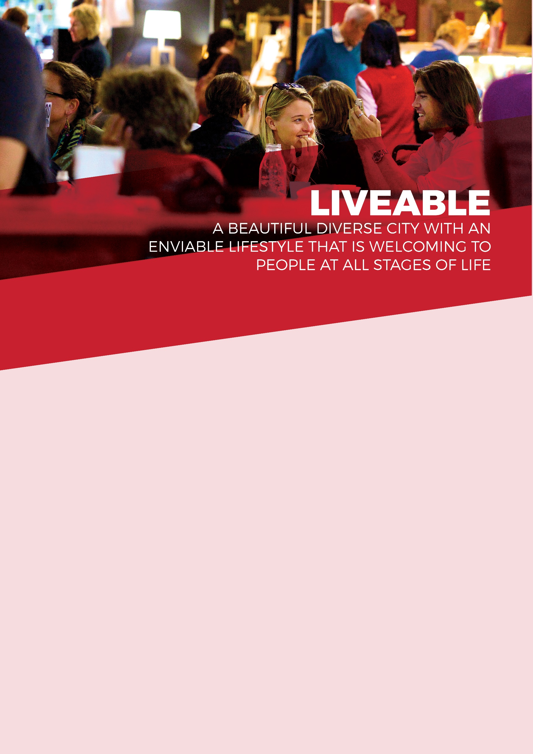

OBJECTIVES
- The number of people living in the city will have grown from 23,000 to 28,000 by 2020
- Adelaide will be listed in the top three most liveable cities in the world by 2020
- City of Adelaide residents will have wellbeing above global average

STATEGIC PLAN ACTIONS
The Liveable theme has 24 actions to be progressed during the life of the 2016-2020 Strategic Plan. The actions focus on exceptional infrastructure, transport linkages, residential and other development, efficient service delivery, enhancing wellbeing, and building strong and resilient communities.  2018 - 2019 DELIVERABLES  The following deliverables were planned for 2018-19. They align to the actions under the Liveable theme of the City of Adelaide 2016-2020 Strategic Plan.  Given the passage of time, some deliverables for 2018-19 will have already been progressed at the time Council receives this document. | - Knowledge of housing delivery models that offer choice, diversity and affordability  - Develop an Asset Management Strategy that delivers world class infrastructure and a three year rolling capital works program  - Management of the Free City Connector Bus Service  - Improvements and inclusion of Smart Technology to Free City Connector Bus Stops and Service  - Currie-Grenfell Transport Boulevard  - Community Centres activity and projects  - Review Council’s advocacy approach for affordable housing and sustainable growth  - Support the integrated Light Rail Network across metropolitan Adelaide including the City  - North Terrace Light Rail Extension  - King William Street (South) Tram stop accessibility improvements  - Finalise and implement Residential Action Plan  - Review current and future Park Land spaces targeted for people activation in conjunction with neighbouring Councils  - APLMS Implementation – Hindmarsh Square Masterplan  - Adelaide 2040 Plan  - Deliver the City West Quietway (City landscape and laneway improvements)  - City of Adelaide Bikeways (North/South and East/West)  - Smart Move Strategy  - Central Market Arcade (secure development partner, stakeholder engagement, lease management, and preparation of masterplan and concept design)  - Collaborate across government to investigate and implement projects with a focus on affordability and diversity  - Strategic Property Plan | - Investigate options for the 211 Pirie Street (City Beach) site  - Deliver a Customer Experience Culture  - Deliver a Customer Experience Measurement and Feedback Program  - Service Reviews  - Heritage Incentive Scheme  - Sponsorship of the South Australian History Festival  - Promote the City’s built heritage and historic character streetscapes  - Economic benefits of heritage investment study  - Community development grants  - Adelaide Community Leaders & Neighbourhood Development initiatives  - Deliver Commonwealth Home Support Program and wellbeing and resilience initiatives  - Deliver a range of social inclusion activities to support our Welcoming City commitment  - Deliver social inclusion activities that support women’s leadership  - Undertake activities that support removal of barriers to participation in City life for people with disabilities  - Volunteer Program  - Adelaide Library Service  - Building cultural connections and community engagement through Library Partnerships  - Community Resilience Initiatives  - Community Wellbeing Initiatives  - Social Infrastructure Plan  - Homeless and Vulnerable People project  - Don Dunstan Foundation strategic partnership  - Develop and deliver initiatives that increase perceptions of safety  - Continue to promote, maintain and extend the Park Lands Trail  - Develop a Master Plan for the North Adelaide Golf Course  - Recreation and sports grants  - Community Sport and Recreation Hub Planning

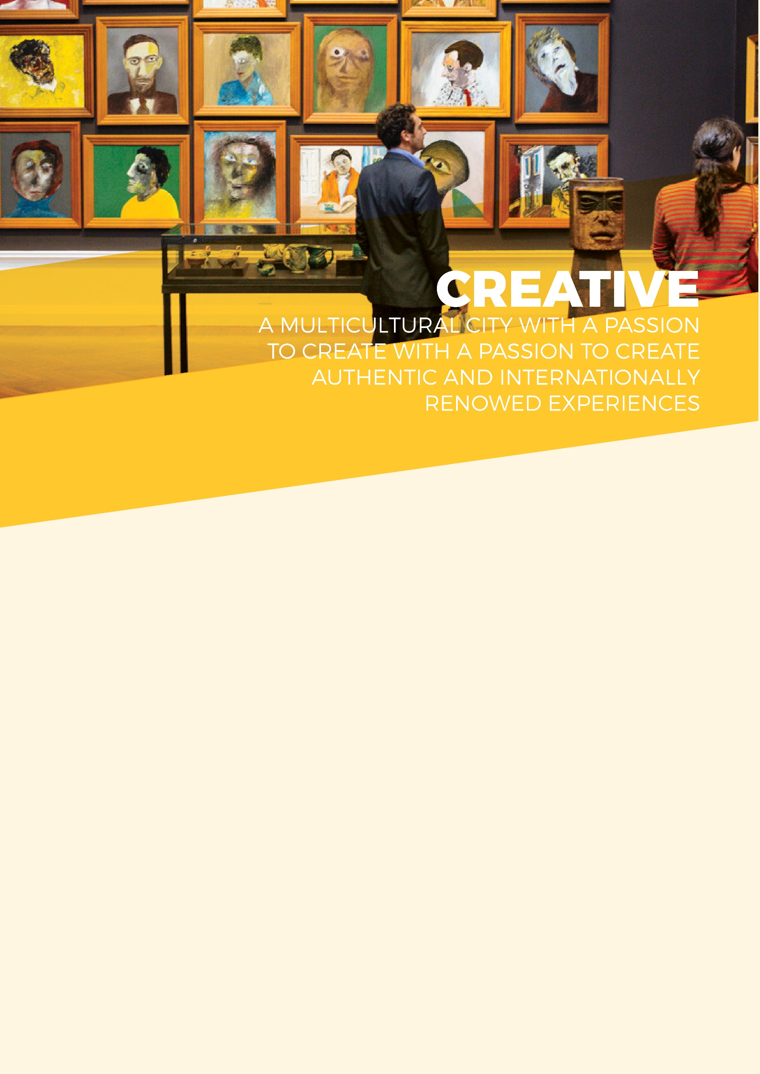

OBJECTIVES
- Attendance at festivals and events in the city and Park Lands will have grown by 5% by 2020
- A detailed measure of the number of people creating and actively participating in arts and cultural activities will have been developed and influences our work
- Bed nights spent in Adelaide by international and domestic visitors will have grown from 8.1 million to 9 million by 2020
- People who say the city has great places to enjoy events, activities, art and culture will have grown from 8.4 to 9 out of 10 by 2020
- The number of people that are visiting the city each day for shopping, leisure or entertainment will have grown from 111,000 to 117,000 by 2020

STRATEGIC PLAN ACTIONS
The Creative theme has 32 actions to be progressed during the life of the 2016-2020 Strategic Plan. The actions under the Creative theme focus on more and better events, events infrastructure, audience development and visitor attraction, the creation and active participation in cultural activity, and the innovative use of public and private spaces for cultural expression.  2018 - 2019 DELIVERABLES  The following deliverables were planned for 2018-19. They align to the actions under the Creative theme of the City of Adelaide 2016-2020 Strategic Plan.  Given the passage of time, some deliverables for 2018-19 will have already been progressed at the time Council receives this document. | - Support APLA, Council and the State Government in the implementation of the Adelaide Park Lands Management Strategy  - Deliver a range of joint funded memorials and public art capital projects  - Deliver APLEMP Project 6 - Improve the spatial distribution of events  - Continue to deliver Projects 1,2 and 8 of the APLEMP  - Continue to deliver projects 3,4 & 7 of the APLEMP  - Strategic partnership with Festivals Adelaide  - Target the attraction of new events  - Delivery of Live Music Action Plan - Goals 1, 2, 3 and 4  - Support and growth of the Umbrella Winter Music festival  - Marketing plan for festivals and events  - Support the delivery of inspiring art, cultural and multicultural projects.  - Increase community contribution to the creative, cultural and artistic life of the City  - Delivery of Public Art Action Plan  - Develop a Measurement tool for capturing Cultural Vitality  - Attract and support artists and cultural entrepreneurs to develop commercial opportunities  - City activation  - Delivery of Activation Plan for 88 O’Connell Street  - Build relationships with and support cultural institutions to activate the city and Park Lands  - Deliver Visitor Information Services  - Enhance and promote City experiences to Chinese visitors and support China relevant businesses | - Deliver 2018/19 Visitor Economy Action Plan  - Adelaide Convention Bureau funding  - Continue to deliver Project 5 of the Adelaide Park Lands Event Management Plan.  - Deliver a network of interactive way-finding  - Enhance the arrival experience into and around the City including digital wayfinding signage  - Advocate for an interstate rail terminal in the City  - Deliver major city infrastructure projects  - Deliver New Year’s Eve  - Christmas in the City experience  - Adelaide Prize  - Elder Park Master Plan  - Collaborate with the State Government to support the implementation of the Planning, Development and Infrastructure Act  - Support public art in private developments through policy implementation and planning  - Include opportunities for specialised lighting in the delivery of infrastructure  - Contribute to the finalisation of a Master Plan of works that delivers a connected North Terrace and Riverbank Precinct  - Deliver the ‘Our Market’ plan  - Design and transport related advice and direction for major State-driven city projects  - Deliver NAIDOC Week celebrations  - Monitor and support delivery of City of Adelaide’s Stretch Reconciliation Action Plan 2018- 2021  - Provide sponsorship and support to Festivals Adelaide  - Festivals and events sponsorship program  - Australia Day in the city

City of Adelaide
Strategy, Planning & Partnerships
25 Pirie Street Adelaide
+61 8 8203 7203
city@cityofadelaide.com.au

