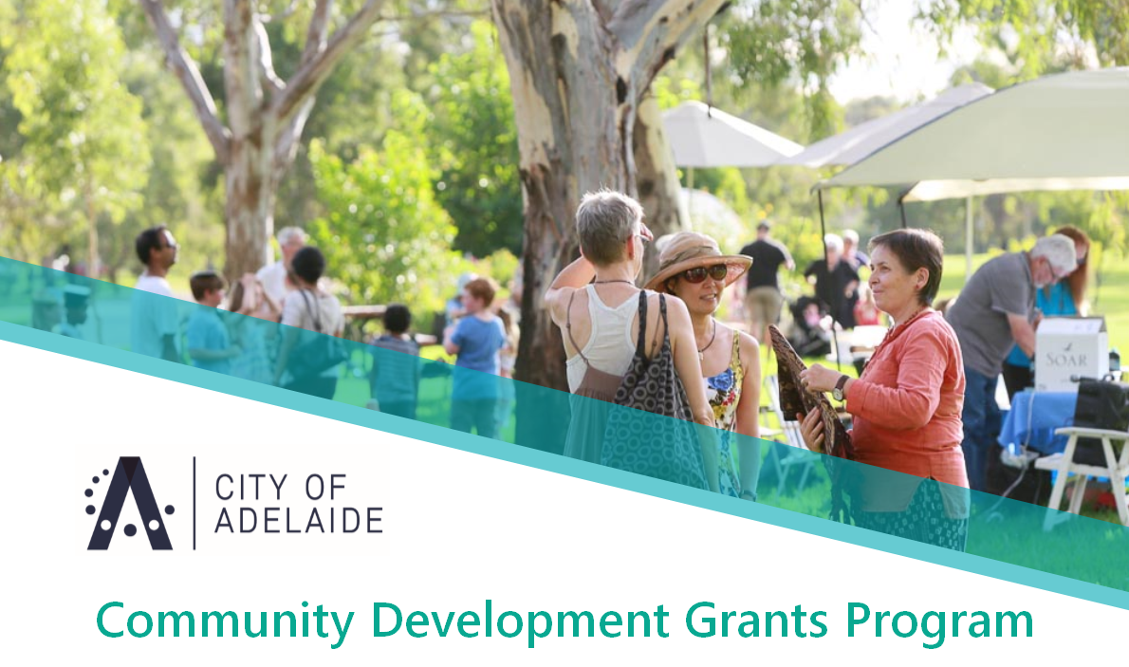
Major Grants Expression of Interest Draft Form
Category One:
- Community Development Major Grant
Up to $50,000 per year for up to 3 years

Please refer to the Grant Guidelines and scheduled before applying and note that hard copy, faxed or emailed application will not be accepted.

Name of Organisation
Street Address
Postal Address
Contact person and Position
Phone
Email
Name of Application
Years of funding sought
Amount of Funding Sought per year (up to $50,000 per year) | Year One: $
 | Year Two: $
 | Year Three: $
Date of Submission

Please indicate which program priorities your application directly relates to
(there can be more than one): 20%

- Encourage residents and community groups to actively participate in their local city community
- Strengthen reconciliation practices
- Deliver inclusive responses to meet the needs of isolated and marginalised groups including, but not limited to, services to vulnerable people who are affected by extreme weather conditions
- Promote lifelong learning
- Increases volunteer participation
- Promote active participation in decision making
- Provide access to learning, services and ideas
- Create opportunities for people to connect with and welcome newcomers into their local neighbourhood

Name of Application |  | Assessment Weighting
Brief Overview of the Application  (Suggested 100 word maximum) |  | N/A
Start Date |  | N/A
End Date |  | N/A
Where will the application take place?  (It must be within the boundaries of the City of Adelaide including any of the Park Lands) |  | N/A
Who is the target group for your application? |  | N/A
How did you determine that this application was needed? What evidence do you have to support its development?  (e.g. service statistics, ABS data, anecdotal observations) |  | 20%
What outcome/s are you seeking to achieve?  (Please ensure that you have read the Liveable actions in the City of Adelaide Strategic Plan 2016- 2020 to ensure that your outcomes are consistent with those sought by Council). |  | 20%
How will you measure your outcomes? |  | 20%

What will COUNCIL'S FUNDS be used for (e.g. marketing, infrastructure hires, performance fees, insurance etc)? 10%

Expenditure | Amount
Wages / Associated Costs / Facilitator Costs
Hire – Equipment / Venue / Infrastructure / Catering
Marketing & Promotion
Insurances
Fees / Permits
Miscellaneous

What partnerships relate to this application and what will each partner contribute? 10%

Partner Organisation/s | Contribution | Confirmed  (yes/no) | Name & Contact Details

