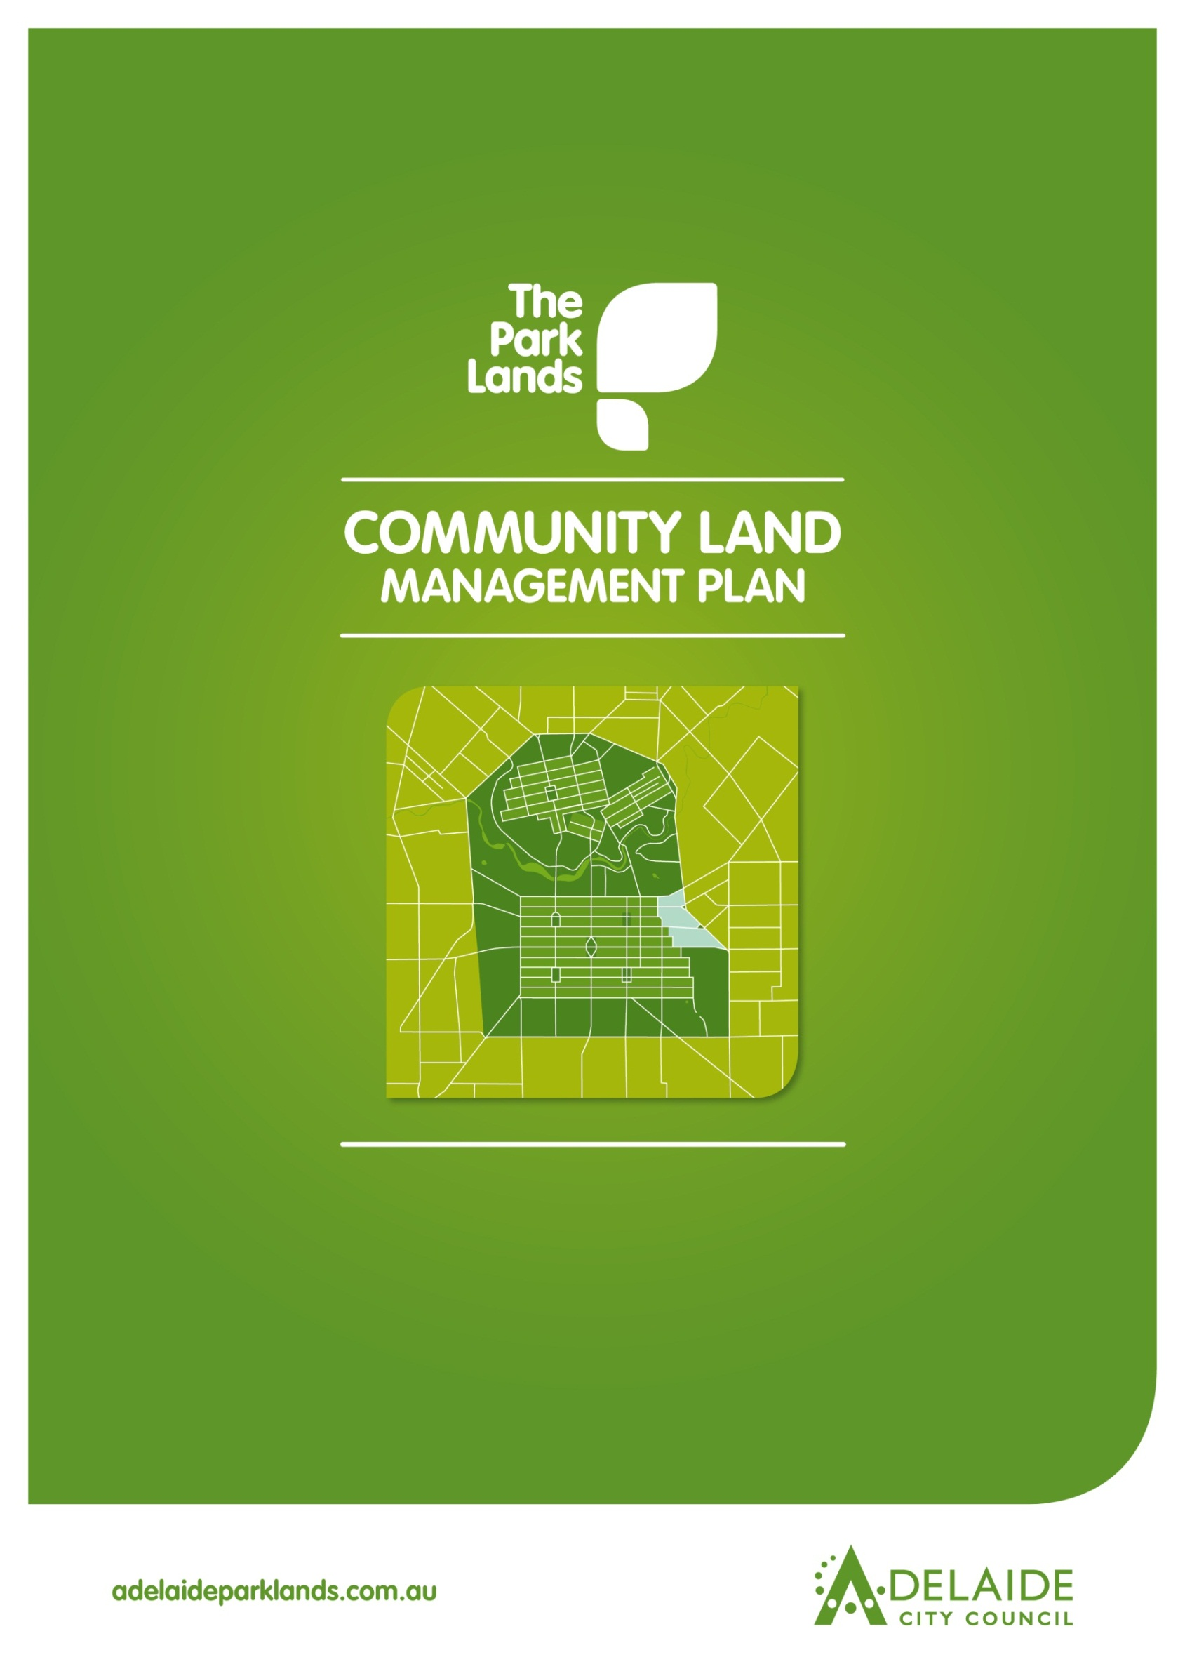

**Chapter 14**

**Rundle Park / Kadlitpina**

**Rymill Park / Murlawirrapurka**

**Ityamai-itpina (Park 15)**



**Rundle Park/Kadlitpina, Rymill Park/Murlawirrapurka and Ityamai-itpina (Park 15)**

**Introduction**

1. **Directions**
   1. **Desired Future Character Statement**
   2. **Challenges/Opportunities**
   3. **Management Directions**
2. **Background**

* 1. **Heritage**
     1. **Kaurna Heritage**
     2. **Kaurna Naming**
     3. **European Significance**
     4. **Heritage Listing**

**2.2 Landscape**

**2.3 Recreation**

**Lease and Licence Areas Map**

**2.4 Natural Systems**

**Introduction: The Community Land Management Plan**

Show

* Parcel boundaries
* Lease areas
* Licence areas
* Core area
* Garden areas
* Intended car parks and carrying capacities
* Roads and access

Show

* Parcel boundaries
* Lease areas
* Licence areas
* Core area
* Garden areas
* Intended car parks and carrying capacities
* Roads and access

This document is Chapter 14 of the Community Land Management Plan for the Park Lands (the CLMP). It should be read together with Chapter 1, which is the CLMP Framework. Chapter 1 explains the requirements for the CLMP, the legislative and planning context, the CLMP Statutory Principles, and the CLMP Framework. ­

Rundle Park/Kadlitpina, Rymill Park/Murlawirrapurka and Ityamai-itpina (Park 15) are grouped together in this chapter because of similarities in landscape character and use. The key to each Chapter is the Management Directions which represent the application of existing strategies and policies in each Park area.

**______________________________________________________________________________**

**1.0 Directions for Rundle Park/Kadlitpina, Rymill Park/Murlawirrapurka and Ityamai-itpina (Park 15)**

**1.1 Desired Future Character Statement**

***The picnic and event spaces of Rundle Park/Kadlitpina and Rymill Park/Murlawirrapurka provide urban parks with unique characteristics, such as the 1960s design of Rymill Park, contrasted with the more natural and sporting uses of Ityamai-itpina (Park 15).***

**1.2 Challenges/Opportunities**

* Strengthening the ***quality and appeal*** of the Park Lands to attract park users.
* Contributing to the ***open space needs and expectations*** of the growing residential communities in and around the City.
* Minimising ***impacts on the parks*** associated with high usage and a wide range of events.
* Maintaining and enhancing the ***formal garden settings*** in Rundle Park/Kadlitpina and Rymill Park/Ityamai-itpina.
* Improving the ***biodiversity values*** ofItyamai-itpina (Park 15) whilst maintaining turfed and shaded areas for recreation and sport
* Maintaining important ***views and vistas*** across the Adelaide Plains to the Adelaide Hills.
* Ensuring ***tree avenues*** are conserved and strengthened.
* Meeting ***demand for improved pedestrian and cyclist access*** for recreation and commuter purposes.
* Managing ***flood mitigation measures*** in the Parks.

**1.3 Management Directions**

1.3.11 Manage the area in the **western part of Rymill Park/Murlawirrapurka** near East Terrace (former road reserve) as Park Lands allowing very limited vehicular access, loading and parking according to a permit system in favour of the Aboriginal Land Trust (Tarndanya).

1.3.12 Provide **supporting infrastructure** for paths such as signage, lighting, path upgrades and supporting facilities (PLPP3).

1.3.13 Maintain and enhance **views and** **vistas to the skyline and the Adelaide Hills** through carefully planned tree planting and spatial arrangements. Views illustrated as:



1.3.14 Protect **revegetation areas** in Ityamai-itpina (Park 15) and implement a selective mowing regime where appropriate.

1.3.15 Maximise **programmed usage** of the lease and licence areas and foster community access in Ityamai-itpina (Park 15).

1.3.16 Manage **car parking availability** for general park visitors (PLP14) including the public car park adjacent the Adelaide Bowling Club.

1.3.17 Support **improved landscaping and fencing interface** between the Park and the Adelaide Bowling Club.

1.3.18 Improve **waste management** associated with kiosk.

1.3.19 Improve **water quality and management of** Botanic Creek by introducing appropriate vegetation in suitable locations and flood mitigation.

1.3.20 Support the **rationalisation of buildings** and upgrade of **regional sports areas courts** in Ityamai-itpina (Park 15) **(**MP4.3 and R17).

1.3.21 Manage the **playground in Ityamai-itpina (Park 15**) for the use of residents and nearby schools recognising its heritage value embodied in remnant plantings and the shelter shed, and seeking opportunities to better integrate the playground with the Park.

1.3.22 Support **improved use and access to courts** in Ityamai-itpina (Park 15).

1.3.23 Permit leases and licences as shown on **Lease and Licence Areas Map** 2.3 and in accordance with Chapter One Framework.

1.3.1 Enable **appropriate activities and events** in the Parks (RS2 & 6) allowing spaces to respond to their context to accommodate both events and informal recreation, ensuring access to facilities such as kiosk, playground and lake during events, and enhancing **event venues** within Rundle Park/Kadlitpina and Rymill Park/Murlawirrapurka while maintaining their existing semi-formal character (LMP p.65).

1.3.2 Conserve, enhance and interpret the identified **cultural heritage landscape** and its contributory features such as exotic species, avenues and corridors (HS3 & 4):

1. Aleppo Pine stand
2. White Cedar Avenue
3. Camphor Laurel Circle
4. Northern Rose Garden
5. Southern Rose Garden
6. Oriental Plane Tree Avenue
7. White Cedar Avenues
8. Olive Grove
9. SA Blue Gum Avenue
10. Pepper Tree Avenue

1.3.3 Retain, conserve and pursue Local Heritage Listing of:

a. the white cedar avenue in Rundle Park.

b. Valve House

c. Alice in Wonderland statue

d. “Picanniny” statue

e. The 1961 landscape design of Rymill Park including the lake, footbridges, sign, rose gardens and sundial

f. former tramline embankment

g East Terrace **Ityamai-itpina (Park 15**) Glover Playground including shelter shed, sign and original as trees

1.3.4 Manage the War memorial horse trough and obelisk in recognition of its status as a **Local heritage Place (City Significance)**.

1.3.5 Retain existing **spatial layout and pathway alignments** which are part of the cultural heritage values of the Parks (HS3).

1.3.6 Strengthen the outer and City edges of the parks through **large tree species plantings** and enhance the Park’s character consistent with the Open Woodland/Sports Zone and the Civic, Cultural and Urban Parks Zone and manage landscape consistent with the planting directions in 2.2 below. (*L13*)

1.3.7 Manage and support improvements to **playground, kiosk, picnic areas and lake** in Rymill Park/Murlawirrapurkaasan activity hub for informal recreation (R9).

1.3.8 Manage **Park Lands Trail, strengthening connections to adjoining parks,**  and other paths for residents and visitors (particularly perimeter paths) linking with City and suburban walking and cycle networks where appropriate (RP10, RP11).

Park Lands Trail is shown as: 

Priority proposed/upgrade shared path: 

1.3.9 **Lighting** should support the safe movement of pedestrians throughout the Park. (R9)

1.3.10 Ensure that **CPTED principles** are taken into consideration, whereby sightlines are supported through vegetation management. (R9)

**DESIRED FUTURE CHARACTER**

*“****The picnic and event spaces of Rundle Park/Kadlitpina and Rymill Park/Murlawirrapurka provide urban parks with unique characteristics, such as the 1960s design of Rymill Park, contrasted with the more natural and sporting uses of Ityamai-itpina (Park 15).”***

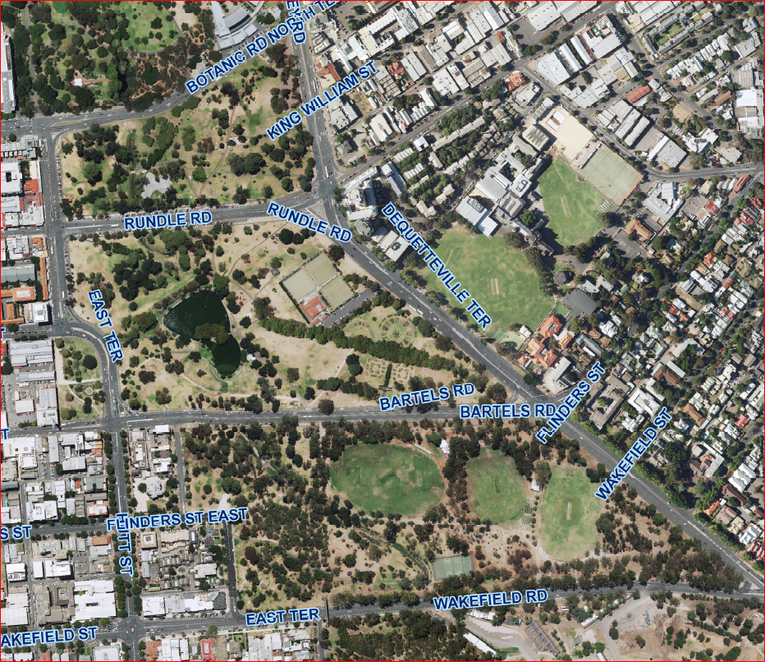

***Rundle Park/Kadlitpina***

**Rundle Park/Kadlitpina, Rymill Park/Murlawirrapurka**

**and Ityamai-itpina (Park 15)**

***Ityamai-itpina (Park 15)***

***Rymill Park/Murlawirrapurka***

**10**

**9**

**8**

**7**

**7**

**4**

**6**

**5**

**4**

**3**

**2**

**1**

**References to Adelaide Park Lands Management Strategy:**

**R** - Recreation **PLP** - Park Lands Priority

**H** - Heritage **S** - Strategy

**L** - Landscape **MP** - Management Principles and Strategies

**NS** - Natural Systems 2 - Number refers to relevant strategy or

principle

*Example:* H.S.3&4 refers to Heritage Strategies 3 & 4

**Parks 2-5**

1. **Background**

**Rundle Park/Kadlitpina, Rymill Park/Murlawirrapurka and Ityamai-itpina (Park 15)** form an important gateway statement for the eastern entrance to the City.

**Rundle Park/Kadlitpina and Rymill Park/Murlawirrapurka** are predominantly a formal landscape with a mixture of native and exotic trees. The parks provide a range of informal recreation facilities and also host a variety of events. The 1961 design of **Rymill Park/ Murlawirrapurka** lend it a unique style characterised by the lake and stone features. Ityamai-itpina (Park 15) is predominantly a semi-natural landscape with well-maintained sports fields and tennis courts and high utilised playground.

The [Adelaide Park Lands Landscape Master Plan](http://www.adelaidecitycouncil.com/assets/acc/Council/policies/docs/111107%20Parklands%20MP%20Report_.pdf) identifies four landscape zones in the Park Lands – **Rundle Park/Kadlitpina and Rymill Park/Murlawirrapurka** are located in the **Civic, Cultural and Urban Parks Zone (3)** characterised by structured and highly utilised parks. These two Parks will respond more positively to the adjacent entertainment, retail and commercial precincts and be redeveloped to provide greater opportunities for city residents, workers, shoppers and visitors to enjoy a range of landscape settings befitting a contemporary city environment.

**Ityamai-itpina (Park 15)** is located within the **Open Woodland/Sports Zone** **(1)** characterised by large open grassed spaces semi-enclosed by predominantly native groves of trees, the open spaces are generally used for sporting activities. Significant areas of native vegetation and revegetation exist in this zone.

**2.1 Heritage**

**2.1.1 Kaurna significance:**

The [Adelaide Park Lands](http://www.adelaidecitycouncil.com/assets/acc/Community/reconciliation/docs/tarndanyungga-kaurna-yetta.pdf) are part of the Red Kangaroo Dreaming Place, an important place for the Kaurna people long before Adelaide was established.

**Rundle Park/Kadlitpina, Rymill Park/Murlawirrapurka and Ityamai-itpina (Park 15)** were part of a major camping area (1840s-1900) for Kaurna people. This area would once have been an area of swamp leading into the waterhole in the Botanic Gardens. It would have provided a wealth of foods and other resources for the Aboriginal people of the area.

**2.1.2 Kaurna Naming:**

As part of the Adelaide City Council’s commitment to reconciliation with Aboriginal communities, places within the City have been given [Kaurna names](http://www.adelaidecitycouncil.com/environment/park-lands/park-lands-heritage.html).

* Rundle Park is known as Kadlitpina which loosely translates as ‘Captain Jack’.
* Rymill Park is known as ‘Murlawirrapurka’ which loosely translates as ‘King John’.
* Park 15 is known as ‘Ityamai-itpina’ which loosely translates as ‘King Rodney’.

**2.1.3 European significance:**

Overall **Rundle Park/Kadlitpina, Rymill Park/Murlawirrapurka and Ityamai-itpina (Park 15)** retain their original shape and form as devised by Colonel William Light[1], and have evidence of substantial tree planting that accords with the general spatial and species intent of John Ednie Brown[2], August Pelzer[3] and Pengilly[4] such as pathway alignments and species plantings which reinforce a semi-formal Victorian style.

A cross-axial pathway lined with white cedars dissects the **Rundle Park/Kadlitpina** and has been evident since the 1870s. The path constitutes an important aesthetic and design element in the Park. In the 1980s a part of the Park was created with the removal of the Kent Town Waterworks, with a predominantly native vegetation character and later dedicated as the “Peace and Friendship Garden”. The former Valve House from the waterworks remains in the Park but was relocated and substantially rebuilt within the north-east corner.

Two cross-axial pathways lined with Oriental Planes and White Cedars dissect **Rymill Park/Murlawirrapurka** that historically has been evident since the 1870s. Both constitute important aesthetic and design elements in the Park. In the 1950s-60s, the Park was transformed to accommodate a lake, picnic and recreation grounds, as well as a large rose garden resulting in much of the present character and planting strategy. Road alignment changes in the 1960s resulted in the south western corner of the Park being excised as a separate garden portion with little logical connection to either the Park or adjacent city streets. It is important that this area is managed as part of the Park, with no car parking permitted, so that it is seen and used as part of the Park Lands rather than disused land, making most of its attractive fountain focal point.

**Ityamai-itpina (Park 15)** has evidence of some tree planting that was undertaken during the Pengilly and Pelzer administrations that sought to create a semi-formal Victorian gardenesque style however this was never realised. Two short avenues of Pepper Trees (*Schinus aeria var molle*) and South Australian Blue Gums (*Eucalyptus leucoxylon*), combined with the Olive (*Olea europaea*) grove create interesting visual features and constitute important aesthetic and design elements in the Park.

**Rundle Park/Kadlitpina** contains the following vegetation and natural elements of heritage value:

* Botanic Creek watercourse
* White Cedar (*Melia azedarach var australica*) avenue that dissects the Park, dating from the mid 1870s.
* Camphor Laurel (*Camphora cinnamomum*) circle planted by the Lions Club, in the south-eastern corner of the Garden, dating from the mid 1990s.
* Aleppo Pine (*Pinus halepensis*) stand of trees along the southern edge of Botanic Road that provides strong visual definition to the road scape and the northern flank of the Park, dating from the 1880s.

**Rymill Park/Murlawirrapurka** contains the following vegetation and natural elements of heritage value:

* Botanic Creek watercourse
* White Cedar (*Melia azedarach var australica*) avenue running from the south-western corner of the Park to the Dequetteville Terrace & Rundle Street East intersection
* White Cedar (*Melia azedarach var australica*) avenue running from the north-western corner of the Park into the Lake precinct
* Oriental Plane (*Platanus orientalis*) avenue running from the south-eastern corner of the Park into the Lake precinct
* Original English Elm (*Ulmus procera*) street tree plantings in the western portion of Rymill Park

**Ityamai-itpina (Park 15)** contains the following vegetation and natural elements of heritage value:

* Botanic Creek watercourse
* Olive (*Olea europaea*) grove in the western portion of the Park
* SA Blue Gums (*Eucalyptus leucoxylon*) along the Wakefield Road frontage and in the centre of the Park
* Pepper Tree (*Schinus aeria var molle*) avenue in the centre of the Park

There are additional (individual) trees of heritage value identified in the (Dr David Jones) the [Adelaide Park Lands and Squares Cultural Landscape Assessment Study](http://www.adelaidecitycouncil.com/environment/park-lands/heritage1/cultural-landscape-study/) for Rundle Park/Kadlitpina, Rymill Park/Murlawirrapurka and Ityamai-itpina (Park 15). Only the avenues, boulevards and groupings of trees are identified in this Plan.

**2.1.4 Heritage Listing:**

**Rundle Park/Kadlitpina, Rymill Park/Murlawirrapurka and Ityamai-itpina (Park 15)** arepart of the [Adelaide Park Lands and City Layout](http://www.environment.gov.au/heritage/places/national/adelaide-parklands/index.html) which are on the National Heritage List. See Part 1, in the CLMP Planning Framework, at 1.3.1 for further information.

**Rundle Park/Kadlitpina** contains the War Horse Memorial Trough and Obelisk which is a Local Heritage Place (City Significance). This Park also contains the Valve House which was moved and rebuilt in the eastern end of the Park which is the last remaining structure from the Kent Town Waterworks, which was demolished in the 1980s. This building is not heritage listed but is an important feature considered to be of cultural and historic importance.

**Rymill Park/Murlawirrapurka and Ityamai-itpina (Park 15)** do not contain any State or local Heritage Placesidentified within the Adelaide (City) Development Plan. However, the Alice in Wonderland statue and the Picanniny statue in Rymill Park/Murlawirrapurka are considered to be of cultural and historic importance and are potential Local heritage places. The Rymill Park 1961 design features including the lake, footbridges (although replaced), sign, rose gardens and sundial, are also considered to be of cultural and historic importance. The former tramline embankment through **Rymill Park/Murlawirrapurka** also tells a story about its former use and layout, as well as providing a topographical feature adding interest to the Park.

**Ityamai-itpina (Park 15**)features a playground which still retains some features of its historic background, including the shelter shed, some remnant plantings and signage. The shelter shed is important to be retained.

* + 1. **Landscape**

The [Adelaide Park Lands Landscape Master Plan](http://www.adelaidecitycouncil.com/assets/acc/Council/policies/docs/111107%20Parklands%20MP%20Report_.pdf) identifies four landscape zones in the Park Lands. Rundle Park/Kadlitpina, Rymill Park/Murlawirrapurka and Ityamai-itpina (Park 15) are located within two zones.

**Rundle Park/Kadlitpina and Rymill Park/Murlawirrapurka** are located in the Civic, Cultural and Urban Parks Zone (Zone 3) which is characterised by structured and intensively-used Parks. Its vision is:

“*This zone, building on the Torrens River and the array of cultural and tourist activities along the northern edge of the city, is the major destination within Adelaide for local residents and visitors alike. Urban gardens and plazas, waterside parks and intensively used recreation hubs and event spaces create a unique sequence of parks which are a defining feature of the city and its lifestyle*”.

Applicable key planting directions from the **Adelaide Park Lands Landscape Master Plan: Civic, Cultural and Urban Parks Zone (3)** are:

* Structure planting to support a wide variety of intensively used spaces.
* Mix exotic and native species to provide spatial definition, shade and wind protection for adjacent spaces.
* Plantings to be more architectural in their patterning and layout, although some areas in the eastern parts of **Rundle Park/Kadlitpina and Rymill Park/Murlawirrapurka** may have a more informal character.
* Characterise the existing planting structure with a strong delineation between mown exotic grass and adjacent enclosing tree plantings.
* Use low plantings to reinforce walkway edges and avenue plantings.
* Grass or terrace slopes along the River and in other areas, use terraced gardens to showcase low water-use vegetation which add colour and texture to the park environment.

**Ityamai-itpina (Park 15)** is located in the Open Woodland/Sports Zone (Zone 1) which is characterised by large open grassed spaces semi-enclosed by predominantly native groves of trees, the open spaces generally used for sporting activities. Its vision is:

“*A broad open landscape with long vistas. This is the defining landscape of the Park Lands; home to a vast urban woodland of native trees, this zone is a reminder of the Adelaide landscape prior to 1836. It is also a place for people to recreate in both sporting and informal activities and enjoy the manicured gardens and avenues nestled within*.”

Applicable key planting directions from the **Adelaide Park Lands Landscape Master Plan: Open Woodland/Sports Zone (1)** are:

* enhance areas of high biodiversity particularly key remnant vegetation sites. Restore and reinforce an open woodland character generally across the Zone.
* Dominant tree species should be native/indigenous, informally planted, and interspersed with open grassland.
* Increase tree planting where spatial structure of open spaces needs enhancement.
* Limit understorey planting to areas that screen out unwanted elements such as vehicular traffic, and areas where natural landscapes for increased biodiversity are proposed, balanced with the general ‘open’ character of this zone, providing long views where appropriate.
* Plant exotic grasslands for sports fields and active recreation, and native grasslands in other areas to reinforce the natural character.
* Retain exotic species around designated facilities and gardens and in culturally significant avenues.
* Conserve and
* Allow for food-bearing plants in suitable locations.

**Rundle Park/Kadlitpina and Rymill Park/Murlawirrapurka** are predominantly recreational landscapes while Ityamai-itpina (Park 15) has predominantly natural landscapes containing significant areas of native vegetation. **Ityamai-itpina (Park 15)** is a site for the state government Million Tree Program which aims to recreate the original woodland environment and protect remnant grasses. The Park has considerable variation in topography which adds visual interest.

Important supporting material to the development of the CLMP is the [Adelaide Park Lands and Squares Cultural Landscape Assessment Study](http://www.adelaidecitycouncil.com/environment/park-lands/heritage1/cultural-landscape-study/) October 2007 by Dr David Jones which provides detailed information about the cultural landscape features of **Rundle Park/Kadlitpina, Rymill Park/Murlawirrapurka and Ityamai-itpina (Park 15)**.

**2.3 Recreation**

**Rundle Park/Kadlitpina, Rymill Park/Murlawirrapurka and Ityamai-itpina (Park 15)** make an important contribution to the recreation facilities of Zone 1, the Open Woodland/Sports Zone indicated by the [Adelaide Park Lands Landscape Master Plan](http://www.adelaidecitycouncil.com/assets/acc/Council/policies/docs/111107%20Parklands%20MP%20Report_.pdf).

**Rundle Park/Kadlitpina, Rymill Park/Murlawirrapurka and Ityamai-itpina (Park 15)** serve as a recreation precinct for a number of licence holders as well as serving the community through the provision of facilities including:

* Picnic facilities
* Pentanque Pisté
* Playground in Rymill Park/Murlawirrapurka
* Bowling Club
* Kiosk
* Sports fields and associated change rooms
* Tennis courts
* Cricket pitches

Leased and licensed facilities are shown on the ***Lease and*** ***Licence Areas Map*** below. Facilities are available for use by other users outside of licensees’ hours of use.

Cycle and pedestrian routes through the Park Lands are used for both commuter and recreation purposes, with proposed upgrades of existing paths, or proposed new paths as determined in the [Smart Move Strategy](http://intranet.adelaide.sa.gov.au/knowledge/Pages/Smart-Move-Strategy.aspx), shown in 1.3.

**Lease and Licence Areas Map**

The Adelaide Bowling Club is the leased area within its fence (marked as 1 below). The sports fields and tennis courts (marked as 2, 3, 4 & 5) are licensed.

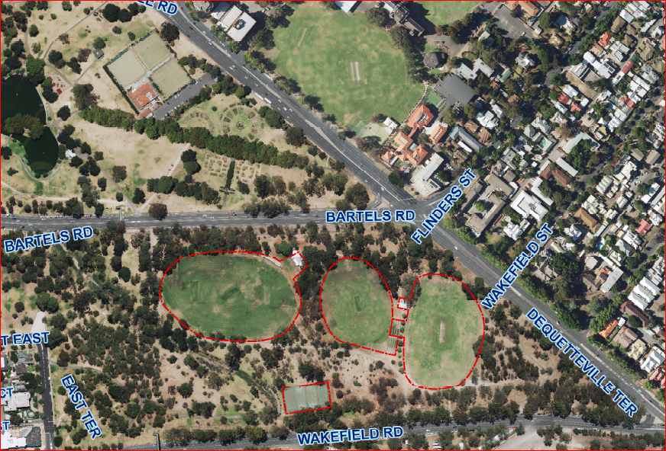

***Legend***

1. *Adelaide Bowling Club*
2. *Sports field(licensed) (plus change rooms which are leased)*
3. *Sports field*
4. *Sports field(plus change rooms which are leased)*
5. *Tennis Courts*

|  |
| --- |
|  |

**2.4 Natural Systems**

A number of remnant native grasses are present in **Rundle Park/Kadlitpina, Rymill Park/Murlawirrapurka and Ityamai-itpina (Park 15)**.   The Adelaide Park Lands Management Strategy (APLMS) Landscape Character map (page 22) identifies Biodiversity Conservation Areas (of importance) in the Park Lands.  There are no areas of importance located in **Rundle Park/Kadlitpina, Rymill Park/Murlawirrapurka and Ityamai-itpina (Park 15)**.

The Biodiversity and Water Quality Action Plan 2011-2016 has been adopted by Council and represents the additional research conducted in the development of the ‘Key Biodiversity Areas’ within the Park Lands.  There are no key biodiversity areas in **Rundle Park/Kadlitpina, Rymill Park/Murlawirrapurka and Ityamai-itpina (Park 15)**.

**Relevant Links:**

Adelaide Park Lands Management Strategy

<http://www.adelaidecitycouncil.com/environment/plans-and-policies/park-lands-management-strategy.html>

Cultural Landscape Study

<http://www.adelaidecitycouncil.com/environment/park-lands/park-lands-heritage/cultural-landscape-study.html>

Landscape Master Plan

<http://www.adelaidecitycouncil.com/environment/park-lands/park-lands-heritage/cultural-landscape-study.html>

Kaurna naming

<http://www.adelaidecitycouncil.com/environment/park-lands/park-lands-heritage.html>

Cultural Landscape Study - general

<http://www.adelaidecitycouncil.com/environment/park-lands/park-lands-heritage/cultural-landscape-study.html>

Cultural Landscape Study – Reports and Assessments on Padipadinyilla (Park 2), Kandarilla (Park 3), Kangattilla (Park 4) and Ngampa Yerta (Park 5))

<http://www.adelaidecitycouncil.com/environment/park-lands/heritage1/cultural-landscape-study/>

Adelaide City Council Biodiversity and Water Quality Action Plan

<http://www.adelaidecitycouncil.com/environment/biodiversity.html>

Smart Move Strategy

http://intranet.adelaide.sa.gov.au/knowledge/Pages/Smart-Move-Strategy.aspx

Park Lands Building Design Guidelines

http://intranet.adelaide.sa.gov.au/knowledge/Pages/ParkLandsBuildingDesignGuidelines.aspx

1. Surveyor General of Adelaide
2. John Ednie Brown, Council’s Supervisor of the Plantations, engaged to prepare a Report on a *System of Planting the Adelaide Park Lands* (1880)
3. August Pelzer, City Gardener 1899-1934
4. William Pengilly, City Gardener 1867-1883