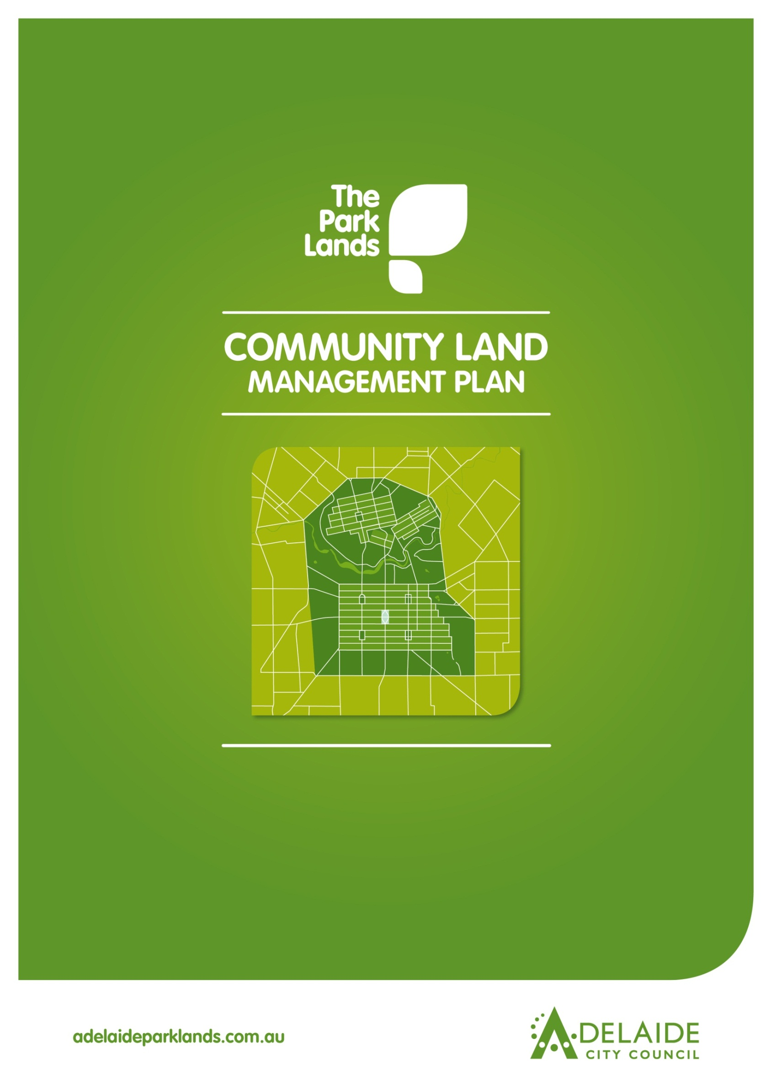

**Chapter 16**

**Victoria Square/Tarntanyangga**



**Victoria Square/Tarntanyangga**

**Introduction**

1. **Directions**
   1. **Desired Future Character Statement**
   2. **Challenges/Opportunities**
   3. **Management Directions**
2. **Background**
   1. **Heritage**
      1. **Kaurna Heritage**
      2. **Kaurna Naming**
      3. **European Significance**
      4. **Heritage Listing**

**2.1.5 Features of Significance**

**2.2 Landscape**

**2.3 Recreation**

**Lease and Licence Areas Map**

**2.4 Natural Systems**

**Introduction: The Community Land Management Plan**

Show

* Parcel boundaries
* Lease areas
* Licence areas
* Core area
* Garden areas
* Intended car parks and carrying capacities
* Roads and access

Show

* Parcel boundaries
* Lease areas
* Licence areas
* Core area
* Garden areas
* Intended car parks and carrying capacities
* Roads and access

This document is Chapter 16 of the Community Land Management Plan for the Park Lands (the CLMP). It should be read together with Chapter 1, which is the CLMP Framework. Chapter 1 explains the requirements for the CLMP, the legislative and planning context, the CLMP Statutory Principles, and the CLMP Framework. ­

The key to each Chapter is the Management Directions which represent the application of existing strategies and policies in each Park area. The symbol shown at each Management Direction (e.g. NS4) refers to the Adelaide Park Lands Management Strategy. The Guiding Principles of the Victoria Square/Tarntanyangga Urban Regeneration Masterplan have also been incorporated into the Management Directions. The CLMP ensures the Masterplan is consistent with the Strategy. The Management Directions show how projects endorsed through the Masterplan would be implemented in each Park area and does not propose new projects.

**1.0 Directions for Victoria Square/Tarndanyangga**

**1.1 Desired Future Character Statement**

***To be an accessible and vibrant public space that is internationally recognised as a symbol of South Australia’s unique culture and lifestyle.***

**1.2 Challenges/Opportunities**

* Obtaining ***capital funding for the redesign and enhancement*** of Victoria Square/Tarntanyangga through design excellence and distinctive features that broaden and enhance its appeal and use.
* ***Maintain the symbolic nature of*** Victoria Square/Tarntanyangga as the principal square
* Contributing to the ***open space needs and expectations*** of the growing residential and working communities in and around the City.
* Enhancing the ***settings of existing markers and monuments***, particularly surrounding monuments, State Heritage Places and items of cultural and historic importance.
* Maintaining important north-south and east-west ***views and vistas*** down the streets to Hills in the distance.
* Strengthening the key ***streetscape connections*** between the Park Lands and the Squares.
* Identifying and understanding ***Aboriginal, European and multicultural heritage*** so that heritage places are appropriately managed and maintained for future generations.
* Improving ***pedestrian accessibility*** and linkages with all modes of public and private transportation.

**1.3 Management Directions**

**DESIRED FUTURE CHARACTER**

*‘To be an accessible and vibrant public Square that is internationally recognised as a symbol of South Australia’s unique culture and lifestyle’.*

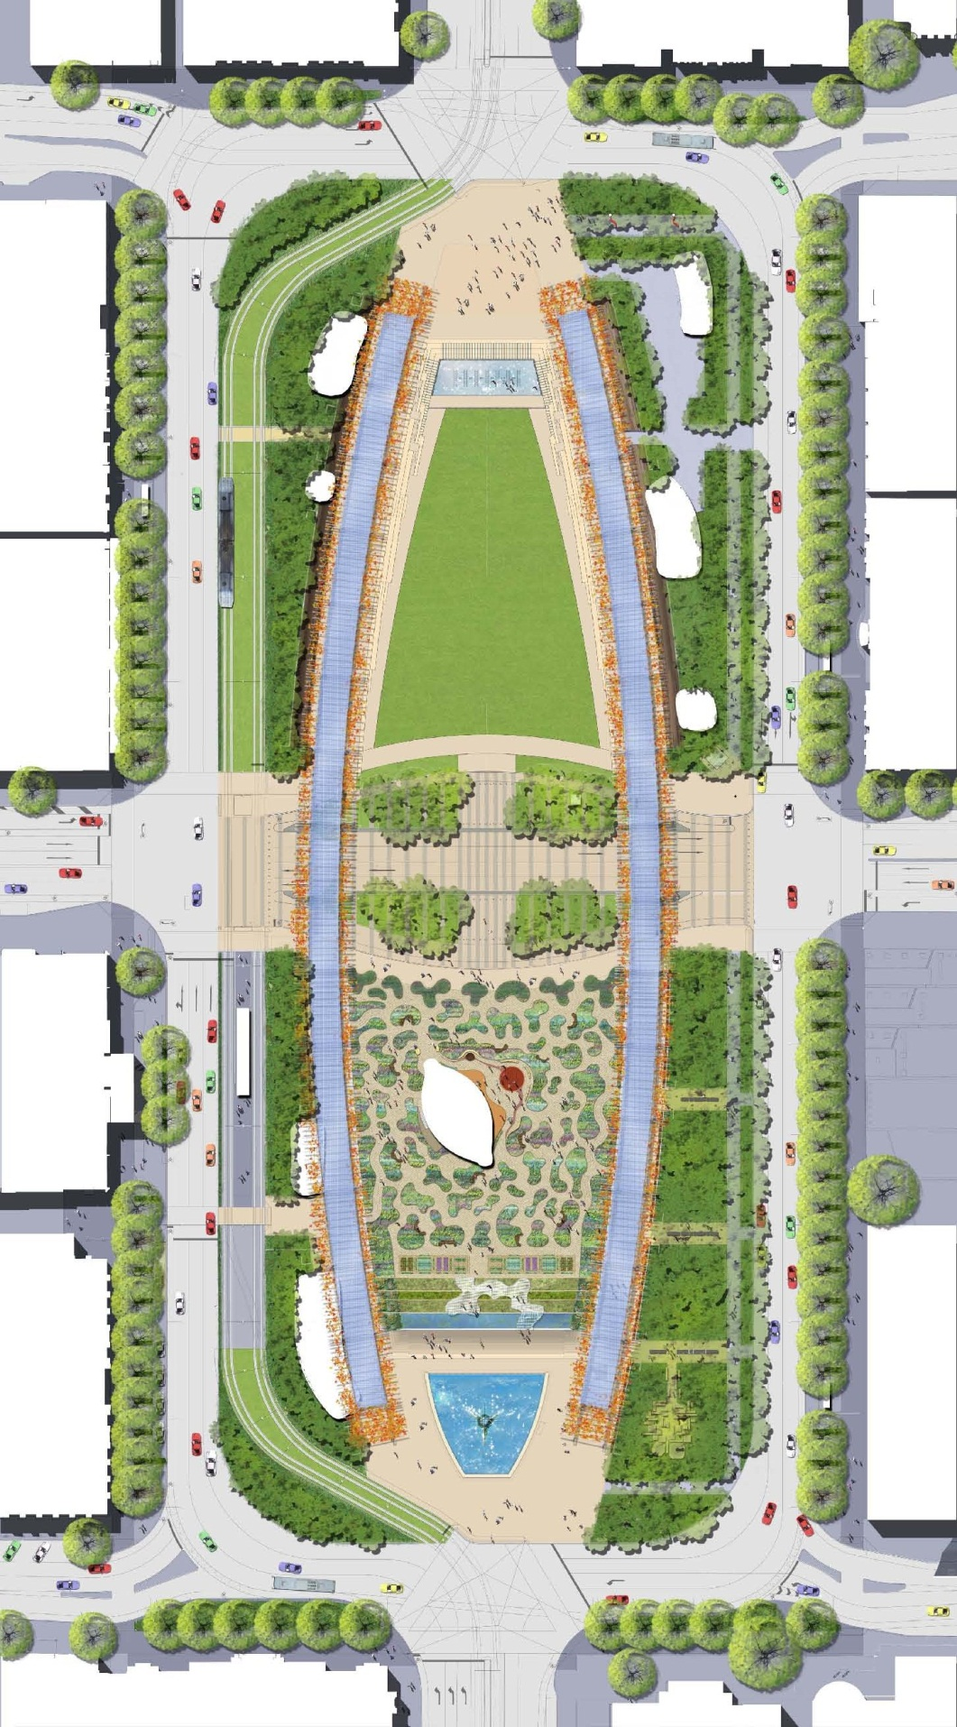

1.3.17 Conserve, retain and pursue **Local Heritage Listing** of:

* Victoria Square Benchmark
* State Survey Mark Plaque
* horse hitching posts

1.3.18 Maintain and enhance **views and** **vistas** along King William Road and Grote-Wakefield Streets. (LS9) Views illustrated as:



1.3.19 Support the completion of the different stages of the Victoria Square/ Tarntanyangga Masterplan.

**Proposed Initiatives of the Victoria Square/Tarndanyangga Masterplan**

**1. Adina Hotel Porte Cochere**

**2. Flags**

**3. Future ‘Fire’ themed artwork**

**4. Relocated tram line**

**5. Perimeter streets**

**6. North Plaza**

**7. Event back of house building**

**8. Information Centre**

**9. North Water Feature**

**10. Event service area**

**11. Event lawn terraces**

**12. Public Toilets**

**13. Arbours**

**14. Café**

**15. Event Lawn**

**16. Central Plaza**

**17. The Garden**

**18. Hilton Hotel Porte Cochere**

**19. Existing tram stop – extended**

**20. Mullabakka (Kaurna and Aboriginal Centre of Culture)**

**21. Café/Kiosk**

**22. Productive Gardens**

**23. Perimeter Gardens**

**24. Bicycle Hub and Public toilets**

**25. Bio-filtration Gardens**

**26. Garden terrace**

**27. Arcadian Grove – relocated statues**

**28. Perimeter footpaths**

**29. Three Rivers fountain - relocated**

**30. South Plaza**

1.3.1 Redevelop the Square as the principal square and **symbolic centre of our city** so that it becomes one of the world’s greatest public spaces, a unique Australian destination and meeting place. (RP21)

1.3.2 Ensure the Square’s design is **bold and visionary** and exhibits design excellence that is fitting for a place that represents our state’s civic and artistic vitality. (RS5)

1.3.3 Ensure the regeneration of the Square is in a form that acknowledges its status as the City’s physical and ceremonial heart.

1.3.4 Encourage mixed-use residential projects within the surrounding precinct to provide **strong passive surveillance**.

1.3.5 Embed into the experience of the square an appreciation of the **cultural significance** of the place for the people of many cultures of Adelaide, especially the Kaurna community. (HS1)

1.3.6 Maximise **pedestrian connections** leading to and from the Square and redress the imbalance between **traffic and pedestrians**, restoring a sense of sanctuary that enables people to access and enjoy the space and activities. (RS5 & LS8)

1.3.7 Ensure **vehicle** **traffic** is managed, carriageways realigned to the outside of the Square to increase the size of the internal section and pavement/road treatments are developed to provide a hierarchy that caters fo pedestrians and cyclists.

1.3.8 Support a **variety of events and activities** to continually renew people’s interest in and attraction to the Square and incorporate a variety of areas to appeal to a wide range of people and their needs. (RP6)

1.3.9 Incorporate infrastructure capable of supporting a range of festivals, events and other activities so that the Square is **adaptable, flexible and dynamic**. (RP6)

1.3.10 Complement temporary and permanent **artwork installations** with a program of **interactive visual and performance art** that encourages people to participate in city life. (LP10, HS5)

1.3.11 Incorporate and promote international best practice in **environmentally sustainable design, water and energy conservation and green construction** so that the Square forms the green heart for the city. (NSSD3, NSS4)

1.3.12 Use **bold planting** to reinforce the formal symmetry of the Square that are appropriate to Adelaide’s environment and follow the **Water Sensitive Urban Design** and **Crime Prevention through Urban Design** principles. (NSS4)

1.3.13 Develop an extensive **management and maintenance** program to ensure the Square is showcased as Adelaide’s premier public space.

1.3.14 Ensure **public and private partnerships** that contribute to the Square redevelopment and on-going maintenance and care.

1.3.15 Retain, conserve, interpret and manage sites of **cultural and historic importance** and protect their settings. (HS3&4)

1.3.16 Manage the following in recognition of their status as **State Heritage Places**:

* John Davie’s Three Rivers Fountain
* Statue of Queen Victoria
* Captain Charles Sturt Monument
* [John McDouall Stuart Monument](http://www.planning.sa.gov.au/index.cfm?objectID=F2D3709D-F203-0D46-AD813765BAD9B959&i=26339)
* [Charles Cameron Kingston Monument](http://www.planning.sa.gov.au/index.cfm?objectID=F2D3709D-F203-0D46-AD813765BAD9B959&i=26340)

**12**

**References to Adelaide Park Lands Management Strategy:**

**R** - Recreation **PLP** - Park Lands Priority

**H** - Heritage **S** Strategy

**L** - Landscape **MP** - Management Principles and Strategies

**NS** - Natural Systems 2 - Number refers to relevant strategy or principle

*Example:* H.S.3&4 refers to Heritage Strategies 3 & 4

**4**

**30**

**29**

**28**

**27**

**26**

**25**

**24**

**23**

**22**

**21**

**20**

**19**

**18**

**17**

**16**

**15**

**13**

**14**

**13**

**12**

**11**

**10**

**9**

**8**

**7**

**6**

**5**

**4**

**3**

**2**

**1**

**Victoria Square/Tarntanyangga**

**5**

**Palmer Gardens/Pangki Pangki, Brougham Gardens/Tandotittingga & Karrawirra (Park 12)**

**4**

**4**

Stage 1 of the Victoria Square/Tarntanyangga Masterplan

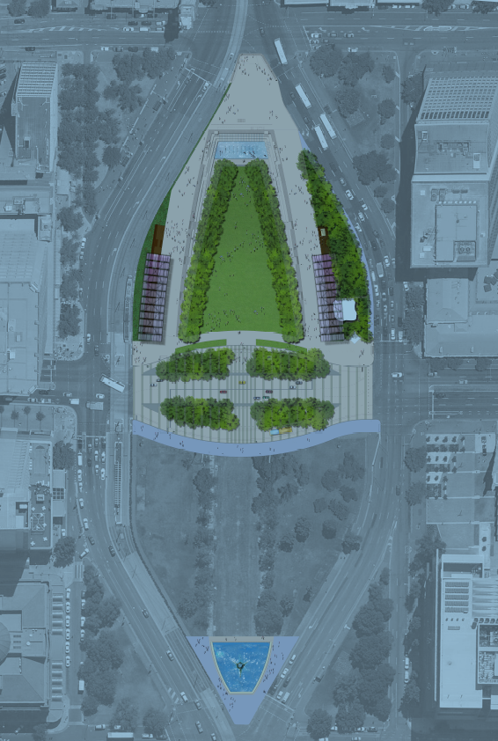The Stage 1 works proposed for Victoria Square/Tarntanyangga have been funded and have commenced. The proposed initiatives for Stage 1 of the Victoria Square/Tarntanyangga Masterplan include the following works:

1. **North Plaza Temporary Staging**
2. **North Water Feature**
3. **Event Lawn**

**1**

1. **Event Lawn Terraces**
2. **Central Plaza**
3. **Shade Shelters**
4. **Three Rivers fountain**

**2**

1. **Toilet/transformer building**
2. **South Plaza**

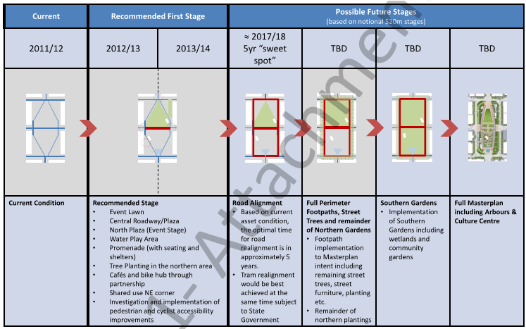An outline of future possible staging is provided within the table below. Future stages of the Victoria Square/Tarntanyangga Masterplan are subject to funding partnerships. Other stages of the Masterplan including a tramline and road configuration, a large urban garden and the proposed Kaurna Culture Centre will be staged as further funding becomes available and when the majority of the current road assets are due for major renewal at approximately 2017-18. The further recommended stages to realise the full Masterplan are also suggested, subject to funding and future Council Commitments.

**3**

**4**

**5**

**6**

**4**

**6**

|  |
| --- |
|  |

**9**

**8**

**7**

**5**

**STAGE 1**

**7**

**6**

**7**

**5**

**4**

**4**

**3**

**2**

**1**

1. **Background**

**Victoria Square/Tarntanyangga** represents an integral segment of the overall Adelaide Park Lands, if not the pivot point, illustrative of Light’s Plan for the City of Adelaide. The Square was designed and has evolved as the grand centre of Adelaide, overlaid as a formal grid on Tarndanyangga, the meeting place of the Kaurna people while hosting other clans of the surrounding plain and hills.

**Victoria Square/Tarntanyangga** is the centrally located square within the City. The [*Adelaide Park Lands Landscape Master Plan*](http://www.adelaidecitycouncil.com/assets/acc/Council/policies/docs/111107%20Parklands%20MP%20Report_.pdf) identifies found landscape zones in the Park Lands - Victoria Square/Tarntanyangga is within the Urban Gardens Zone (4).

The Urban Gardens Zone is characterised by formal gardens and avenue plantings and provide a distinctive transition landscape between the river and North Adelaide and includes the six Squares of the City.

**Victoria Square/Tarntanyangga** is Adelaide’s principal square, the centre and focal point of Adelaide. At approximately six hectares, it is 50 per cent larger than each of the other five squares integral to Colonel William Light’s plan for Adelaide’s city centre.

Yet **Victoria Square/Tarntanyangga** has failed to become the great public space that Light planned. Its status has been diminished over time by the movement of government institutions and offices to other parts of Adelaide. Its role as a traffic thoroughfare has divided the Square’s original shape and made it more difficult for people to access and enjoy its space and features.

**Victoria Square/Tarntanyangga** is adjacent to some of the densest development in the City and exhibits a landscape formality unlike other places within the Park Lands. The Square is dissected by major roads and has roads around the perimeter acting as a barrier for easy access.

The civic and ceremonial importance of **Victoria Square / Tarntanyangga** since European settlement is well known to South Australians. What is not well understood is that the Square has been and always will be an important gathering place for Aboriginal people.

The link between the Aboriginal people and the Square area stretches back many centuries, to a time when Tarndanya (Red Kangaroo Dreaming) people gathered there for special ceremonies and dances. Anthropologist Daisy Bates tells us that Tarntanyangga was the “headquarters” or central camp of the “Dundagunya tribe”, a community numbering in the thousands.

**2.1 Heritage**

**2.1.1 Kaurna significance:**

The Adelaide Park Lands and Squares are part of the Red Kangaroo Dreaming Place, an important place for the Kaurna people long before Adelaide was established.

**Victoria Square/Tarntanyangga** is of high cultural, spiritual and physical significance to the Tarndanya (Kaurna) people and to the wider Aboriginal population. **Victoria Square/Tarntanyangga** has special associations as the central camp and traditional meeting place of the Tarntanyangga Clan of Kaurna community and for Aboriginal visitors generally since colonisation.

The Square is linked to Tarnda Kanya, the Red Kangaroo rock site on the south side of the River Torrens, a highly significant cultural heritage site concerned with this Creation Ancestor.

From the 1960’s **Victoria Square/Tarntanyangga** became the focus of Aboriginal activities. These activities included its role as a central meeting place for Aboriginal people from all over Australia, becoming a social and gathering point outside the central Police Station (now the Commonwealth Law Courts building) and Court House.

**Victoria Square/Tarntanyangga** is where the National Aboriginal Flag, the red, black and yellow Aboriginal flag, designed by Harold Thomas, was flown for the first time anywhere at Victoria Square on National Aboriginal and Islander Day on 9 July 1971. It now flies permanently alongside the Australian flag on one of the two tall flagpoles in the centre of the Square.

The Adelaide City Council honours the historical association of **Victoria Square/Tarntanyangga** as the birthplace of the Aboriginal flag. The Council also acknowledges the traditional custodianship of the Adelaide Plains area by Kaurna people, and in 2002 it formally recognised this relationship by bestowing the dual name **Victoria Square/Tarndanyangga**.

**2.1.2 Kaurna Naming:**

As part of the Adelaide City Council’s commitment to reconciliation with Aboriginal communities, places within the City have been given[*Kaurna names*](http://www.adelaidecitycouncil.com/community/reconciliation/kaurna/place-naming).

The Square is known as Tarntanyangga which is derived from ‘*tarnta*’ which loosely translates as ‘red kangaroo’ and ‘*kanya*’ which loosely translates as ‘*rock*’, with the locational suffix *ngga*, for the Square.

**2.1.3 European Significance:**

**Victoria Square/Tarntanyangga** was created in Colonel William Light’s *City of Adelaide Plan* of 1836 resulting in an area of approximately now 6 hectares, including a park and roadway, comprising the Square. The design incorporated a central square to function as Adelaide’s focal point and provide open space for recreational activities. On his first map, Light called the precinct 'The Great Square'. It was eventually named in honour of Princess Victoria before her accession in 1837.

Light surveyed the Square as a rectangle on a north-south axis and sketched an approximate internal spatial configuration of two rectangular park areas with a rectangular encircling an east-west movement system. This spatial configuration remained from 1864 until 1883 when King William Street was constructed north-south through the Square, with the Queen Victoria statue being unveiled in its present location in 1894. Landscape design remodelling works again transpired in 1945-46 and 1966.

The Square was a dusty, treeless paddock until 1854, when the Adelaide City Council embarked on a planting program, constructed four broad diagonal pedestrian paths and erected a wooden fence. Other work on the Square included construction of an east-west roadway that created two garden areas. A fountain was also considered, but it took 100 years for this idea to come to fruition.

By 1883, plans were underway to extend King William Street directly through Victoria Square, dividing it into four garden areas. The original wooden fence was replaced by ornate iron railings which were relocated to the University of Adelaide. A statue of Queen Victoria, who had ascended to the throne in June 1837, was erected in the centre of the Square in 1894.

The layout remained unchanged until 1967 when the Square assumed its present diamond form. The Three Rivers Fountain by artist John Dowie was built to commemorate the visit of Her Majesty Queen Elizabeth II and His Royal Highness Prince Philip, Duke of Edinburgh, in 1968. The Murray, Onkaparinga and Torrens Rivers are represented by an Aboriginal male with an Ibis, a female with a heron, and a female with a black swan.

The land use of **Victoria Square/Tarntanyangga** has remained consistently, as proposed by Light in 1836, as a public park or village common. The overall Square has retained its design intent and purpose as proposed by Light as a central gathering point and passive recreation venue although it has been compromised by its change in layout to accommodate traffic.

**2.1.4 Heritage Listing:**

**Victoria Square/Tarntanyangga** is part of the Adelaide Park Lands and City Layout which is on the National Heritage List. The views and vistas into and out of the Square are important in reading and understanding the importance of the Square to the listing. See Part 1, in the CLMP Planning Framework, at 1.3.1 for further information.

**Victoria Square/Tarntanyangga** does not contain any State and local Heritage Placesidentified within the [*Adelaide (City) Development Plan*](http://sa.gov.au/upload/franchise/Housing,%20property%20and%20land/PLG/Online%20DPs/Greater%20metropolitan/Adelaide_Council_Development_Plan.pdf) and there are no sites of cultural or historic importance in the Square.

**Victoria Square/Tarntanyangga** has a number of State Heritage Places including:

* [John Dowie’s Three Rivers Fountain](http://www.planning.sa.gov.au/index.cfm?objectID=F2D3709D-F203-0D46-AD813765BAD9B959&i=26252)
* [Statue of Queen Victoria](http://www.planning.sa.gov.au/index.cfm?objectID=F2D3709D-F203-0D46-AD813765BAD9B959&i=26253)
* [Captain Charles Sturt Monument](http://www.planning.sa.gov.au/index.cfm?objectID=F2D3709D-F203-0D46-AD813765BAD9B959&i=26338)
* [John McDouall Stuart Monument](http://www.planning.sa.gov.au/index.cfm?objectID=F2D3709D-F203-0D46-AD813765BAD9B959&i=26339)
* [Charles Cameron Kingston Monument](http://www.planning.sa.gov.au/index.cfm?objectID=F2D3709D-F203-0D46-AD813765BAD9B959&i=26340)

**Victoria Square/Tarntanyangga** has many sites of cultural and historic importance including:

* State Survey Mark Plaque - bronze plaque recording the event of Light placing the first survey peg to establish the City of Adelaide survey.
* Victoria Square/Tarntanyangga Benchmark - a surveying benchmark for all city infrastructure planning and construction documentation and installation and possibly the only existing benchmark.
* Hitching Posts - two jarrah horse hitching posts
* Drinking fountains - two 1925 ‘Hitchcock’ design bronze drinking fountains.
* Water benchmark

**2.2 Landscape**

The [Adelaide Park Lands Landscape Master Plan](http://www.adelaidecitycouncil.com/assets/acc/Council/policies/docs/111107%20Parklands%20MP%20Report_.pdf) identifies four landscape zones in the Park Lands. **Victoria Square/Tarntanyangga** is located within Zone 4, the Urban Gardens Zone. The Urban Gardens Zone is characterised by formal gardens and avenue plantings and provides a distinctive transition landscape between the river and North Adelaide and includes the six Squares of the City.

**Victoria Square/Tarntanyangga** is Adelaide’s geographic centre. Located at the crossroads of King William and Grote-Wakefield Streets, the Square is a main thoroughfare between the city’s north-south and east-west corridors. Thousands of South Australians use Victoria Square / Tarndanyangga, either as pedestrians or commuters, each day.

**Victoria Square/Tarntanyangga** is adjacent to some of the densest development in the City and exhibits a landscape formality unlike other places within the Park Lands. The Square is surrounded by some of the state’s most significant historic and contemporary civic buildings such as the SA Water building, Old Treasury building, the General Post Office and the Magistrates building, each occupied by legal and commercial professionals and government office workers. Students are attracted to the new international university precinct within the Square. Ground-level retail businesses are being established around the Square’s perimeter to support the growing worker and student populations.

Recent city development has brought significant commercial and retail growth along Grote Street to the west, King William Street to the south and Flinders Street to the east. Current and planned developments such as City Central will continue to increase the number of people and businesses in the immediate Square precinct.

**2.3 Recreation**

There are no formal recreational facilities or lease or licence areas within the Square. **Victoria Square/Tarntanyangga** is a venue for regular major events and festivals such as Tour Down Under and the Lord Mayor’s Christmas Tree Lighting. The Masterplan envisages maximising its capacity for community events.

**2.4 Natural Systems**

|  |
| --- |
|  |

**Victoria Square/Tarntanyangga** is perched on a slight ridge which drops off to form the Torrens Valley to the north, natural systems do not operate in Victoria Square.

The *[Adelaide Park Lands Management Strategy](http://www.adelaidecitycouncil.com/environment/plans-policies/park-lands-management-strategy/)* (APLMS) Landscape Character map (page 22) does not identify any Biodiversity Conservation Areas in Victoria Square/Tarndanyangga.

[*Adelaide City Council Biodiversity and Water Quality Action Plan*](http://www.adelaidecitycouncil.com/assets/acc/Council/policies/docs/Biodiversity-and-Water-Quality%20-Action-Plan.PDF) has been adopted by Council and represents the additional research conducted in the development of the ‘key biodiversity areas’ within the Park Lands. There are no key biodiversity areas identified in **Victoria Square/Tarntanyangga** ).

**Relevant Links:**

Adelaide Park Lands Management Strategy

<http://www.adelaidecitycouncil.com/assets/acc/Environment/plans-policies/docs/parklands_management_strategy.pdf>

Landscape Master Plan

<http://www.adelaidecitycouncil.com/assets/acc/Council/policies/docs/111107%20Parklands%20MP%20Report_.pdf>

Kaurna naming

<http://www.adelaidecitycouncil.com/community/reconciliation/kaurna/place-naming>

Cultural Landscape Study - general

<http://www.adelaidecitycouncil.com/environment/park-lands/heritage1/cultural-landscape-study/>

Cultural Landscape Study – Reports and Assessments on Victoria Square/Tarntanyangga <http://www.adelaidecitycouncil.com/environment/park-lands/heritage1/cultural-landscape-study/>

Adelaide City Council Biodiversity and Water Quality Action Plan

<http://www.adelaidecitycouncil.com/assets/acc/Council/policies/docs/Biodiversity-and-Water-Quality%20-Action-Plan.PDF>

Victoria Square/Tarndanyangga Urban Regeneration Masterplan

<http://www.adelaidecitycouncil.com/development/victoria-square-tarndanyangga/>

Park Lands Building Design Guidelines

<http://intranet.adelaide.sa.gov.au/knowledge/Pages/ParkLandsBuildingDesignGuidelines.aspx>