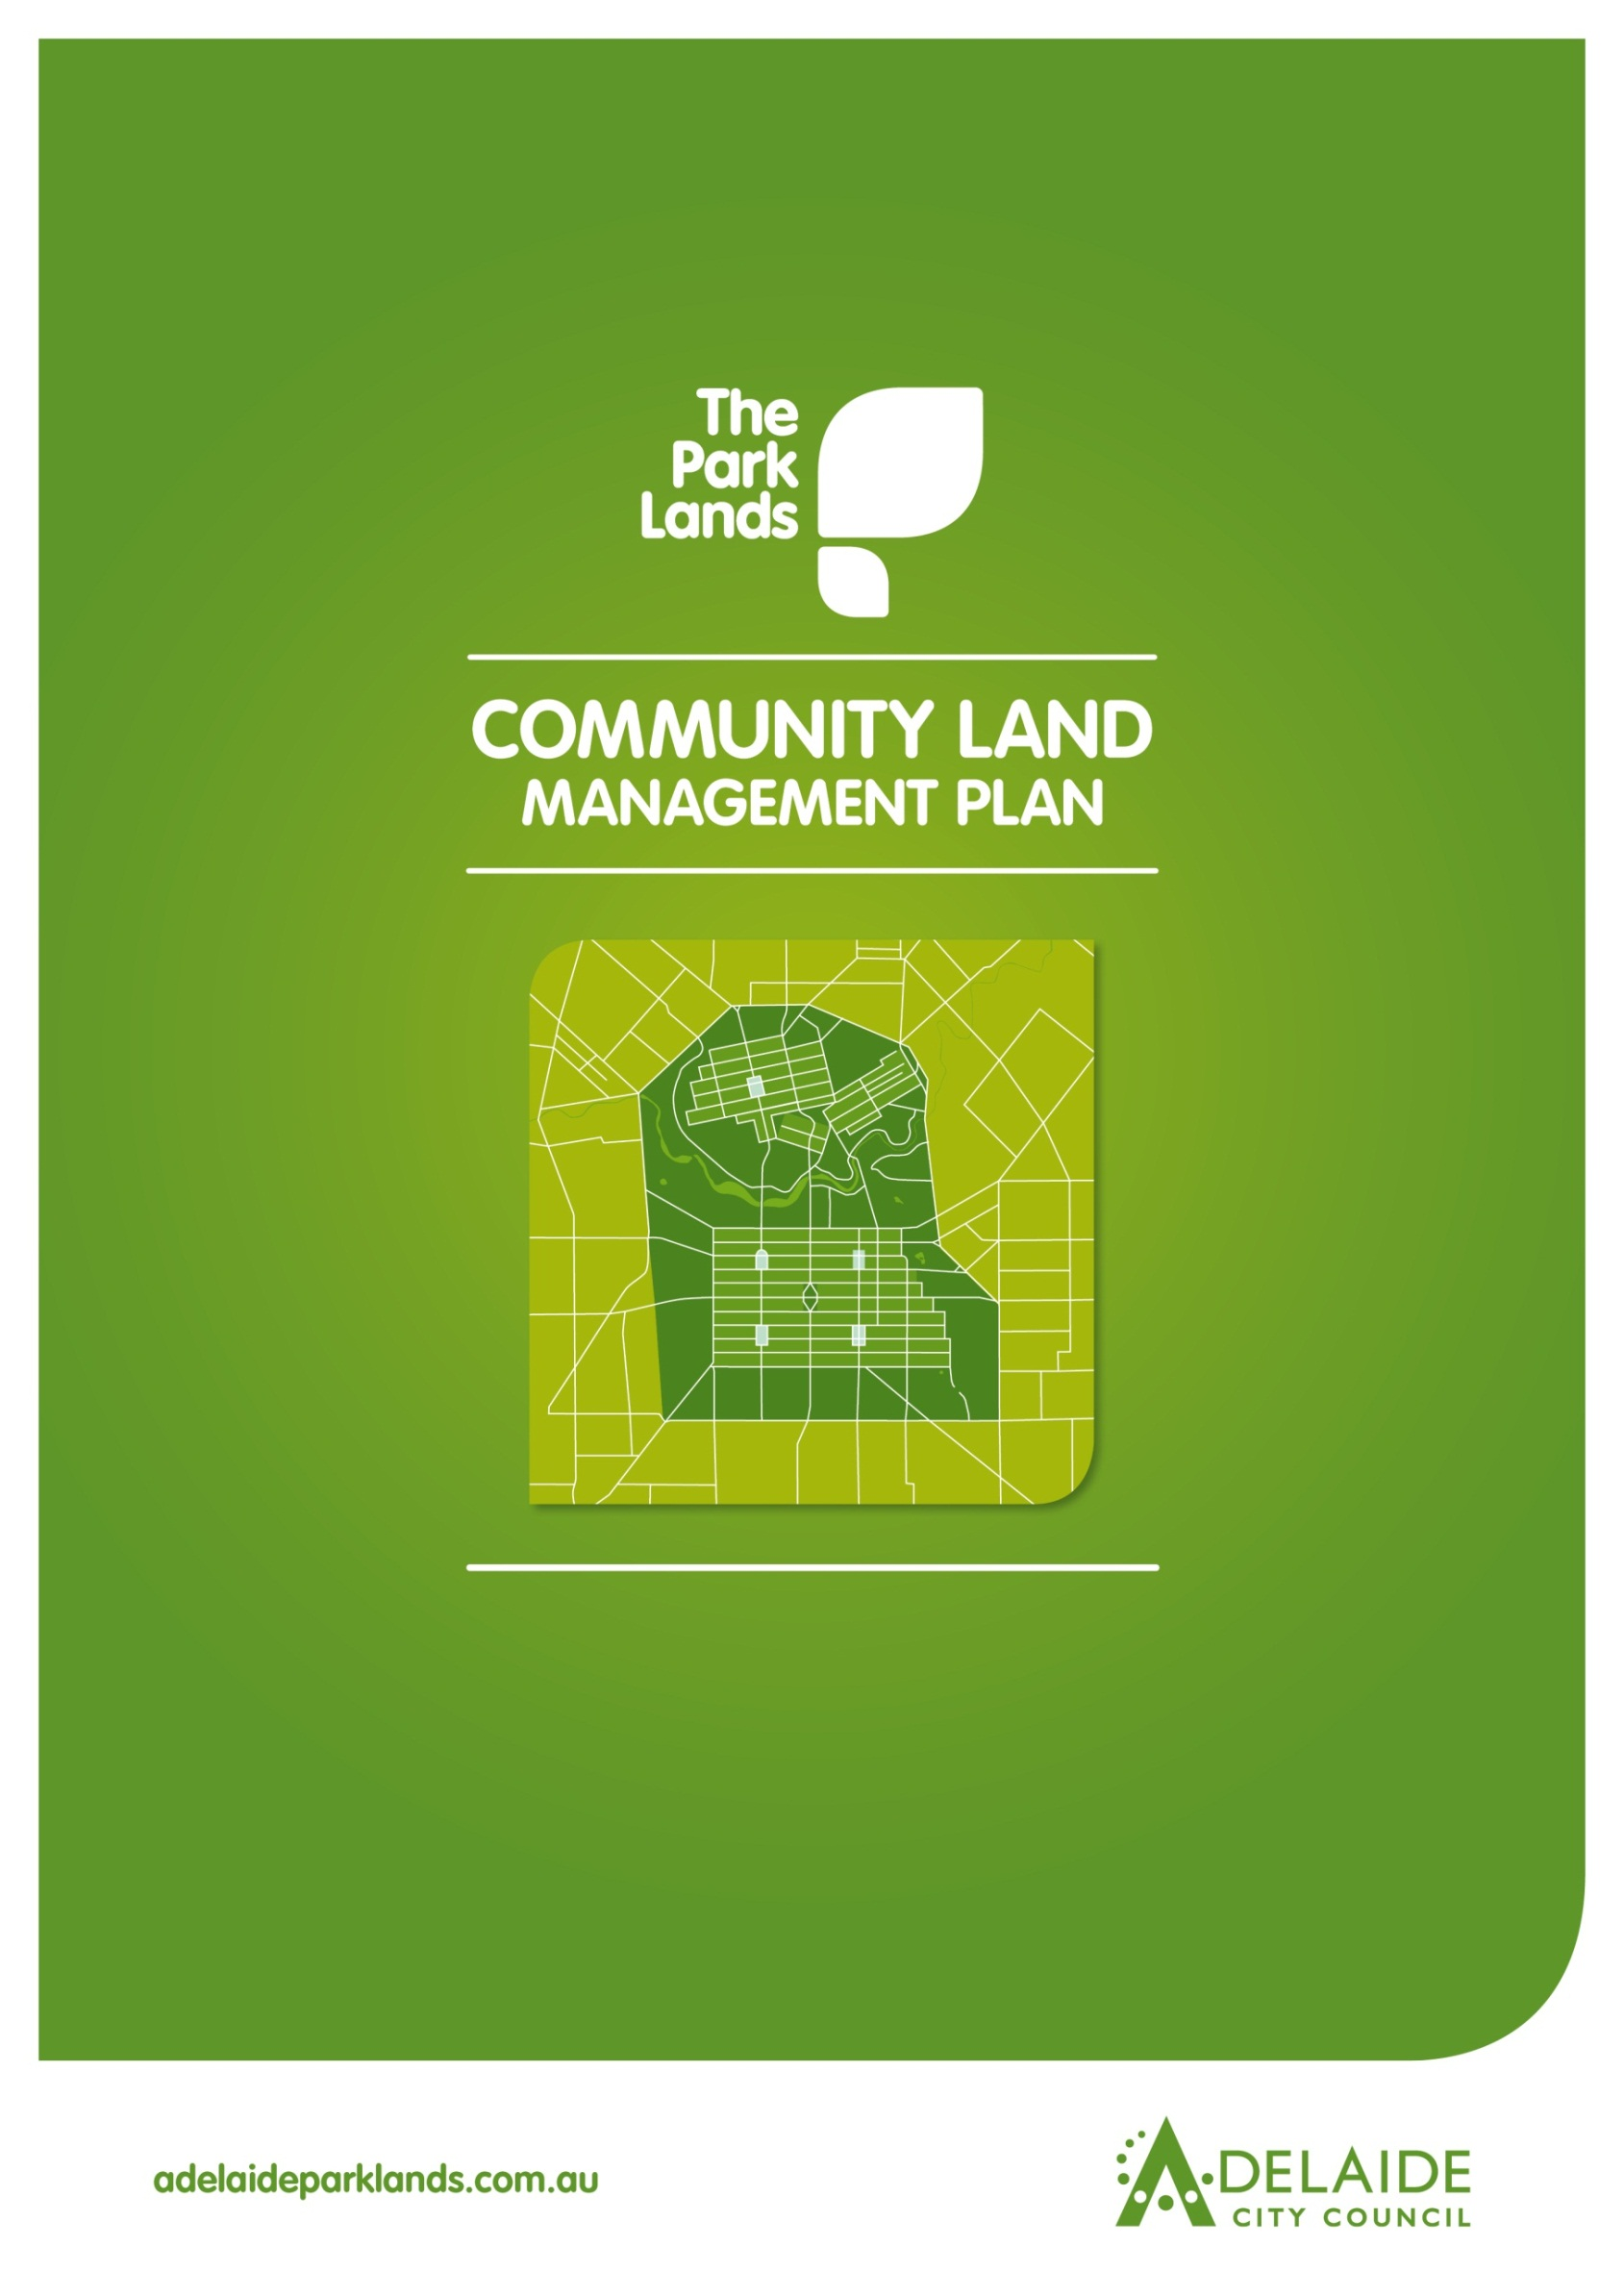
Chapter 17
Wellington Square/Kudnartu
Light Square/Wauwi
Whitmore Square/Iparrityii
Hurtle Square/Tangkaira
Hindmarsh Square/Mukata

Wellington Square/Kudnartu
Light Square/Wauwi
Whitmore Square/Iparrityii
Hurtle Square/Tangkaira
Hindmarsh Square/Mukata

Introduction
- Directions
  - Desired Future Character Statement
  - Challenges
  - Management Directions
1.3.1 Wellington Square/Kudnartu
1.3.2 Light Square/Wauwi
1.3.3 Whitmore Square/Iparrityii
1.3.4 Hurtle Square/Tangkaira
1.3.5 Hindmarsh Square/Mukata
- Background
  - Heritage
2.1.1 Kaurna Heritage
2.1.2 Kaurna Naming
2.1.3 European Significance
2.1.4 Heritage Listing
2.2 Landscape
2.3 Recreation
Lease and Licence Areas Map
2.4 Natural Systems

Introduction: The Community Land Management Plan
Show
- Parcel boundaries
- Lease areas
- Licence areas
- Core area
- Garden areas
- Intended car parks and carrying capacities
- Roads and access
Show
- Parcel boundaries
- Lease areas
- Licence areas
- Core area
- Garden areas
- Intended car parks and carrying capacities
- Roads and access

This document is Chapter 17 of the Community Land Management Plan for the Park Lands (the CLMP). It should be read together with Chapter 1, which is the CLMP Framework. Chapter 1 explains the requirements for the CLMP, the legislative and planning context, the CLMP Statutory Principles, and the CLMP Framework.
Wellington Square, Light Square, Whitmore Square, Hurtle Square and Hindmarsh Square are grouped together in this Chapter because they play the same important role in the life of the City and have similarities in landscape character and use. The key to each Chapter is the Management Directions which represent the application of existing strategies and policies in each Square.
Victoria Square/Tarndanyangga is dealt with separately in Chapter 16 given its unique status as the central civic space in the City.

- Directions for Wellington Square/Kudnartu, Light Square/Wauwi, Whitmore Square/Iparrityii, Hurtle Square/Tangkaira, Hindmarsh Square/Mukata

1.1 Desired Future Character Statement
The Squares provide high quality formal garden landscapes in the City and North Adelaide and function as vibrant parks responding to their local context and as a relief to the surrounding urban environment.

1.2 Challenges/Opportunities

- Providing high amenity, high quality and formal urban spaces recognising the historic and cultural significance of the Squares.
- Contributing to the open space needs and expectations of the growing residential communities in and around the City.
- Reclaiming the Squares as public space reducing the area dedicated to traffic and parking.
- Reconnecting the Squares to the surrounding built form so they provide appropriate refuges and civic spaces for surrounding workers and residents.
- Ensuring the landscaped character enhances the setting of focal features, such as statues and water features, using formal plantings of both exotic and native species.
- Encouraging flexibility in design of the Squares so as to respond to their context, providing a range of activities, appropriate access, and surfaces to accommodate both daily use and events.
- Enhancing accessibility, particularly safe pedestrian crossings into the Squares.
- Providing appropriate design, including lighting, to facilitate safe day and night time use of the Squares.
- Providing community amenities, as well as water features and public artwork, to ensure the Squares are destinations in their own right.

1.3 Management Directions
Each Square is dealt with below.
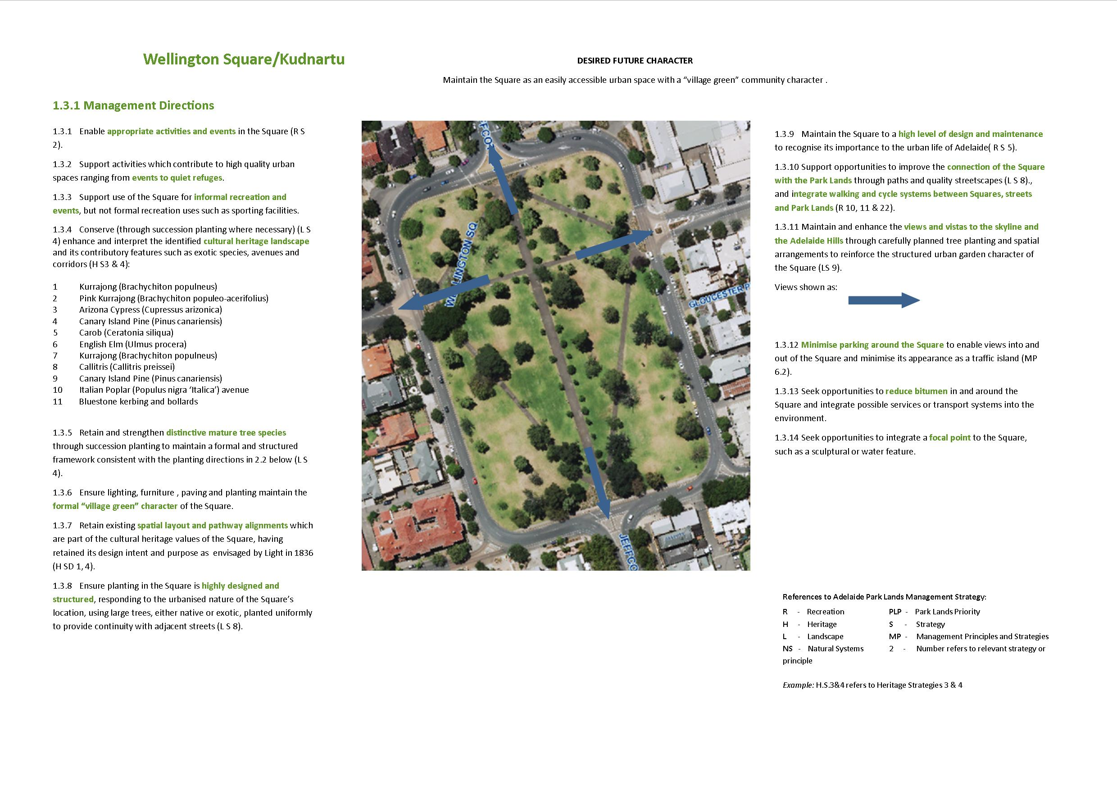
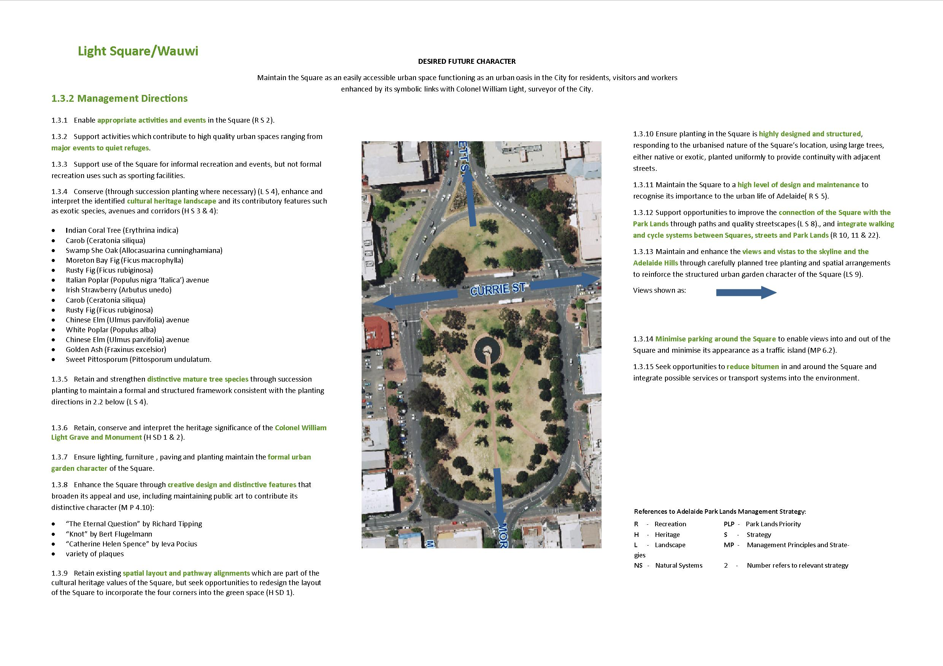
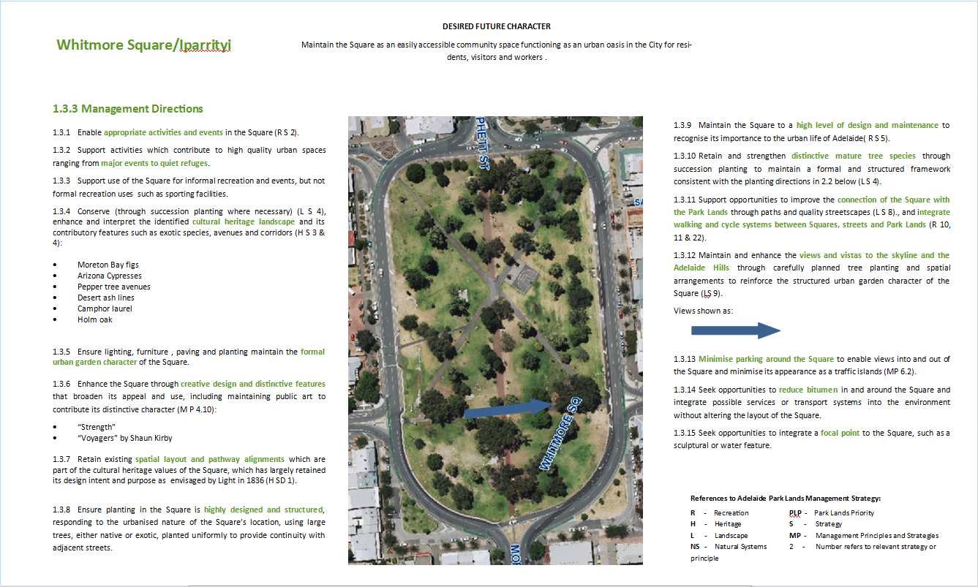
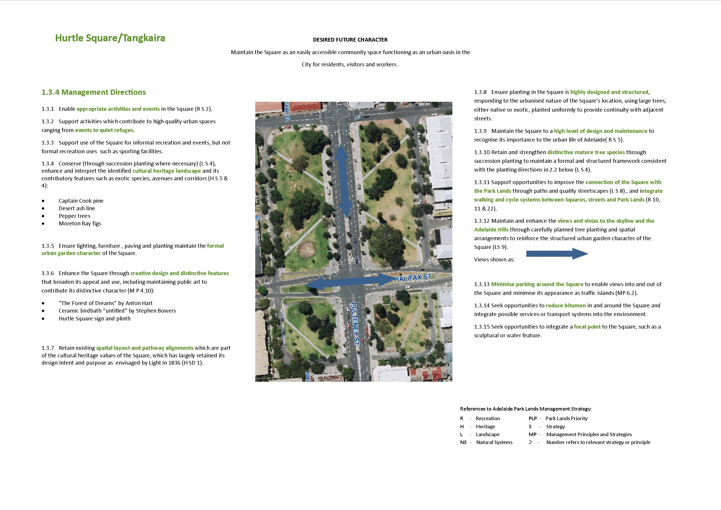
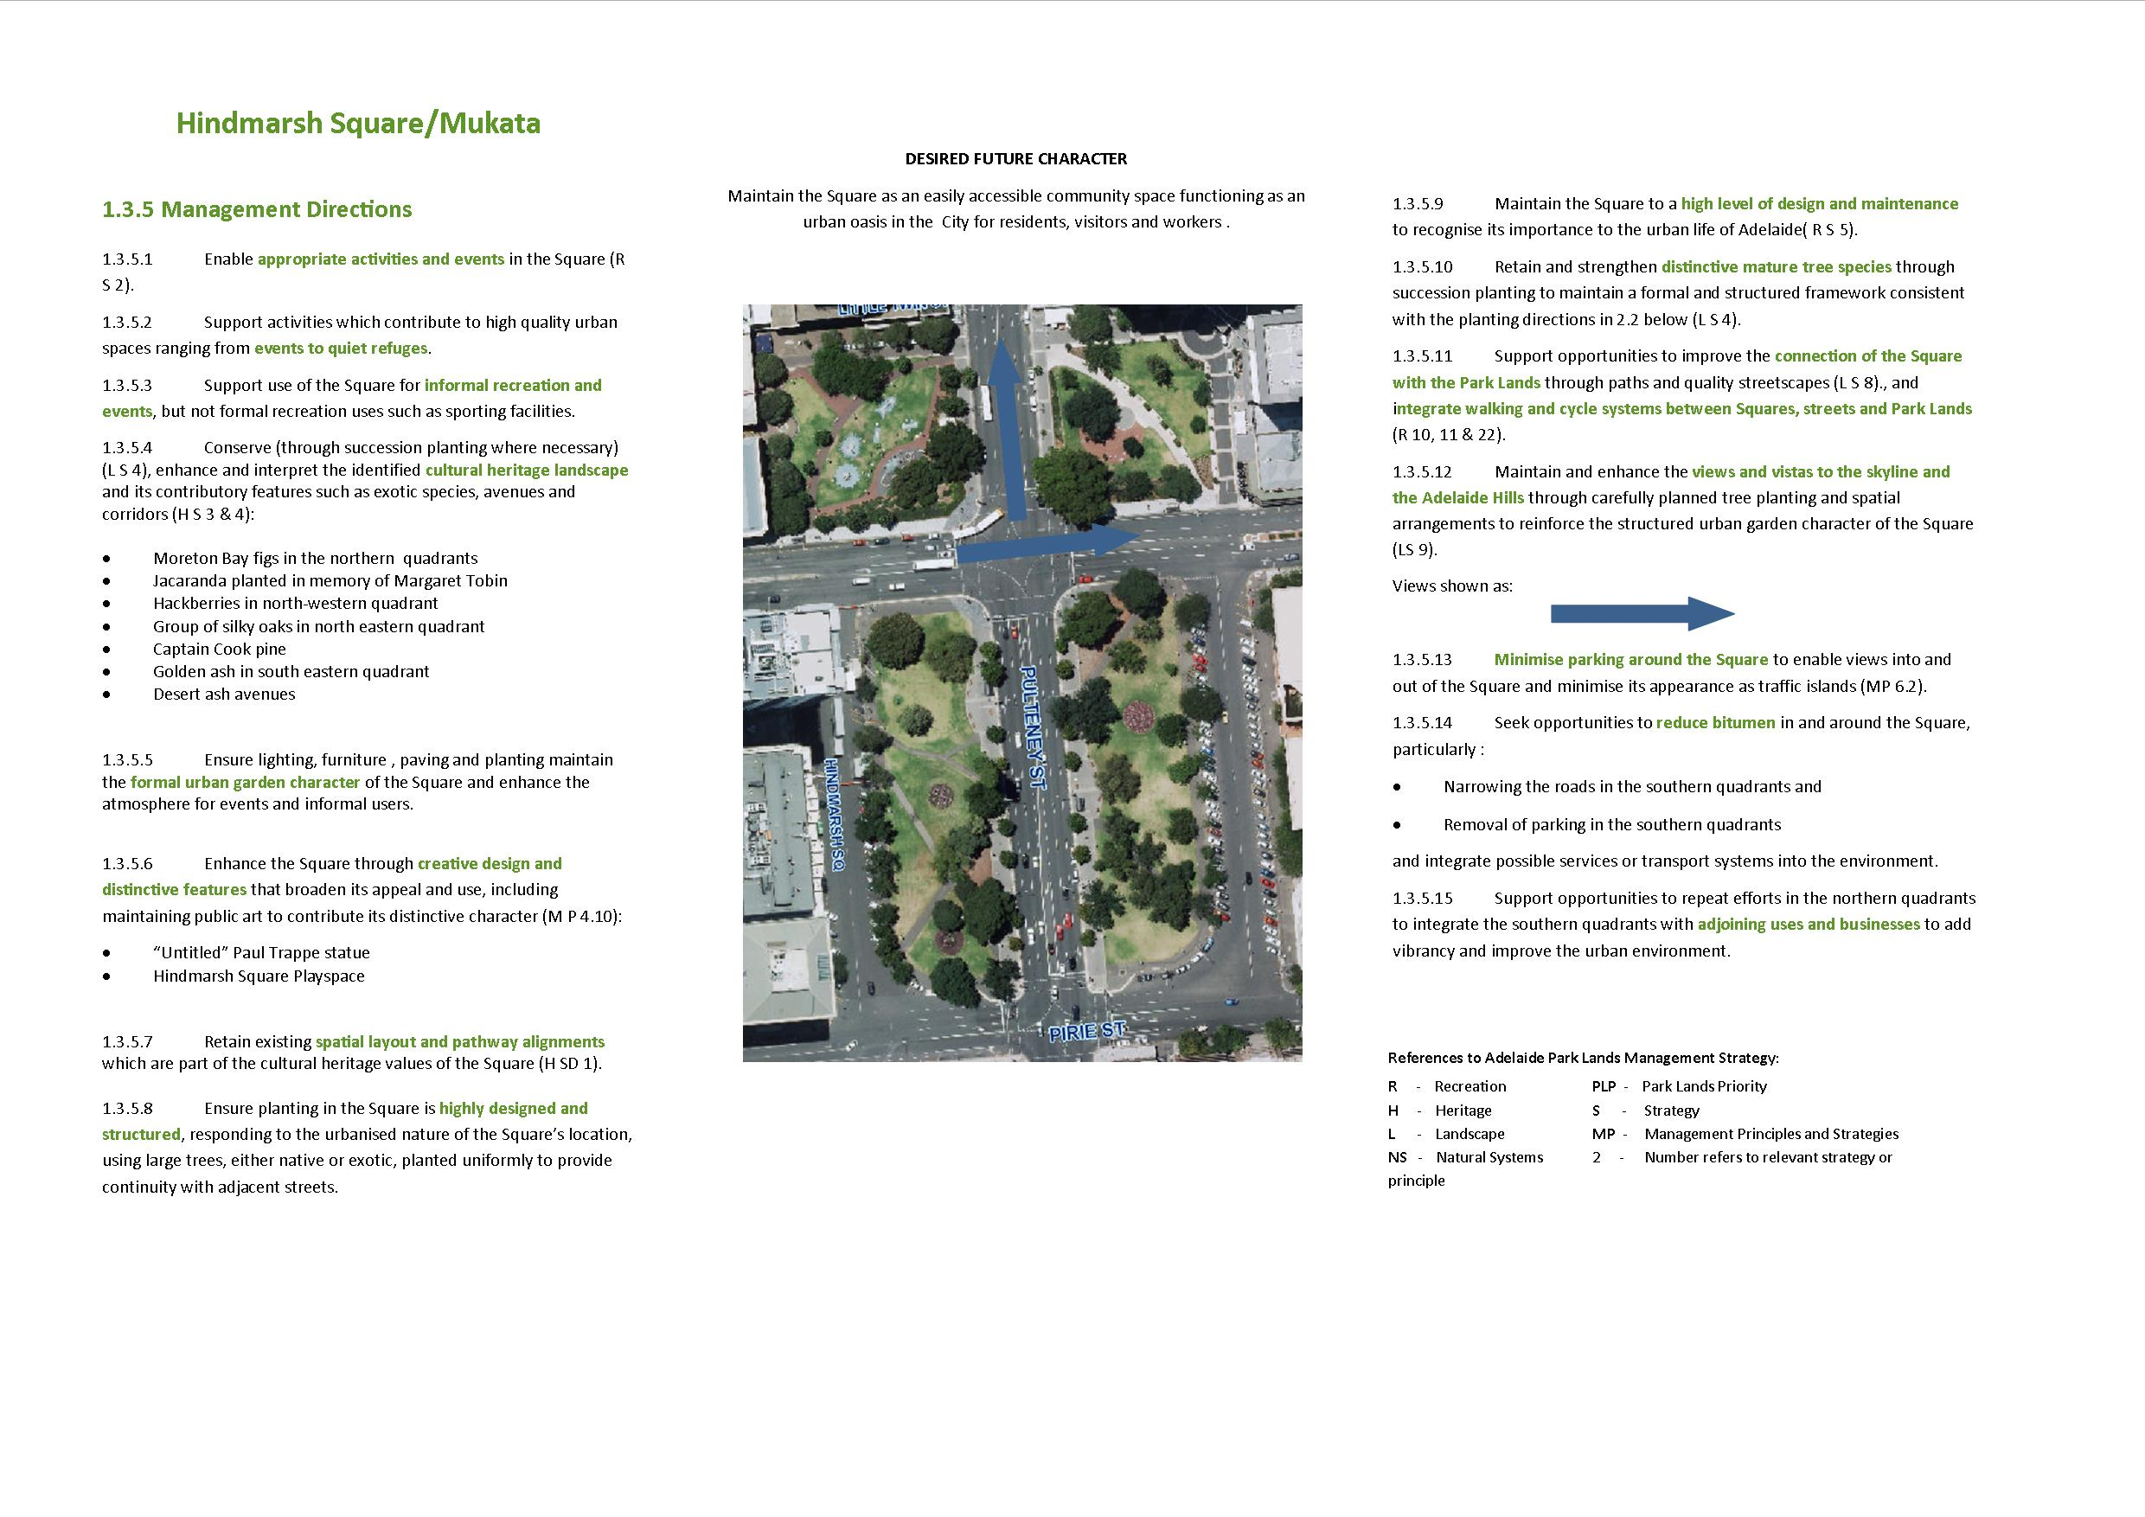

- Background

The five Squares in this chapter, Wellington Square/Kudnartu, Light Square/Wauwi, Whitmore Square/Iparrityi, Hurtle Square/Tangkaira and Hindmarsh Square/Mukata, are a significant element for both indigenous and European cultural history of the City of Adelaide. Victoria Square/Tarntanyangga is dealt with separately in Chapter 16 of the CLMP given its unique status as the central civic space in the City.
The Squares and Park Lands are areas of which the Kaurna people lived prior to and following European settlement. The Squares are also an important factor in the history of European culture due to being an integral part of the City of Adelaide Historic Layout. Squares have traditionally fulfilled a civic and social centre to towns, an opportunity which Colonel Light took when laying out the City to provide refuges from the urban centre.
The Squares are currently surrounded by both commercial and residential dwellings, and are used as recreational spaces for the public.
Wellington Square/Kudnartu and Whitmore Square/Iparrityi have remained relatively unchanged from the original layouts, whilst Light Square/Wauwi, Hurtle Square/Tangkaira and Hindmarsh Square/Mukata have each been divided into four sections by now arterial roads. Within the Adelaide Park Lands Master Plan the five Squares are listed as being in zone 4 – Urban Garden Zone.
ark )

2.1 Heritage

2.1.1 Kaurna significance:

The Adelaide Park Lands and Squares are part of the Red Kangaroo Dreaming Place, an important place for the Kaurna people long before Adelaide was established. There are six Squares integral to the design of the City and North Adelaide by Colonel William Light, five of which are outlined in this CLMP; Wellington Square/Kudnartu, Light Square/Wauwi, Whitmore Square/Iparrityi, Hurtle Square/Tangkaira and Hindmarsh Square/Mukata. These five Squares have indigenous significance as part of the Square and Park Lands where the Kaurna people lived prior to and following European settlement, and as a place to gather in regard to Whitmore Square/Iparrityi.
2.1.2 Kaurna Naming:

As part of the Adelaide City Council’s commitment to reconciliation with Aboriginal communities, places within the City have been given Kaurna names. The Squares have endorsed Kaurna names:
Wellington Square - Kudnartu, the first Aboriginal woman (in SA) to marry a European
Light Square - Wauwi, named to commemorate the wife of Kadlitpinna. Wauwe means female Kangaroo
Whitmore Square - Iparrityi, a Kaurna ancestor born in the 1840s
Hurtle Square - Tangkaira, named to commemorate the wife of Ityamaiitpinna, Tangkaira or “Charlotte, from the Clare District” (Gara 1990:64)
Hindmarsh Square - Mukata, who was King John’s wife, a prominent member of the Kaurna community.

2.1.3 European Significance:

Wellington Square/ Kudnartu has European cultural significance as an integral part of the Adelaide Park Lands and City Layout, and it is also the only Square located in North Adelaide. The spatial arrangement and plantings are substantially the same when the City was laid out by Colonel William Light in 1836. The Square was named after Field Marshal the Duke of Wellington, who recommended the appointment of Light.
The layout of the Square (according to the Smith Survey of the 1880s) has altered little since it was established, with the same path pattern and style of Victorian tree plantings. The Square itself remains intact as intended by Colonel William Light.
Light Square/Wauwi was named after Colonel William Light, the first surveyor-General of Adelaide, responsible for its planning and layout. When he died in 1839, he was buried in this city square. Over his grave there now stands a memorial in the form of a marble column surmounted by the representation of a surveyor’s theodolite. The original layout of the Square was compromised in 1910 when Currie Street was cut through the Square. The Square is now split into two parts and consists of a large southern rectangle and a small northern semi-circle.
Whitmore Square/Iparrityi was named after Mr W Woolryche Whitmore, one of the Colonisation Commissioners for South Australia and a member of the House of Commons. The original layout of the Square has remained remarkably intact from when first laid out in Light’s plan, the only changes have been to reduce the angles of the corners of the Square, leaving some small traffic islands.
The Square provides a large open space, surrounded by mature exotic trees and is well-used by residents. The Square has also become a focus for public art initiatives in the City, including the Shaun Kirby sculpture “Voyagers”.
Hurtle Square/Tangkaira was named after Sir James Hurtle Fisher, the first Resident Commissioner and pioneer founder of the colony of South Australia. The South Australian Commissioners appointed Fisher to organise the local constitution. In 1837, Fisher saved the Adelaide Park Lands from land speculators. Fisher was elected the first Lord Mayor of the City of Adelaide (1840-1842).
The original layout of the Square was compromised in 1909 when the electric tram tracks were laid dividing the Square into its present four main quadrants. This Square has also become a focus for public art initiatives in the City with a pigeon fountain and “The Forest of Dreams” art installation.
Hindmarsh Square/Mukata is one of the six Squares integral to the design of the City and North Adelaide by Colonel William Light, and one of the five Squares in the City itself. Anecdotal evidence suggests this is the most heavily-used Square reflecting its proximity to Rundle Mall, the East End and surrounding office buildings.
The original layout of the Square has changed. When established by Colonel Light, the Square was one large grassed area, curved to the north to accommodate the tram and the roads. It is now comprised of four quadrants divided by Grenfell and Pulteney Streets.

2.1.4 Heritage Listing:

Wellington Square/Kudnartu, Light Square/Wauwi, Whitmore Square/Iparrityi, Hurtle Square/Tangkaira and Hindmarsh Square/Mukata are part of the “Adelaide Park Lands and City Layout” which are on the National Heritage List. See Part 1, in the CLMP Planning Framework, at Chapter 1, 1.3.1 for further information.
Wellington Square/Kudnartu, Whitmore Square/Iparrityi, Hurtle Square/Tangkaira and Hindmarsh Square/Mukata do not contain any State or Local Heritage Places identified within the Adelaide (City) Development Plan nor are there any particular sites of cultural or historic importance, although all the Squares have significance as cultural landscapes.
Light Square/Wauwi does however contain the Colonel William Light Grave and Monument, Light Square, which is listed as a State Heritage Place.
29
28
24
22
23
21
20
19
18
17
16
25
15
14
13
12
11 10
10 10
9
8
7
5
3
4
1
6
2.2 Landscape
The Adelaide Park Lands Landscape Master Plan identifies four landscape zones in the Park Lands. Wellington Square/Kudnartu, Light Square/Wauwi, Whitmore Square/Iparrityi, Hurtle Square/Tangkaira and Hindmarsh Square/Mukata are within the Urban Gardens Zone. The City Squares are adjacent to some of the densest development in the city and exhibit a landscape formality unlike most other places within the Park Lands. The Squares generally provide a low level of amenity and are under-utilised. In all cases they are either dissected by major roads and/or have roads around their perimeter acting as barriers to easy access.
The planting in all Squares requires attention to maximise its value in providing special definition, ameliorating climatic conditions and contributing to aesthetic values. The proposed character relating to the Squares is to redevelop each of the Squares responding to their context and providing high quality urban spaces which accommodate a variety of activities from major events to quiet refuges. Each Square will respond to its immediate context in terms of access through and around, the activities it accommodates and the mix of hard and soft surfaces.
Important supporting material to the development of the CLMP is the Adelaide Park Lands and Squares Cultural Landscape Assessment Study October 2007 by Dr David Jones. The Study provides detailed information about the cultural landscape features on all five of the Squares; Wellington Square, Light Square, Whitmore Square, Hurtle Square and Hindmarsh Square.
The Adelaide Park Lands Landscape Master Plan identifies four landscape zones in the Park Lands. Wellington Square/Kudnartu, Light Square/Wauwi, Whitmore Square/Iparrityi, Hurtle Square/Tangkaira and Hindmarsh Square/Mukata are located within Zone 4, the Urban Gardens Zone, which has the following Vision:
“The squares and formal gardens within the Urban Gardens zone are unique landscape spaces within the city. They provide open space and contact with nature in the densest developed locations. They are critical components in the Park Lands network, bringing greenery, colour, texture and a setting for outdoor activities and relaxation into the daily experience of residents, workers and visitors”.

Key Planting directions for the Adelaide Park Lands Landscape Master Plan: Urban Gardens Zone are:
- Redevelop each of the gardens to respond to their context and provide high quality urban spaces ensuring they respond to their immediate precinct context in terms of access through and around, the activities it accommodates and the mix of hard and soft surfaces.
- Structure of planting is highly ordered in response to the urban context.
- Trees are both native and exotic, and frequently deciduous, with uniformity of species to provide continuity of appearance and a sense of order, especially on avenues along streets and bisecting paths.
- Patterning of planting reinforces a formal character both in tree and lower shrub plantings.
- Trees are commonly large, for shade and scale.
- Under-planting is low water use, rich in colour and texture to provide a high level of visual interest.

Wellington Square/Kudnartu – The layout has altered little since it was established, with the same path pattern and style of Victorian tree plantings. The Square itself remains intact as intended by Colonel William Light. Wellington Square should be managed as part of the whole Park Lands open space system in terms of its significance, cultural landscape, accessibility and use, but responding to its local context.
Light Square/Wauwi - The original layout was compromised in 1910 when Currie Street was cut through the Square. The Square is now split into two parts and consists of a large southern rectangle and a small northern semi-circle. In 1983 Council embarked on an improvement program of Light Square and a redesign plan was developed and later implemented. The program included the undergrounding of power lines, the widening of footpaths around the perimeter, planting of extra street trees, and Elms around the perimeter, work on the memorial, construction and landscaping of the southern median strips and the northern quadrant, incorporation of the Catherine Helen Spence statue and the resurfacing of all internal footpaths.
Whitmore Square/Iparrityi – The original layout of the Square has remained remarkably intact from when first laid out in Light’s plan, the only changes are the reduced the angles of the corners of the Square, leaving some small traffic islands. Whitmore Square should be managed as part of the whole Park Lands open space system in terms of its significance, cultural landscape, environment, accessibility and use.
Hurtle Square/Tangkaira – The original layout for the square was compromised in 1909 when the electric tram tracks were laid, dividing the square into its current four quadrants. Hurtle Square has also been focus for public art, with the inclusion of a pigeon fountain and ‘The Forest of Dreams’ art installation.
Hindmarsh Square/Mukata – The Square has changed since it was first established. Originally the Square was one large grassed area, curved to the north to accommodate the tram and the roads. Today the Square comprises four quadrants divided by Grenfell and Pulteney Streets. Outlined in the Hindmarsh Square Urban Design Master Plan (“the Master Plan”), implementation of the Master Plan commenced with removal and replacement of trees as part of the upgrade of Pulteney Street, and removal of the toilet and gardeners’ facility. Since then, the Hindmarsh Square Playspace has been installed with a subsequent landscaping of the north-west quadrant, and landscaping of the north-east quadrant to respond to safety concerns and the reuse of the surrounding buildings as a hotel rather than cinemas.

2.3 Recreation
Wellington Square/Kudnartu, Light Square/Wauwi, Whitmore Square/Iparrityi, Hurtle Square/Tangkaira and Hindmarsh Square/Mukata contribute to the recreation facilities of Zone 4, Urban Gardens Zone as indicated by the Adelaide Park Lands Landscape Master Plan. Although there are no formal recreational activities conducted within the Squares, apart from Whitmore Square/Iparrityi (see below), informal recreational activities are conducted by the public and organisations which are encouraged in response to the context of the Square. The Adelaide Park Lands Landscape Master Plan proposes major recreation and events spaces at Park Land Square through the review and development of trails and path networks for recreational walking, running and cycling.
Cycle and pedestrian routes through the Park Lands are used for both commuter and recreation purposes, with proposed upgrades of existing paths, or proposed new paths as determined in the Smart Move Strategy.
Whitmore Square/Iparrityi – has a large scale chess (draughts) board in the north western part of the Square and a small scale basketball court.
Hindmarsh Square/Mukata – has a play space/ sculptural play element in the north-west quadrant.
Lease and Licence Areas Map
There are no lease or licence areas in Wellington Square/Kudnartu, Light Square/Wauwi, Whitmore Square/Iparrityi, Hurtle Square/Tangkaira and Hindmarsh Square/Mukata.

2.4 Natural Systems
The Biodiversity and Water Quality Action Plan 2011-2016 has been adopted by Council and represents the additional research conducted in the development of the ‘key biodiversity areas’ within the Park Lands. There are no key biodiversity areas identified in the Squares.
Wellington Square, Light Square, Whitmore Square, Hurtle Square and Hindmarsh Square are highlighted as being predominately formal landscapes in the Adelaide Park Lands Management Strategy. Prior to European settlement, the indigenous landscape of the Squares would have been characterised by Grey Box (Eucalyptus macrocarpa), SA Blue Gum (Eucalyptus lencoxylon) and Mallee (Eucalyptus porosa) woodland across the five Squares. There is no evidence of this vegetation remaining. The Adelaide Park Lands Master Plan outlines that the existing conditions of the Squares require attention to maximise their value in providing special definition, ameliorating climatic conditions and contributing to aesthetic values.

Relevant Links:
Adelaide Park Lands Management Strategy
http://www.adelaidecitycouncil.com/environment/plans-and-policies/park-lands-management-strategy.html
Cultural Landscape Study
http://www.adelaidecitycouncil.com/environment/park-lands/park-lands-heritage/cultural-landscape-study.html
Landscape Master Plan
http://www.adelaidecitycouncil.com/environment/park-lands/park-lands-heritage/cultural-landscape-study.html
Kaurna naming
http://www.adelaidecitycouncil.com/environment/park-lands/park-lands-heritage.html
Cultural Landscape Study - general
http://www.adelaidecitycouncil.com/environment/park-lands/park-lands-heritage/cultural-landscape-study.html
Adelaide City Council Biodiversity and Water Quality Action Plan
http://www.adelaidecitycouncil.com/environment/biodiversity.html
Smart Move Strategy
http://intranet.adelaide.sa.gov.au/knowledge/Pages/Smart-Move-Strategy.aspx
Park Lands Building Design Guidelines
http://intranet.adelaide.sa.gov.au/knowledge/Pages/ParkLandsBuildingDesignGuidelines.aspx

