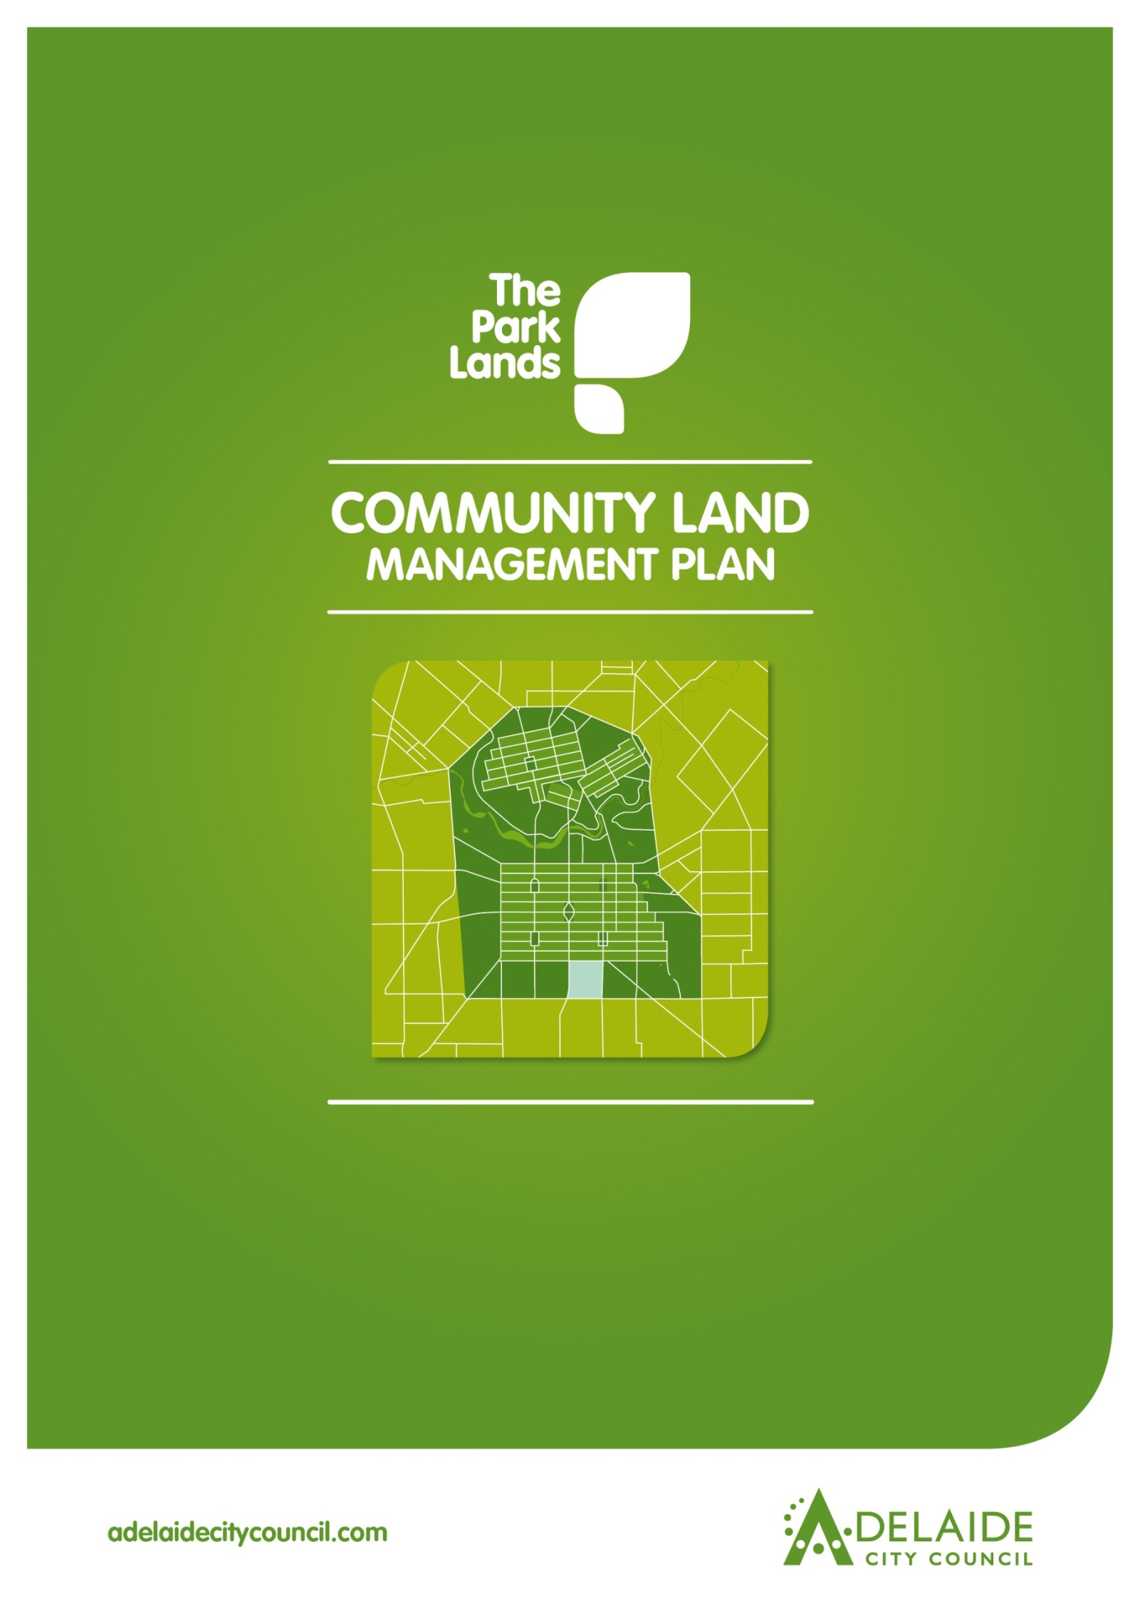

**Chapter 3**

**Kurangga (Park 20)**



**Kurangga (Park 20)**

**Introduction**

**1.0 Directions**

**1.1 Desired Future Character Statement**

**1.2 Challenges and Opportunities**

**1.3 Management Directions**

**2.0 Background**

**2.1 Heritage**

**2.1.1 Kaurna Heritage**

**2.1.2 Kaurna Naming**

**2.1.3 European Significance**

**2.1.4 Heritage Listing**

**2.2 Landscape**

**2.3 Recreation**

**Lease and Licence Areas Map**

**2.4 Natural Systems**

**Introduction: The Community Land Management Plan**

Show

* Parcel boundaries
* Lease areas
* Licence areas
* Core area
* Garden areas
* Intended car parks and carrying capacities
* Roads and access

This document is Chapter 3 of the Community Land Management Plan for the Park Lands (the CLMP). It should be read together with Chapter 1, which is the CLMP Framework. Chapter 1 explains the requirements for the CLMP, the legislative and planning context, the CLMP Statutory Principles, and the CLMP Framework.

The key to each Chapter is the Management Directions which represent the application of existing strategies and policies in each Park area.

**1.0 Directions for Kurangga (Park 20)**

* 1. **Desired Future Character Statement**
* ***Meet the sporting and other recreation needs of the community in attractive wide open spaces***

***surrounded by large shady trees within an open woodland character.***

**1.2 Challenges and Opportunities**

* Managing the Park’s ***competing uses and activities***, including various licence-holders, while preserving its cultural landscape character.
* Contributing to the ***open space recreational needs*** of the growing residential communities of the City of Adelaide and Unley (particularly along South Terrace and Greenhill Road).
* Managing changes to the Park as a result of the draft ***Brown Hill Keswick Creek Stormwater Management Plan***.
* Addressing pressure on ***underground aquifers*** accentuated by bore water use.
* Meeting demand for improved ***pedestrian and cyclist access*** for recreation and commuter purposes.

**1.3 Management Directions**

**DESIRED FUTURE CHARACTER**

*‘Meet the sporting and other recreation needs of the community in attractive wide open spaces surrounded by large shady trees within an open woodland character’*

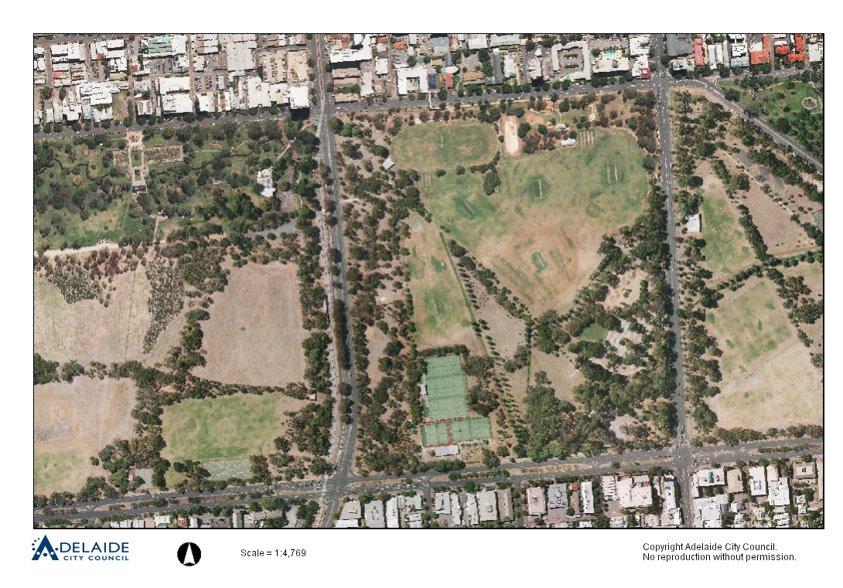

**11**

**1**

**2**

**3**

**6**

**5**

**4**

1.3.1 Enable appropriate **activities and events** in the Park (RS 2 & 6).

1.3.2 Conserve, enhance and interpret the **identified cultural heritage landscape** and its contributory features, such as exotic specimen trees, avenues and corridors, including (HS3 & 4):

1. English Elms and Desert Ash in playground
2. Stone pines
3. Poplar avenue
4. Kurrajong Avenue
5. Poplar avenue
6. Sellar Avenue (White Cedar)

*\*Note: Retain the alignment of the poplar avenues and gradually replace poplars with red gums as they cope better with dry conditions.*

1.3.3 Retain existing **spatial layout and pathway alignments** which are part of the cultural heritage values of the Park and reinstate the southern end of Sellar Avenue (see 6) (H8).

1.3.4 Strengthen the **outer and City edges of the Park through large tree species plantings,** retain and strengthen distinctive mature tree species through succession planting to enhance the Park’s open woodland character consistent with the Open Woodland/Sports Zone, and **manage landscape consistent with the planting directions** in 2.2 below (L13).

1.3.5 Manage **car parking availability** for park visitors to ensure short-term stays and improve their appearance in the Park (MP6.2).

1.3.6 Manage **Park Lands Trail and other paths** for the use of residents and visitors, and, where appropriate, completing the Trail (including supporting facilities), upgrading existing and constructing new paths and linking with City and suburban walking and cycle networks. (R10, R11, R22).

Park Lands Trail shown as:

Priority Park Lands Paths for upgrade shown as:



1.3.7 **Lighting** should support the safe movement of pedestrians throughout the Park. (R9)

1.3.8 Ensure that **CPTED principles** are taken into consideration, whereby sightlines are supported through vegetation management. (R9)

1.3.9 Plan for the **needs of residents** of both Unley and Adelaide City Councils and pursue convenient and safe access across adjoining main roads (Greenhill Rd).

**1**

**Kurangga (Park 20)**

**Kurangga (Park 20)**

1.3.10 Retain, conserve, and pursue **Local Heritage Listing of the Glover Playground,** South Terrace. Including signs and original trees (incorporating shelter shed already a Local Heritage Place), recognising it as the first formal playground established by the Council (playground shelter is a Local Heritage Place) (H6).

1.3.11 Maintain and enhance **views and** **vistas to the skyline and the Adelaide Hills** through appropriate plantings and spatial arrangements to reinforce the open and expansive character of the Open Woodland/Sports Zone. (LS9)Views are illustrated as:



1.3.12 Manage the **playground and the BMX track** as regional youth activity hubs in the Park supported by adjoining picnic and recreation facilities, and promote the BMX track for use by non-powered bicycles during daylight hours (R9).

1.3.13 Ensure drainage lines are managed to accommodate stormwater management and temporary detention of overflow and integrate **stormwater management** into the recreation and aesthetic values of the Park (NS4, NS5, NS8).

1.3.14 Reduce licensees’ reliance on **bore water** (NS9 & 10).

1.3.15 Enhance the south-eastern corner of the Park, where a series of natural and artificial drainage lines meet, as a **semi-natural environment (**NS4).

1.3.16 Seek opportunities to improve the **biodiversity value of the Park** (NS3 & 4).

1.3.17 Manage courts for **community use**.

1.3.18 Support **rationalistion of buildings** and upgradeof regional sports areas **(**MP4.3 &R17).

1.3.19 Continue to protect and manage the **Biodiversity Revegetation Sites**. Biodiversity Revegetation sites shown as:



1.3.20 Permit leases and licences as shown on the **Lease and** **Licence Areas Map** in 2.3 and in accordance with Chapter One.

**References to Adelaide Park Lands Management Strategy:**

**R** - Recreation **PLP** - Park Lands Priority

**H** - Heritage **S** - Strategy

**L** - Landscape **MP** - Management Principles and Strategies

**NS** - Natural Systems 2 - Number refers to relevant strategy or principle *Example:* HS3 & 4 refers to Heritage Strategies 3 & 4

**2.0 Background**

Kurangga (Park 20) comprises part of the South Park Lands. The [Adelaide Park Lands Landscape Master Plan](http://www.adelaidecitycouncil.com/assets/acc/Council/policies/docs/111107%20Parklands%20MP%20Report_.pdf) identifies four landscape zones in the Park Lands - Kurangga (Park 20) is within the Open Woodland/Sports zone characterised by large open grassed spaces semi-enclosed by predominantly native groves of trees, the open spaces generally used for sporting activities.

Kurangga (Park 20) serves as a recreation precinct for a number of licence holders as well as serving the community through provision of facilities including two community netball and basketball courts. The Park features isolated examples of remnant vegetation as well as a number of significant and attractive vegetation features including avenues and creeks. The Glover Playground and the BMX track are key attractions in the Park.

**2.1 Heritage**

**2.1.1 Kaurna significance:**

There are no specific references to Kaurna sites or activities[, pre-contact or post-contact for this Park](http://www.adelaidecitycouncil.com/assets/acc/Community/reconciliation/docs/tarndanyungga-kaurna-yetta.pdf)[1]. However, there are general references that point to the regular use of the South Park Lands as a camping venue.

**2.1.2 Kaurna Naming:**

As part of the Adelaide City Council’s commitment to reconciliation with Aboriginal communities, places within the City have been given [Kaurna names](http://www.adelaidecitycouncil.com/community/reconciliation/kaurna/place-naming). This Park is known as “Kurangga (Park 20)” which loosely translates as ‘blue gum place’.

**2.1.3 European significance:**

Kurangga (Park 20) retains its original shape and form as devised by Colonel William Light, reflects the design intent and philosophies of John Ednie Brown[2], and August Pelzer[3], such as species plantings and pathway alignments. There are several contemporary facilities that have partially compromised the original intent but provide additional cultural and social significance to the place, such as the BMX track.

There are important pathway and woodland elements proposed in early 1880 plans for the Park , and also the first ‘first generation’ playground in Adelaide established 1918 and South Australia, named after its major donor and the Lord Mayor of Adelaide, CRJ Glover.

Kurangga (Park 20) has several vegetation elements of significance, especially avenues, including the Kurrajong Avenue, Sellar Avenue of white cedars, the Lombardy Poplar avenue and the White Poplar avenue.

**2.1.4 Heritage Listing:**

Kurangga (Park 20) is part of the Adelaide Park Lands and City Layout which are on the National Heritage List. See Part 1, in the CLMP Planning Framework, at 1.3.1 for further information.

The Playground shelter is a Local Heritage Place (City Significance) identified in the [Adelaide (City) Development Plan](http://sa.gov.au/upload/franchise/Housing,%20property%20and%20land/PLG/Online%20DPs/Greater%20metropolitan/Adelaide_Council_Development_Plan.pdf).

See the Adelaide Park Lands and Squares Cultural Landscape Assessment Study [Report](http://www.adelaidecitycouncil.com/assets/acc/Environment/park-lands/docs/apl_3.1.18_pk_20_kurrangga_report.pdf) and [Assessment](http://www.adelaidecitycouncil.com/assets/acc/Environment/park-lands/docs/apl_4.1.18_pk_20_kurrangga_assessment.pdf) for further information about heritage places in the Park.

**2.2 Landscape**

The [Adelaide Park Lands Landscape Master Plan](http://www.adelaidecitycouncil.com/assets/acc/Council/policies/docs/111107%20Parklands%20MP%20Report_.pdf) identifies four landscape zones in the Park Lands - Kurangga (Park 20) is within the Open Woodland/Sports zone characterised by large open grassed spaces semi-enclosed by predominantly native groves of trees, the open spaces generally used for sporting activities.

Important supporting material to the development of the CLMP is the [Adelaide Park Lands and Squares Cultural Landscape Assessment Study](http://www.adelaidecitycouncil.com/environment/park-lands/heritage1/cultural-landscape-study/) October 2007 by Dr David Jones which provides detailed information about the cultural landscape features of Kurangga (Park 20).

Key planting directions from the *Adelaide Park Lands Landscape Master Plan*: Open Woodland/Sports Zone are:

* Restore and reinforce an open woodland character generally across the Zone.
* Dominant tree species should be native/indigenous, informally planted, and interspersed with open grassland.
* Increase tree planting where spatial structure of open spaces needs enhancement.
* Limit understorey planting to areas that screen out unwanted elements such as vehicular traffic, and areas where natural landscapes for increased biodiversity are proposed, balanced with the general ‘open’ character of this zone, providing long views where appropriate.
* Plant exotic grasslands for sports fields and active recreation, and native grasslands in other areas to reinforce the natural character.
* Retain exotic species around designated facilities and gardens and in culturally significant avenues.
* Conserve and enhance areas of high biodiversity particularly key remnant vegetation sites.

**2.3 Recreation**

Kurangga (Park 20) makes an important contribution to the recreation facilities of Zone 1, the Open Woodland/Sports Zone indicated by the [Adelaide Park Lands Landscape Master Plan](http://www.adelaidecitycouncil.com/assets/acc/Council/policies/docs/111107%20Parklands%20MP%20Report_.pdf). These include a number of licensed sporting facilities and leased buildings (shown on the ***Lease and Licence Areas Map*** below), community netball/basketball courts, Glover Playground and the BMX track. Existing facilities are available for use by other users outside of licensees’ hours of use.

Kurangga (Park 20) also hosts a range of sporting and minor events.

**Lease and Licence Areas Map**

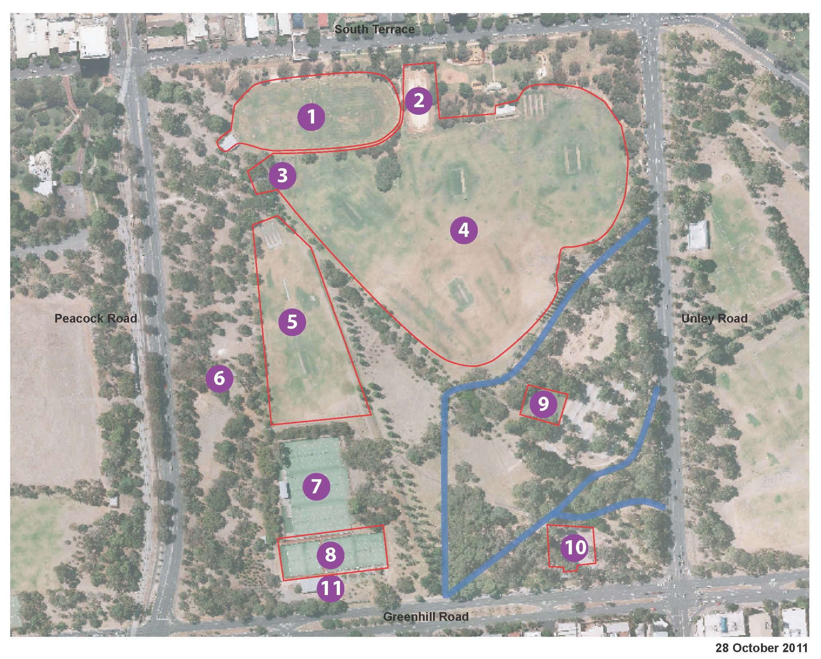

|  |
| --- |
| ***Legend***  *1. Running Track(Licensed) and Change Rooms and Soccer Pitch*  *2. Community Netball and Basketball Courts*  *3. Change Rooms*  *4. Sports Fields*  *5. Sports Fields*  *6. Redundant Buildings*  *7. 12 Tennis Courts*  *8. 6 Tennis Courts and Hockey Pitch*  *9. 3 Lawn Tennis Courts*  *10. Petanque Piste*  *11. Car Park and Club Rooms* |

**2.4 Natural Systems**

Kurangga (Park 20) contains isolated examples of rare remnant vegetation as identified in the [Biodiversity and Water Quality Action Plan 2011-2016](http://www.adelaidecitycouncil.com/assets/acc/Council/policies/docs/Biodiversity-and-Water-Quality%20-Action-Plan.PDF). There is a creek through the south (see map), drainage lines, and a number of significant vegetation features and avenues.

**Relevant Links:**

Adelaide Park Lands Management Strategy: Towards 2020

<http://www.adelaidecitycouncil.com/assets/acc/Environment/plans-policies/docs/parklands_management_strategy.pdf>

Cultural Landscape study

<http://www.adelaidecitycouncil.com/environment/park-lands/heritage1/cultural-landscape-study/>

Landscape Master Plan

<http://www.adelaidecitycouncil.com/assets/acc/Council/policies/docs/111107%20Parklands%20MP%20Report_.pdf>

Cultural Landscape Assessment Report for Kurangga (Park 20)

[http://www.adelaidecitycouncil.com/assets/acc/Environment/park-lands/docs/apl_3.1.18_pk_20_Kurangga_report.pdf](http://www.adelaidecitycouncil.com/assets/acc/Environment/park-lands/docs/apl_3.1.18_pk_20_kurrangga_report.pdf)

[http://www.adelaidecitycouncil.com/assets/acc/Environment/park-lands/docs/apl_4.1.18_pk_20_Kurangga_assessment.pdf](http://www.adelaidecitycouncil.com/assets/acc/Environment/park-lands/docs/apl_4.1.18_pk_20_kurrangga_assessment.pdf)

Adelaide City Council Biodiversity and Water Quality Action Plan

<http://www.adelaidecitycouncil.com/assets/acc/Council/policies/docs/Biodiversity-and-Water-Quality%20-Action-Plan.PDF>

1. Tarndanyangga Kaurna Yerta – A 1998 Report on the Indigenous Cultural Significance of the Adelaide Park Lands.
2. John Ednie Brown, Council’s Supervisor of the Plantations, engaged to prepare a Report on a System of Planting the Adelaide Park Lands (1880)
3. August Pelzer, City Gardener 1899-1934