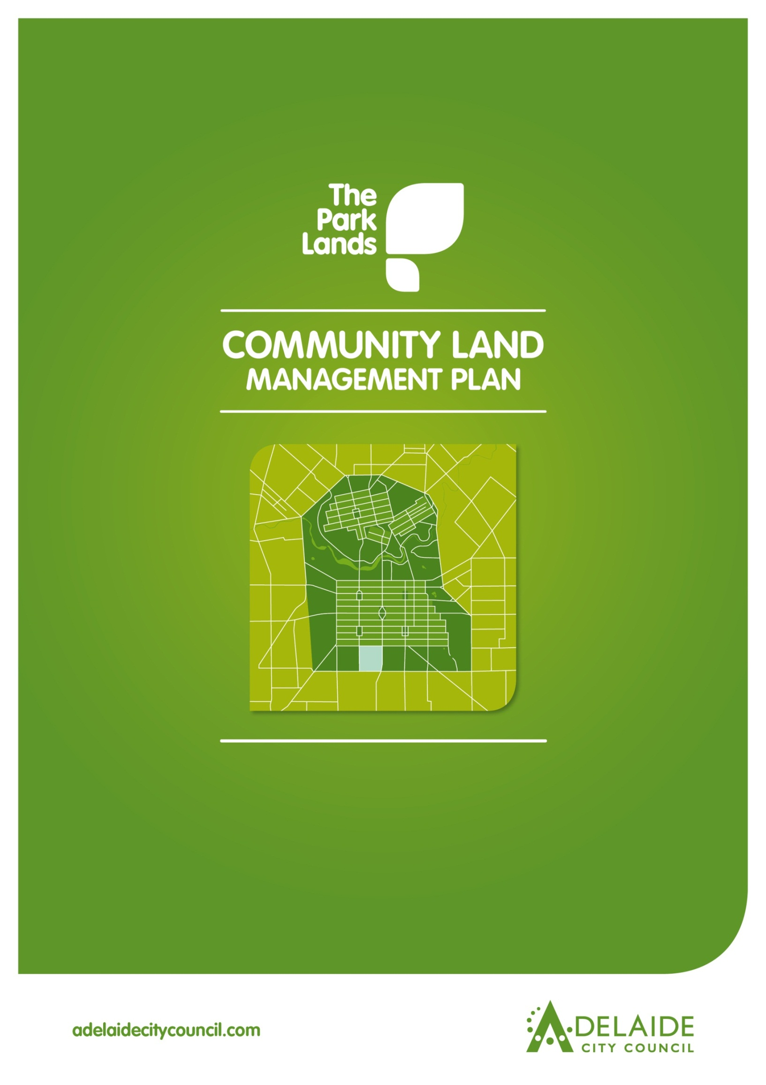
Chapter 4
Walyu Yarta (Park 21)

Walyu Yarta (Park 21)

Introduction

1.0 Directions
1.1 Desired Future Character Statement
1.2 Challenges and Opportunities
1.3 Management Directions

2.0 Background
2.1 Heritage
2.1.1 Kaurna Heritage
2.1.2 Kaurna Naming
2.1.3 European Significance
2.1.4 Heritage Listing

2.2 Landscape

2.3 Recreation
Lease and Licence Areas Map

2.4 Natural Systems

Introduction: The Community Land Management Plan
This document is Chapter 4 of the Community Land Management Plan for the Park Lands (the CLMP). It should be read together with Chapter 1, which is the CLMP Framework. Chapter 1 explains the requirements for the CLMP, the legislative and planning context, the CLMP Statutory Principles, and the CLMP Framework.
The key to each Chapter is the Management Directions which represent the application of existing strategies and policies in each Park area. The key to each Chapter is the Management Directions which represent the application of existing strategies and policies in each Park area.

1.0 Directions for Walyu Yarta (Park 21)

1.1 Desired Future Character Statement
- Meet the sporting and other recreation needs of the community in attractive wide open spaces surrounded by large shady trees within an open woodland character, while supporting the unique landscape setting and events use of Veale Gardens as well as the community garden.

1.2 Challenges and Opportunities
- Managing the Park’s competing uses and activities, including various licence-holders, while preserving its cultural landscape character.
- Contributing to the open space recreational needs of the growing residential communities of the City of Adelaide and Unley (particularly along South Terrace and Greenhill Road).
- Addressing pressure on underground aquifers accentuated by bore water use
- Improving the biodiversity values by continuing to revegetate important sites around the perimeter and in the middle of the Park whilst ensuring it remains safe for users and maintains important views and vistas across the Adelaide Plains.
- Appropriately managing remnant native grasses to ensure positive biodiversity outcomes.
- Meeting demand for improved pedestrian and cyclist access for recreation and commuter purposes.

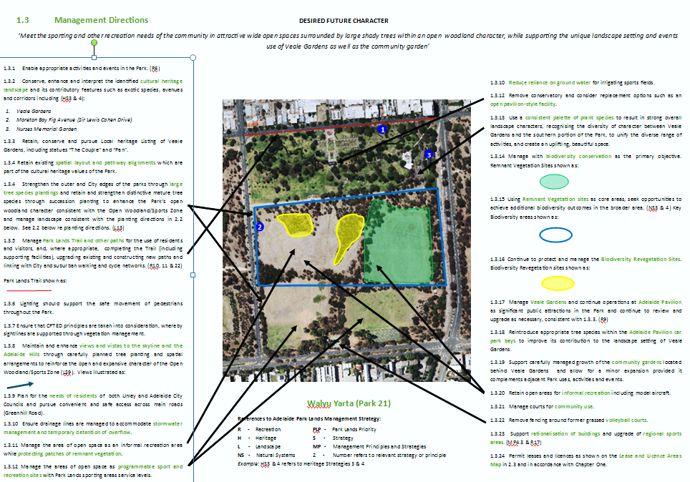

- Background

Walyu Yarta (Park 21) comprises part of the South Park Lands. Adelaide Park Lands Landscape Master Plan identifies four landscape zones in the Park Lands - Walyu Yarta (Park 21) is within the Open Woodland/Sports zone characterised by large open grassed spaces semi-enclosed by predominantly native groves of trees, the open spaces generally used for sporting activities.
Walyu Yarta (Park 21) serves as a recreation precinct for a number of licence holders as well as serving the community through provision of facilities including tennis courts, soccer fields and general sporting fields. Isolated examples of remnant vegetation are scattered around the edges and within the Park. Significant revegetation sites have been planted in the middle of the Park and in recent times, a community garden has been established behind Veale Gardens.
Adelaide Pavilion and Veale Gardens are key attractions to the Park. Both are regularly used for formal occasions including weddings and small-medium scale events. The Glenelg to Adelaide tramline transects the eastern edge of the Park and is separated from the rest of the park by a boundary fence.

  - Heritage

2.1.1 Kaurna significance:
There are no specific references to Kaurna sites or activities, pre-contact or post-contact for this Park. However, there are general references that point to the regular use of the South Park Lands as a camping venue.

2.1.2 Kaurna Naming:
As part of the Adelaide City Council’s commitment to reconciliation with Aboriginal communities, places within the City have been given Kaurna names.
This Park is known as “Walyu Yarta (Park 21)” which loosely translates as ‘walyo root ground’. Walyo is an edible white root (resembling a radish) and Yerta is the ground.

2.1.3 European significance:

Walyu Yarta (Park 21) retains its original shape and form as devised by Colonel William Light, and has evidence of substantial tree planting that accord with the design intent and species intent of reflects of John Ednie Brown, and August Pelzer, such as species plantings and pathway alignments.
There are several contemporary facilities that have partially compromised the original intent but provide additional cultural and social significance to the place, such as Adelaide Pavilion (function centre) and Veale Gardens.
Veale Gardens changed the image of the open expansive woodland by establishing more intensive planting approaches and enabling a change of land use function to ceremonial and intensive recreational roles.
The overall spatial integrity of the Park has been compromised by the historic division of the Park into two equal portions to permit the construction of Sir Lewis Cohen Drive, the planting changes as a consequence of the construction of this road, and the creation of Veale Gardens.
Walyu Yarta (Park 21) has several vegetation elements of significance, especially avenues, including Sir Lewis Cohen Drive, South Terrace (refer to 1.3).

2.1.4 Heritage Listing:
Walyu Yarta (Park 21) is part of the Adelaide Park Lands and City Layout which are on the National Heritage List. See Part 1, in the CLMP Planning Framework, at 1.3.1 for further information.
Walyu Yarta (Park 21) contains no State or Local heritage places that are identified in the Adelaide (City) Development Plan.

2.2 Landscape
The Adelaide Park Lands Landscape Master Plan identifies four landscape zones in the Park Lands - Walyu Yarta (Park 21) is within the Open Woodland/Sports zone characterised by large open grassed spaces semi-enclosed by predominantly native groves of trees, the open spaces generally used for sporting activities.
Important supporting material to the development of the CLMP is Adelaide Park Lands and Squares Cultural Landscape Assessment Study October 2007 by Dr David Jones which provides detailed information about the cultural landscape features of Walyu Yarta (Park 21).
Key planting directions from the Adelaide Park Lands Landscape Master Plan: Open Woodland/Sports Zone are:
- Restore and reinforce an open woodland character generally across the Zone.
- Dominant tree species should be native/indigenous, informally planted, and interspersed with open grassland.
- Increase tree planting where spatial structure of open spaces needs enhancement.
- Limit understorey planting to areas that screen out unwanted elements such as vehicular traffic, and areas where natural landscapes for increased biodiversity are proposed, balanced with the general ‘open’ character of this zone, providing long views where appropriate.
- Plant exotic grasslands for sports fields and active recreation, and native grasslands in other areas to reinforce the natural character.
- Retain exotic species around designated facilities and gardens and in culturally significant avenues.
- Conserve and enhance areas of high biodiversity particularly key remnant vegetation sites.
- Retain exotic species around designated facilities and gardens (including Veale Gardens) and in culturally significant avenues.
The Park Lands are managed to supply the public with outcomes which include Quality, Reliability, Sustainability, Safety & Accessibility at an affordable cost. These criteria represent a Level of Service that is determined by Corporate Strategy & Budgets.

2.3 Recreation
Walyu Yarta (Park 21) makes an important contribution to the recreation facilities of Zone 1, the Open Woodland/Sports Zone indicated by the Adelaide Park Lands Landscape Master Plan. These include a number of licensed sporting facilities (shown on the Lease and Licence Areas Map below), including a soccer field, tennis courts and a general sports oval. Existing facilities are available for use by other users outside of licensees’ hours of use. An opportunity exists to find an alternate use for the grass volleyball courts that are currently leased.
Lease and Licence Areas Map
15 November 2011
4
2
3
1
Legend
- Sports Fields
- Tennis Courts
- Sports Fields and Tennis Courts
- Adelaide Pavilion

2.4 Natural Systems
Walyu Yarta (Park 21) contains isolated examples of rare remnant vegetation. The Adelaide Park Lands Management Strategy Landscape Character map (page 22) identifies a biodiversity conservation area (of importance) in the Park. The Biodiversity and Water Quality Action Plan 2011-2016 has been adopted by Council and represents the additional research conducted in the development of the ‘key biodiversity areas’ within Walyu Yarta (Park 21).

Relevant Links:
Adelaide Park Lands Management Strategy
http://www.adelaidecitycouncil.com/assets/acc/Environment/plans-policies/docs/parklands_management_strategy.pdf
Kaurna cultural heritage
http://www.adelaidecitycouncil.com/environment/park-lands/park-lands-heritage/cultural-landscape-study.html
Kaurna naming
http://www.adelaidecitycouncil.com/environment/park-lands/park-lands-heritage.html
Cultural Landscape Study - general
http://www.adelaidecitycouncil.com/environment/park-lands/heritage1/cultural-landscape-study/
Cultural Landscape Study – Report on Walyu Yarta (Park 21)
http://www.adelaidecitycouncil.com/assets/acc/Environment/park-lands/docs/apl_3.1.20_pk_21_w_minno_yerta_report.pdf
Cultural Landscape Study – Assessment for Walyu Yarta (Park 21)
http://www.adelaidecitycouncil.com/assets/acc/Environment/park-lands/docs/apl_4.1.20_pk_21_w_minno_yerta_assessment.pdf
Adelaide City Council Biodiversity and Water Quality Action Plan
http://www.adelaidecitycouncil.com/assets/acc/Council/policies/docs/Biodiversity-and-Water-Quality%20-Action-Plan.PDF

Tarndanyungga Kaurna Yerta – A 1998 Report on the Indigenous Cultural Significance of the Adelaide Park Lands.
John Ednie Brown, Council’s Supervisor of the Plantations, engaged to prepare a Report on a System of Planting the Adelaide Park Lands (1880)
August Pelzer, City Gardener 1899-1934

