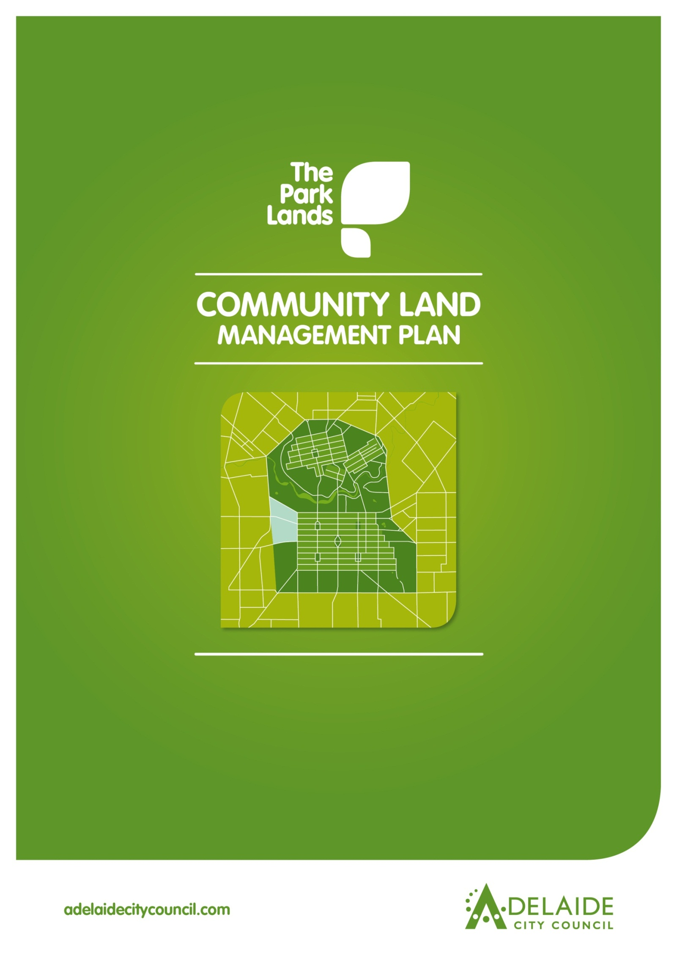

**Chapter 6**

**Tampawardli (Park 24)**

**Narnungga (Park 25)**



**Tampawardli (Park 24) & Narnungga (Park 25)**

**Introduction**

1. **Directions**

**1.1 Desired Future Character Statement**

**1.2 Challenges and Opportunities**

**1.3 Management Directions**

1. **Background**

**2.1 Heritage**

**2.1.1 Kaurna Heritage**

**2.1.2 Kaurna Naming**

**2.1.3 European Significance**

**2.1.4 Heritage Listing**

**2.2 Landscape**

**2.3 Recreation**

**Lease and Licence Areas Map**

**2.4 Natural Systems**

**________________________________________________________________**

**Introduction: The Community Land Management Plan**

Show

* Parcel boundaries
* Lease areas
* Licence areas
* Core area
* Garden areas
* Intended car parks and carrying capacities
* Roads and access

This document is Chapter 6 of the Community Land Management Plan for the Park Lands (the CLMP). It should be read together with Chapter 1, which is the CLMP Framework. Chapter 1 explains the requirements for the CLMP, the legislative and planning context, the CLMP Statutory Principles, and the CLMP Framework.

The key to each Chapter is the Management Directions which represent the application of existing strategies and policies in each Park area. The symbol shown at each Management Direction (e.g. NS4) refers to the [*Adelaide Park Lands Management Strategy*](http://www.adelaidecitycouncil.com/assets/acc/Environment/plans-policies/docs/parklands_management_strategy.pdf). The Management Directions show how projects endorsed through the Strategy would be implemented in each Park area and does not propose new projects.

1. **Directions for Tampawardli (Park 24) and Narnungga (Park 25)**

**1.1 Desired Future Character Statement**

* ***Meet the sporting and other recreation needs of the community, in particular the proposed major event space, in attractive wide open spaces surrounded by large shady trees within an open woodland character.***

**1.2 Challenges and Opportunities**

* Managing the Parks’ ***competing uses and activities***, including various licence-holders, while preserving their cultural landscape character.
* Contributing to the ***open space needs*** of the growing residential communities of the City of Adelaide and West Torrens.
* Meeting demand for ***improved pedestrian and cyclist access*** for recreation and commuter purposes*.*
* Managing needs of ***Adelaide High School*** within the recreational requirements of Tampawardli (Park 24).
* Ensuring the success of the***proposed new event space*** in Tampawardli (Park 24).

**1.3 Management Directions**

‘**DESIRED FUTURE CHARACTER**

*Meet the sporting and other recreation needs of the community, in particular the proposed major event space, in attractive wide open space surrounded by large shady trees with an open woodland character’*

|  |
| --- |
| 1.3.13 Maintain and enhance **views and** **vistas to the skyline and the City** through appropriate tree planting and spatial arrangements to reinforce the open and expansive character of the Open Woodland/Sports Zone. (L9) Views illustrated as:    1.3.14 Support **rationalisation of the number of buildings** through the removal of existing buildings and the establishment of a sports building that services all sports and recreational facilities within the Park, when the opportunity arises. (MP 4.3)  1.3.15 **Enhance landscaping** of Sir Donald Bradman Drive and Glover Avenue with planting of large Eucalypts (L3).  1.3.16 Manage **car parking** availability for park visitors. Redesign the car park footprints to increase capacity while enhancing the appearance of the site.  1.3.17 Respect the heritage value of **Adelaide High School**, work collaboratively with the School to ensure future development achieves consistent landscape design and integrates with the Park Lands, and that any expansion beyond that approved in 2012, occurs offsite. (HS3).  1.3.18 Encourage **irrigation efficiency** by licence holders.  1.3.19 Support the creation of a **major event space** that co-exists with surrounding sporting areas and that has a strong multi-function recreation focus. (R5 & 17)  1.3.20 Permit leases and licences as shown on **Lease and Licence Areas Map** 2.3.  1.3.21 Support **community use of courts** as multipurpose facilities.  1.3.22 Manage with **biodiversity conservation** as the primary objective. Remnant Vegetation Sites shown as:  1.3.23 Continue to encourage and support the establishment and management of **Volunteer Biodiversity Sites**. Volunteer Biodiversity Sites shown as: |

|  |
| --- |
| 1.3.1 Enable appropriate **activities and events** in the Park. (RS2 & 6)  1.3.2 Support the completion of the **new park** on the former SA Water Depot site as an environmental interpretation area. (PLP21)  **9**  1.3.3 Enhance the **screening** of the railway line with large native trees and develop areas of high biodiversity in the Park Lands to increase native biodiversity and ecological value.  1.3.4 Seek opportunities to improve **the biodiversity value** of the Parks. (NS3 & 4).  **7**  **6**  1.3.5 Conserve, enhance and interpret the identified **cultural heritage landscape** and its contributory features such as exotic specimens, avenues and corridors, including: (HS3  & 4)   1. Desert Ash plantings 2. grove of Moreton Bay Figs 3. row of Desert Ash 4. Desert Ash plantings 5. Canary Island Palms and Himalayan Cypress 6. Row of Desert Ash 7. Hill’s Fig 8. Row of Morton Bay Figs 9. Row of Pepper Trees 10. Former railway lines   1.3.6 Retain, conserve and pursue **Local Heritage Listing** of Emigration Square/Bureau of Meteorology Memorial interpretative site.  1.3.7 Strengthen the **outer and** **City edges** of the Park Lands through large tree species plantings. (L3)  1.3.8 Support and facilitate the upgrading of the West Terrace Sports Area as a **regional sports area** containing flexible programmable spaces and multi-use facilities. Support the upgrading of lighting of sports fields. (PLP10)  1.3.9 Manage **Park Lands Trail and other paths** for the use of residents and visitors, and, where appropriate, completing the Trail (including supporting facilities), upgrading existing and constructing new paths and linking with City and suburban walking and cycle networks. (R10, R11, R22). Park Lands Trail shown as:    1.3.10 Strengthen opportunities for recreational walking and cycling by supporting the completion of the **multi-use trail** for recreational walking, cycling and other recreational purposes (R11).  1.3.11 **Lighting** should support the safe movement of pedestrians throughout the Park. (R9)  1.3.12 Ensure that **CPTED principles** are taken into consideration, whereby sightlines are supported through vegetation management. (R9) |

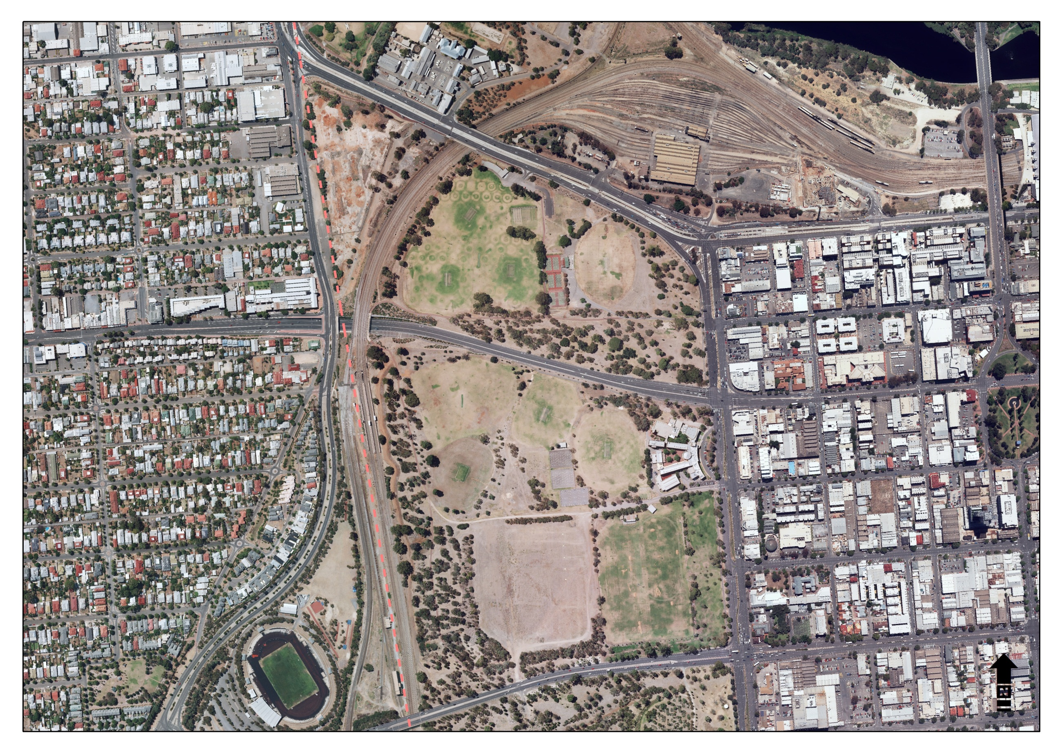

**References to Adelaide Park Lands Management Strategy:**

**R** - Recreation **PLP** - Park Lands Priority

**H** - Heritage **S** - Strategy

**L** - Landscape **MP** - Management Principles and Strategies

**NS** - Natural Systems 2 - Number refers to relevant strategy or principle

*Example:* H.S.3&4 refers to Heritage Strategies 3 & 4

**2**

**1**

**3**

**8**

**10**

**4**

**5**

**Tampawardli (Park 24) and Narnungga (Park 25)**

**DESIRED FUTURE CHARACTER**

*‘Meet the sporting and other recreation needs of the community, in particular the proposed major event space, in attractive wide open spaces surrounded by large shady trees within an open woodland character’*

1. **Background**

Tampawardli (Park 24) and Narnungga (Park 25) comprise of part of the Western Park Lands. The [Adelaide Park Lands Landscape Master Plan](http://www.adelaidecitycouncil.com/assets/acc/Council/policies/docs/111107%20Parklands%20MP%20Report_.pdf) identifies four landscape zones in the Park Lands - Tampawardli (Park 24) and Narnungga (Park 25) are within the Open Woodland/Sports zone characterised by large open grassed spaces semi-enclosed by predominantly native groves of trees. The open spaces are generally used for sporting activities and leased to nearby school and sporting groups.

Tampawardli (Park 24) and Narnungga (Park 25) serves as a recreation precinct for a number of licence holders as well as serving the community through provision of facilities including three Ovals, six tennis courts, three netball courts and cricket practice nets.

The Parks also feature some small isolated examples of remnant vegetation as well as a number of attractive vegetation features.

**2.1 Heritage**

**2.1.1 Kaurna significance:**

There are no specific references to Kaurna sites or activities[, pre-contact or post-contact for this Park](http://www.adelaidecitycouncil.com/assets/acc/Community/reconciliation/docs/tarndanyungga-kaurna-yetta.pdf)[1]. However, there are general references that point to the regular use of the Western Park Lands as a camping venue.

**2.1.2 Kaurna Naming:**

As part of the Adelaide City Council’s commitment to reconciliation with Aboriginal communities, places within the City have been given [Kaurna names](http://www.adelaidecitycouncil.com/community/reconciliation/kaurna/place-naming). The Parks are known as “Tampawardli (Park 24)” which loosely translates as ‘plains place’ and “Narnungga (Park 25)” translates to ‘native pine place’.

**2.1.3 European significance:**

Tampawardli (Park 24) and Narnungga (Park 25) retain their original shape and form as devised by Colonel William Light and reflects the spatial and planting design intent and philosophies of John Ednie Brown[2], and August Pelzer[3], such as species plantings and pathway alignments.

Tampawardli (Park 24) and Narnungga (Park 25) were originally used for soil and stone extraction, agistment, temporary encampment and council works before becoming used for recreational purposes and more organised sporting grounds in the 1920s and onwards, wherein a tree planting program intermittently occurred.

Tampawardli (Park 24) contains the following trees of aesthetic merit:

* grove of Moreton Bay Figs along the western railway boundary
* boundary plantings of Desert Ash along the Waymouth Street extension
* Desert Ash plantings along Glover Avenue

Tampawardli (Park 24) also contains a variety of other species such Monterey Cypress, Sugar Gum, Moreton Bay Fig, Canary Island Pines, South Australian Blue Gum, Pepper Tree, Arizona Cypress, White Pine Cypress.

Narnungga (Park 25) has a number of trees that are of historic or aesthetic merit, these include:

* Canary Island Palms, Himalayan Cypress located near the South Australian Railways Memorial
* row of Desert Ash along the eastern edge of the oval
* Hill’s Fig located in the south eastern Corner
* row of Morton Bay Fig’s along the railway boundary to the west
* row of Pepper Trees along the East Terrace Frontage

Narnungga (Park 25) also contains a variety of other species such as White Cedar, Canary Island Palms, Cotton Palms, Aleppo Pines, Sugar Gums, River Red Gums, Lemon scented Gums, Spotted Gum, English Elm, Stone Pine, Chinese Elms and Ombu.

**2.1.4 Heritage Listing:**

Tampawardli (Park 24) and Narnungga (Park 25) are part of the Adelaide Park Lands and City Layout which are on the National Heritage List. See Part 1, in the CLMP Planning Framework, at 1.3.1 for further information.

No component in Tampawardli (Park 24) is identified as a local Heritage Place within the [Adelaide (City) Development Plan](http://sa.gov.au/upload/franchise/Housing,%20property%20and%20land/PLG/Online%20DPs/Greater%20metropolitan/Adelaide_Council_Development_Plan.pdf)*.* Adelaide High School (formerly Adelaide Boys High School) is, however, identified on the South Australian Heritage Register, although on State Government land and outside the scope of this CLMP.

No component in Narnungga (Park 25) is identified on the South Australian Heritage Register nor is identified as a local Heritage Place within the *Adelaide (City) Development Plan*. The Park does however, possess several points of historic reference associated with the city survey and the horticultural history of the state that and these include:

* South Australian Railways Institute pavilion
* South Australian Railway Institute War Memorial
* Thomas Allen Memorial
* Old rail lines eastern side of the eastern oval

It is recommended that Local Heritage listing of Emigration Square/Bureau of Meteorology Memorial interpretative site be pursued.

See the Adelaide Park Lands and Squares Cultural Landscape Assessment Study for Tampawardli (Park 24) [Report](http://www.adelaidecitycouncil.com/assets/acc/Environment/park-lands/docs/apl_3.1.23_pk_24_tambawodli_report.pdf) and [Assessment](http://www.adelaidecitycouncil.com/assets/acc/Environment/park-lands/docs/apl_4.1.23_pk_24_tambawodli_assessment.pdf) and Narnungga (Park 25) [Report](http://www.adelaidecitycouncil.com/assets/acc/Environment/park-lands/docs/apl_3.1.24_pk_25_narnungga_report.pdf) and [Assessment](http://www.adelaidecitycouncil.com/assets/acc/Environment/park-lands/docs/apl_4.1.24_pk_25_narnungga_assessment.pdf) for further information about heritage places in the Park.

**2.2 Landscape**

The [Adelaide Park Lands Landscape Master Plan](http://www.adelaidecitycouncil.com/assets/acc/Council/policies/docs/111107%20Parklands%20MP%20Report_.pdf) identifies four landscape zones in the Park Lands - Tampawardli (Park 24) and Narnungga (Park 25) are within the Open Woodland/Sports zone which are characterised by large open grassed spaces semi-enclosed by predominantly native groves of trees and open spaces generally used for sporting activities.

Important supporting material to the development of the CLMP is the [Adelaide Park Lands and Squares Cultural Landscape Assessment Study](http://www.adelaidecitycouncil.com/environment/park-lands/heritage1/cultural-landscape-study/) (October 2007) by Dr David Jones. The study provides detailed information about the cultural landscape features of Tampawardli (Park 24) and Narnungga (Park 25).

Key planting directions from the *Adelaide Park Lands Landscape Master Plan: Open Woodland/Sports Zone* are:

* Restore and reinforce an open woodland character generally across the Zone.
* Dominant tree species should be native/indigenous, informally planted, and interspersed with open grassland.
* Increase tree planting where spatial structure of open spaces needs enhancement.
* Limit understorey planting to areas that screen out unwanted elements such as vehicular traffic, and areas where natural landscapes for increased biodiversity are proposed, balanced with the general ‘open’ character of this zone, providing long views where appropriate.
* Plant exotic grasslands for sports fields and active recreation, and native grasslands in other areas to reinforce the natural character.
* Retain exotic species around designated facilities and gardens and in culturally significant avenues.
* Conserve and enhance areas of high biodiversity particularly key remnant vegetation sites.

**2.3 Recreation**

Tampawardli (Park 24) and Narnungga (Park 25) make an important contribution to the recreation facilities of Zone 1, the Open Woodland/Sports Zone indicated by the [Adelaide Park Lands Landscape Master Plan](http://www.adelaidecitycouncil.com/assets/acc/Council/policies/docs/111107%20Parklands%20MP%20Report_.pdf). The recreational facilities include a number of leased and licensed sporting facilities (shown on the ***Lease and Licence Areas Map*** below), ovals, tennis/netball courts, basketball courts, cricket practice nets, soccer pitches and athletes track. Existing facilities are available for use by other users outside of licensees’ hours of use. Tampawardli (Park 24) is also used as a major events venue.

**Lease and Licence Area Map**

|  |
| --- |
| *Legend*  *1. Sports Fields*  *2. Change Rooms*  *3. Tennis Courts*  *4. Storage Room*  *5. Sports Fields*  *6. Cricket Practice Nets*  *7. Change Rooms*  *8. Sports Field*  *9. Sports Buildings*  *10. Tennis Courts*  *11. Netball Courts*  *12 Cricket practice Nets*  *13. Sports Field*  *14 Sports Field*  *15. Sports Building and Public*  *Toilet*  *16. Sports building*  *17. Events* |

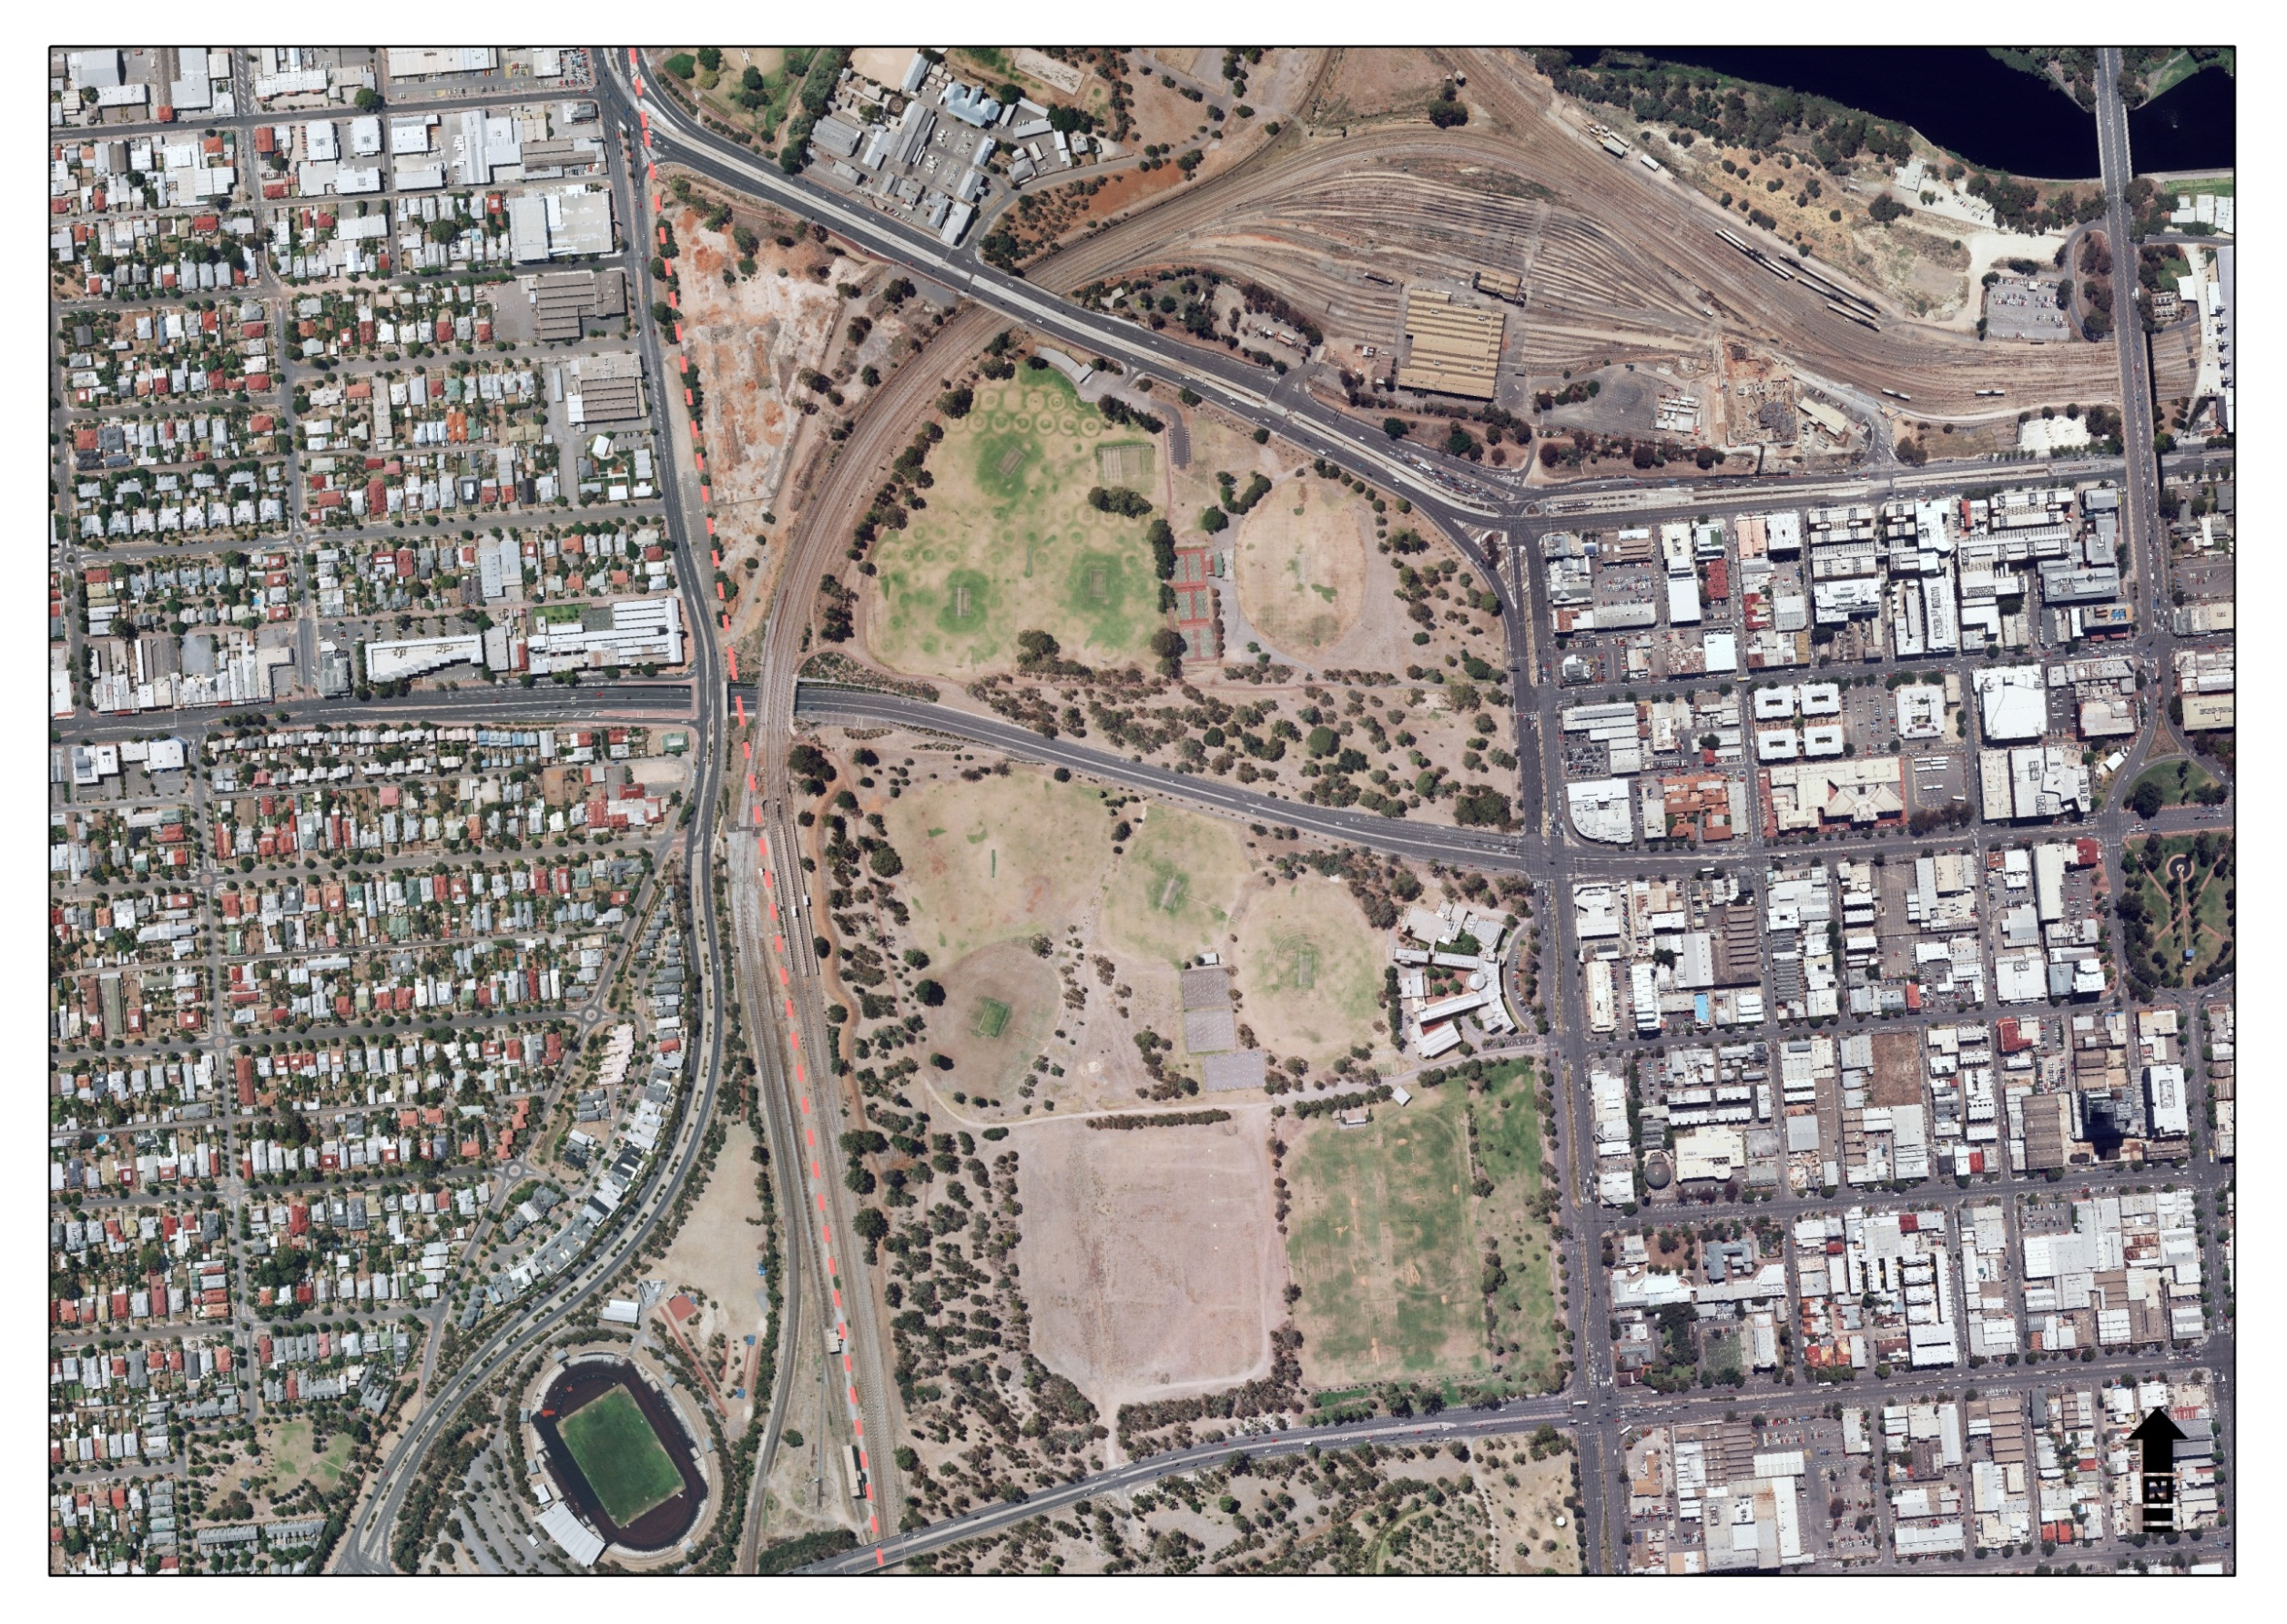

**2**

**4**

**8**

**15**

**3**

**13**

**9**

10

**11**

**12**

**14**

**16**

**17**

**7**

**6**

**5**

**1**

**2.4 Natural Systems**

Tampawardli (Park 24) and Narnungga (Park 25) contain some isolated examples of remnant vegetation. The Adelaide Park Lands Management Strategy identifies a Biodiversity Conservation Area (of importance) in Tampawardli (Park 24) and Narnungga (Park 25).

The [Adelaide City Council Biodiversity and Water Quality Action Plan](http://www.adelaidecitycouncil.com/assets/acc/Council/policies/docs/Biodiversity-and-Water-Quality%20-Action-Plan.PDF) has been adopted by Council and represents the additional research conducted in the development of the ‘key biodiversity areas’ within Tampawardli (Park 24) and Narnungga (Park 25) however these areas are considered to be in poor condition.

A flood mitigation embankment has established along the railway lane west of Tampawardli (Park 24) and Narnungga (Park 25).

**Relevant Links**

Adelaide Park Lands Management Strategy: Towards 2020

<http://www.adelaidecitycouncil.com/assets/acc/Environment/plans-policies/docs/parklands_management_strategy.pdf>

Cultural Landscape study:

<http://www.adelaidecitycouncil.com/environment/park-lands/heritage1/cultural-landscape-study/>

Kaurna Naming

<http://www.adelaidecitycouncil.com/community/reconciliation/kaurna/place-naming>

Landscape Master Plan

<http://www.adelaidecitycouncil.com/assets/acc/Council/policies/docs/111107%20Parklands%20MP%20Report_.pdf>

Cultural Landscape Assessment Report for Tampawardli (Park 24) and Narnungga (Park 25)

<http://www.adelaidecitycouncil.com/environment/park-lands/heritage1/cultural-landscape-study/>

Adelaide City Council Biodiversity and Water Quality Action Plan

<http://www.adelaidecitycouncil.com/assets/acc/Council/policies/docs/Biodiversity-and-Water-Quality%20-Action-Plan.PDF>

1. Tarndanyungga Kaurna Yerta – *A 1998 Report on the Indigenous Cultural Significance of the Adelaide Park Lands.*
2. John Ednie Brown, Council’s Supervisor of the Plantations, engaged to prepare a Report on a *System of Planting the Adelaide Park Lands* (1880)
3. August Pelzer, City Gardener 1899-1934