RECREATION & SPORTS

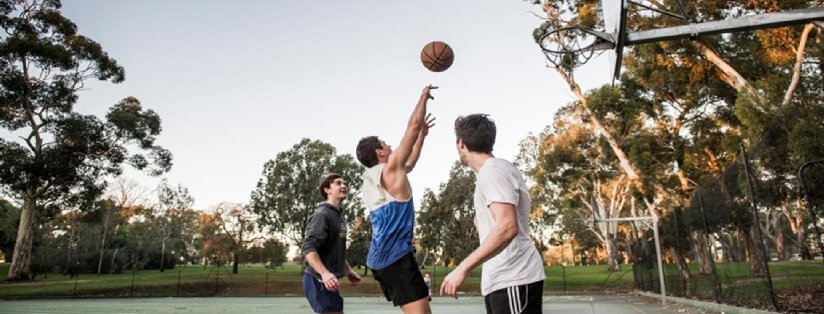
DRAFT APPLICATION FORM

Category Four:
(3) Quick Response Grant
Up to $2,000 per application
Please refer to the Grant Guidelines and schedule before submitting an application and note that hard copy, faxed or emailed applications will not be accepted.
Name
Street Address
Contact Person and Position
Phone
Email
Project Name
Amount of Funding Requested
Date of Submission

- Please indicate which of Council’s Strategic Directions your application directly relates to: (Tick multiple boxes if required)
  - Increase community use of and access to the Adelaide Park Lands
  - Healthy and resilient communities
  - Safe and welcoming community spaces
  - Aboriginal and Torres Strait Islander peoples and cultures strongly represented in City life
  - Beautiful, surprising places
  - Celebration of diverse community, culture and creativity
  - A climate ready organisation and community
- Please indicate which Recreation and Sport Grants program priorities your application directly relates to:
(Tick multiple boxes if required)
  - Programs or events increasing participation and/or physical activity in the City;
  - Programs or events utilising public spaces;
  - Programs or events that are run at minimal cost;
  - Programs or events for emerging and minority sports;
  - Programs or events targeting people from specific or vulnerable population groups;
  - Programs, events or facilities, improving community access, inclusion, wellbeing and resilience;
  - Programs, events, or facilities resulting in multi-use and/or increasing a facilities carrying capacity;
  - Programs, events or facilities demonstrating environmentally sustainable practises; and
  - Programs or events that represent good return on investment of significant social impact.

Part 1:
 |  | Assessment Weighting
Brief Overview of the Application and what funds would be used for:  Suggested 100-word maximum  E.g. marketing, equipment hire, coordination, insurance, etc. |  | Part of  Community  Benefit  Assessment  50%
How did you determine that this application was needed? What evidence do you have to support its development?
(E.g. Service statistics, ABS data, anecdotal
observations, local engagement)
Who is the target group and how do you plan to engage your target group?
(Inclusivity of all members of our community- please also add in target age group and brief engagement plan)
How many people will benefit directly from this grant? &
(Number of individuals/age & demographic)
Will any of these be City users?
Where in the City will the application take place? Do you have a current agreement/ permission to use that space?  (It must be within the boundaries of the City of  Adelaide including any of the Park Lands) |  | Part of  Activation  Assessment  25 %
What plans do you have to support participants to continue their participation beyond the completion of your program?
Recreation & Sports Grants – as at July 2020 - Category Four(4) - Quick Response 2019/20 - Page 2
Please provide details of how you plan to deliver the project to achieve the Strategic outcome/s you outlined |  | Part of  Strategic  Plan  Assessment  25 %
Please provide details on how your project will demonstrate consideration of:
- Environmental sustainability
- inclusivity of all members of our community and
- low or no cost for disadvantagedgroups
Start Date |  | N/A
End Date |  | N/A

Part 2:
Please click here to access the Proposed Budget Template:
If your grant application is for the purchase of equipment and/or uniforms, please provide an official quote from a appropriate supplier.
If you have any partnerships assisting in delivering the project (contributing both in kind and/or financial) please indicate these below
Item | Amount
Facility Hire | $100
Insurance | $150
Total (must match funding amount requested)
** Individual residents and unincorporated groups applying for funds to support a neighbourhood party or small scale event on Council land (e.g. a street or Park Lands) may be able to be covered by Council’s Ad Hoc Hirers Liability Policy at no cost (subject to discussion with Council’s provider). Please discuss with the Grants Officer if you think your proposal might fit within this policy**
Checklist
Before submitting your application make sure you have:
 Discussed your application with a Grants Officer at the City of Adelaide
 Completed all sections of the application form, including evidence of local support (for individual applicants) and any other relevant documents
 Kept a copy of your application for future reference

Authorisation Details
I certify to the best of my knowledge that the statements made in this application are true. I have read the City of Adelaide’s Community Development Grant Program guidelines. I understand that should this application be approved by the City of Adelaide that I would be required to accept the conditions of the grant in accordance with the Council’s accountability and reporting requirements.
Name of Delegated Officer / Auspice Organisation
Position
Recreation & Sports Grants – as at July 2020 - Category Four(4) - Quick Response 2019/20 - Page 3

