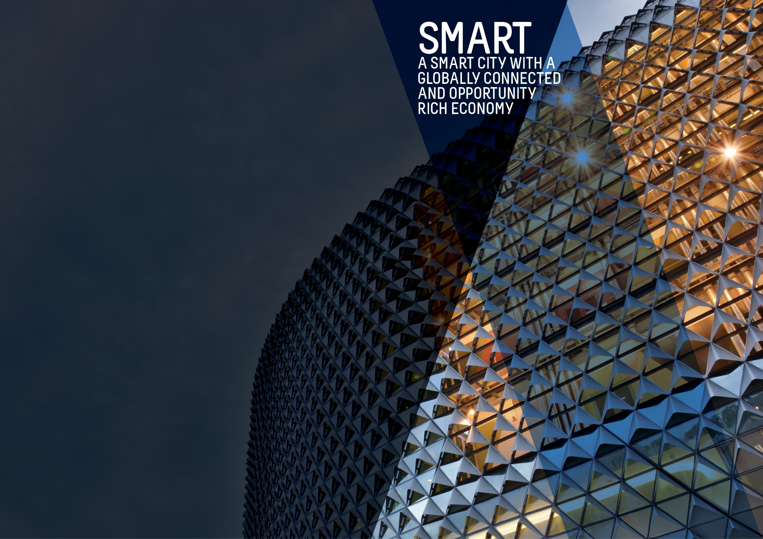
Second Quarter Report 2019-20

OBJECTIVES SUMMARY
The Smart theme has four objectives. Updated data was available for one of the objectives during the quarter.
ACTIONS SUMMARY
Of the 26 actions under Smart, 20 are On Track, two are On Watch, none are Off Track and four are Complete at end Q2 2019-20.

20  ON TRACK |  | 2  ON WATCH |  | 0  OFF TRACK |  | 4  COMPLETE

OBJECTIVE | UPDATE | STATUS
BY 2020, OUR CITY’S ECONOMY WILL BE GROWING FASTER THAN THE AUSTRALIAN ECONOMY | UPDATED In the year to 30 June 2019 the city's economy (GRP) grew by 2.3% to $19.45 billion. In comparison, South Australia's economic growth (GSP) was 1.4% and Australia's economic growth (GDP) was 1.9%  Data source: National Institute of Economic and Industry Research (NIEIR) 2018, presented by economy.id; ABS catalogue 5204.0 - Australian System of National Accounts, 2018-19; ABS catalogue 5220.0 - Australian National Accounts: State Accounts, 2018-19 | BASELINE:  GRP growth 2.4% (June 2014)  GDP growth 2.5% (June 2014)  UPDATE ON OBJECTIVE:  GRP growth 2.3% (Jun 2019)  GDP growth 1.9% (Jun 2019)  NEXT UPDATE: N/A  DIRECTION OF CHANGE: favourable variance
TOTAL BUSINESSES IN THE CITY WILL GROW FROM 5,000 TO OVER 5,300 AND WORKERS ON ANY GIVEN DAY FROM 89,000 TO 94,000 BY 2020 | The number of workers in the city has continued to increase from the baseline figure of 89,000 although at a slower pace compared to previous years. In 2018, there are an estimated 91,500 workers in the city on an average weekday.  Data source: City of Adelaide Census of Land Use and Employment (ACCLUE) 2016; City of Adelaide City User Profile (CUP) Survey 2016; ABS, ‘Regional Population Growth, Australia, 2014-15’ (Cat. No. 3218.0) | BASELINE:  89,000 workers daily (2014)  5,055 city businesses (2014)  UPDATE ON OBJECTIVE:  91,500 workers daily (2018)  5,196 city businesses (2016)  NEXT UPDATE: 2020  DIRECTION OF CHANGE: favourable variance
WORKERS IN PROFESSIONAL AND TECHNICAL SERVICES, EDUCATION, FINANCE, TELECOMMUNICATIONS, CREATIVE AND MEDIA SECTORS WILL HAVE GROWN FROM 41,000 TO OVER 49,000 | The number of workers employed by knowledge sector establishments fell by 12% from 40,279 people to 35,650 and is due to a decline in employment across all the knowledge industries. The largest decrease was in the Professional, Scientific and Technical Services sector (-1,968) and the Information, Media and Telecommunications sector (-1,802). This is likely to be due to the reduction in the city-based Telstra workforce and the reduction/amalgamation of internet service providers (ISPs) since 2014. (Last updated Q2 2016-17)  Data source: City of Adelaide Census of Land Use and Employment (ACCLUE) 2016 | BASELINE:  40,700 workers in knowledge sectors (2014)  UPDATE ON OBJECTIVE:  35,650 workers in knowledge sectors (2016)  NEXT UPDATE: 2020  DIRECTION OF CHANGE: unfavourable variance
BY 2020, THE NUMBER OF STUDENTS IN THE CITY ON ANY GIVEN DAY OF THE WEEK WILL INCREASE FROM 39,000 TO 41,000 | In 2017, there were approximately 43,000 students in the city on an average weekday. This represents a 7.5% decrease from the number of students in 2016 and could be due to the increasing prevalence of online courses and delivery modes that make it easier for students to study off-site. Nevertheless, student numbers of 43,000 continue to exceed the 2014 baseline of 39,200 students in 2014 and the target of 41,000. (Last updated Q4 2017-18)  Data source: City of Adelaide City User Profile (CUP) Survey 2018; ABS, ‘Regional Population Growth, Australia, 2016-17’ (Cat. No. 3218.0) | BASELINE:  39,200 students daily (2014)  UPDATE ON OBJECTIVE:  43,400 students daily (2017)  NEXT UPDATE: 2020  DIRECTION OF CHANGE: favourable variance

ACTION | RESPONSIBLE OFFICER | UPDATE | STATUS
Adopt smart technologies that demonstrate a clear return on investment through new recurring revenue generation models such as; sourcing of external funding, fee for services, data, intellectual property, licensing, proprietary technologies, sharing of services and efficiency dividends | Associate Director, Information Management | An additional metro Council has expressed interest and sought assistance in connecting to CoA. Discussions occurred about a joint collaborative project commencing, once the other Councils involved achieve the necessary prerequisites to connect to CoA, joint project discussions will commence. | oN WATCH
Assist businesses and institutions to attract talent by developing and making available collateral promoting Adelaide as a great place to work and live | Associate Director, Economic Development & Innovation | The Adelaide Investment Prospectus is being updated to support the Lord Mayor's visit to Texas in March 2020. InvestAdelaide.com.au has now transitioned onto City of Adelaide Website which brings with it new functionality. Thirty business stories were developed and promoted on www.investadelaide.com.au and on CoA social media. These stories are a strong generator of website traffic. Continued to maintain ongoing and regular engagement with external agencies and businesses to help industry development opportunities. These included but were not limited to Business SA, Property Council, DTTI, Australian China Business Council, Australian Hotels Association, Defence Teaming Centre and SA Small Business Commissioner. | oN TRACK
Become a world-renowned education City by supporting and partnering with the City’s education sector to attract and retain international, national, regional South Australian and local students, and highly credentialed academic and research staff | Associate Director, Economic Development & Innovation | A City of Adelaide representative attended the quarterly Board meeting in November 2019. CoA funding for Study Adelaide has supported the development of the following activities:  (a) Develop a feasibility case study for the development of a career mentor program for graduates. This follows various discussions and activities to improve international students’ employability and exposure to work opportunities. Case study to be presented at the first Board meeting in 2020  (b) The development of a campaign to promote the benefits of international education. The campaign would provide a narrative to key stakeholder groups outlining economic benefits to the State, investment and efforts made to recruit students and to achieve aggressive targets outlined in International Education 2030 plan.  In December 2019, International education became the number one export for South Australia. In figures released by the ABS, international education was valued at $1.921billion in 2018/19, just beating wine at $1.914billion. The value of this sector grew by another 16% compared to the previous financial year. | oN TRACK
Bring together the creative, arts, business, university, education and entrepreneurial sectors to promote unique opportunities for business growth | Associate Director, Economic Development & Innovation | In Q2 the Business Capability Program continued to deliver a rolling calendar of events involving a range of engagements utilising business associations, business leaders, precinct groups, small-medium enterprises, start-ups and new business migrants.  1) The Ten Gigabit Adelaide team hosted a Christmas event for the businesses using the network (Ten Gigabit Adelaide Community) to maintain business engagement and assist them benefit from the network. The event, which backed onto the Gouger St Party with the Adelaide Rally, was called “Get festive, FAST, with Ten Gigabit Adelaide and V8 Supercar Driver Time Slade”. It provided attendees an opportunity to hear from V8 Supercar Driver, Tim Slade and the inner workings of V8 Supercar Team and how data drives their performance. Preparations for the official launch of the Ten Gigabit Adelaide Community in early 2020 are taking shape.  2) In December the City of Adelaide sponsored the University of Adelaide e-challenge category “Social Enterprise” and delivered a speech positioning City of Adelaide as a city “designed for life” where emerging enterprise has a supportive ecosystem to grow and millennials are encouraged to consider living in the City.  3) In November the City of Adelaide sponsored Southstart – Adelaide’s tech and innovation conference. The three-day event at the Adelaide Convention Centre brought together the creative arts, business, social impact, university and entrepreneurial sectors in a collaborative environment for learning. | oN TRACK
Build upon the growing laneway and entrepreneurial culture in the City by rejuvenating primary laneways and pedestrian connections. Priorities for completion by 2018 will be the Adelaide Railway Station to Adelaide Central Market link and Rundle Mall laneways, including Gawler Place | Associate Director, Planning Design & Development | The Gawler Place upgrade was completed in December 2019. Works in Bentham Street are expected to commence in the first half of 2020. Tavistock Lane upgrade will be undertaken in partnership with Kyren Group in early 2020. Tree planting in Wright Court will be undertaken in the first half of 2020, along with consultation and design work in Field Street upgrades to include changing the street into a one-way street. Design work on the Paxton’s Walk and Vaughan Place Stormwater and Public Realm Upgrade is being undertaken and will be completed in mid-2020 and will include engagement on the concept design with the building owners, strata and Ayres House, including community engagement. | oN TRACK
Implement smart parking technology in selected areas across the City and North Adelaide to move towards an expiation-free environment | Associate Director, Information Management | Smart Parking technology including 'Park Adelaide' app successfully launched on 27 March 2019. Number of Users continues to grow and as at 10 October 2019 there were 15,829 total users; 10,369 registered customers have used the app to locate available parking and make payments; and 5,460 guest customers have used the app to locate available parking bays only.  The Smart Parking project was successfully delivered, and this action is now closed. | Complete
Promote an international city brand that showcases the smart, liveable, green and cultural advantages of Adelaide | Associate Director, Marketing & Communications | Designed for Life campaigns, digital content, collateral and marketing material continues to be produced and distributed by Marketing and Communications. Brand Book, digital assets and other supporting documents currently being produced. New leadership in team has been tasked with greater permeation of the place brand internally within CoA and externally to other Adelaide organisations. | on track
By June 2018, leverage, upgrade and expand our AdelaideFree WiFi network to higher download and upload speeds | Associate Director, Information Management | This Action was reported as complete in Quarter 2 2018-19. | Complete
Review Council’s commercial operations to determine the best management models | Associate Director, Property & Commercial | Draft Needs Analysis for the Adelaide Aquatic Centre complete and currently undertaking community consultation to further inform the analysis and enable it to progress to completion. Services required within the centre and available operating models will be further defined based on the Needs Analysis findings. An Unsolicited Bid process is also progressing which could define future operating models for the Adelaide Aquatic Centre should Council determine it wishes to progress into Stage 3 of the Participation Framework. | ON TRACK
By June 2018, work with key stakeholders in main streets and districts to develop business plans that will provide greater participation at the local level and appropriate governance models, as well as work on projects such as an O’Connell Street enhancement program | Associate Director, Economic Development & Innovation | The City-Wide Business Model Project was presented to Council on 7 November 2019. Following this meeting, Administration has conducted a forum with the seven funded precinct groups and met with the Adelaide Business Collective and Rundle Mall Management Authority. A comprehensive communications strategy is being prepared to keep all stakeholders informed and provide a platform for feedback and suggestions moving forward. | ON TRACK
By June 2020, increase the City’s share of the retail and hospitality sectors and deliver ten new high-end stores and 40 start-up businesses by delivering the ‘Experience Adelaide’ Adelaide City Retail Strategy | Associate Director, Economic Development & Innovation | Using an iterative approach and close interaction with the vendor the SMARTCBD minimum viable product was delivered. Additionally, the data has been represented in visualisations and will be available for sharing via the Economic Insights Dashboard in Q3 2019/20. Reporting on alignment with Retail Strategy outcomes and completion will be fulfilled in Q4 2019/20. | ON WATCH
Council will continue to liaise and work closely with NBN Co in support of the NBN roll-out across the City | Associate Director, Information Management | This Action was reported as complete in Quarter 1 2018-19. | complete
Council will work with key partners to facilitate a 10GB per second capable broadband network across the City and North Adelaide to all premises | Associate Director, Economic Development & Innovation | As at 31 December, TPG are on track to deliver Milestone 6 as per the contract. | on track
Each year increase online open access to meaningful Council-held data and information that empowers residents, visitors, researchers, investors, start-ups and established businesses to make informed, smart decisions | Associate Director, Economic Development & Innovation | The migration of Invest Adelaide website into the new CoA template has been completed. Connection to new data sources has been established and the new visualisations have been built. Current reports on the dashboard have been updated and we are finalising the new reports that will be released during Q3. | on track
Establish single-point-of-contact case managers to support established businesses to grow and attract sustainable businesses, investment and new corporate headquarters to the City | Associate Director, Economic Development & Innovation | The second quarter of the 2018/19 financial year was characterised by a continuing investor interest in Adelaide with also a strong focus on case management aftercare for existing and upcoming major development projects in the CBD. Offshore investors continue to be the main drivers of high value investment transactions in the City (and metro area) both from development and acquisition activity. Confidence in the Adelaide market from national and offshore investors remains strong on the back of continuing growth from the defence, biomed, interactive entertainment, creative digital and the international education sectors. However, ongoing deliberations with the Government land tax provisions have impacted on local investment activity and the levels of inquiry with the City of Adelaide and the commercial property market. There has been engagement with 7 new investment cases of varying scope and stages of development and aftercare processes applying to 13 existing investment cases which include strong liaison with builders and affected stakeholders on the impacts and interface of construction works with local environs. | on track
Facilitate development of the fastest growing sectors, including professional and scientific services, arts and creative industries, by engaging with business leaders to foster collaboration and to assist in identifying and responding to opportunities and challenges | Associate Director, Economic Development & Innovation | A review was undertaken on the format of the Lord Mayor Roundtables and a revised option has been prepared for consideration. Continued to deliver a Business Capability Program with a rolling calendar of events. The events included a mix of hosted, sponsored and supported events which support the success of precinct groups, Small-Medium enterprises, start-ups and new business migrants. Partnering with the Australia China Business Council continued by offering the “China Business Ready" Program. To help businesses maximise the opportunities emerging with the growing Chinese Visitor Economy, CoA based businesses were offered eight workshops and webinars at discounted rates. The Business Advisors (Customer Program) continued to provide information and support to a mix of start-up and established businesses. Contributed to the development of industry led, creative industry sector strategies and worked with industry to integrate these ideas into the South Australian Government’s "Growth State: our plan for prosperity initiative". Attended State Government’s Creative Industry Engagement sessions to assist inform council’s response to their consultation due on 28 February 2020. Developed and promoted a story to promote the success of the Gaming Industry ecosystem in Adelaide. | on track
From 2016 to 2019, increase activity in underutilised premises by providing three years' financial support to Renew Adelaide | Associate Director, Economic Development & Innovation | Renew Adelaide focus was on the East End precinct this quarter, these included placing eyewear designer Coombs and Co at 249 Rundle Street, hot dog vendor Let's Be Frank at 260a Rundle Street, sleepwear fashion label Oosel at 18 Ebenezer Place, and fashion collaborative “202 Collective” opening in Rundle Mall. The precinct also saw Retro Room, a mid-century furniture retailer, graduate onto a commercial lease at 18 East Terrace. Other new businesses that are opening include Star Blaze, a nostalgic and retro collectables retailer, and Flaming Arrow, a creative arts production studio. | on track
Promote opportunities and develop projects to showcase the City’s unique heritage and character as a catalyst for sustainable growth and to grow the heritage tourism market | Associate Director, Economic Development & Innovation | Built Heritage Management Promotion program tasks are well underway. These tasks include, but not limited to, sponsorship of the Modernism and Modernist SA Architecture 1934-1977 exhibition which was co-curated by Phillips/Pilkington Architects and the Architecture Museum at the University of South Australia, the build and soft launch of the online heritage places database on the City of Adelaide’s website, the filming of three adaptive reuse of heritage places case studies and the photographic survey of the City of Adelaide’s heritage listed places.  The City of Adelaide was also confirmed to once again be a major sponsor of the South Australian History Festival in 2020. | on track
Pursue a definitive outcome for the future of the former Royal Adelaide Hospital site as a world class precinct that complements the Park Lands, North Terrace cultural precinct and the East End commercial precinct | Associate Director, Planning Design & Development | This Action was reported as complete in Quarter 3 2017-18. | complete
Showcase the City as the location of choice for international and national trade and investment, especially for the knowledge, arts and cultural sectors, through our sister cities and other partnerships and connections, and align with State Government economic targets for increasing foreign investment, service exports and skilled migration | Associate Director, Economic Development & Innovation | The International Engagement Plan has been completed as a draft, pending final edits to be completed following the adoption of the City of Adelaide Strategic Plan 2020-2024. This will ensure alignment with Councils’ new strategic objectives and the plan will serve as a delivering mechanism. | on track
Strengthen relationship with Study Adelaide via continued support from 2016 to 2020 to market Adelaide as an international student destination | Associate Director, Economic Development & Innovation | CoA continues to work with StudyAdelaide to develop initiatives and programs that promote Adelaide as a destination to study and live. StudyAdelaide has discussed with CoA the opportunity to create a “Campus Tour Product Development” program in conjunction with Flinders University and UniSA. The program would deliver a custom itinerary for potential international students and their families to holiday in South Australia and undertake tours of University campuses, city tourism experiences and information presented on living and studying in Adelaide. University of Adelaide will also be approached to seek interest. | on track
Support development of the clean technology sector through a range of programs, services, initiatives and data, including supporting start-up and growth of new businesses and working with universities to assist with commercialising research and intellectual property for clean-tech applications | Associate Director, Economic Development & Innovation | Supported the implementation of the Low Carbon Council Road Map. Promoted the City of Adelaide Sustainability Incentives and Building Upgrade Finance Program to businesses as per the Market Development Plan (being developed by the Sustainability Program). The Sustainability Program are also partnering with the Property Council to deliver a boardroom lunch scheduled to be hosted by the Lord Mayor on 5 February 2020. Successfully attracted Fohat (Brazilian Micro-grid Energy trading platform) R&D facilities to SA with the company CEO now residing in Adelaide CBD. | on track
Transform our services and business processes to improve our effectiveness and efficiency and provide improved quality communications, including having all Council forms able to be submitted online by 2018 and all development applications able to be submitted online by 2020 | Associate Director, Customer & People | The draft Temporary Use of Public Space Policy was endorsed by Council in December for public consultation. This Policy will supersede multiple outdated policies and set the platform for further simplification of permit classifications, fees and processes. | on track
Provide input to future innovation-related initiatives on Lot Fourteen to influence best possible economic outcomes for the city | Associate Director, Economic Development & Innovation | Continued presence of Innovate Adelaide at Lot Fourteen, with increasing activity with State Government regarding roles and responsibilities between the two with small business out-growing/not landing in Lot Fourteen.  As a result of attending a delegation visit to Massachusetts Institute of Technology (MIT) in November 2019, MOUs have been drafted between CoA & MIT (re Adelaide Living Lab) and CoA & Berklee (re Open Music Initiative). Outcomes will include CoA having access to the MIT Living Lab at Lot Fourteen and an opportunity to collaborate on economic development research projects. CoA’s collaboration with the Open Music Initiative will complement Adelaide’s UNESCO City of Music status and demonstrate a commitment to impactful innovation in the creative industries. | on track
Work with our local and global partners through a range of projects and initiatives to build on the city-wide culture of entrepreneurship, start-ups and the commercialisation of research and ideas | Associate Director, Economic Development & Innovation | The Innovate Adelaide team is established and operational, with a strategy in place for the next twelve months and a plan established. A 3-5 year plan forward is being drafted. | on track
Work with partners to develop and implement a range of policies, programs and services to support business start-ups, business growth and business sustainability | Associate Director, Economic Development & Innovation | Continued to deliver Business Capability Program with a rolling calendar of events incorporating various levels of business engagement such as business associations, business leaders, precinct groups, Small-Medium enterprises, start-ups and new business migrants.  Continued to work closely with the Ten Gigabit Adelaide team to capitalise on investment attraction and opportunities to build business capability. To help value add to the network and those connected, we are shaping a Ten Gigabit Adelaide Community to maximise the project investment and the new network capacity. The value of this concept has been tested with the first 100 businesses connected to the network. Information captured confirms their interest. To maintain businesses engagement and the opportunity Ten Gigabit Adelaide offers we hosted a Christmas function which backed onto the Gouger St Party with the Adelaide Rally which was called “Get festive, FAST, with Ten Gigabit Adelaide and V8 Supercar Driver Time Slade” where attendees had an exclusive opportunity to hear from V8 Supercar Driver, Tim Slade and the inner workings of a V8 Supercar Team and how data drives their performance. Currently preparations are underway to launch the Ten Gigabit Adelaide Community officially in early 2020. The community will receive information and access to the latest data applications, services and opportunities via a variety of high-quality social events and unique networking opportunities. In the interest of supporting and fostering young Entrepreneurship in the City, the City of Adelaide sponsored the University of Adelaide e-challenge category “Social Enterprise” in December and delivered a speech positioning City of Adelaide as a city “designed for life” where emerging enterprise has the supportive ecosystem to grow | on track

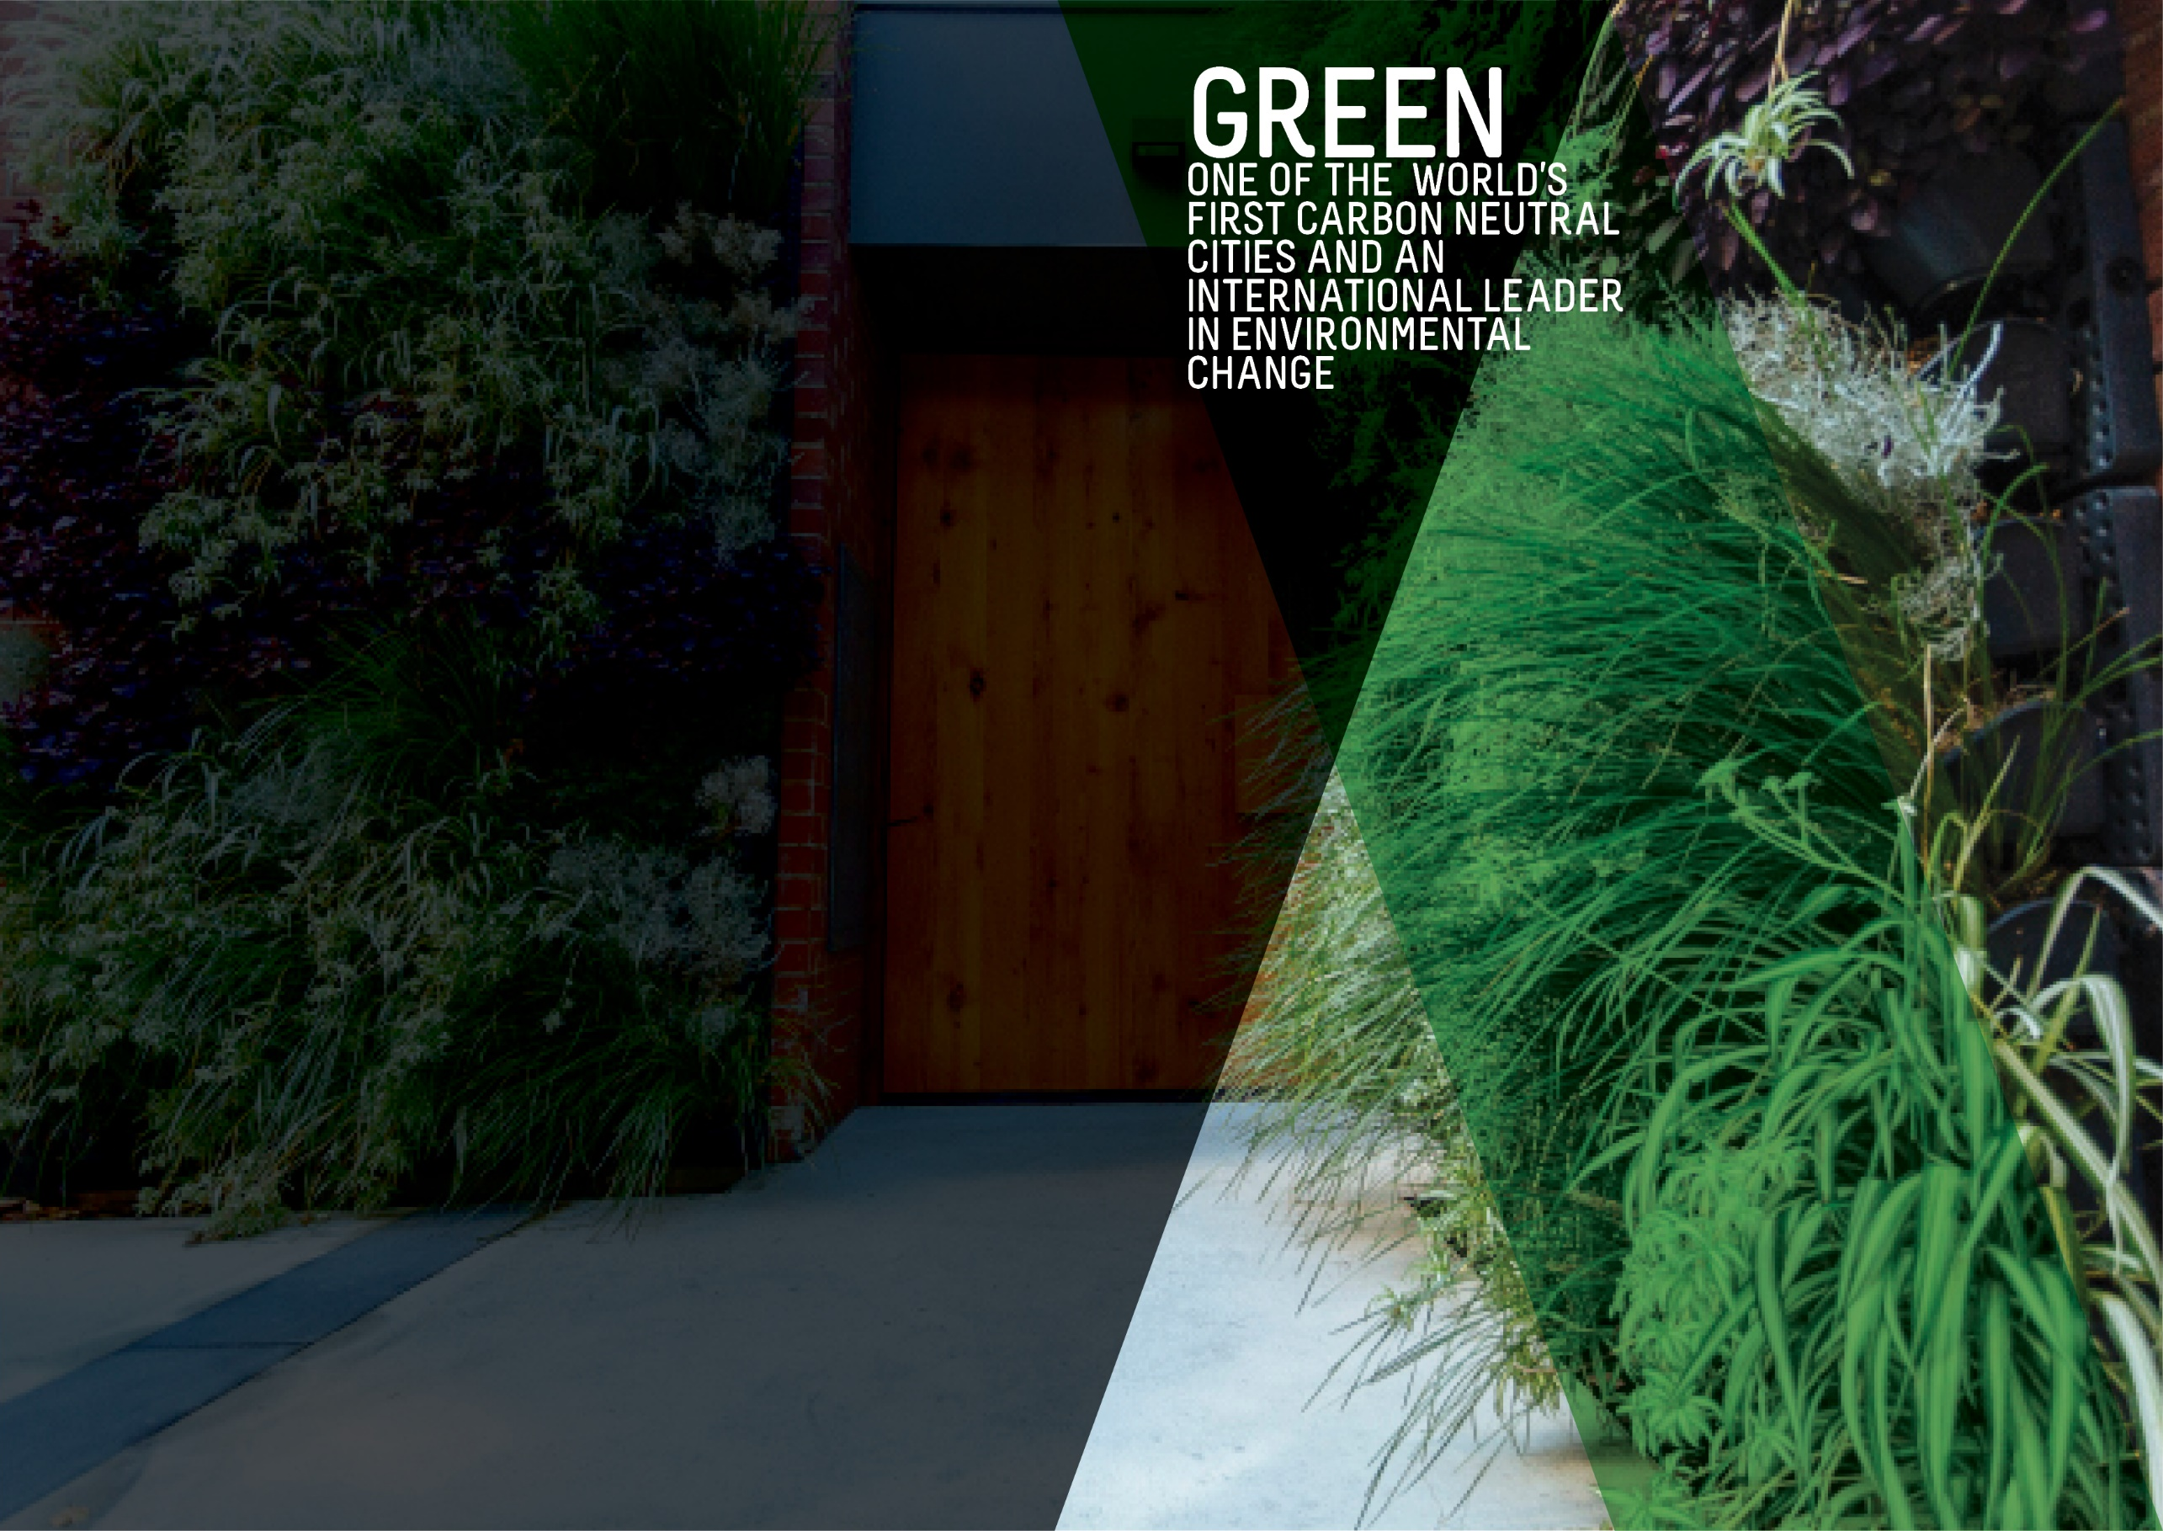
OBJECTIVES SUMMARY
The Green theme has five objectives. The commentary for three of the objectives has been updated this quarter.
ACTIONS SUMMARY
Of the 28 actions under Green, 21 are On Track, one is On Watch, none are Off Track and six are Complete at end Q2 2019-20.

21  ON TRACK |  | 1  ON WATCH |  | 0  OFF TRACK |  | 6  COMPLETE

OBJECTIVE | UPDATE | STATUS
CITY CARBON EMISSIONS WILL BE REDUCED BY 35% FROM THE 2006-07 BASELINE BY 2020 | UPDATED The greenhouse gas emissions inventories for the City of Adelaide community were finalised for Financial Years 2016 and 2017 and updated for Financial Years 2007 (base year), 2014 and 2015 to ensure consistency with the latest calculation methodologies and were reported to Council. This has shown a 15% emissions reduction achieved between 2007 and 2017.  The overall reduction in emissions has been driven by a 37% reduction in stationary energy emissions, that is, emissions associated with the consumption of purchased electricity and natural gas. This demonstrates a decoupling of City of Adelaide community GHG emissions from the City of Adelaide Gross Regional Product which has increased by 35% over the same period. (Last updated Q3 2017-18)  The Community GHG Emissions Inventory will next be calculated for FY 2019-20 (and reported in 2020/21) to align with external reporting requirements. Data source: City of Adelaide Community GHG Emissions Inventory  Data source: City of Adelaide Community GHG Emissions Inventory | BASELINE:  1,148 kt CO2-e (2006-07)*  UPDATE ON OBJECTIVE:  976 CO2-e (2016-17)  NEXT UPDATE: FY 2020-21  DIRECTION OF CHANGE: favourable variance  * Revised from 1,175 kt CO2-e to ensure consistency with the latest calculation methodology
GREEN SPACE AND GREENERY IN THE BUILT-UP AREAS OF THE CITY WILL HAVE INCREASED BY 100,000 METRES BY 2020 | The baseline figure for green space and greenery comes from the Green Infrastructure Benchmark Data and Mapping project undertaken in 2015. Total green coverage is calculated by adding the total pervious area (total area minus total impervious area) to the area of tree canopy cover in built-up areas within the City. The built-up area of the City is the entirety of the City of Adelaide area minus the Park Lands  Data source: City of Adelaide | BASELINE:  1,241,777.11 (2015)  UPDATE ON OBJECTIVE:  Not available  NEXT UPDATE: 2020  DIRECTION OF CHANGE: not applicable
BY 2020, AQUATIC NATIVE PLANTS ON THE TORRENS LAKE FLOOR WILL HAVE INCREASED FROM ALMOST ZERO TO 7,500 SQUARE METRES | UPDATED Planting aquatic plants on the Torrens Lake floor was found to not be successful. A Torrens Lake Wetlands project is being investigated to install in-line wetlands to increase aquatic vegetation to help improve water quality, amenity, river health and provide a new recreational offering in the area.  Data source: City of Adelaide | BASELINE:  Almost zero (2015)  UPDATE ON OBJECTIVE:  Not available  NEXT UPDATE: Late 2020  DIRECTION OF CHANGE: not applicable
A DETAILED MEASURE OF REDUCTION IN KERBSIDE AND GENERAL WASTE WILL HAVE BEEN DEVELOPED AND INFLUENCES OUR WORK | Council currently tracks kerbside waste and the proportion of recyclables. The scope of a suitable measure for kerbside and general waste reduction is being considered. Council has seen a small increase in waste going to landfill over the last 12 months because of providing waste services to an increasing number of medium to high density dwellings. | BASELINE:  To be determined  UPDATE ON OBJECTIVE:  Not available  NEXT UPDATE: TBA  DIRECTION OF CHANGE: not applicable
A COMPREHENSIVE INTEGRATED WATER MANAGEMENT MEASURE WILL HAVE BEEN DEVELOPED AND INFLUENCES OUR WORK | UPDATED CoA is developing a Water Sensitive City Transition Plan. A water sensitive city is a liveable, climate ready city which uses a diverse range of fit for purpose water resources and infrastructure. CoA is running a series of internal and community capacity building activities to enable us to transition our operations and processes from business as usual to water sensitive. | BASELINE:  To be determined  UPDATE ON OBJECTIVE:  Not available  NEXT UPDATE: TBA  DIRECTION OF CHANGE: not applicable

ACTION | RESPONSIBLE OFFICER | UPDATE | STATUS
Achieve adoption of sustainable commercial practices through incentives, purchasing approaches, waste services and regulation | Associate Director, Sustainability | No update as no activity was planned for Quarter 2. | ON TRACK
By 2020, Council’s New Year’s Event will send zero-waste to landfill and by 2018, clear guidelines will be developed for organisers of larger community events in Council-operated areas to achieve zero-waste and carbon neutrality | Associate Director, Sustainability | Using the City of Adelaide’s Sustainable Event Guidelines, NYE 2019 showed leadership in reducing waste, energy and water, encouraging active transport and inspiring sustainable choices. Event actions taken include:  - Promoting sustainable messaging throughout the event campaign and on the night  - SA Fire appeal fundraising  - Being plastic straw and balloon free  - Using compostable food and drink packaging  - Encouraging patrons to bring reusable containers and drink bottles  - Providing multiple waste streams for patrons and vendors  - Reducing cable-tie use and recycling any necessary cable ties  - Reusing event signage and trialling new recyclable signage  - Contracting local entertainers to provide children’s activities that produce no landfill material and encourage interaction with nature  - Engaging audiences with roving waste education performers  - Educating the audience with waste warrior volunteers who assisted patrons with waste education  - Providing free water refill stations for the audience, staff and artists  - Encouraging active and public transport.  These sustainable actions delivered the following outcomes:  - 74% of materials (by volume) were diverted from landfill and fewer materials than previous years were sent to landfill  - Of the diverted materials:  - 25% of materials were composted locally; double the 2018 amount  - 36% of materials were recycled with specialty recycling for cable-ties  Overall weights of all waste materials decreased significantly, around half of previous years. The City of Adelaide embraced the opportunity to engage skilled and passionate volunteers to assist the community by providing help in the information stand and waste education. Thirty-one volunteers generously gave their time; a 55% increase from 2018 and 4 of these were repeat NYE volunteers. Surveys at the event revealed that our community is progressive, committed to embedding positive, sustainable change, and that sustainable events are highly valued. | on track
By 2025, working with City waste collectors, all Council serviced premises will have their landfill, recycling and green waste collection measured and reported to Council, with the data to be available online to the premises' occupant | Associate Director, Public Realm | The Council Solution's waste services procurement process is on track to commence in July 2020. Final discussions for the transition are also underway with the new contractor. The technology provided by the new contractor will provide capability for us to further pursue this initiative. | on track
By December 2020, increase our efficient use of recycled water from the GAP scheme in Council-irrigated areas by 25% to an overall level of 80% | Associate Director, Infrastructure | This Action was reported as complete in Quarter 1 2019-20. | COMPLETE
By December 2017, complete a procurement plan for all Council vehicles to be low or zero emissions | Associate Director, Public Realm | This Action was reported as complete in Quarter 3 2017-18. | COMPLETE
Council will have developed a Green City Plan detailing Council’s contribution to greening the city and showing activities with aligned annual targets, including an additional 1,500 trees in the built-up areas of the City by June 2020 | Associate Director, Sustainability | Data collection is underway to ensure that the space is available for tree planting. This includes service surveys and other physical restrictions; traffic surveys; detailed engineering surveys and design for impacts to stormwater. | ON TRACK
By June 2019, our procurement practices will reasonably require the environmental track record and/or credentials of suppliers, and estimates of carbon emissions of products and services | Associate Director, Sustainability | The review of the procurement policy and guidelines has commenced, which incorporates sustainability. Material procurement categories have been identified. The total for CoA’s Scope 3 emissions for 2018/19 is 10,971 tCO2e, with 1,444 tCO2e from Category 1: Purchased goods and services (including water, paper, catering, IT, chlorine and fertilisers). | ON TRACK
By June 2020, all Council-owned and maintained public lighting will be converted to LED lights and smart lighting wherever possible | Associate Director, Infrastructure | The tender request for supply and installation of this year's LED Replacement Program is out to market for the delivery of the LED conversion - focussing on North Adelaide in 2019/20. Twenty-six additional streets are planned to be upgraded to LED streetlighting by June 2020. | ON TRACK
By June 2020, the energy requirement for all Council buildings will be sourced from low carbon or renewable energy sources | Associate Director, Sustainability | A 9.5year Power Purchase Agreement for renewable electricity for all City of Adelaide operations has been executed with the successful tenderer and will commence in 2020. The project will deliver emissions reductions of over 50% of operational greenhouse gas emissions and provide cost savings. | ON TRACK
Continue the development of a waste, Recycling and Reuse approach for the City, together with an implementation plan, that meets the needs of our residents, businesses and visitors, and utilises smart technology | Associate Director, Sustainability | The results of the City of Adelaide Waste Audits were presented to Council Committee and feedback was sought. Feedback gathered will be used to inform the direction of the waste programs (where opportunities have been identified) as well as the Waste and Recycling Management Strategy. | on track
Commit through to June 2020 to continue the Sustainable City Incentives Scheme, with annual reviews of incentive funding budget allocations | Associate Director, Sustainability | A major review of the SIS was completed in Q4 2018/19, considering technology and market developments, including falling technology prices and the emergence of other programs and rebates. Following the review, Council approved the recommended changes to the SIS to be implemented from July 2019.  FY2018/19 Outcomes:  • 127 approved applications  • $295,000 of rebates provided  • Catalysed over $2.7 million of community investment in the City of Adelaide  • Leveraged $9.14 for every $1 spent  FY19/20 Q1 & Q2 Outcomes:  • 52 approved applications  • $126,000 of rebates provided  • Catalysed over $818,000 of community investment in the City of Adelaide  • Leveraged $6.49 for every $1 spent | on track
Continue to work with the State Government and other councils to reduce stormwater and other pollutants into the Torrens River catchment | Associate Director, Sustainability | Torrens Lake Rehabilitation Assessment was finalised and a report was provided to Council on Option 2 - Wetlands. Investigations into progressing Option 2 (Wetlands) has commenced. City of Adelaide continues to partner with the State Government on River Torrens Governance Project (ongoing) and River Torrens Water Quality Improvement Project (on-going). Feedback was provided to the Department of Environment and Water on its proposed governance model for the River Torrens. Carp removal and a survey of carp population density in the River Torrens was completed. | on track
Develop international trade, investment and tourism opportunities based on our green and clean reputation | Associate Director, Economic Development & Innovation | Promoted CoA green credentials via the creation and promotion of news stories. These covered investments made by businesses and projects Council is undertaking to activate green investment opportunities. Supported multiple investment leads which can support the growth of a CoA green economy. Maintained a working relationship with DTTI to foster lead development and ways to leverage Council’s Sustainability Incentives and its commitment to being Carbon Neutral and waste minimisation policies. Supported and informed the Sustainability Team in the promotion of Building Upgrade Finance. | on track
Enhance biodiversity in the Park Lands and strengthen the role of the Park Lands in achieving a carbon neutral City | Associate Director, Sustainability | The planting of 300 native species appropriate for a River Red Gum Woodland as part of the Tainmuntilla (Park 11) Restoration Project is now complete. The priority listed woody weed tree removal has now been completed along Tainmuntilla (Park 11) in partnership with Botanic Gardens. This Action is now complete. | COMPLETE
Facilitate the reuse and recycling of equipment, consumables and materials used in festivals and events in the City | Associate Director, Community & Culture | NYE 2019 was our most sustainable NYE event to date. Areas of focus were reduction in single use plastic on site via the single use plastic straw ban, provision of quench benches, compostable packing requirements placed on all food vendors, a team of 31 volunteers who assisted with sustainability (waste) education and information and with the correct disposal of waste on site with multiple streams for source separation and litter sweeps to reduce bundled waste and litter. | on track
From 2016, collaborate with City-based businesses, interest groups and the education sector through a series of Lord Mayor summits and forums to build partnerships that promote environmental issues and broader innovations | Associate Director, Sustainability | City of Adelaide hosted the Carbon Neutral Adelaide Biannual Awards and the CitySwitch Green Office Program Awards. An Electric Vehicle (EV) Fleet Managers Forum to coincide with the World Solar Car Challenge was also held. | on track
From 2016, Council will commit ongoing funding for powerline undergrounding (PLEC) to assist with greening initiatives | Associate Director, Infrastructure | The PLEC project on Jeffcott Street has reached Practical Completion with all overhead powerlines now undergrounded. All property connections complete and public lighting installed. Council will continue to apply for PLEC funding as appropriate. | on track
Identify opportunities for building adaptation and re-use that supports heritage aspirations while reducing carbon emissions and waste | Associate Director, Sustainability | The City of Adelaide continued to offer Building Upgrade Finance for environmental and heritage upgrades in the City of Adelaide. Agreement with the Property Council of South Australia was reached to hold a forum on Building Upgrade Finance in the city. | on track
Improve energy performance and use of renewable energy in Council and privately-owned buildings, including consideration of solar heating, solar energy generation and battery storage | Associate Director, Sustainability | Installation of solar PV on Adelaide Aquatic Centre, Adelaide Town Hall, UPark Topham and UPark Pirie/Flinders has been completed and commissioned. | on track
Improve the ecological value of watercourses and biodiversity in the Park Lands | Associate Director, Sustainability | The Biodiversity Monitoring Framework and the final Fauna Survey under the Integrated Biodiversity Management Plan have been completed. Implementation of Biodiversity Monitoring Framework, including partnership to monitor Chequered Copper Butterflies with Butterfly Conservation SA is ongoing. | on track
Partner with the State Government to implement a Carbon Neutral Adelaide Partnership Framework to pursue the shared aspiration for Adelaide to be the world’s first carbon neutral city | Associate Director, Sustainability | Carbon Neutral Adelaide Awards were held on 13 November 2019, at the U City building, a landmark 6-Star Green Star building. Winners were Enerven (Partner of the year, Low Carbon Economy Award), Downer EDI (Applied Innovation), SUHO (Leadership and Influence), and Jamie and Nick (Low Carbon Lifestyle). Other finalists included Allume Energy & Suntrix, Christie Walk, Fonzarelli, Finsbury Green, MyCar, Womadelaide, for their diverse contributions to our city’s transition to a low carbon economy. The awards were presented by the Minister for Environment and Water, David Speirs, and the Lord Mayor Sandy Verschoor. The Electric Vehicle Forum for Business was held on Monday 22 October, as a component of the Carbon Neutral Adelaide program. Around 100 people attended who have roles related to fleet management in government and private sector. Speakers shared information about total cost of ownership models, case studies of EV in business and new commercial vehicles entering the markets, and there were 13 different models of passenger and commercial vehicles available on display and for test drives.  This Action is now complete. | COMPLETE
Provide a range of incentives for the use of electric-powered and low-emission vehicles within the City | Associate Director, Sustainability | The City of Adelaide supported the Electrikana 'Come and try' event in the City that was held alongside the World Solar Car Challenge. An Electric Vehicle Forum was held for fleet managers where around 100 guests heard case studies, vehicle market insights and total cost of ownership considerations for electric vehicles. More than 12 models of cars were on display and available for test drives. This Action is now complete. | COMPLETE
Reduce storm water run-off and pollution into the Torrens River through integrated catchment management and water sensitive urban design | Associate Director, Infrastructure | Brown Hill Keswick Creek (BHKC) Stormwater Project, realignment to assist in water management – Council will continue to fund our share of the BHKC project as our commitment to integrated catchment management and Water Sensitive Urban Design (WSUD). | on track
Work with all City stakeholders to increase public and private greening with street trees, gardens, community gardens, green walls and roofs providing incentives where appropriate | Associate Director, Planning Design & Development | Adelaide Design Manual - Greening technical standards are being finalised. Greening design for Grote Street upgrade to be included in tender for construction in March. Traffic and engineering survey planned for March to confirm impacts to residential streets. Ongoing liaison with community groups to finalise acquittals of green city grant funding. | on track
Work with Federal and State governments to provide appropriate infrastructure and promote sustainable transport options, such as public transport, cycling and walking, to improve the experience of commuters and reduce transport-related carbon emissions | Associate Director, Planning Design & Development | The City Access Strategy Working Group is underway overseeing communication and engagement strategy for commencement in February.  Whitmore Square Safety Improvements detail design tender is closing 14 January 2020. | on track
Work with local communities on public greening activities that will beautify streets and parks | Associate Director, Community & Culture | This Action was reported as completed in Quarter 1 2019-20. | COMPLETE
Work with partners to reduce mains water use through water sensitive urban design and increasing the use of recycled and reused water | Associate Director, Sustainability | The Smart Water Meter Project to deliver water meters at eight CoA sites to help identify opportunities to reduce potable water use, identify leaks and diversify supplies for non-drinking purposes has now been completed. The development of a Water Sensitive Urban Design (WSUD) Map for the CoA has been completed. | on track
Work with private property owners and the State Government to embed better environmental performance into new and existing developments | Associate Director, Planning Design & Development | The draft Planning & Design Code has been released for consultation by the State Planning Commission until 28 February 2020. Staff are currently preparing a response for council to consider before consultation closes. The draft response will review how the Code transfers across existing policy from the Development Plan into the new code and opportunities for improvement in environmental outcomes of development. | on WATCH

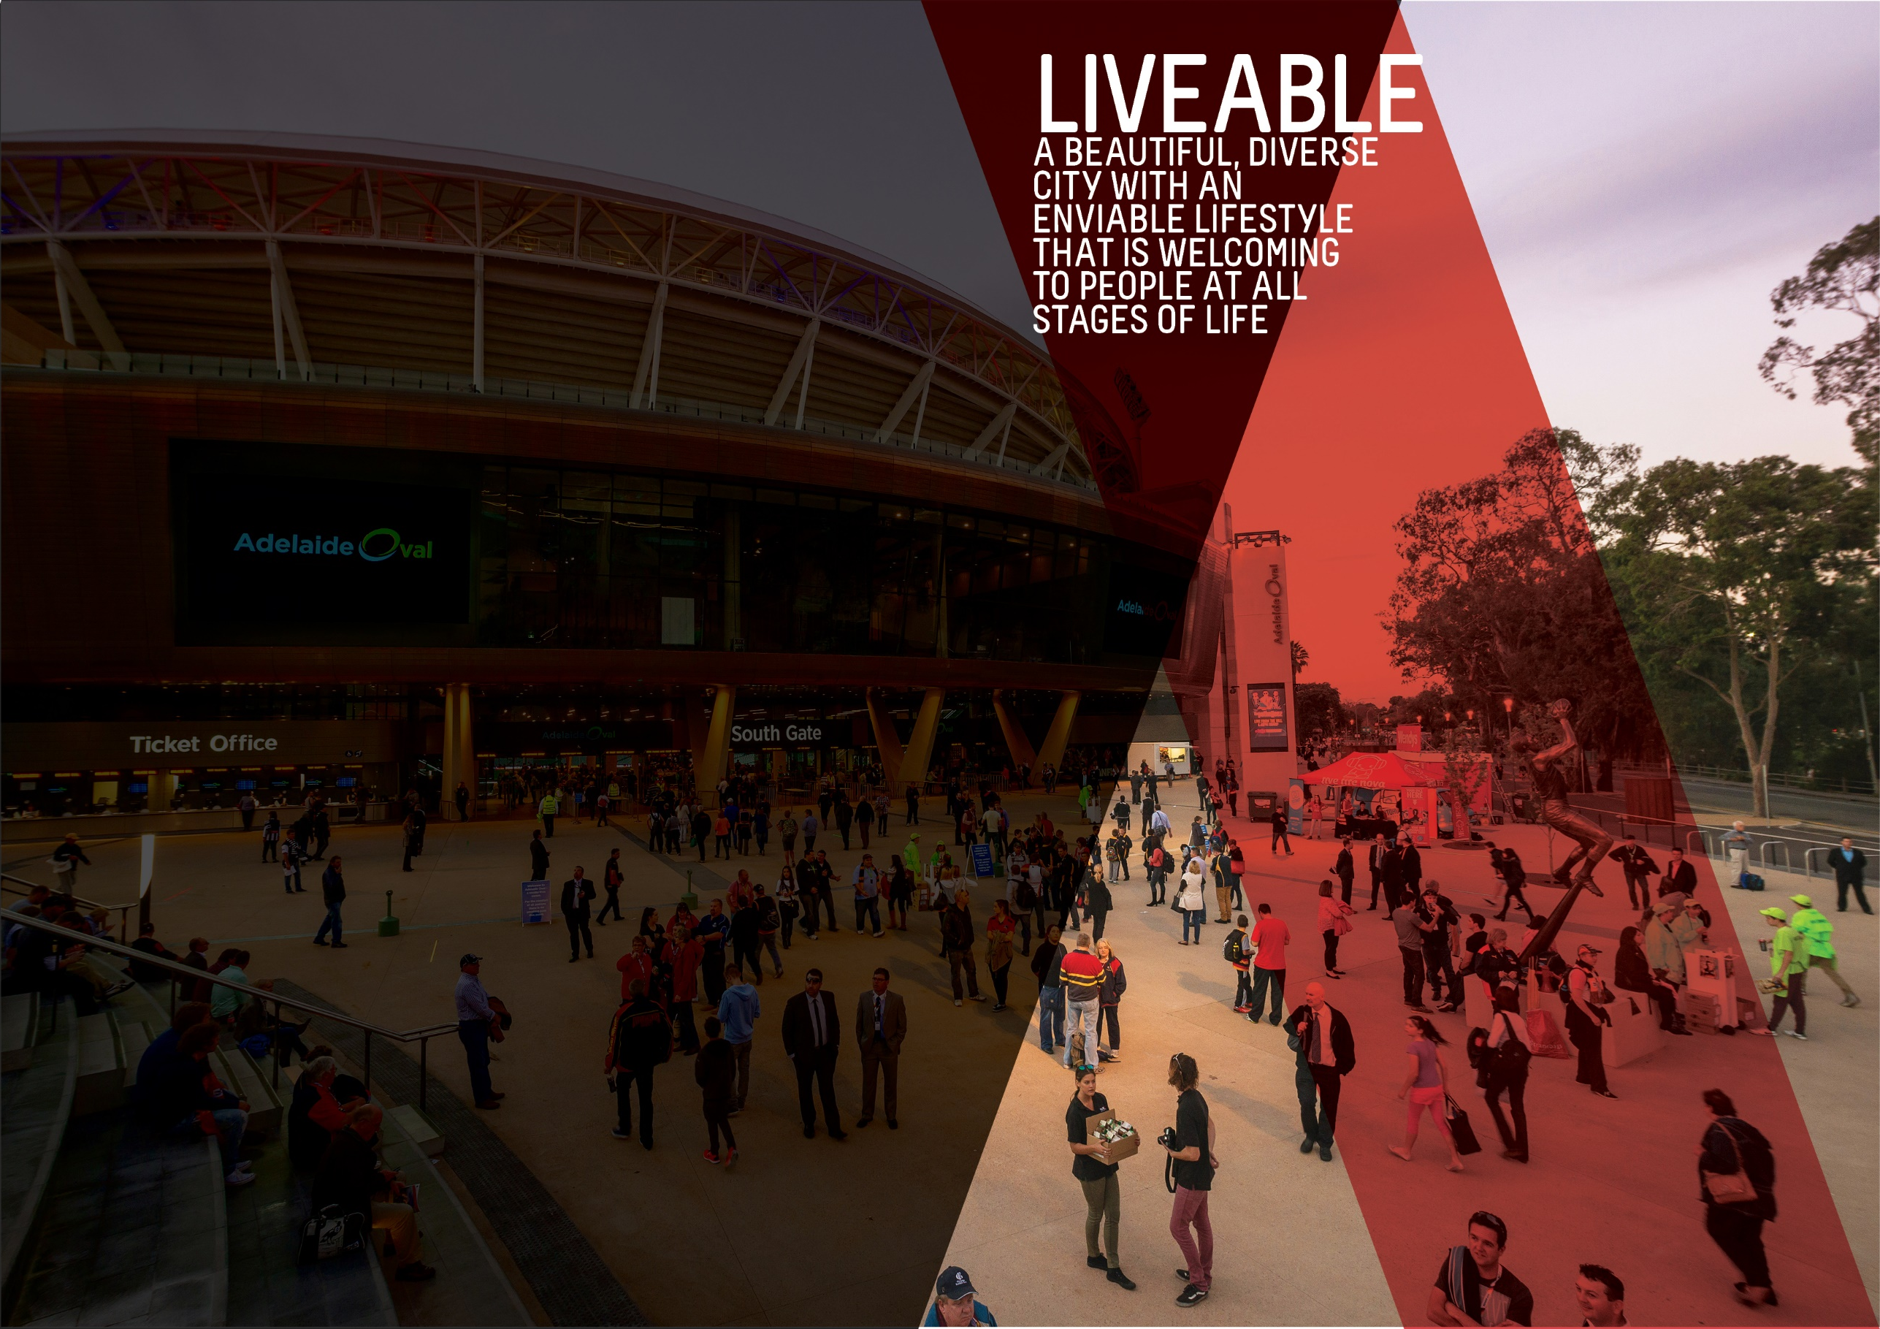

OBJECTIVES SUMMARY
The Liveable theme has three objectives. Updated data was not available for any of the objectives in the quarter.
ACTIONS SUMMARY
Of the 24 actions under Liveable, 19 are On Track, one is On Watch, none are Off Track and four are Complete at end Q2 2019-20.

19  ON TRACK |  | 1  ON WATCH |  | 0  OFF TRACK |  | 4  COMPLETE

OBJECTIVE | UPDATE | STATUS
THE NUMBER OF PEOPLE LIVING IN THE CITY WILL HAVE GROWN FROM 23,000 TO 28,000 BY 2020 | As at June 2018, the estimated resident population (ERP) of the city was 24,794 persons. This is 2.3% higher than the previous year and 10.0% higher than the baseline year of 2014. Population growth in the city continues to outpace the State's population growth. Between June 2017 and June 2018, population growth across South Australia increased by 0.58%.  Data source: ABS, ‘Regional Population Growth, Australia, 2017-18 (Cat. No. 3218.0) | BASELINE:  22,539 (ERP June 2014)  UPDATE ON OBJECTIVE:  24,794 (ERP June 2018)  NEXT UPDATE: Mid 2020  DIRECTION OF CHANGE: favourable variance
ADELAIDE WILL BE LISTED IN THE TOP THREE MOST LIVEABLE CITIES IN THE WORLD BY 2020 | For the second year in a row Adelaide was ranked 10th in the Economist Intelligence Unit’s (EIU) Global Liveability rankings.  According to the latest EIU results, Adelaide’s overall rating score was 96.6 (unchanged from 2018).  Of the five categories of liveability assessed by the EIU measure, Adelaide continued to score lowest (94.2/100) in the area of culture and environment, which includes factors such as sporting availability, cultural availability and food and drink, and its highest scores (a perfect 100 for each) in the education and healthcare categories. The EIU liveability rankings relate to the entirety of Adelaide and not specifically to the City of Adelaide. (Last updated Q1 2019-20)  Data source: Economist Intelligence Unit, Global Liveability Ranking 2019 | BASELINE:  Ranked 5th (2015)  UPDATE ON OBJECTIVE:  Ranked 10th (2019)  NEXT UPDATE: Not applicable  DIRECTION OF CHANGE: unfavourable variance
CITY OF ADELAIDE RESIDENTS WILL HAVE WELLBEING ABOVE THE GLOBAL AVERAGE | During Quarter 2 2017-18, Council endorsed a change to the wellbeing objective from “A nation leading wellbeing and resilience measure will be applied and influences our work’ to ‘City of Adelaide residents will have wellbeing above global average”. This wording reflects the outcome of the PERMA+ survey undertaken with South Australian Health & Medical Research Institute (SAHMRI) in 2016 to contribute to the development of a baseline for residents’ wellbeing. It also reflects the focus of Council’s work to maintain resident wellbeing above the global average as articulated in the City of Adelaide’s Wellbeing Roadmap. | BASELINE:  PERMA+ score of 7.2 (September 2016)  UPDATE ON OBJECTIVE:  Not available  NEXT UPDATE: Late 2020  DIRECTION OF CHANGE: not applicable

ACTION | RESPONSIBLE OFFICER | UPDATE | STATUS
Advocate for an urban growth boundary that limits urban sprawl and promotes the City as the commercial, cultural, residential and social heart of metropolitan Adelaide | Associate Director, Planning Design & Development | This Action was reported as complete in Quarter 1 2017-18. | complete
Advocate to the Federal and State governments for changes in housing taxation and levies to reduce the cost of housing, including an extension of the State government's 'Off-the-Plan Stamp Duty Concession’ for apartments | Associate Director, Economic Development & Innovation | On 22 October 2019, Council resolved to prepare a policy on social and affordable housing. As part of the policy development, consideration will be given to all levers (including advocacy) that could be actioned by Council to influence the delivery of more affordable housing in the City. It is proposed that the Policy will be finalised mid-2020. | on track
By 2020, commence works on the Central Market Arcade redevelopment | Associate Director, Property & Commercial | Launch of the Central Market Arcade Redevelopment and associated signing of the Project Delivery Agreement with ICD Property was undertaken on 6 December 2019. Key stakeholders were updated following project launch with associated communications through on-site information, website, social media and media release. Design development process underway. | on track
By June 2020, develop an Adelaide 2040 Plan to achieve long-term economic, environmental, social and cultural goals, incorporating a spatial and transport plan for the City and Park Lands | Strategy, Planning & Partnerships | This Action was reported as complete in Quarter 4 2018-19. | COMPLETE
Create world class infrastructure by adopting a three-year rolling capital works program for the City and Park Lands to ensure all new and existing infrastructure are delivered and maintained to high quality standards, incorporating universal access, technology, heritage, arts and green elements. | Associate Director, Infrastructure | We have a 3-year rolling program, which is considered as part of the Integrated Business Plan (IBP) planning process and is presented to Committee/Council for consideration and adoption prior to the new financial year. This Action is now complete. | COMPLETE
Deliver Council’s core services efficiently and with brilliant customer service for a growing and increasingly diverse and multicultural community | Associate Director, People & Customer | The consolidated service directory and cost of service model was shared with Council at an informal gathering on 26 October 2019. Following that, a prioritisation model has been developed to identify services for review by conducting a high level opportunity analysis of each service, highlighting those services which may provide value or efficiency opportunities if reviewed. | on TRACK
Deliver sport and recreation activity hubs consistent with the Active City Strategy and Adelaide Park Lands Management Strategy | Associate Director, Community & Culture | This quarter a revised Concept Plan for Golden Wattle Park and a revised chapter of the applicable Community Land Management Plan was supported by the Adelaide Park Lands Authority. A design contract was awarded for the new City Skate Park in Gladys Elphick Park and community and stakeholder engagement was undertaken to inform the development of a Concept Plan. | on TRACK
Develop and celebrate strong and resilient City communities that are welcoming and encourage people of all ages, cultures and means to participate in City life, including through volunteer opportunities | Associate Director, Community & Culture | A total of 973 hours and 249 trips were delivered to CoA residents through CHSP in home services. A community led SALA exhibition was held at the Adelaide South West Community Centre. Council participated in Zestfest, offering market tasting and forest bathing experiences, and Mental Health Week with Tai Chi at the North Adelaide Community Centre. 332 volunteers are registered with CoA from diverse cultural backgrounds and age groups. The NYE sustainability education role attracted 32 volunteers, with 60% under the age of 30 and 85% born in countries other than Australia. The Community Resilience Leaders program attracted 22 volunteers, with 30% being under the age of 30 and 60% born in a country other than Australia. The Access and Inclusion Advisory Panel met in December with a site visit of Rymill Park to discuss the Masterplan and Quentin Kenihan Inclusive Playspace case study. An Emergency Preparedness awareness campaign was run with a focus on heatwaves. Educational activities with partners from SES were held at Council locations. 27 Community Resilience Leaders have been recruited and begun their training in emergency preparedness and resilience. Three engagement sessions were held with multicultural community groups and service providers to determine how Council can support community groups to thrive in the City. A report to Council endorsed the allocation of $25,000 to further explore key themes, continue engagement with the community and identify further activity for 20/21. Integration of the Social Infrastructure Audit with City Plan project was commenced in this quarter. Over 5,000 people attended Library programs, including the History Hub run photograph scanning and archiving training, and hosted programs including the State Records of South Australia historical stories from SA Railway’s employee history sheets. Feast Festival 2019 was celebrated through workshops, seminars and an exhibition by gay, disabled fibre artist Richard Boyle AKA The Gay Hooker. Through the Lens photography exhibition, delivered in partnership with Office for the Ageing, celebrated the skills of older South Australians and promoted active ageing. Female Archetypes, delivered in partnership with the Adelaide Festival Centre, featured iconic costumes from the Performing Arts Collection. History Hub display 'Adelaide On The Town' showcased objects and photographs of moments of celebration and enjoyment in the City from the Archives. Music in the Library program featured local artists Steve Lennox, Jen Lush, L.R. Marsh and Richard Coates. Activities for National Nutrition Week included education and engagement with nutritionists from Flinders University. Fusion Cafe at the Adelaide Aquatic Centre was supported in implementing changes to offer healthier choices. Mental Health Week 2019 included a Festival of Now event in Light Square/Wauwe, in partnership with Mental Health Coalition SA, that attracted 750 people, and Thinking Outside the Box social event at the Box Factory Community Centre, which was developed by young people and attracted around 50 young people and local residents for a variety of activities. A Lord Mayor's Christmas Lunch, a City of Adelaide Suffrage 125 Honor Roll and a feature in Adelaide Living celebrated the 125th Anniversary of Women's Suffrage in SA. The Community Development Grants Program received 12 enquiries for Minor Grant funding in Round 2, with five grants receiving funding. $84,990 worth of Quick Response and Minor Grants have been approved with $50,788 remaining for future round applications. | on TRACK
Encourage City living by understanding the demand drivers and developing a distinctive City living promotion campaign that builds on the Already Home campaign | Associate Director, Economic Development & Innovation | Stage 2 of the City Living Campaign was delivered throughout September and October 2019. Components include outdoor screens, billboards, commuter screens, Google search & display ads, social and digital media. A post campaign report for the Stage 2 campaign burst (September/October) has been analysed and informed the approach for the Stage 3 City Living campaign burst in February/March 2020. A City Living video was delivered in December 2019 as part of Stage 3 and is being screened at the Adelaide International Tennis event and will continue to be used throughout February/March. | on track
Encourage growth in the full range of residential property development in a mixed-use environment in a manner that respects the human scale and different characters of districts in the City | Associate Director, Economic Development & Innovation | Council endorsed the preparation of a social and affordable housing policy on 22 October 2019. Alternative housing delivery models may be identified as part of this work. In addition, progress has been made on the apartment development activity dashboard via Pathway and PowerBi. A working draft is available for internal use and ongoing refinement, subject to budget. The apartment development activity dashboard will assist in monitoring and analysing the types of residential development occurring in the City with the view to assisting with market analysis and policy development. | on track
Encourage the State Government to improve public transport to promote greater patronage, including continued investment and expansion of the free City Connector Services | Associate Director, Planning Design & Development | The City Access Strategy is underway - information is currently being collated and analysed with engagement due to commence in early 2020. The strategy is due to be completed in mid-2020. Improvements to public transport will be considered during the City Access Strategy, as part of delivering a fully integrated network approach for all travel modes within the city. | on track
Enhance the role of the Park Lands in increasing levels of physical activity and wellbeing through formal and informal sport and recreation opportunities | Associate Director, Community & Culture | The Recreation and Sport Grants Program saw two Community Programs, five Quick Response and two Community Facilities grant applicants receive funding.  The Draft Golf Links Master Plan is currently under review. Golf trends are being reviewed to identify positive trends and maximise visitation via a staged implementation of the master plan. | on WATCH
Explore opportunities in Council’s current property holdings and pursue strategic opportunities to lead or partner in future property developments | Associate Director, Property & Commercial | Strategic Property Review outcomes including assessment approach, city shaping activities and key short-term opportunities presented to Elected Members at an informal session in late October 2019. Consultant report in the process of being finalised for presentation to Elected Members.  Council endorsed a proponent to progress into the 88 O'Connell Street Stage 3 of the RFDP process. The Administration will work with the proponent to finalise the Heads of Agreement design requirements as requested by Council and to progress the Development Agreement prior to the State Government requirement (May 2020) as per the funding deed arrangement. | on track
In partnership with the State Government, explore the possibility of redeveloping Currie-Grenfell streets as a public transport boulevard to cater for increased demand | Associate Director, Planning Design & Development | The City Access Strategy is underway - information is currently being collated and analysed with engagement due to commence in early 2020. The strategy is due to be completed in mid-2020. The future development of the Currie-Grenfell corridor as a public transport boulevard will be considered during the City Access Strategy, as part of delivering a fully integrated network approach for all travel modes within the city. | on track
Increase participation by the broadest range of residents in the community life of their neighbourhood | Associate Director, Community & Culture | The Community Centres are continuously responding to ideas from the local community and this past quarter have directly responded to requests for more sustainable workshops and initiatives in local neighbourhoods. The Adelaide South West Community Centre hosted a seasonal low waste gift and wrapping workshop that had 13 people in attendance including seven young people through partnering from Headspace, and the Centre has become a host for two community-based recycling initiatives. The Box Factory Community Centre ran a children’s paper Christmas tree workshop using recycled materials that had over 20 children and parents attending, and staff have been actively exploring the idea of community composting alongside community. Finally, North Adelaide Community Centre staff have been working with KESAB to develop an exciting “Circular Economy” recycling and waste bus tour for City and North Adelaide residents. | on track
Plan and deliver priority walking and cycling routes throughout and beyond the City and Park Lands, including the provision of East-West and North-South cycleways and connections | Associate Director, Planning Design & Development | The North-South Bikeway is progressing as planned, with two sections of shared path in North Adelaide (Parks 6 and 12) completed in November 2019. Planning for the next stages is progressing:  - Detailed design work for Brougham Gardens shared path is underway.  - Negotiations are underway with third-party developers to plan the first phase of construction for the Frome Street (North Tce-Rundle St) section.  The City Access Strategy is underway - initial information collation has commenced and engagement with stakeholders and the wider community will occur in early 2020. Completion of the strategy is expected in mid-2020. | ON TRACK
Plan and seek partnerships for major City infrastructure projects, including cycling corridors, major transport routes and laneways | Associate Director, Planning Design & Development | The City Access Strategy is underway, in partnership with DPTI. Communication and engagement plans will commence in February 2020.  Smart Move Implementation Plan outcomes including traffic and pedestrian movement data to be completed in February to inform the City Access Strategy. | on track
Promote and protect Adelaide’s built character and heritage through our operations, incentives, policies and direct investment, while working with and advocating to Federal and State governments for an increase in City buildings protected under State or Local Heritage regulations | Associate Director, Planning Design & Development | A draft Council Heritage Strategy and Action Plan was endorsed for consultation by Council on 19 November 2019. Consultation will occur in early 2020 with the intent to present a final strategy and action plan to Council for adoption in April/May 2020. The delivery of the 2019/2020 Heritage Promotion Plan has delivered new case studies on re-use of heritage places and has in progress a photographic survey of all heritage places in the City of Adelaide (around 2500 places). | on track
Support social entrepreneurs to develop business models that have a positive impact on the City’s wellbeing and resilience | Associate Director, Community & Culture | This Action was reported as complete in Quarter 2 2018-19. | complete
Work with neighbouring councils and the State Government to enhance the facilities, attractions, landscapes and movement networks in the Park Lands to meet the needs and expectations of growing high-density communities living in and near the City | Associate Director, Planning Design & Development | The City Access Strategy is underway - information is currently being collated and analysed with engagement due to commence in early 2020. The strategy is due to be completed in mid-2020. The future development of movement networks in the Park Lands to meet the needs and expectations of the growing high-density communities in adjacent suburbs will be considered during the City Access Strategy, as part of delivering a fully integrated network approach for all travel modes within the city. | on track
Work with the community and other stakeholders through a range of initiatives to activate key areas to enable people to use the City safely and seek to reduce crime | Associate Director, Community & Culture | A series of conversations with young people from universities and City-based schools were conducted to inform a co-design process for developing ‘Welcoming Spaces for Young People’. In December Council endorsed improvements to lighting and the development of a CCTV rebate scheme in response to community concern raised with Council about safety in the Chinatown and Market District. A thorough review of safety in the area was conducted including trader consultation, an audit with perceptions of day and night safety with Chinatown representatives and a technical lighting audit. Four AEDs from inside the Community Centres and Hutt Street Library were moved to nearby locations in December to provide 24/7 resident access. | on track
Work with the State and Federal governments and other councils through the Mayors for AdeLINK advocacy group to engage with local communities to progress an integrated light rail network across the City’s key precincts, with key connections to inner city suburbs | Associate Director, Planning Design & Development | The City Access Strategy is underway - information is currently being collated and analysed with engagement due to commence in early 2020. The strategy is due to be completed in mid-2020. The future development of the light rail network in the city will be considered during the City Access Strategy, as part of delivering a fully integrated network approach for all travel modes within the city. | on track
Work with the State Government to address housing affordability, including diversity of dwelling stock, and deliver a range of initiatives such as adaptive building re-use and new building technologies | Associate Director, Economic Development & Innovation | The report on "Social & Affordable Housing in the City" was considered by Committee on 15 October 2019. An amended recommendation was adopted by Council on 22 October 2019 which supported the preparation of a social and affordable housing policy but removed reference to undertaking additional research. A Project Team and preliminary timeline has been established to deliver the Policy and the first Project Team meeting is scheduled for early February 2020. | on track
Work with the State Government, community leaders and community organisations to support vulnerable members of the community | Associate Director, Community & Culture | Delivered Homeless and Vulnerable People Project by ensuring that City-based social services are made aware of people at risk/experiencing homelessness in the public realm and working with to achieve the best outcome. The CoA Quick Guide to Homelessness Services in the City was updated with information on available social services for people at risk/experiencing homelessness. Participation in Mental Health Week ‘Festival of Now’ event, distributing information on community centres functions and events. The Adelaide Zero Project continues to deliver outcomes of the strategic partnership. Council has allocated further funds to support work that is being developed through the Project Steering Group: a business case for an Inner City Services Hub including stronger coordination of services; and to increase the responses to Aboriginal mobility into the City of Adelaide and support for groups of Aboriginal people who use public spaces. | on track

OBJECTIVES SUMMARY
The Creative theme has five objectives. Updated data was available for one of the objectives in the quarter.
ACTIONS SUMMARY
Of the 32 actions under Creative, 23 are On Track, three are On Watch, none are Off Track and six are Complete at end Q2 2019-20.

23  ON TRACK |  | 3  ON WATCH |  | 0  OFF TRACK |  | 6  COMPLETE

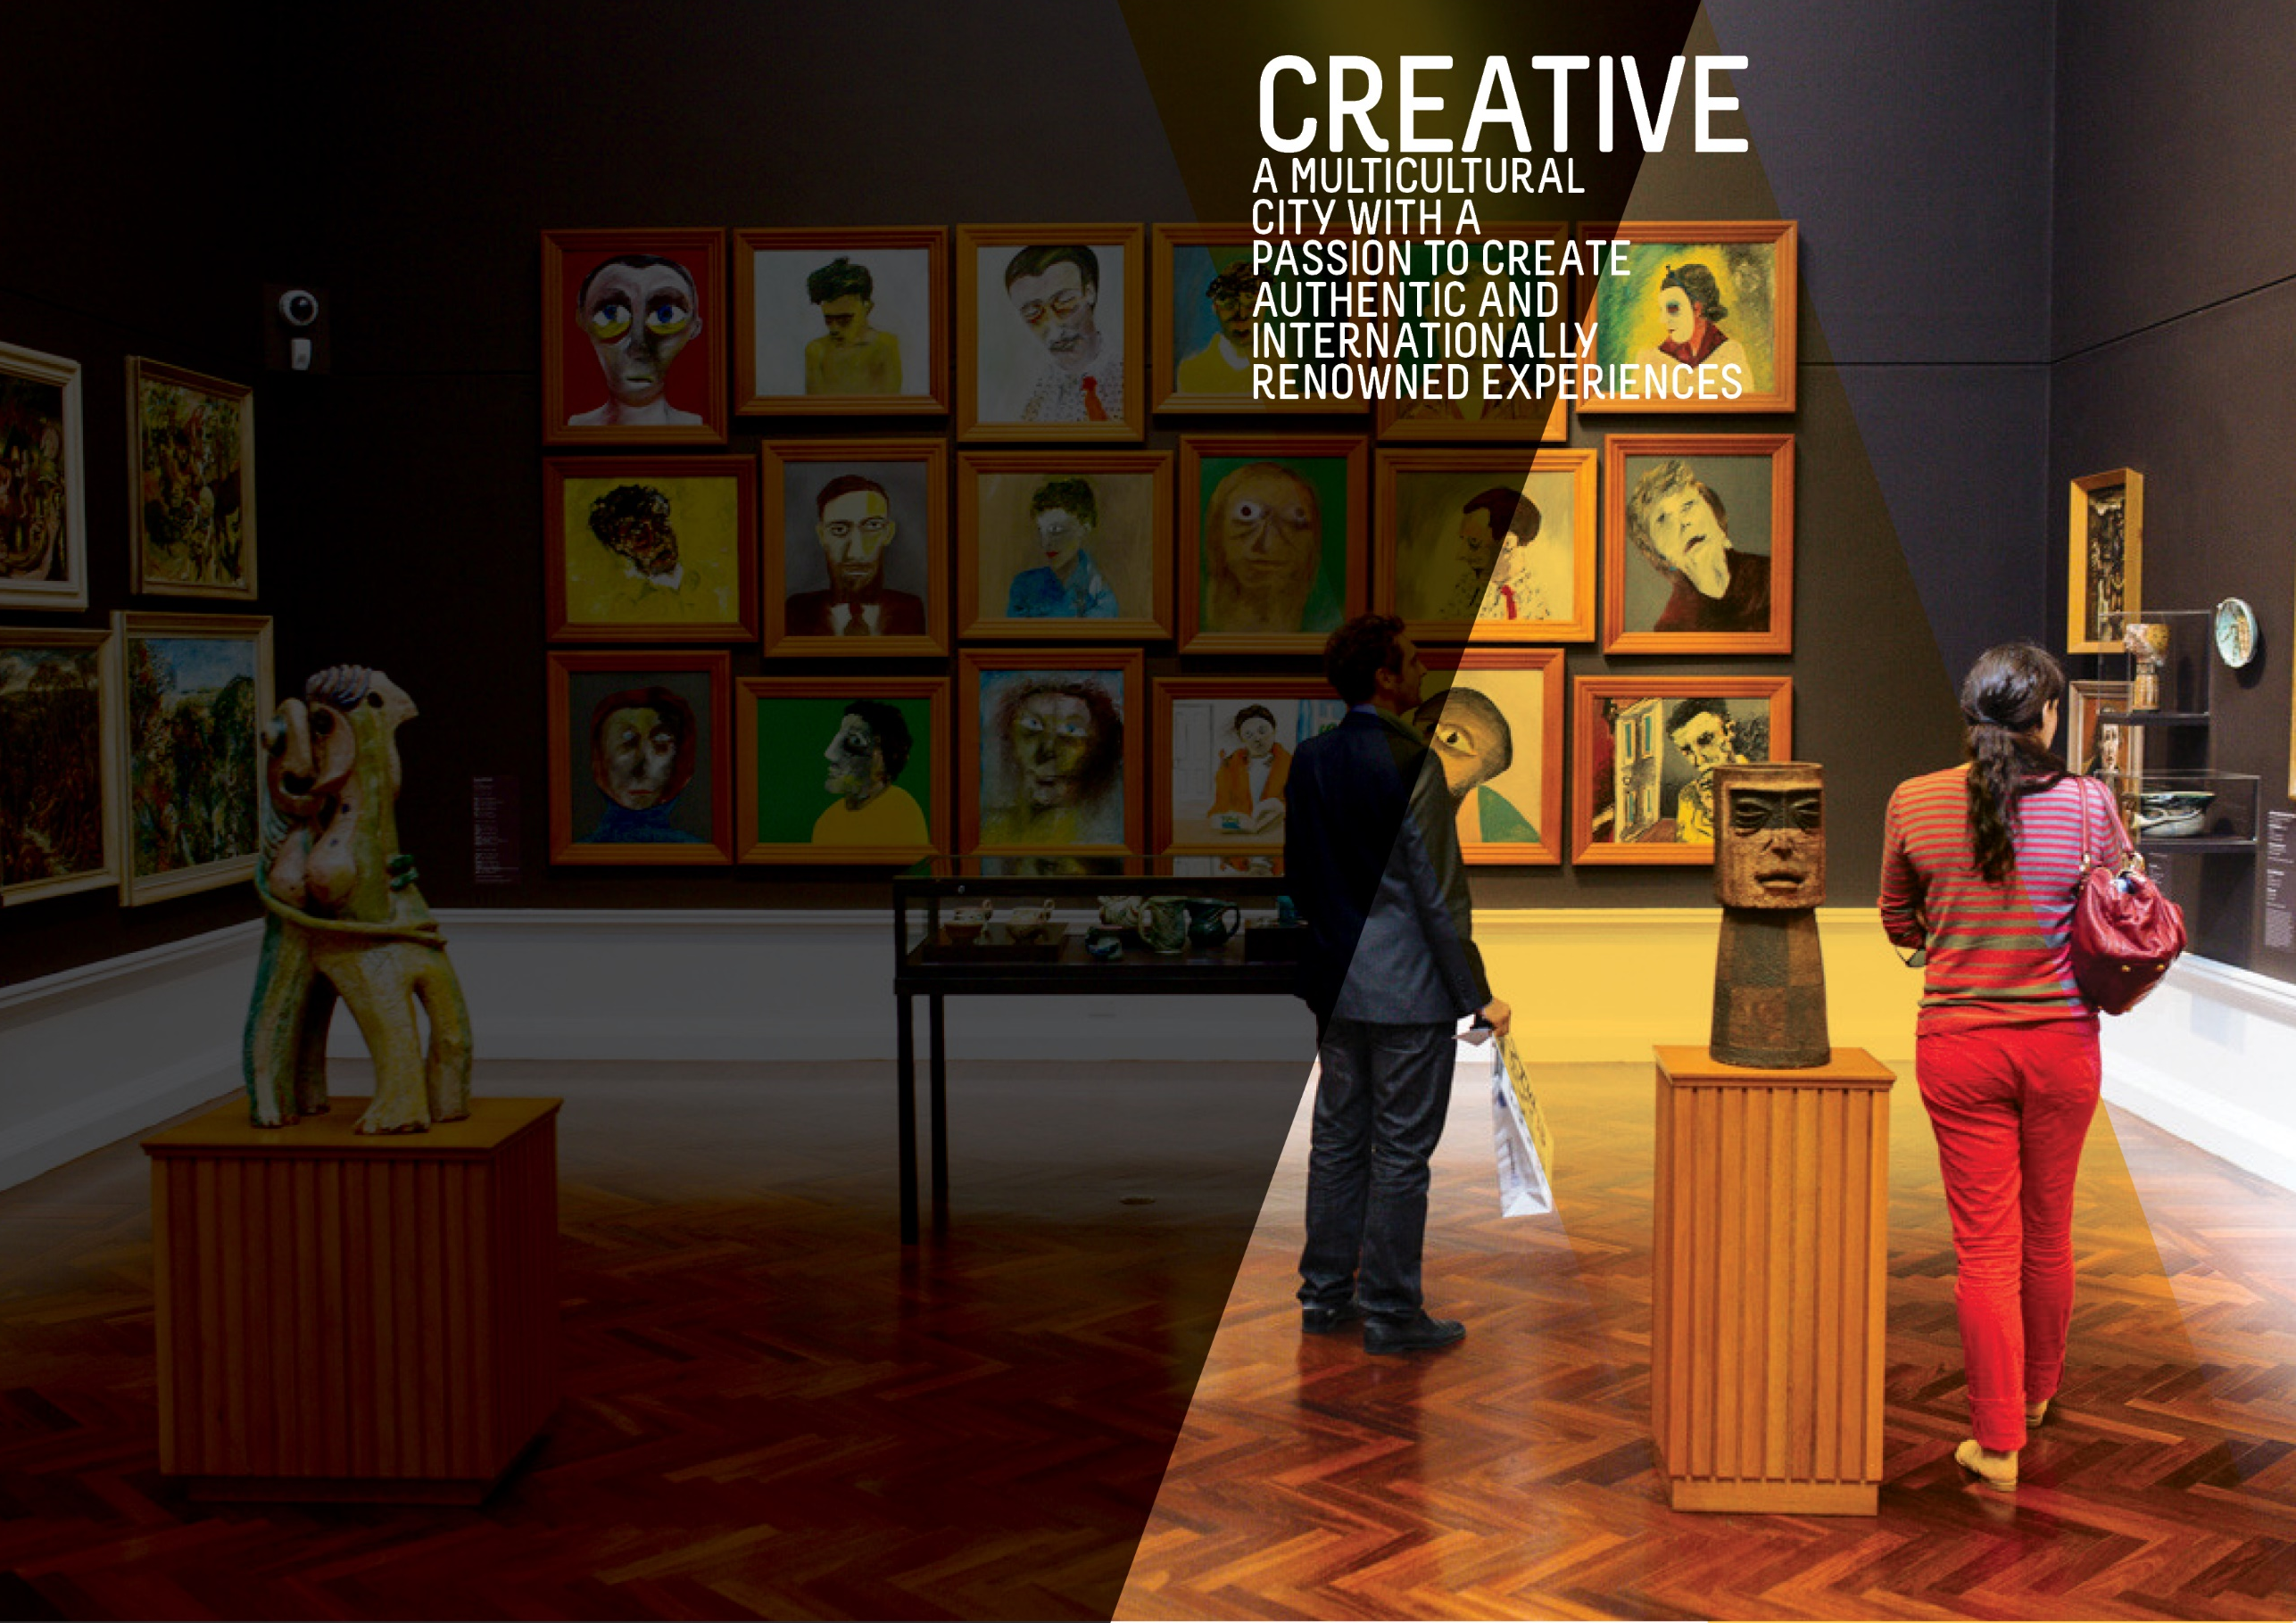

OBJECTIVE | UPDATE | STATUS
ATTENDANCE AT FESTIVALS AND EVENTS IN THE CITY AND PARK LANDS WILL HAVE GROWN BY 5% BY 2020 | According to the latest event attendance figures available, there were an estimated 6.77 million attendances at festivals and events in the city in 2018-19 (averaged over two years). This represents a growth of 20.4% or 1.15million attendances from the baseline.  The latest increase has been driven by a markedly greater attendance figure for the Adelaide Fringe Festival 2019. (Last updated Q1 2019-20)  Data source: City of Adelaide; Adelaide Oval Stadium Management Authority | BASELINE:  5.62 million attendances  (average of 2013-14 and 2014-15)  UPDATE ON OBJECTIVE:  6.77 million attendances  (average of 2017-18 and 2018-19)  NEXT UPDATE: Not applicable  DIRECTION OF CHANGE: favourable variance
A DETAILED MEASURE OF THE NUMBER OF PEOPLE CREATING AND ACTIVELY PARTICIPATING IN ARTS AND CULTURAL ACTIVITIES WILL HAVE BEEN DEVELOPED AND INFLUENCES OUR WORK | This measure captures the level of active participation in arts and cultural activities in the city. The data is collected through the City of Adelaide's annual City User Profile (CUP) Survey, which asks city users (people who are in the City on the day of the survey) whether they had actively participated in any of a specified range of activities in the city in the preceding 12 months. These activities include creating music, participating in a theatre/dance/ performance/event, parade or show, visual arts and craft and creative writing and is based on the Australian Council of Arts definition of active participation.  The 2019 CUP Survey found that the number of city users who actively participated in arts and cultural activities remained at 15%. This is lower than the level of participation recorded in 2017 (18%) and is also marginally lower than the baseline level of 16% in 2016. (Last updated Q4 2018-19)  Data source: City of Adelaide City User Profile (CUP) Survey 2019 | BASELINE:  16% (2016)  UPDATE ON OBJECTIVE:  15% (2019)  NEXT UPDATE: Not applicable  DIRECTION OF CHANGE: unfavourable variance
BED NIGHTS SPENT IN ADELAIDE BY INTERNATIONAL AND DOMESTIC VISITORS WILL HAVE GROWN FROM 8.1 MILLION TO 9 MILLION BY 2020 | UPDATED In the year to June 2019, the number of international and domestic visitor nights spent in the city pushed 9.85 million and is 3.0% higher than the same time last year. The number of visitor nights to the city has increased from the baseline figure of 8.1 million and continues to exceed the target of 9 million visitor nights.  The growth over the year was driven by a higher number of domestic visitor nights, which increased by 20.5%. In comparison, international visitor nights fell by 17.7% during the same period.  Data source: Tourism Research Australia, unpublished data | BASELINE:  8.059 million (June 2014)  UPDATE ON OBJECTIVE:  9.849 million (year to June 2019)  NEXT UPDATE: Not applicable  DIRECTION OF CHANGE: favourable variance
PEOPLE WHO SAY THE CITY HAS GREAT PLACES TO ENJOY EVENTS, ACTIVITIES, ART AND CULTURE WILL HAVE GROWN FROM 8.4 TO 9 OUT OF 10 BY 2020 | The results of the 2019 City User Profile (CUP) survey show that the rating out of 10 for agreement with this statement is 8.0. This is lower than the 8.3 recorded in 2018 and lower than the baseline figure of 8.4 recorded in 2015. (Last updated Q4 2018-19)  Data source: City of Adelaide City User Profile (CUP) Survey 2019 | BASELINE:  8.4/10 (2015)  UPDATE ON OBJECTIVE:  8.0/10 (2019)  NEXT UPDATE: August 2020  DIRECTION OF CHANGE: Unfavourable variance
THE NUMBER OF PEOPLE THAT ARE VISITING THE CITY EACH DAY FOR SHOPPING, LEISURE OR ENTERTAINMENT WILL HAVE GROWN FROM 111,000 TO 117,000 BY 2020 | The number of people visiting the City each day for these purposes continues to increase and has exceeded the target of 117,000 by 2020. In 2018, there were an estimated 156,900 people in the City for shopping, leisure or entertainment on an average weekday. (Last updated Q4 2017-18)  Data source: City of Adelaide | BASELINE:  111,141 (2014)  UPDATE ON OBJECTIVE:  156,900 (2018)  NEXT UPDATE: Early 2020  DIRECTION OF CHANGE: Favourable variance

ACTION | RESPONSIBLE OFFICER | UPDATE | STATUS
Advocate for the interstate rail station to be relocated back to the Adelaide Railway Station to capitalise on the iconic Indian Pacific, Ghan and Overland rail services | Associate Director, Planning Design & Development | The City Access Strategy is underway - information is currently being collated and analysed with engagement due to commence in early 2020. The strategy is due to be completed in mid-2020. The future location of the interstate rail station will be considered during the City Access Strategy, as part of delivering a fully integrated network approach for all travel modes within the city. | ON TRACK
Attract and support artists and cultural entrepreneurs to develop commercial opportunities | Associate Director, Community & Culture | The Splash Adelaide season for 2019/20 opened on 3 October 2019 with the launch of a refreshed logo, new website and the introduction of the Splash Adelaide Ideas Hub. The Ideas Hub visited 88 O'Connell Street, Hindmarsh Square, Hutt Street, Light Square, Whitmore Square and Victoria Square, and offered the community an opportunity to share their ideas for the City with the Splash Adelaide Team. In total, over 250 ideas have been shared with the Splash Adelaide team to date. These ideas will be reviewed in early 2020 and a number of projects will be selected to roll-out as the year progresses.  36 East End businesses participated in Vogue Festival 2019 on 18-19 October with a special in-store experience and/or shopping offer. The on-street experience included live music, social moments as part of an Instagram competition, a Sparkling Oyster Bar outside Eros Kafe, a pop-up party in Ebenezer Place including local fashion market stalls and twilight markets delivered by the Belgian Beer Cafe. Additionally, a ticketed Q&A for emerging designers with Paul Vasileff of Paolo Sebastian was held at Chateau Apollo as well as a special screening of fashion film "McQueen" at Palace Nova.  Lighting of the Christmas Tree and Christmas Lights, Festive Nights ten-day activation was delivered successfully with significant increases in attendance and positive feedback received. Post event reporting and analysis is being undertaken in late January 2020.  A program of events and activities have continued to be delivered on 88 O’Connell Street this year, which has seen approximately 31,000 people visit the site. Events included support for Stage 1 of the Tour Down Under, the History month installation, numerous school holiday activities, Halloween movie night and most recently the Christmas Markets and movies.  The Business of Being Creative (TBOBC) 2019 cohort continues to be supported by collaborative partners Carclew, Flinders University New Venture Institute and Guildhouse. The Helpmann Academy sought applications for its Elevate Mentorship Program, four places are directly funded by TBOBC. Partner and participant highlights, outcomes, and reflections are now being sought to inform the next iteration of the program. | ON TRACK
Attract people from around the world, especially from China and India, to spend more time and experience more hospitality activities in the City | Associate Director, Economic Development & Innovation | During Q2 the Visitor Growth team, through the International Relations unit, coordinated the following activities with Sister City partners – Qingdao, Jinan, Austin, Christchurch:  • Associate Director and International Relations & Engagement Advisor participated in a SA Government led delegation to a Sister State conference in Jinan, Shandong. The delegation attended a Trade Expo which included SA producers and exhibitors.  • Following the visit to Jinan the team travelled to Qingdao to attend the Qingdao International Friendship cities conference to represent the City of Adelaide and attended an Import Expo, ceremonial activities and presentations. Further meetings were held with Qingdao Red Lions Football Club, Qingdao City Council representatives regarding lighting displays and Hi-Sense technology company.  • In October Vogue Fashion Festival and City of Adelaide hosted Matt Swinney from Austin Fashion Festival as part of the Sister City reciprocal hosting exchange around home grown fashion creators and makers.  • In November the Lord Mayor and City of Adelaide representatives travelled to Christchurch to unveil new Adelaide designed artwork at the Sister City garden. A three-day program of ceremonies and council meetings supported the visit to Christchurch – activities included tour of city development sites post-earthquake and a meeting with ‘Christchurch NZ’, an agency set up to promote the region. | on track
By 2020, develop build and upgrade infrastructure that supports events and is sensitive to the environment within key event spaces in the city and Park Lands | Associate Director, Community & Culture | The review of the Community Land Management Plans will be progressed in 2020. | on WATCH
By December 2020, Council will install a network of NBN-enabled interactive wayfinding stations to build on the current roll out | Associate Director, Economic Development & Innovation | The City Deal is still in the negotiation stage with clarity of the City Deal project scopes still being determined. The reference to NBN is now superseded with the near-completion of the Ten Gigabit project installation. Ten Gigabit Adelaide will now be the infrastructure used to support any potential interactive kiosks. | on track
By June 2017, develop an Arts and Culture Strategy | Associate Director, Community & Culture | This Action was reported as complete in Quarter 3 2017-18. | complete
Complete the Rundle Mall Master Plan, including Gawler Place, to link major City attractions | Associate Director, Infrastructure | The Gawler Place project has achieved Practical Completion. A public opening ceremony for the space has been held and the upgrade is available for public use. This Action is now complete. | complete
Consider policy de-regulation to allow more interesting temporary opportunities in private buildings | Associate Director, Planning Design & Development | Council has worked collaboratively with DPTI on the implementation of the Planning & Development Code transition. Council provided submissions on the various discussion papers and used this process to raise ongoing issues relating to 'temporary change of land use' process and how the legislation could be improved to allow more interesting temporary occupation. This Action is now complete. | COMPLETE
Identify opportunities to use specialised lighting to showcase the City’s unique attractions, character and heritage | Associate Director, Planning Design & Development | The Lighting Master Plan has been presented to APLA and Council Committee. Feedback has been incorporated into the Final Draft for Council Q3 2019/20. A decorative lighting project has been completed in Grote Street (in front of Cumbia) and in Whitmore Square. Decorative lighting projects will be implemented in Hurtle Square and in Hindley Street in Q4 2019/20. | on track
Increase public art and cultural expression in private development by using planning levers and requirements | Associate Director, Planning Design & Development | The draft Planning & Design Code has been released for consultation by the State Planning Commission until 28 February 2020. Staff are preparing a draft response to be presented to Council before this date. The response will consider opportunities to improve policy that seeks the incorporation of public art in new development. | ON WATCH
Partner with cultural institutions to increase visitations in the City and Park Lands | Associate Director, Community & Culture | Three new strategic partnerships developed supporting the exhibition and community programming for public art and the incubation of creative practice. These include partnership with the Adelaide Festival for the presentation of A Doll’s House, the free public art centre-piece of the Festival’s 60th anniversary; partnership with Guildhouse to deliver ArtWorks across the Adelaide Town Hall first floor foyer, Manukurri-api Kuu, ArtPOD and City Library; and partnership with The Mill’s Residency Program supporting the development of emerging artists. | on track
Promote and showcase multiculturalism and Aboriginal culture and support local organisations to express this heritage | Associate Director, Community & Culture | All 2019 actions have been successfully delivered in promoting and showcasing multiculturalism and Aboriginal cultures and furthermore the extended support to local organisations to express this heritage has been successful. In relation to Kaurna-led Stretch Reconciliation Plan initiatives, these actions are on track as per Stretch RAP 2018-2021 Implementation Progress Report – July to December 2019, presented and highlighted to the City of Adelaide Reconciliation Committee on 4 December 2019. | On TRACK
Promote our UNESCO Live Music accreditation to attract more opportunities for new live music venues | Associate Director, Community & Culture | Asia Pacific Creative Cities Conference: Adelaide Festival Centre Trust and City of Adelaide partnership, with over 200 delegates attending from 34 Cities from across 15 countries, including 20 from the Asia-Pacific UNESCO Creative Cities Network (UCCN). UNESCO banners were displayed in 36 sites in Grote Street during the Conference. City of Music Laneway Naming project: Implementation commenced and development of artwork to add to the experience of four laneway names, celebrating the music and creative contributions of here the South Australian Music icons: Paul Kelly, Cold Chisel, Sia Furler and The Angels. South Australian artist Jasmin Crisp has been selected to develop the designs of the mural art for the Sia Furler Lane to be installed in partnership with Rockford Hotel on Morphett Street. Music in the Square: three events were delivered in Hindmarsh Square featuring six bands/artists including Oopsie Daisy, The Empty Threats, Diamond Skies, Stellie, Stacy Says and Bermuda Bay. Adelaide Town Hall Organ concert: over 800 people attended the October concert featuring international organist, Simon Nieminski. Lord Mayor's Xmas Gala on 8 December: music performances included Louise Blackwell, Women with Latitude choir, Julian Ferraretto and The McCall Sisters. Live Music Backline incentive scheme: Council approved $18,000 pilot scheme to assist city venues to provide bulky backline equipment to musicians. | on track
Provide support to key festivals and organisations to assist them in offering events and activities that attract visitors to the City | Associate Director, Economic Development & Innovation | The contract negotiation cycle has continued with consideration to recommendations included in the independent review.  Benefit delivery and leveraging activities have continued.  Alternative options to fund small/medium scale multicultural events and festivals were explored and has been resolved that the Glendi Greek Festival, Lunar New Year Street Party and Indofest will now be required to seek opportunities through the Community and Culture Grants Program from 2020/21. | on track
Pursue completion of the North Terrace Boulevard, focusing on the evolving health and biomedical precinct and the Riverbank precinct | Associate Director, Planning Design & Development | North Terrace West Concept Plan tabled at Capital City Committee (CCC) and distributed to City Access Strategy team. Continued liaison with Renewal SA for Lot 14 public realm. | on track
Streamline Council processes for events to be hosted in the City and better enable City businesses to benefit from these events | Associate Director, Community & Culture | Work is currently being undertaken to understand from internal stakeholders what they believe is working well with the current APLEMP and where there are challenges. Planning for the new iteration of the APLEMP will commence in line with the Strategic Plan 2020-2024. | on WATCH
Support businesses, community groups and individuals to grow their contribution to the creative, cultural and artistic life of the City | Associate Director, Community & Culture | Highlights of the delivery of the Public Art Action Plan included: Genius loci exhibition, installed in Adelaide Town Hall 1st Floor Gallery and Manukurri-api Kuu, curated by CoA’s Curator; and Summer Studio Residency with artist Deborah Prior, transforming the Art Pod space into a working artist studio. Public Art support and advice was provided for the Quentin Kenihan Playspace, skate park, Market to Riverbank project, Terrance Plowright sculpture and the potential donation of a Place of Courage memorial. The Creative and Cultural Vitality Dashboard was endorsed by Council in December. The Dashboard enables an understanding of the impact of creative and cultural activities in City including cultural, social, economic and environmental outcomes. Arts and Cultural Grants: Seven Quick Response Grants awarded for the delivery of: Test Fest Adelaide, 4th Ghan International Film Festival Australia (GIFFA), Symbiotic Crossroads as part of Fringe, Loy Krathong - The Festival of Light 2019, Fringe Street Art Explosion 2020, Play / Pause / Play Heaps Good 50 listening party celebrating SA Music, and Expressions Media live music event at the Vault on Hutt St. One Cultural Promotion Grant awarded to support creative mentoring, marketing and branding strategy for Erin Fowler Projects Company Launch. Quarterly forum (Culture Club) Amplifying Adelaide’s Creativity: Panellists Anne Wiberg (Music SA), Becc Bates (Department for Innovation and Skills), Nara Wilson (South Australian Film Corporation) and Peter Drew (Visual Artist) outlined opportunities and challenged conventional thinking about obstacles for our creative practitioners and creative industries. The audience of 65 enjoyed the dynamic discussion, networking and music by the Lazaro Numa Duo. Feedback gathered informed the Council’s Strategic Plan 2020-2024. | on track
Support the Adelaide Convention Bureau financially and in-kind to encourage longer stays and add value to the visitor experience, especially in areas that support Council’s strategic agenda | Associate Director, Economic Development & Innovation | During Q2 Visitor Growth team met with Adelaide Convention Bureau (ACB) to discuss a number of initiatives outlined in the Partnership agreement including: (a) the use of Adelaide Designed for Life branding in ACBs bid documents, marketing materials and website. (b) the development and implementation of the Delegate booster kit which will encourage conference delegates to linger longer in Adelaide.  Met with ACB to discuss CoA involvement in their major inbound PCO/Event organiser conference "Destination SA" in March 2020. CoA will participate as a seller delegate and promote Town Hall, North Adelaide Golf Course, Visitor Services and city services i.e. park lands, banners, city dressing etc.  Ongoing discussions with ACB regarding China Incentive groups to Adelaide in 2019/20 and the services CoA can provide.  CoA responded to support ACB with one large incentive group bid request planned for 2022. | on track
Surprise, delight and attract people by continuing to encourage and support dynamic and changing urban public spaces, heritage, art, laneways, streets, facilities and activities | Associate Director, Planning Design & Development | The NYE 2019 event was successfully planned and delivered. The event attracted its largest audience in excess of 80,000 people over the duration. The diverse program of entertainment at both the Kids Zone and on the main Elder Park stage as well as the increased sustainability measures were highlights of this year’s event. | on track
Upgrade and improve amenity to create a higher quality visitor and trader experience by implementing the Our Market District Plan | Associate Director, Economic Development & Innovation | The Market District Reference Group were invited to attend the Lord Mayor’s Open Forum in October 2019 which provided an update on the Market Arcade redevelopment, 88 O’Connell Street and Splash Adelaide 2.0. | on track
Work in partnership with key stakeholders to attract a winter music festival by June 2018. | Associate Director, Community & Culture | This Action was reported as complete in Quarter 2 2018-19. | complete
Work with businesses and other partners to bring creativity and smart technology into the everyday experience of our City | Associate Director, Information Management | This Action was reported as complete in Quarter 2 2018-19. | complete
Work with existing festivals and events to increase the number and diversity of audiences and visitors | Associate Director, Economic Development & Innovation | Quarter 2 saw the City of Adelaide participate, host and support a number of events including; Carols by Candlelight, the Christmas Pageant, Australian Master Games, World Solar Challenge, Oz Asia, Three Day Event (equestrian) and the Adelaide Rally. Work continues to increase diversity and numbers at city of Adelaide sponsored events by providing access to the following in-kind promotional opportunities:  1.1 Feature article in the CoA’s What’s On weekly e-news;  1.2 Banner ad on the bottom of the CoA’s What’s On weekly e-news;  1.3 Social media promotion via CoA channels including any key announcements;  1.4 Opportunity to provide content for promotion via the City Cross super screen in Rundle Mall;  1.5 Opportunity to provide content for promotion via Visitor Information Centre screens;  1.6 Access to a site hire waiver for street banners booked for the event conditional on using the Council branded banner template; and  1.7. Access to a 50% discount on permit fees for footpath stickers used to promote the event. | ON TRACK
Work with neighbouring councils and the State Government in funding and governance to enhance the role of the Park Lands as a key City asset in supporting artistic and cultural activities | Associate Director, Planning Design & Development | Gawler Place Public Art Program: Installation of Gawler Place arbour and integrated furniture artworks. Artist contracted to commence design development for the signature artwork.  Produce Lane: Artist EOI for Produce Lane light-based artwork in partnership with TAFE SA and the Adelaide College of the Arts completed.  Moonta Street precinct: Creation of two murals that reflect the precinct community. Vietnamese Boat People’s Monument: Design development completed, and development approval submitted. Draft donation agreement developed and in negotiation.  Place of Reflection: The Project Advisory Group convened to provide advice to enable the development of a detailed and specific artist brief. The continuing Public Art Assessment Panel established to oversee the delivery of the artwork.  Cultural Marker: Development of a complementary sound aspect for the Cultural Marker commenced, for delivery via the nearby flag poles. Studio recordings of Kaurna words and songs performed by the Gilles Street Primary School students was led by the Kaurna Warra Karpanthi at the Adelaide University.  Highlight: Installation and launch of Gawler Place arbour and integrated furniture artworks. | ON TRACK
Work with partners and key stakeholders to develop Adelaide as the premier international arts market, especially within the Asian region | Associate Director, Economic Development & Innovation | Through the Festival & Events Sponsorship program the CoA funded the OzAsia Festival during Q2. The event is an Asia-focussed arts festival in South Australia, presented by the Adelaide Festival Centre and features theatre, dance, music, film and visual arts from across Asia as well as outdoor events and food stalls. This Action is now complete. | COMPLETE
Work with partners to improve the arrival experience of tourists at Adelaide International Airport and other entry points into the City | Associate Director, Economic Development & Innovation | The City of Adelaide provided input into the Adelaide Airport Strategic Plan which has now been finalised and released. | ON TRACK
Work with partners to increase opportunities for live music / performers by developing and implementing a range of policies, programs and services | Associate Director, Community & Culture | Umbrella Winter City Sounds 2019 delivered. Outcomes included 18 curated events, principally focussed on creative activation throughout North Adelaide. Adelaide Town Hall inducted into the South Australian Hall of Fame, with Civic Reception held to celebrate. AusMusic Month article in Adelaide Living featured Chair of Music SA Anne Wiberg's summer playlist and highlighted Music in the Square. Off the Grid an Adelaide Guide to Live Music was reprinted and distributed. National Live Music Awards, South Australia supported by City of Adelaide, with Best Live Act in South Australia presented by the Deputy Lord Mayor. | on track
Work with partners to promote a comprehensive calendar of events and activities | Associate Director, Community & Culture | The dashboard, showing a two-month overview of upcoming events, continues to be provided on the CoA website and is frequently visited. Additionally, quarterly ENews updates continue to be provided to Council. The information is provided via Power BI Dashboards. | on track
Work with the Federal and State governments and Aboriginal Elders and representatives to establish a national centre for Aboriginal and Torres Strait Islander culture and heritage | Associate Director, Community & Culture | The State Government has committed to the establishment of a national centre for Aboriginal and Torres Strait Islander culture and heritage at Lot Fourteen. Council is monitoring progress of this project alongside Kaurna and other Aboriginal community stakeholders. | on track
Work with the South Australian Tourism Commission and the private sector to develop a visitor experience that maximises visitor spend in the City | Associate Director, Economic Development & Innovation | On Thursday 28 November at a confidential Committee workshop, options for the visitor centre location and business model were presented from the results of the feasibility study. Feedback was positive towards the proposed business model with further work to be done on the preferred site location. Work on this will continue into Q3.  The following activity was undertaken against items in the Visitor Economy Action Plan 2030:  Item 1.7: Continued CoA WeChat platform implemented marketing plan. Subscribers grew to 1938 which is an increase of 218.  Item 1.8 Four itineraries have been updated and translated into 4 languages. Chinese/German/French/Italian.  Item 1.10.1 Delivered Adelaide Town Hall Open Day and participated in State Government’s Heritage Tourism Alliance forums and strategy development.  Item 1.10.2 Updated the Live Music 'Off the Grid' trail, reprinted and distributed.  Item 2.5 Enhance arrival experience into Adelaide - continued to provide the Cruise Ship Meet and Greet service in the Adelaide Railway Station, working with SATC and Event Managers Australia to deliver a seamless service from terminal to the City. In 2019/20 cruise season there are 20 cruise arrivals with over 2000 passengers where this service will be utilised. Created the Cruise Passenger City Passport, Offers and Map, includes 75 offers.  Item 2.9 Supported ACBC “China Business Ready” Masterclass series as per partnership.  Item 3.2.2 Leverage existing key visitor segments through partnerships - International students - advertising package to promote City of Adelaide taken out in Adelaide, IDP, China and India international student guides. Business & conference visitors - commenced discussions with Adelaide Convention Bureau to develop a conference/event toolkit/delegate booster kit. Cruise ships - developed Cruise Passenger City Passport, Offers and Map. Distributed to Cruise terminal and to VIS Cruise volunteers. There are 75 offers across experiences, hospitality and retail. Cruise specific webpage set up with an interactive map for the offers and links to other relevant information. www.cityofadelaide.com.au/cruise  Item 3.3 Support the development of the tourism industry at relevant events - Presented at a Concierge briefing updating them on CoA events and tourism activity, opportunities etc. Sponsored the TiCSA Tourism Awards. | on track
Work with the State Government to facilitate the attraction of an additional major annual international event during the winter months | Associate Director, Economic Development & Innovation | A project is currently being undertaken that directly relates to this Action, but progress cannot be disclosed at this point in time due to confidentiality orders. An update may be provided in Q3 or Q4. | on track
Work with the State Government, to achieve the best outcome for the City in the development of the Riverbank Precinct, including the Festival Plaza upgrade, the Adelaide Convention Centre redevelopment, the South Australian Health and Biomedical Precinct, and planning for the old Royal Adelaide Hospital site redevelopment. | Associate Director, Planning Design & Development | No activity with REPAC. Continued liaison with Renewal SA on design for public realm interface with SkyCity. | on track

