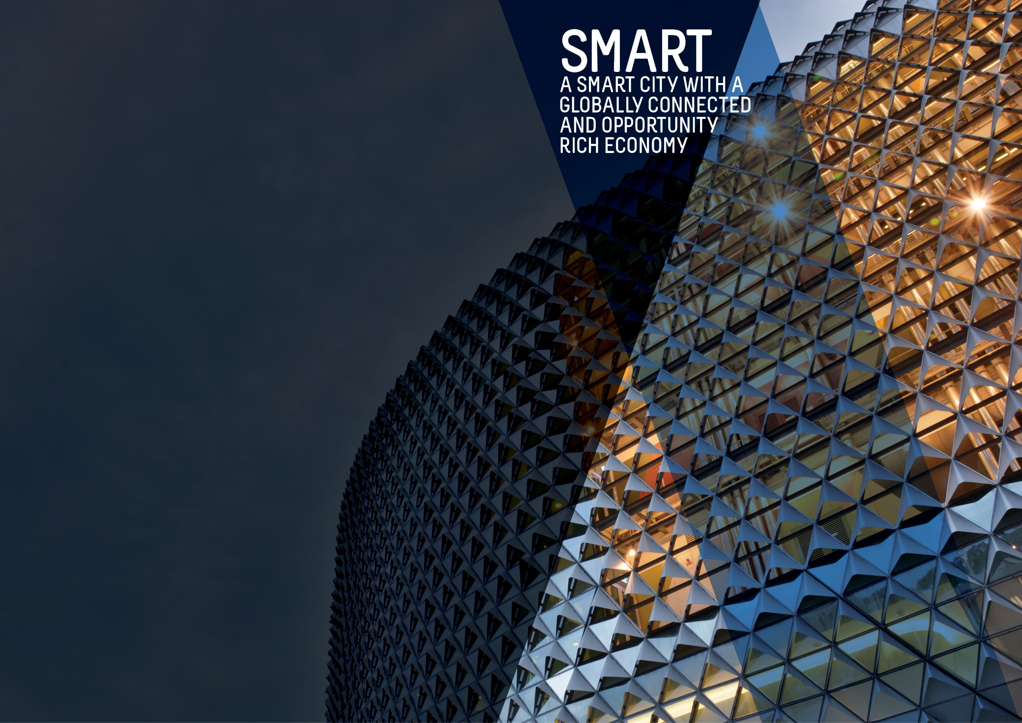
OBJECTIVES SUMMARY
The Smart theme has four objectives. Updated data was not available against any of these objectives in the quarter.
ACTIONS SUMMARY
Of the 26 actions under Smart, 20 were on track, four were on watch and two were off track.

20  ON TRACK |  | 4  ON WATCH |  | 2  OFF TRACK

OBJECTIVE | UPDATE | STATUS
BY 2020, OUR CITY’S ECONOMY WILL BE GROWING FASTER THAN THE AUSTRALIAN ECONOMY | Between 2014-15 and 2015-16 the City's economy increased by 3.4% from  $18.0 billion to $18.7 billion. In comparison, national Gross Domestic Product (GDP) rose by 2.8% while Gross State Product (GSP) increased by 2.1% over the same period. The City's economic growth in the 12 months to June 2016 was double the growth rate of 1.6% experienced between June 2014 and June 2015. Higher rates of growth were also experienced at the state and national level compared to the previous period. This is consistent with the results from the January 2017 publications of the Sensis Business Index and the ANZ Stateometer, both of which identified improving conditions for South Australia. (Last updated Q3 2016/17)  Data source: National Institute of Economic and Industry Research (NIEIR) 2016, presented by economy.id | BASELINE:  GRP growth 2.4% (June 2014)  GDP growth 2.5% (June 2014)  UPDATE ON OBJECTIVE:  GRP growth 3.4% (Jun 2016)  GDP growth 2.8% (Jun 2016)  NEXT UPDATE: May 2018  DIRECTION OF CHANGE: favourable variance
TOTAL BUSINESSES IN THE CITY WILL GROW FROM 5,000 TO OVER 5,300 AND WORKERS ON ANY GIVEN DAY FROM 89,000 TO 94,000 BY 2020 | The number of workers in the City has continued to increase from the baseline figure of 89,000 although at a slower pace compared to the previous year. Between 2014 and 2016, the number of workers in the City on an average weekday increased by 7,200 people. (Last updated Q1 2017/18)  Data source: City of Adelaide Census of Land Use and Employment (ACCLUE) 2016; City of Adelaide City User Profile (CUP) Survey 2016; ABS, ‘Regional Population Growth, Australia, 2014-15’ (Cat. No. 3218.0) | BASELINE:  89,000 workers daily (2014)  5,055 city businesses (2014)  UPDATE ON OBJECTIVE:  96,200 workers daily (2016)  5,196 city businesses (2016)  NEXT UPDATE: TBA  DIRECTION OF CHANGE: favourable variance
WORKERS IN PROFESSIONAL AND TECHNICAL SERVICES, EDUCATION, FINANCE, TELECOMMUNICATIONS, CREATIVE AND MEDIA SECTORS WILL HAVE GROWN FROM 41,000 TO OVER 49,000 | The number of workers employed by knowledge sector establishments fell by 12% from 40,279 people to 35,650 and is due to a decline in employment across all the knowledge industries.  The largest decrease was in the Professional, Scientific and Technical Services sector (-1,968) and the Information, Media and Telecommunications sector  (-1,802). This is likely to be due to the reduction in the City based Telstra workforce and the reduction/amalgamation of Internet Service Providers (ISPs) since 2014. (Last updated Q2 2016/17)  Data source: City of Adelaide Census of Land Use and Employment (ACCLUE) 2016 | BASELINE:  40,700 workers in knowledge sectors (2014)  UPDATE ON OBJECTIVE:  35,650 workers in knowledge sectors (2016)  NEXT UPDATE: TBA  DIRECTION OF CHANGE: unfavourable variance
BY 2020, THE NUMBER OF STUDENTS IN THE CITY ON ANY GIVEN DAY OF THE WEEK WILL INCREASE FROM 39,000 TO 41,000 | The number of students that are in the City on an average weekday continues to grow and is well above the target of 41,000. (Last updated Q1 2017/18)  Data source: City of Adelaide City User Profile (CUP) Survey 2016; ABS, ‘Regional Population Growth, Australia, 2014-15’ (Cat. No. 3218.0) | BASELINE:  39,200 students daily (2014)  UPDATE ON OBJECTIVE:  46,900 students daily (2016)  NEXT UPDATE: August 2018  DIRECTION OF CHANGE: favourable variance

ACTION | UPDATE | STATUS
Adopt smart technologies that demonstrate a clear return on investment through new recurring revenue generation models such as; sourcing of external funding, fee for services, data, intellectual property, licensing, proprietary technologies, sharing of services and efficiency dividends | Fibre connection to Adelaide Hills Council, City of Holdfast and Unley Council are complete. Address directories have been shared between Unley Council, Adelaide Hills Council and City of Adelaide. City of Holdfast Bay connection address sharing is incomplete and on hold due to an organisational restructure at the City of Holdfast Bay. | on watch
Assist businesses and institutions to attract talent by developing and making available collateral promoting Adelaide as a great place to work and live | The Economic Insights Dashboard and news stories continue to be a valuable resource to drive traffic to the website. 11 stories were promoted on the website which covered new investments into Adelaide and the capability of Ten Gigabit Adelaide as a business enabler.  Businesses and investment intermediaries have been provided with collateral and visitation driven to the Invest Adelaide website  A revised Investment Prospectus is underway. | ON TRACK
Become a world-renowned education City by supporting and partnering with the City’s education sector to attract and retain international, national, regional South Australian and local students, and highly credentialed academic and research staff | Discussions have been held with Study Adelaide with a view to implementing a partnership plan in 2018. | on track
Bring together the creative, arts, business, university, education and entrepreneurial sectors to promote unique opportunities for business growth | Discussions have been held with Study Adelaide with a view to develop a plan with a focus on supporting entrepreneurship in the international student population in 2018. | on track
Build upon the growing laneway and entrepreneurial culture in the City by rejuvenating primary laneways and pedestrian connections. Priorities for completion by 2018 will be the Adelaide Railway Station to Adelaide Central Market link and Rundle Mall laneways, including Gawler Place | Bank Street and Topham Mall are now complete.  Gawler Place - Initial construction activities have commenced including the locating of underground service utilities. A contractor will be appointed soon and full construction will commence in May 2018.  Bentham Street – A change of road use to one-way travelling south was implemented on 1 January 2018. Early works in the street have commenced as detailed design is being finalised through the Early Contractor Involvement procurement exercise.  Topham Mall South - Design has commenced with the concept design community consultation programmed for late May 2018.  Leigh Street - The refurbishment of the existing art work has commenced.  Pitt Street - Consultation activities for concept design are being programmed. | on track
By June 2018, as part of an improved customer experience we will develop a business plan and implement smart parking technology across the City and North Adelaide to move towards an expiation-free environment | The installation of 56 smart parking sensors and relays has commenced around Light Square and verification and validation of sensor data is underway. Further sensor installation is being planned.  Work has commenced on the configuration of business rules and customer app. Draft Marketing and Branding plan developed. Communications and community engagement plan are progressing. | off track
By June 2018, develop and promote an international City brand that showcases the smart, liveable, green and cultural advantages of Adelaide | New City of Adelaide Brand Guidelines have been rolled out across the organisation, and all portfolios are now delivering projects and communications within brand guidelines. A Brand Ambassador program is underway across the organisation. City of Adelaide brand narrative and handbook is being developed alongside a city-wide external facing "city brand" campaign aimed at engaging key consumer segments. | On track
By June 2018, leverage, upgrade and expand our AdelaideFree WiFi network to higher download and upload speeds | Opportunities to expand and improve the AdelaideFree Wi-Fi Network will now be investigated through potentially leveraging the 10Gigabit Adelaide infrastructure. | on watch
By June 2017, review Council’s commercial operations to determine the best management models | Part 1 of the Strategic Review of UPark Operations was tabled at Committee in March. The second part of the review, Strategic Property, will be delivered in Quarter 4. The Strategic Review of Golf Operations was scheduled for Quarter 3 however this has now been rescheduled for June 2018. | on track
By June 2018, work with key stakeholders in mainstreets and districts to develop business plans that will provide greater participation at the local level and appropriate governance models, as well as work on projects such as an O’Connell Street enhancement program | Administration have met with North Adelaide Precinct Association, key stakeholders and affected businesses to discuss the proposed upgrades at the O'Connell Street/ Tynte Street Intersections and public realm upgrades.  Mainstreet Advancement Grants of $20,000 have been provided to North Adelaide Precinct Association, Chinatown Association, East End Coordination Group and Adelaide West End Association Inc.  A scoping document is currently being prepared utilising rates modelling data to provide options for potential new funding and governance models for precinct and district management.  The Lord Mayor's Precinct forum was held in February 2018. Administration are working with the groups to finalise acquittals and funding responsibilities. | on track
By June 2020, increase the City’s share of the retail and hospitality sectors and deliver ten new high-end stores and 40 start-up businesses by delivering the ‘Experience Adelaide’ Adelaide City Retail Strategy | A Lord Mayor’s Business Forum was held 15th March with 28 attendees where businesses had the opportunity to share their perspectives on the current business environment. Council shared key projects including Ten Gigabit Adelaide, 88 O’Connell Street, Central Market Arcade Redevelopment, Business Support Program and an update on City capital works projects. This forum will become the Lord Mayor’s Business Association Forum to be held twice per twice a year with an increased focus on industry bodies / Associations.  The retail sector saw the announcement of H&M moving to Rundle Mall, the first flagship store announcement since the Retail Strategy was endorsed by Council in 2015.  A workshop was held in the East End on 'Trading with China' with 40 plus attendees. Flat lay promotion of city retailer offers marketing to social media and web channels were made available as part of Summer in the City. Support was provided to retailers for the Lunar New Year activation activities. | on track
Council will continue to liaise and work closely with NBN Co in support of the NBN roll-out across the City | The City of Adelaide is continuing to support NBN Co with their city-wide rollout based on NBN Co's schedules for deployment. | on track
Council will work with key partners to facilitate a 10GB per second capable broadband network across the City and North Adelaide to all premises | The main Project Agreement has been completed and signed with TPG Internet Pty Ltd. The first 45 buildings have been connected and the first customer announced, Australian Institute of Business. Ten Gigabit Adelaide was officially launched with 600 attendees across a wide range of industries. Over 500 buildings have registered for connection. | on track
Each year, increase online open access to meaningful Council-held data and information that empowers residents, visitors, researchers, investors, start-ups and established businesses to make informed, smart decisions | The online reporting system continues to be used across the organisation to provide quarterly progress updates against the City of Adelaide 2016-2020 Strategic Plan. During this quarter, a short survey was distributed to users to evaluate the usability of the online system. This feedback has been used to inform future improvements to the reporting system as well as to identify gaps in training. Work on developing an interactive public-facing version of the quarterly reports continues to be undertaken. | on track
Establish single-point-of-contact case managers to support established businesses to grow and attract sustainable businesses, investment and new corporate headquarters to the City | The case management process has been implemented across the organisation with an interest in investment proposals and cases. The process is now strongly external facing with high level of engagement with State Government's Investment Attraction SA agency, the commercial property sector, fund managers, student accommodation managers, property developers, the universities, peak industry and sector groups.  A total of 22 investment initiatives are currently under case management with the City of Adelaide.  The major projects underway of greatest investment value are in the development of purpose built student accommodation (PBSA). These developments are at various stages from concept approval through to actual construction and completion. These projects involve significant inbound capital investment by off shore companies with a global presence in the PBSA market.  Other smaller cases are equally significant in either delivering and/or contributing to the achievement of a number of outcomes across different strategic themes. | on track
Facilitate development of the fastest growing sectors, including professional and scientific services, arts and creative industries, by engaging with business leaders to foster collaboration and to assist in identifying and responding to opportunities and challenges | The Adelaide Smart City Studio has played an important role in supporting Adelaide businesses developing new smart city products and services.  During this quarter, the Adelaide Smart City Studio hosted three (3) smart city events, attracting over 120 participants. Twelve (12) businesses were supported through one-on-one Entrepreneur in Residence consultations.  The Adelaide Startup Digest was launched and the monthly 'Introduction to the Adelaide Startup Scene' event program was produced. | On track
From 2016 to 2019, increase activity in underutilised premises by providing three years' financial support to Renew Adelaide | Approval was granted to fund Renew Adelaide to address the Melbourne Street challenges. One (1) property has been leased to a business in this period.  Renew Adelaide is continuing to promote to landlords and start-up businesses in all areas of the CBD.  Promotion in the Hutt Street area has commenced within current funding. | on track
Promote opportunities and develop projects to showcase the City’s unique heritage and character as a catalyst for sustainable growth and to grow the heritage tourism market | No activity planned for the quarter. | on track
Pursue a definitive outcome for the future of the former Royal Adelaide Hospital site as a world class precinct that complements the Park Lands, North Terrace cultural precinct and the East End commercial precinct | This strategic action is now complete and can be closed. East end activations will occur as part of business as usual.  Council positions established in 2017 have continued to support Council comment and requests for input on planning for the future of the site. No new proposals or plans for the site were presented to Council in Q3. Stage 1 demolition has commenced with co-ordination on the construction process occurring with Council Administration. | ON TRACK  (COMPLETED)
Showcase the City as the location of choice for international and national trade and investment, especially for the knowledge, arts and cultural sectors, through our sister cities and other partnerships and connections, and align with State Government economic targets for increasing foreign investment, service exports and skilled migration. | Traffic has been driven to the Invest Adelaide website following meetings with businesses and investment intermediaries and the distribution of marketing collateral in hard copy formats.  News stories and the Economic Insights Dashboard continue to be a valuable resource to drive traffic to the website. Eleven (11) stories were promoted on the website which covered new investments and the Ten Gigabit Adelaide opportunity.  A meeting was hosted with the Australian High Commissioner to Malaysia at the Adelaide Town Hall, discussions were held on the Adelaide - George Town, Penang Sister City relationship.  The Lord Provost, City of Edinburgh was officially invited to visit Adelaide in 2018 and a draft copy of the City of Adelaide Edinburgh Activity Plan provided for the City of Edinburgh’s consideration. The draft Activity Plan involves a variety of projects that City of Adelaide and City of Edinburgh can collaborate on that will be mutually beneficial. (IS THIS CONFIDENTIAL?) | on track
Strengthen relationship with Study Adelaide via continued support from 2016 to 2020 to market Adelaide as an international student destination | No activity was planned for the quarter. | on track
Support development of the clean technology sector through a range of programs, services, initiatives and data, including supporting start-up and growth of new businesses and working with universities to assist with commercialising research and intellectual property for clean-tech applications | The City of Adelaide green credentials have been promoted via the creation and promotion of news stories. These stories covered investments made by businesses and projects Council is undertaking to activate green investment opportunities.  Multiple investment leads have been supported which could assist the growth of a City of Adelaide green economy. Work continued on a Low Carbon Economy Plan to inform the Low Carbon Council Road Map.  Input has been provided on how Council can foster take-up of the Building Upgrade Finance Program with the Market Development Plan currently being developed. | on track
Transform our services and business processes to improve our effectiveness and efficiency and provide improved quality communications, including having all Council forms able to be submitted online by 2018 and all development applications able to be submitted online by 2020 | Stage 2 of the ePlanning project is well underway with the completion of the analysis, design and mapping of the process improvements for those activities in scope for this stage.  The Online Forms project is also well progressed with the procurement of an enterprise online forms platform nearing completion and a contract to be awarded in April 2018.  This quarter has also continued to see the successful removal of fixed outdoor dining furniture as part of the Outdoor Dining Transition Plan. | on watch
Work with key partners to create a national centre for applied research and education into the digital economy | Research and discussions with stakeholders have identified that greater benefit will accrue from facilitating the development of a high growth start-up precinct rather than a National Centre for Applied Research and Education into the Digital Economy. A draft concept proposal has been developed involving extensive consultation with the start-up community and building owners for this precinct to be centred around Topham Mall. | on watch
Work with our local and global partners through a range of projects and initiatives to build on the city-wide culture of entrepreneurship, start-ups and the commercialisation of research and ideas | Significant resources are required to support and sustain the operations of the Adelaide Smart City Studio.  Active support was provided for the planning of Entrepreneurs Week (July 9-13) with the opening event to occur on July 9.  Considerable in-kind support was provided for a variety of entrepreneurship programs including ThincLab, D3 Digital Challenge, the Seed Round, the Australian Science and Mathematics School Challenge and Don Dunstan Foundation Thinker in Residence. | off track
Work with partners to develop and implement a range of policies, programs and services to support business start-ups, business growth and business sustainability | As part of the Future of the Precincts series, the City of Adelaide hosted an exclusive Trading with Chinese Visitors workshop for all East End businesses. Attendees were provided with tools on how to optimise retail capability to meet the demands of the growing number of Chinese tourists. The 48 attendees had the opportunity to hear from special guest speakers; Jing Cao, Chinese Language and Cultural Advice, Hugh Macgillivray, Hop The Wall, Simon Henry, UWAI and Wilfred Fernandes, UNIONPAY. The event was very well received with 90% of attendees reporting the content beneficial. The survey suggested the highlights for businesses were the opportunity to network and the knowledge gained from industry experts.  The Enterprise Adelaide Business Advisors continued to provide tailored information and support to a mix of start-up and established businesses. In this quarter, a total of 126 one-to-one meetings regarding starting a business in Adelaide were conducted new/start-up businesses.  Over 200 in-person visits were made to established businesses in the City of Adelaide to offer support. This included businesses in Wyatt, Currie, Hutt, Pirie, Flinders and Gouger Streets among others | ON TRACK

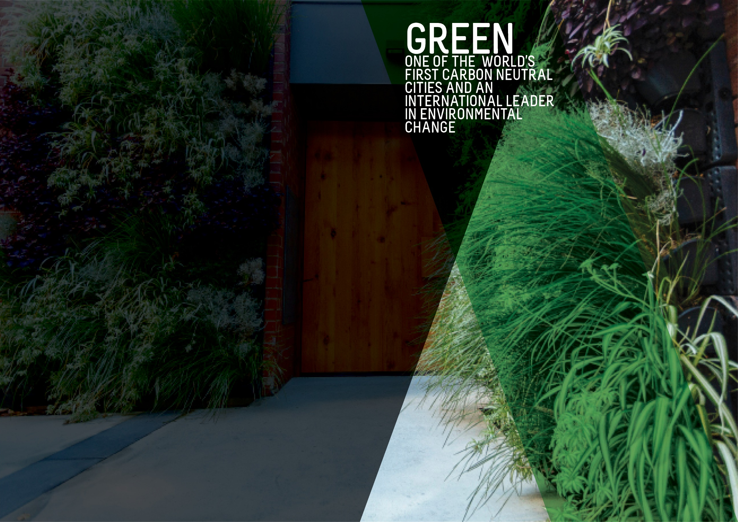
OBJECTIVES SUMMARY
The Green theme has five objectives. Updated data was not available for any of the objectives in the quarter.
ACTIONS SUMMARY
Of the 28 actions under Green, 22 were on track, six were on watch and none were off track.

22  ON TRACK |  | 6  ON WATCH |  | 0  OFF TRACK

OBJECTIVE | UPDATE | STATUS
CITY CARBON EMISSIONS WILL BE REDUCED BY 35% FROM THE 2006-07 BASELINE BY 2020 | The greenhouse gas emissions inventories for the City of Adelaide community were finalised for Financial Years 2016 and 2017, and updated for Financial Years 2007 (base year), 2014 and 2015 to ensure consistency with the latest calculation methodologies and were reported to Council. This has shown a 15% emissions reduction achieved between 2007 and 2017.  The overall reduction in emissions has been driven by a 37% reduction in stationary energy emissions, that is, emissions associated with the consumption of purchased electricity and natural gas. This demonstrates a decoupling of City of Adelaide community GHG emissions from the City of Adelaide Gross Regional Product which has increased by 35% over the same period.  Data source: City of Adelaide Community GHG Emissions Inventory | BASELINE:  1,148 kt CO2-e (2006-07)*  UPDATE ON OBJECTIVE:  976 CO2-e (2016-17)  NEXT UPDATE: TBA  DIRECTION OF CHANGE: favourable variance  * Revised from 1,175 kt CO2-e to ensure consistency with the latest calculation methodology
GREEN SPACE AND GREENERY IN THE BUILT-UP AREAS OF THE CITY WILL HAVE INCREASED BY 100,000 METRES BY 2020 | The baseline figure for green space and greenery comes from the Green Infrastructure Benchmark Data and Mapping project undertaken in 2015. Total green coverage is calculated by adding the total pervious area (total area minus total impervious area) to the area of tree canopy cover in built-up areas within the City. The built-up area of the City is the entirety of the City of Adelaide area minus the Park Lands.  Data source: City of Adelaide | BASELINE:  1,241,777.11 (2015)  UPDATE ON OBJECTIVE:  Not available  NEXT UPDATE: 2018  DIRECTION OF CHANGE: not applicable
BY 2020, AQUATIC NATIVE PLANTS ON THE TORRENS LAKE FLOOR WILL HAVE INCREASED FROM ALMOST ZERO TO 7,500 SQUARE METRES | The re-introduction of aquatic native plants to the Torrens Lake floor is an ongoing process with results likely to take some time to achieve and quantify. Nursery propagation over winter has been successful. This year 7,125 aquatic plants have been planted in the Torrens Lake.  Data source: City of Adelaide | BASELINE:  Almost zero (2015)  UPDATE ON OBJECTIVE:  Not available  NEXT UPDATE: 2018  DIRECTION OF CHANGE: not applicable
A DETAILED MEASURE OF REDUCTION IN KERBSIDE AND GENERAL WASTE WILL HAVE BEEN DEVELOPED AND INFLUENCES OUR WORK | Council currently tracks kerbside waste and the proportion of recyclables. The scope of a suitable measure for kerbside and general waste reduction is being considered. Council has seen a small increase in waste going to landfill over the last 12 months as a result of providing waste services to an increasing number of medium to high density dwellings. | BASELINE:  To be determined  UPDATE ON OBJECTIVE:  Not available  NEXT UPDATE: TBA  DIRECTION OF CHANGE: not applicable
A COMPREHENSIVE INTEGRATED WATER MANAGEMENT MEASURE WILL HAVE BEEN DEVELOPED AND INFLUENCES OUR WORK | Council currently tracks mains water use, recycled water use and the cost of both. The recommendations from the review of the Biodiversity and Water Quality Action Plan have been finalised and will help to inform and develop the Integrated Water Management Plan and Integrated Water Management Measure. | BASELINE:  To be determined  UPDATE ON OBJECTIVE:  Not available  NEXT UPDATE: TBA  DIRECTION OF CHANGE: not applicable

ACTION | UPDATE | STATUS
Achieve adoption of sustainable commercial practices through incentives, purchasing approaches, waste services and regulation | A post pilot survey is being finalised for cafe pilot participants to complete. The survey will inform recommendations to Council on the opportunities to promote the use of compostable takeaway containers in City businesses.  A review of Council waste services to events commenced and will inform potential future options to support sustainable events | on track
By 2020, Council’s New Year’s Event will send zero-waste to landfill and by 2018, clear guidelines will be developed for organisers of larger community events in Council-operated areas to achieve zero-waste and carbon neutrality | A review of the Waste Minimisation Guide for Events and Venues has been undertaken during the quarter. Consultants have been appointed and are preparing the draft Guidelines for Sustainable Events. Project Plans were also completed for a review of Council services and infrastructure for medium and major events. Green Industries SA has provided $25,000 in funding towards the development of the Sustainable Events Guidelines and a Roadmap for Sustainable Events to 2025. | on track
By 2025, working with City waste collectors, all Council serviced premises will have their landfill, recycling and green waste collection measured and reported to Council, with the data to be available online to the premises' occupant | In Quarter 3, information gathered in 2017 from the waste innovation market sounding exercise (Request for Information) is being incorporated into the tender specifications. This will support reporting of waste and recycling performance at a premise level. | on watch
By December 2020, increase our efficient use of recycled water from the GAP scheme in Council-irrigated areas by 25% to an overall level of 80% | The 2016/17 Water Profile shows 78% of irrigated water was sourced from GAP. The Water Inventory and a Profile of irrigated water used has been completed for 2014 to 2017. This provides a 3-year trend and analysis for consumption costs and metering charges. This intelligence will inform future decisions around the continued use of recycled water. | on track
By December 2017, complete a procurement plan for all Council vehicles to be low or zero emissions | No further update as this Action is completed. | on track (completed)
By June 2017, Council will have developed a Green City Plan detailing Council’s contribution to greening the city and showing activities with aligned annual targets, including an additional 1000 trees in the built-up areas of the city by June 2020 | All excavation works have been completed, new kerb and water table is being poured commencing 26 March 2018 for the Waymouth Street Greening Works. The completion date is now planned for mid-May.  The Draft Green City Plan and Implementation Plan will be brought to Council for consideration in June 2018. | on track
By June 2019, our procurement practices will reasonably require the environmental track record and/or credentials of suppliers, and estimates of carbon emissions of products and services | Administration has continued to undertake further investigations in regards to capturing environmental credentials and carbon emissions estimates from suppliers and comparing the practices of government entities across Australia.  The Zero and Low Emissions Vehicles Procurement Plan was completed. | on track
By June 2020, all Council-owned and maintained public lighting will be converted to LED lights and smart lighting wherever possible | LED Update - New technical solution has been identified and currently being trialled for roll-out.  Data has continued to be collected via maintenance night audits and data recorded through the RAMS asset management system during scheduled preventive maintenance and break and fix repairs.  Data is being analysed by the assets systems team for preventative maintenance, replacement planning and design. | on track
By June 2020, the energy requirement for all Council buildings will be sourced from low carbon or renewable energy sources | Energy market consultants have been engaged to provide advice on procurement options for future electricity supply for Council's operations, which are both cost effective and contribute to Council's aim for its operations to be carbon neutral by 2020. Detailed business cases of three (3) preferred procurement options that outline the costs, timing, benefits and risks have been prepared by the energy market consultants. A procurement plan will be developed following an approved procurement approach. | on track
By the end of 2017, develop and implement a Waste, Recycling and Reuse approach for the City that reflects world’s best practice and the use of smart technology | Waste Management has a globally changing profile; work has commenced on a review of our Waste Management policy and practices from a holistic perspective taking into account financial, economic, environment, cultural and social impacts and influences. This will be the subject of a Committee Workshop to be held in June 2018. | on watch
Commit through to June 2020 to continue the Sustainable City Incentives Scheme, with annual reviews of incentive funding budget allocations | During Quarter 3, 50 applications received approval with a total value of approximately $98,000 being given out in rebates, leveraging a total investment of $445,000. An additional 59 new applications were received during the quarter. Due to unprecedented demand for the Scheme, Council endorsed reallocating $50,000 from within the Climate Change Action Initiatives Fund, along with an additional $50,000 in new funding. | on track
Continue to work with the State Government and other councils to reduce stormwater and other pollutants into the Torrens River catchment | Scheduled maintenance in the water sensitive urban design areas has continued with weed management and removal of litter and debris from reed beds during the quarter.  Planting macrophytes at various locations in the River Torrens Lake Bed is on hold due to non-planting season. Propagation of aquatic plants for future planting in the Torrens River has taken place with planting to restart in May 2018.  The River Torrens Feasibility Study has commenced. | on track
Develop international trade, investment and tourism opportunities based on our green and clean reputation | City of Adelaide worked with 'Adelaide Tree Climb' to assist in facilitating relationships with the South Australian Tourism Commission to identify opportunities based on the City’s green reputation.  The support of nature based experiences in the city through web, social and the visitor centre and services has continued. A content update on Expedia around Adelaide Parks and Gardens was actioned in March. | ON TRACK
Enhance biodiversity in the Park Lands and strengthen the role of the Park Lands in achieving a carbon neutral City | The draft Integrated Biodiversity Management Plan has been developed. A stakeholder consultation workshop was held with feedback incorporated into Plan. Maps of Key Biodiversity Areas have been developed. The Project Plan for Tainmuntilla Woody Weed Removal was completed. The Project to establish a Volunteer group for the Victoria Park Grasslands has been initiated.  Successful biodiversity activities have included collection of seeds for future propagation, propagated plants for future planting and site management including weed eradication. Delivery of the Green Gym Volunteer program for our older community to get fit in the Park Lands has continued. | on track
Facilitate the reuse and recycling of equipment, consumables and materials used in festivals and events in the City | In this quarter, work continued on the draft Sustainable Event Guidelines which will be applicable state-wide, addressing topics including energy, water, waste, transport, venues, infrastructure, procurement, supply chain, marketing and communications. These draft guidelines will be presented for discussion and feedback prior to consideration by Council.  In addition to this, the City of Adelaide engaged KESAB to undertake patron surveys at two major Fringe-registered events and Council’s New Year’s Eve event to deepen our understanding of patron behaviour at City events as it relates to recycling. Over 250 event patrons were surveyed as part of this exercise. This data will assist us with our broader Sustainable Events project work.  Finally, administration is actively looking for opportunities to demonstrate good sustainable event practice at Council-run events. As an example, some initiatives were put in place at Council’s New Year’s Eve 2017 event to reduce waste to landfill and the event’s carbon footprint. This included increasing the number and usage of audio visual screens to reduce the usage of corflute signage. In addition to this, three quench benches were provided to encourage patrons to bring and refill their own water bottles. | on track
From 2016, collaborate with City-based businesses, interest groups and the education sector through a series of Lord Mayor summits and forums to build partnerships that promote environmental issues and broader innovations | CoA has continued to support City schools by working collaboratively with the State Government on a low-carbon schools’ initiative, as part of Carbon Neutral Adelaide. Participating City of Adelaide schools include Gilles Street Primary School, North Adelaide Primary and Sturt Street Community School. CoA has also been supporting Pulteney Grammar and Christian Brothers College in their interest in Carbon Neutral Adelaide, Tree Tagging & Native Bee hotels. | on track
From 2016, Council will commit ongoing funding for powerline undergrounding to assist with greening initiatives | PLEC submission for Gouger Street has been submitted to the Regulator. Jeffcott Street project is underway. | on track
Identify opportunities for building adaptation and re-use that supports heritage aspirations while reducing carbon emissions and waste | Consultants have continued to liaise with building owners on potential Building Upgrade Finance (BUF) projects. Several inquiries have been made with City of Adelaide on potential BUF projects in the City. Consultants have been engaged to prepare and launch a BUF Market Development Plan to facilitate and accelerate widespread uptake of the BUF mechanism in South Australia through engagement with, and upskilling of potential BUF industry service and product providers and consultants. | on track
Improve energy performance and use of renewable energy in Council and privately-owned buildings, including consideration of solar heating, solar energy generation and battery storage | The feasibility study for solar PV on City of Adelaide buildings commenced with priority sites being assessed to inform the tender specification.  The installation of solar PV systems at all 40 properties participating in Solar Savers Adelaide was completed and the separate rate charges have commenced. The Monitoring & Evaluation project of Stage 1 of Solar Savers Adelaide is continuing. A review of the Sustainability Incentive Scheme commenced. The promotion of Building Upgrade Finance (BUF) has continued with a draft Market Development Plan being prepared to maximise uptake of BUF. | on track
Improve the ecological value of watercourses and biodiversity in the Park Lands | The River Torrens Lake Redesign Feasibility Assessment Project commenced and will provide options for a future project to improve the ecological function and values of Torrens Lake.  Propagation of aquatic plants for future planting in the Torrens River continued. Investigations into planting methods has continued. Macrophyte planting in the River Torrens Lake Bed is on hold due to non-planting season. The planting season will resume in May 2018.  Brown Hill Keswick Creek (BHKC) Storm Water Management Project is currently finalising its selection of the preferred Tenderer for the design of the South-East Park Lands (Parks 16 and 20) project. The Minister for Local Government has endorsed and gazetted the BHKC subsidiary model. Participating Councils will form a nominations committee for the purposes of selecting subsidiary members. | on watch
Partner with the State Government to implement a Carbon Neutral Adelaide Partnership Framework to pursue the shared aspiration for Adelaide to be the world’s first carbon neutral city | The Carbon Neutral Adelaide Partner Program grew from 126 Founding Partners to 141 Partners. Thirty-two (32) additional Partner profiles were published in the searchable Partner Directory on the Carbon Neutral Adelaide website. An e-book containing seventeen case-studies of Partners was updated and published on the Carbon Neutral Adelaide website.  Carbon Neutral Adelaide e-News (Business and Community Editions) were sent monthly promoting incentives, events, news and highlighting partner achievements. 1,308 residents and 477 business representatives have subscribed to date.  The City of Adelaide sponsorship of WOMADelaide Planet Talks focussed on Carbon Neutral Adelaide. The greenhouse gas emissions inventories for the City of Adelaide community were finalised for Financial Years 2016 and 2017, and updated for Financial Years 2007 (base year), 2014 and 2015 to ensure consistency with the latest calculation methodologies and were reported to Council. This has shown a 15% emissions reduction achieved between 2007 and 2017. | on track
Provide a range of incentives for the use of electric-powered and low-emission vehicles within the City | The EV charging stations in Central Market UPark were completed with performance verification occurring during the quarter. Construction of on-street EV charging stations has commenced. | on watch
Reduce storm water run-off and pollution into the Torrens River through integrated catchment management and water sensitive urban design | The Water Sensitive Urban Design program is currently in flight with the following projects under construction: Gouger Street, Waymouth Street, and the following in design; Boulton Street; St Helena Place; Gawler Place. | on track
Work with all City stakeholders to increase public and private greening with street trees, gardens, community gardens, green walls and roofs providing incentives where appropriate | A total of 38 new street trees planted in the year to date. New and replacement tree preparation occurred over summer. The next stage of street tree planting is due to commence in May 2018.  We are continuing to develop a process to assess new or recalibrated open spaces within the CBD and North Adelaide - outside of the Adelaide Park Lands - with an initial focus on streets and spaces in locations in the CBD. | on track
Work with Federal and State governments to provide appropriate infrastructure and promote sustainable transport options, such as public transport, cycling and walking, to improve the experience of commuters and reduce transport-related carbon emissions | Work continues on the delivery of actions outlined in the Smart Move Interim Action Plan 2016-2018.  The key projects for 2017/18 are:  1. South Ward Local Area Traffic Management Plan  2. Smart Traffic Technology and Optimisation  3. City Connector Enhancements  4. City wide speed limit review  5. Review of the City Ring Route  6. The CBD Servicing and Loading Zone Management Plan  7. Cycling and Transport education programs  8. Motorcycle and scooter parking expansion.  As per Council’s decision in Quarter Two, all work on the East-West Bikeway is on hold until further notice. | on watch
Work with local communities on public greening activities that will beautify streets and parks | Due to the non-planting season, public greening activities were put on hold during this quarter. Work will recommence in Quarter Four. | on track
Work with partners to reduce mains water use through water sensitive urban design and increasing the use of recycled and reused water | The 2016/17 Annual Water Profile report has been finalised. The Profile Report will provide the evidence base for decision-making on priority actions.  Sites have been identified for their potential to minimise potable use and increase GAP use, however SA Water does not have any current business plan for expansion of GAP ring main to offer supply to proposed areas. | on watch
Work with private property owners and the State Government to embed better environmental performance into new and existing developments | The 'Blueprint for South Australia's Planning & Design Code' was released on 23 March 2018 by the State Planning Commission. This identifies a future Discussion Paper to be released on Natural Resources and Environment and includes conversations on green infrastructure, water sensitive urban design and environmental resilience. Opportunities to remove and improve policy in these areas was identified in the Stage 1 Development Plan Audit that was submitted to the Department of Planning, Transport and Infrastructure (DPTI) in December 2017 and discussed in workshops with DPTI staff in February 2018. | on track

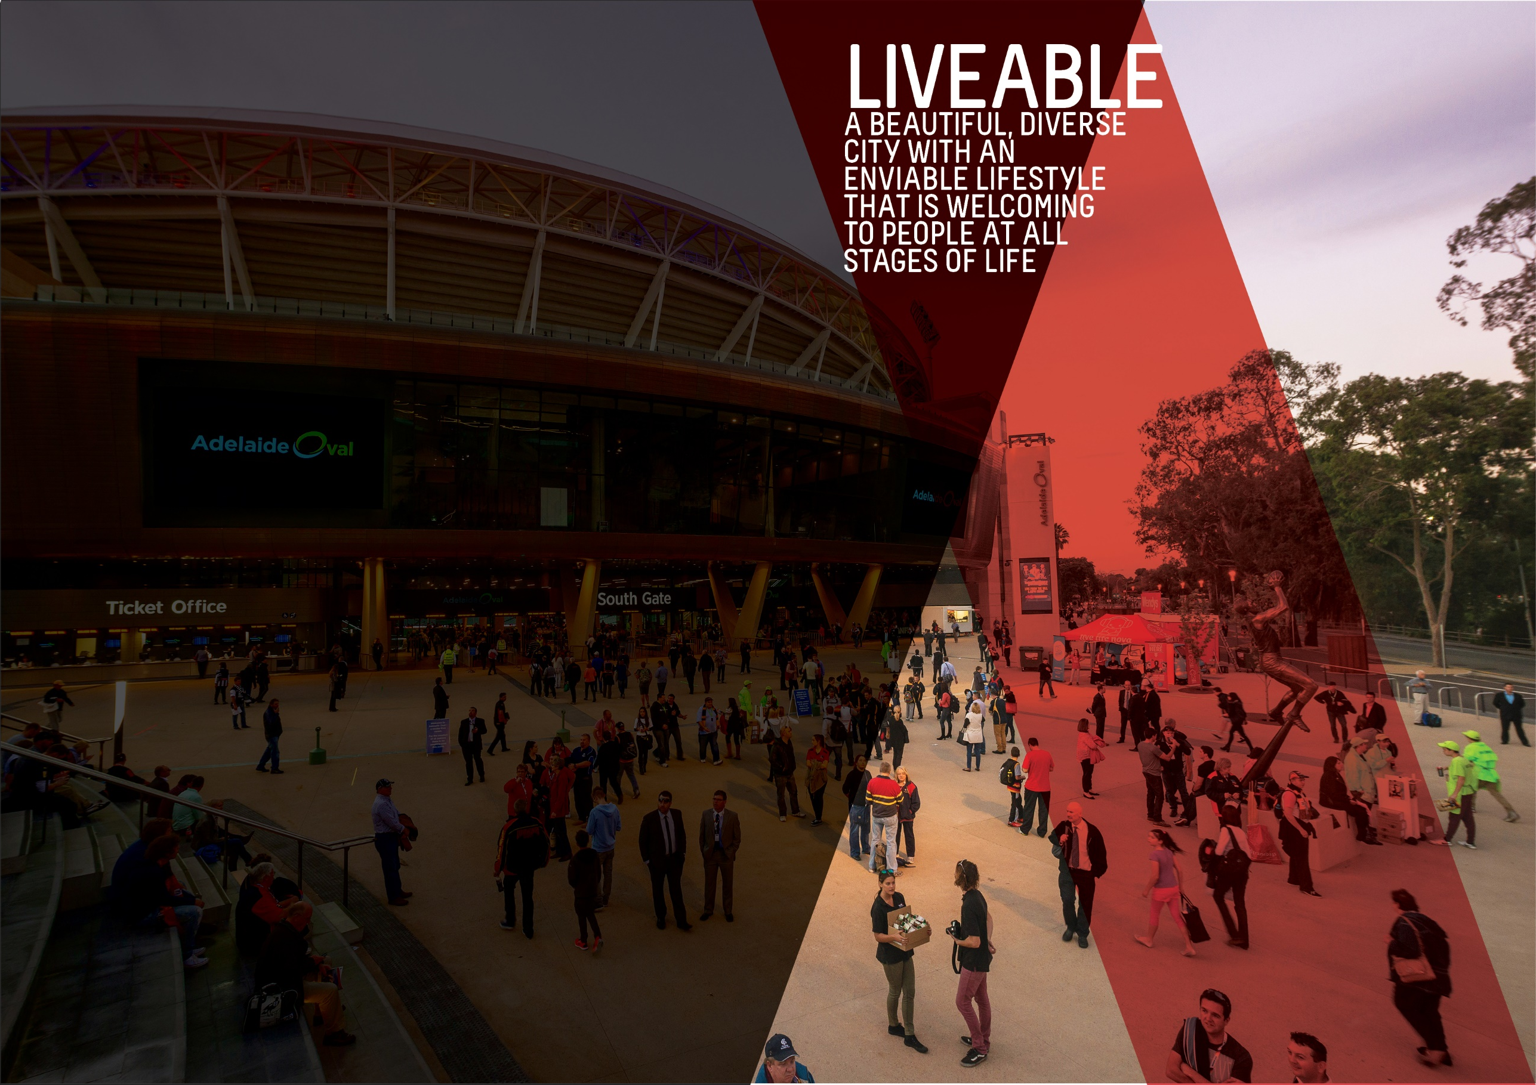

OBJECTIVES SUMMARY
The Liveable theme has three objectives. Updated data was not available for any of the objectives in the quarter.
ACTIONS SUMMARY
Of the 24 actions under Liveable, 22 were on track, one was on watch and one was off track.

22  ON TRACK |  | 1  ON WATCH |  | 1  OFF TRACK

OBJECTIVE | UPDATE | STATUS
THE NUMBER OF PEOPLE LIVING IN THE CITY WILL HAVE GROWN FROM 23,000 TO 28,000 BY 2020 | As at June 2017, the estimated resident population (ERP) of the City was 23,916 persons. This is 2.2% higher than the previous year and 6.1 % higher than the baseline year in 2014. Population growth in the City continues to outpace the State's population growth. Between June 2016 and June 2017, population growth across South Australia increased by 0.6%.  Data source: ABS, ‘Regional Population Growth, Australia, 2015-16 (Cat. No. 3218.0) | BASELINE:  22,539 (ERP June 2014)*  UPDATE ON OBJECTIVE:  23,916 (ERP June 2017)  NEXT UPDATE: Early 2019  DIRECTION OF CHANGE: favourable variance  * Baseline figure has been revised due to a change in the methodology the ABS use to estimate regional populations.
ADELAIDE WILL BE LISTED IN THE TOP THREE MOST LIVEABLE CITIES IN THE WORLD BY 2020 | In 2017, Adelaide was once again ranked 5th in the Economist Intelligence Unit's (EIU) Global Liveability rankings. Adelaide has been ranked fifth since 2012. There has generally been little change in the top five rankings over the past few years. The list continues to be topped by Melbourne, Vienna, Vancouver and Toronto.  Of the five categories of liveability assessed by the EIU measure, Adelaide continued to score lowest (94.2/100) in the area of culture and environment, which includes factors such as sporting availability, cultural availability and food and drink, and its highest score (a perfect 100) in the education and healthcare categories. The EIU liveability rankings relate to the entirety of Adelaide and not specifically to the City of Adelaide. (Last updated Q1 2017/18)  Data source: Economist Intelligence Unit, Global Liveability Ranking 2017 | BASELINE:  Ranked 5th (2015)  UPDATE ON OBJECTIVE:  Ranked 5th (2017)  NEXT UPDATE: August 2018  DIRECTION OF CHANGE: no change
CITY OF ADELAIDE RESIDENTS WILL HAVE WELLBEING ABOVE THE GLOBAL AVERAGE | During Quarter 2, Council endorsed a change to the wellbeing objective from “A nation leading wellbeing and resilience measure will be applied and influences our work’ to ‘City of Adelaide residents will have wellbeing above global average”. This wording reflects the outcome of the PERMA+ survey undertaken with South Australian Health & Medial Research Institute (SAHMRI) in 2016 to contribute to the development of a baseline for residents’ wellbeing. It also reflects the focus of Council’s work to maintain resident wellbeing above the global average as articulated in the City of Adelaide’s Wellbeing Roadmap. | BASELINE:  PERMA+ score of 7.2 (September 2016)  UPDATE ON OBJECTIVE:  Not available  NEXT UPDATE: TBA  DIRECTION OF CHANGE: not applicable

ACTION | UPDATE | STATUS
Advocate for an urban growth boundary that limits urban sprawl and promotes the City as the commercial, cultural, residential and social heart of metropolitan Adelaide | No further updates Required - Completed. Commenced with enactment of the Planning, Development and Infrastructure Act 2016, as reflected in the Updated 30 Year Plan for Greater Adelaide. | ON TRACK
Advocate to the Federal and State governments for changes in housing taxation and levies to reduce the cost of housing, including an extension of the State government's 'Off-the-Plan Stamp Duty Concession’ for apartments | The State Government election during Quarter 3 and associated caretaker period has restricted opportunity for advocacy work. | ON TRACK
By 2017, endorse a Central Market Arcade redevelopment plan and commence works by 2020 | Stage 2 has commenced with shortlisted proponents, with the outcomes to be presented to Council in June 2018.  The outcomes will reflect Council’s guiding principles, commercial negotiations and design principles which talks to the return works to Council.  Current negotiations with tenants at the Central Market Arcade continue with handover of the facility in September 2018, representations have been made to Property Managers in relation to facility management. | on watch
By June 2020, develop an Adelaide 2040 Plan to achieve long-term economic, environmental, social and cultural goals, incorporating a spatial and transport plan for the City and Park Lands | No update required - no further activity against this Action in 2017/18. | on track
Create world class infrastructure by adopting a three year rolling capital works program for the City and Park Lands to ensure all new and existing infrastructure are delivered and maintained to high quality standards, incorporating universal access, technology, heritage, arts and green elements. | Council continues to deliver core maintenance in line with current endorsed service standards. Administration has provided core input into new designs for world class infrastructure at the Gawler Place redevelopment and maintaining Bank Street and Topham Mall to higher standards as part of the Market to Riverbank Laneways Upgrade. | on track
Deliver Council’s core services efficiently and with brilliant customer service for a growing and increasingly diverse and multicultural community | Work has begun on the review of our City Works processes, guidelines and customer reference materials which will also lead to significant benefits for customers and staff. The broader permit review is also progressing well having endorsed the proposed Guiding Principles & project approach.  Work has also commenced on building the capability of the organisation to deliver brilliant customer experiences. | on track
Deliver sport and recreation activity hubs consistent with the Active City Strategy and Adelaide Park Lands Management Strategy | The Concept Plan for Josie Agius Park / Wikaparntu (Park 22) was endorsed by Council this quarter, and will now progress to business plan proposal and building design concepts.  Construction of Ellis Park / Tampawardli (Park 24) community sports pavilion commenced, and a new community sports pavilion in Gladys Elphick Park / Naurnungga (Park 25) was launched in this quarter. However, the landscape/access plan for Park 24 has been delayed to consider broader access requirements.  The draft Concept Plan for Golden Wattle Park / Mirnu Wirra (Park 21W) has been developed and stakeholder engagement is underway.  Construction of the Victoria Park / Pakapakanthi (Park 16) change room and toilet facility will commence in mid-April and finish mid-June. Final preparations for the construction phase are underway, and the irrigation has been altered in preparation for the new facility. | ON TRACK
Develop and celebrate strong and resilient City communities that are welcoming and encourage people of all ages, cultures and means to participate in City life, including through volunteer opportunities | The Adelaide Community Leaders in Sustainability program has commenced with 24 participants recruited for the program this year. Preparation for Youth Week in the City activities are well underway with Council providing support to more than ten (10) youth-led events planned for early next month. Ten (10) events were held across the City and North Adelaide as part of Neighbour Day 2018, with a total of over 400 people attending. These events support local residents to get to know each other, prevent isolation and form more resilient communities.  Commonwealth Home Support Program (CHSP) services were delivered to 132 City residents during this quarter, along with a range of social activities. A survey of CHSP customers in January 2018 found that 94% of customers were satisfied with Council’s Healthy Ageing Team, nearly 90% were satisfied with CHSP Services and over three-quarters were engaged with their local communities. Staff communicated on a daily basis with the City’s older residents, and are continuing to support an externally initiated walking trail project and a precious document/photo scanning service for City residents.  Driven from a request from the local community, a successful resume writing workshop series was held at the Adelaide South West Community Centre with fifteen (15) participants learning practical skills and knowledge over three weeks. The centres hosted the Adelaide Symphony Orchestra which saw 45 community members, who would generally not have the opportunity, enjoy the experience of the ASO by wearing a set of earphones and a Virtual Reality headset.  In response to feedback from the Access and Inclusion Advisory Panel (AIAP), site visits were held for Bank Street (Market to Riverbank) to inform the Shopfront Improvement Scheme and Frome Road Bikeway. AIAP also provided feedback on the Changing Places project. An AIAP member was engaged to create personas for upcoming scenario planning for Inclusive Play Space for Rymill Park.  International Women’s Day was marked with a Women Rock the Square event in Victoria Square / Tarntanyangga, facilitated by Council. Staff attended the International Women’s Day Breakfast, allowing for networking with other organisations and a planning session for promoting women’s participation in the community.  City of Adelaide volunteers were engaged in several training opportunities including CPR, Volunteering with Older People, Communicating Effectively, Communicating with Confidence and Customer Service Made Simple.  Library Out & About visits to business and organisations in Rundle Mall, Hutt Street and Tynte Street received ongoing positive feedback. Library Out & About attended the Fringe, Writers Week and WOMAD. Living Well Program at the library service included budget living, Bike SA – Be Safe Be Seen, I’m Not As Old As I Used To Be and NBN & You sessions. Smart Experiences at the Library Program delivered regular one-to-one sessions in the Digital Hub Spaces and partnered with the Brainary to host the SA event of the National Everybody Dance NAO Robot dance competition. A successful Science Club Program was delivered featuring Magic with Muggles, Science That Glows and Wonderful Water workshops.  During this quarter, six Community Development Grant enquiries were received (two Minor and four Quick Response) with two Minor Grant applications being approved to the value of $17,305. | ON TRACK
Encourage City living by understanding the demand drivers and developing a distinctive City living promotion campaign that builds on the Already Home campaign | The Residential Growth Action Plan was presented at a Council workshop on Tuesday 20 March 2018. Feedback was documented and is now being actioned. The Action Plan will be amended as necessary prior to seeking endorsement from Council at a future Council meeting, together with a budget proposal. | ON TRACK
Encourage growth in the full range of residential property development in a mixed use environment in a manner that respects the human scale and different characters of districts in the City | A briefing was presented to Elected Members on 211 Pirie St (Beach Volley Ball site) at the Committee meeting on the 20 February 2018. To progress with land revocation requires Council to define its guiding principles and intent for the site.  Administration are currently reviewing site modelling options, which includes financial, design and purpose, to assist in progressing with land revocation. | on track
Encourage the State Government to improve public transport to promote greater patronage, including continued investment and expansion of the free City Connector Services | Council continues to work in partnership with the State Government on the provision of the free City Connector service, monitor the performance and feedback of the service, and explore options to expand the service to other areas of the City if required. The State Government has implemented changes to public transport fares to encourage more people to use services more often. The new fares commenced in April 2018.  Administration are continuing discussions with the State Government to roll out an expanded audio and visual display system to the remaining City Connector bus fleet. New digital bus stops were installed in December 2017 have been implemented successfully and now fully functioning. | on track
Enhance the role of the Park Lands in increasing levels of physical activity and wellbeing through formal and informal sport and recreation opportunities | Nine Quick Response Recreation and Sports grants were received in this quarter with four allocated funding. All Quick Response applications were processed and applicants notified of the outcome of their application within ten working days. The grants programs were promoted directly to the recreation and sport database and more broadly through advertisements in the City North and City Messenger Newspapers and on digital screens located in various Council facilities. A total of seven Program and Events applications were received with two programs allocated funding, including the Pashtun Association of SA Multicultural Cricket program. Four Facilities applications were received with assessment to occur in Quarter Four.  In principle support for the Women’s and Children’s Hospital (WCH) to enhance Peace Park for their consumers was received by Council. WCH has established a Terms of Reference for a Project Steering Group, with the first meeting held in this quarter.  Administration has continued to work with Parkrun in the establishment of a second community run site. The new Parkrun will be held in Victoria Park / Pakapakanthi (Park 16) and is due to commence in Quarter Four. Work continued with the One Culture Football program in supporting them to boost participation. This included helping them to secure an additional site with lights so that their multicultural program can continue through winter and a site for conducting their disability tournament.  Concept designs and estimated costings for a North Adelaide Golf Course Master Plan have been completed by consultants with a view to the Draft Master Plan being completed by the end of April. The Draft will be presented to APLA and Council in Quarter Four for approval to begin formal consultation with the community.  As at the end of this quarter, total spend for the Adelaide Park Lands Trail was $1.5m of $2.5m. Updates on key projects include King Rodney Park / Ityamai-itpina (Park 15) playspace - nearing completion; Blue Gum Park / Kurangga (Park 20) BMX track and tennis courts – works complete and currently the subject of community consultation review; Glayds Elphick Park / Narnungga (Park 25) Access Road – works complete; and Western Entry Statement – works to commence April 2018. | ON TRACK
Explore opportunities in Council’s current property holdings and pursue strategic opportunities to lead or partner in future property developments | A Committee workshop was undertaken on the 20 February 2018 to discuss the site known as 211 Pirie Street (Beach Volley Ball site). The Committee in its deliberations asked the Administration to undertake further modelling of the site to understand potential uses and financial implications. This would guide Council in defining its guiding principles for the site and assist in undertaking revocation should Council wish to change its use. | on track
In partnership with the State Government, explore the possibility of redeveloping Currie-Grenfell streets as a public transport boulevard to cater for increased demand | The changes implemented to the Currie and Grenfell Street corridor in December 2017 to coincide with the opening of the O-Bahn tunnel are now functioning. We continue to advocate to State Government for the complete upgrade of the Currie-Grenfell Street Transport Boulevard and are preparing concept design options to facilitate discussion on the future upgrade of the corridor. The concept options and analysis is anticipated to be completed by mid-2018. . | on track
Increase participation by the broadest range of residents in the community life of their neighbourhood | Staff continue to support the eVanced booking system ensuring that the customer experience is consistent across all Library and Community Centres when booking rooms or events. | on track
Plan and deliver priority walking and cycling routes throughout and beyond the City and Park Lands, including the provision of East-West and North-South cycleways and connections | Construction of the North-South Bikeway is continuing while construction has been completed between Grenfell - Pire Streets and Wakefield - Carrington Streets.  In February 2018 engagement with adjacent ratepayers was undertaken for the section between Pirie - Wakefield streets.  Design, engagement and construction works will continue on the North-South Bikeway as a rolling program until the route is complete.  As per Council's decision of 28 November 2017, all engagement strategy and design work remains on hold for the East-West Bikeway until further notice. An extension of the Bikeways funding agreement was agreed to by the previous Government. Construction is Blenheim Street is currently underway and is expected to be completed in May 2018, followed by road resurfacing in Blenheim and Lowe streets. | off track
Plan and seek partnerships for major City infrastructure projects, including cycling corridors, major transport routes and laneways | Liaison continues with several government agencies to advocate for partnerships across a range of infrastructure projects in the CBD and Park Lands. | on track
Promote and protect Adelaide’s built character and heritage through our operations, incentives, policies and direct investment, while working with and advocating to Federal and State governments for an increase in City buildings protected under State or Local Heritage regulations | On Friday 23rd March the public campaign for the Heritage Incentives Scheme 30 years celebrations launched in Rundle Mall. Approximately 120 were in attendance. Four (4) large cubes containing colourised archival photographs and the associated stories were installed between Charles Street and Pulteney Street until Sunday 8th April. A social media campaign supported the physical exhibition and attracted a significant amount of interest from several media agencies and the general public.  The Heritage Incentive Scheme (HIS) is being delivered on track. Facade Improvement Incentive (FII) guidelines have been revised to enable more buildings in the city to be eligible. | on track
Support social entrepreneurs to develop business models that have a positive impact on the City’s wellbeing and resilience | The Business of Being Creative (Creative Social Ventures Incubator program) was fully scoped in Quarter Three (3), preparing for commencement in Quarter Four (4). More than 40 applications were received for this program. | on track
Work with neighbouring councils and the State Government to enhance the facilities, attractions, landscapes and movement networks in the Park Lands to meet the needs and expectations of growing high density communities living in and near the City | In line with the Adelaide Park Lands Management Strategy Implementation, Park 19 is now complete and open. Park 25 is under construction and nearing completion with an official opening event planned for Sunday 29 April 2018. The Rymill Park Master Plan is nearing completion for consideration by Council. Park 2 (Pardipardinyilla) and Park 3 (Kantarilla) master plan and concept designs are underway, working with the City of Prospect with $3m committed by the State Government. | on track
Work with the community and other stakeholders through a range of initiatives to activate key areas to enable people to use the City safely and seek to reduce crime | Community conversations have been held leading to resilience building and emergency preparedness around precious document and photo scanning. City of Adelaide have been working with external agencies to increase opportunities for older people to walk for recreation, enhancing Peace Park to support Women’s and Children’s Hospital patients and visitors, increasing use by students of the West End Village Association garden and the staging of a vulnerable youth art exhibition.  Council noted the successful 12 month ‘Shockingly Easy to Save A Life’ evaluation and endorsed a project extension with funding for nine additional 24/7 Automated External Defibrillators (AED) in key locations across the City and North Adelaide. SA Ambulance will continue to provide AED awareness and CPR training in new and existing AED locations. | on track
Work with the State and Federal governments and other councils through the Mayors for AdeLINK advocacy group to engage with local communities to progress an integrated light rail network across the City’s key precincts, with key connections to inner city suburbs | Council continues to provide ongoing design support and leadership in investigating the AdeLINK Integrated Light Rail Network in the City and to the surrounding suburbs including the progress of a city loop and extension to North Adelaide. The North Terrace light rail extension is nearing construction completion, with operations expected to commence in May 2018. Work continues with the State Government on the upgrade of the City South tram stop on King William Street. | on track
Work with the State Government to address housing affordability, including diversity of dwelling stock, and deliver a range of initiatives such as adaptive building re-use and new building technologies | The Residential Growth Action Plan includes participation in a cross program internal working group to discuss housing policy issues including diversity, affordability and adaptive re-use. | on track
Work with the State Government, community leaders and community organisations to support vulnerable members of the community | The Homeless and Vulnerable People Project (HVPP) continues to meet requirements of the State Government funding agreement. Council has recently entered into a partnership with the Don Dunstan Foundation to work on the Adelaide Zero Project. | on track

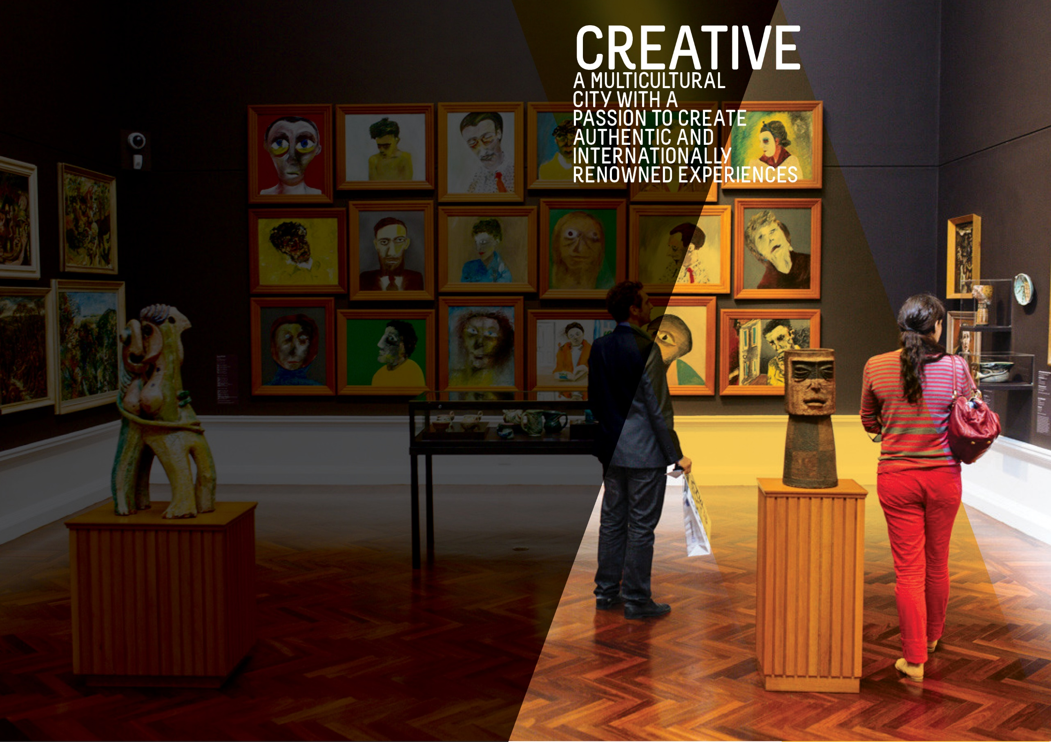
OBJECTIVES SUMMARY
The Creative theme has four objectives. Updated data was available for one of these objectives in the quarter and has been included in this report.
ACTIONS SUMMARY
Of the 32 actions under Creative, 31 were on track, none were on watch and one was off track.

31  ON TRACK |  | 0  ON WATCH |  | 1  OFF TRACK

OBJECTIVE | UPDATE | STATUS
ATTENDANCE AT FESTIVALS AND EVENTS IN THE CITY AND PARK LANDS WILL HAVE GROWN BY 5% BY 2020 | According to the latest event attendance figures available, there were a total of 5.693 million attendances at festivals and events in the City in 2016-17 (averaged over two years). This is an increase of 0.9% or 48,000 attendances from the baseline.  In 2017, the Fringe Festival experienced record-breaking ticket sales, which is reflected in their increased attendance and was the main driver of higher attendances in 2016-17. There were also higher attendances at the Tour Down Under however these have been tempered by slight declines in attendance at other events. (Last updated Q1 2017/18)  Data source: City of Adelaide | BASELINE:  5.62 million attendances  (average of 2013-14 and 2014-15)  UPDATE ON OBJECTIVE:  5.69 million attendances  (average of 2015-16 and 2016-17)  NEXT UPDATE: 2018  DIRECTION OF CHANGE: favourable variance
A DETAILED MEASURE OF THE NUMBER OF PEOPLE CREATING AND ACTIVELY PARTICIPATING IN ARTS AND CULTURAL ACTIVITIES WILL HAVE BEEN DEVELOPED AND INFLUENCES OUR WORK | This measure was established to capture the level of active participation in arts and cultural activities in the City. The data is collected through the City of Adelaide's annual City User Profile (CUP) Survey, which asks City users (people who are in the City on the day of the survey) whether they had actively participated in any of a specified range of activities in the City in the preceding 12 months. These activities include creating music, participating in a theatre/dance/performance/event, parade or show, visual arts and craft and creative writing and is based on the Australian Council of Arts definition of active participation.  The results from the 2017 CUP Survey found that the number of City users who actively participated in arts and cultural activities increase to 18% compared to 16% in 2016. (Last updated Q1 2017/18)  Data source: City of Adelaide City User Profile (CUP) Survey 2017 | BASELINE:  16% (2016)  UPDATE ON OBJECTIVE:  18% (2017)  NEXT UPDATE: August 2018  DIRECTION OF CHANGE: favourable variance
BED NIGHTS SPENT IN ADELAIDE BY INTERNATIONAL AND DOMESTIC VISITORS WILL HAVE GROWN FROM 8.1 MILLION TO 9 MILLION BY 2020 | In the year to December 2017, the number of international and domestic visitor nights to the City reached 9.2 million and is 14.2% higher than the same time last year.  The growth over the year has been driven mainly by an increase in the number of international visitor nights, which in rose from 3.8 million in the year to December 2016 to 4.7 million in the year to December 2017 (+22.7%). Domestic visitor nights on the other hand, also increased from the previous year though a smaller rate of 6.6% from 4.2 million to 4.5 million.  Data source: Tourism Research Australia, unpublished data | BASELINE:  8.059 million (June 2014)  UPDATE ON OBJECTIVE:  9.271 million (year to December 2017)  NEXT UPDATE: Mid 2018  DIRECTION OF CHANGE: favourable variance
PEOPLE WHO SAY THE CITY HAS GREAT PLACES TO ENJOY EVENTS, ACTIVITIES, ART AND CULTURE WILL HAVE GROWN FROM 8.4 TO 9 OUT OF 10 BY 2020 | According to the 2017 results of the City User Profile (CUP) Survey, the average rating out of ten for this statement has remained the same as the baseline figure and is slightly higher than the 8.2 recorded in 2016. (Last updated Q1 2017/18)  Data source: City of Adelaide City User Profile (CUP) Survey 2017 | BASELINE:  8.4/10 (2015)  UPDATE ON OBJECTIVE:  8.4/10 (2017)  NEXT UPDATE: August 2018  DIRECTION OF CHANGE: No change
THE NUMBER OF PEOPLE THAT ARE VISITING THE CITY EACH DAY FOR SHOPPING, LEISURE OR ENTERTAINMENT WILL HAVE GROWN FROM 111,000 TO 117,000 BY 2020 | The number of people visiting the City each year continues to increase and has exceeded the target of 117,000 by 2020. (Last updated Q1 2017/18)  Data source: City of Adelaide | BASELINE:  111,141 (2014)  UPDATE ON OBJECTIVE:  146,600(2016)  NEXT UPDATE: August 2018  DIRECTION OF CHANGE: No change

ACTION | UPDATE | STATUS
Advocate for the interstate rail station to be relocated back to the Adelaide Railway Station to capitalise on the iconic Indian Pacific, Ghan and Overland rail services | Liaison continues with the State Government on the return of interstate train services to Adelaide Railway Station. | on track
Attract and support artists and cultural entrepreneurs to develop commercial opportunities | In Quarter 3, Business Models Inc. (BMI) was engaged as partner for the creative entrepreneurs program The Business of Being Creative (TBOBC), and expressions of interest for participation in the program have opened.  Interim Emerging Curator exhibition delivered ‘Looking Backwards, Moving Forwards’, showcasing the Civics collections across the Art Pod, Adelaide Town Hall and Pirie Street Breezeway screens. This was the first comprehensive exhibition of the Contemporary Art Acquisitions from the CoA Civic Collection featuring significant artists such as CJ Taylor and James Tylor whose works are held in national collections, to critically engaged emerging artists, Sophia Nuske, and Emmaline Zanelli. As part of the Emerging Curator program review, an interim partnership has been developed with an external partner to deliver the program from May to the end of August, including exhibitions that will feature in SALA Festival 2018. | ON TRACK
Attract people from around the world, especially from China and India, to spend more time and experience more hospitality activities in the City | The Lord Mayor, on behalf of the City of Adelaide officially invited our Sister Cities to visit Adelaide in 2018. A City of Adelaide representative presented at the OzAsia Smart City Forum on a "New urban agenda through smart cities" in our Sister City, Penang, Malaysia.  As part of the City of Adelaide & Qingdao Tourism Memorandum of Understanding, 1,000 Chinese language printed copies of the ‘Top Ten Sights and Activities’ itinerary were sent to Qingdao for distribution. Qingdao collateral was received in mid-March and initial distribution has commenced in Adelaide. | ON TRACK
By 2020, develop build and upgrade infrastructure that supports events and is sensitive to the environment within key event spaces in the City and Park Lands | Following the infrastructure audit of key Park Land event sites and consultation with key stakeholders, an Event Infrastructure Upgrades in the Park Lands Committee workshop was presented to Council in March. This workshop outlined the current state of four Park Land event sites identified for priority event infrastructure upgrading as well as the future needs and aspirations for these sites. Approaches for upgrades, including co-contribution funding models were also discussed. Planning for infrastructure upgrades will now commence as part of the relevant Park Land master planning. | off track
By December 2020, Council will install a network of NBN-enabled interactive wayfinding stations to build on the current roll out | Procurement for wayfinding devices were completed in Quarter 3 with contract negotiations currently underway. | on track
By June 2017, develop an Arts and Culture Strategy | No further updates as this Action is complete. | on track  (completed)
Complete the Rundle Mall Master Plan, including Gawler Place, to link major City attractions | Initial construction activities have commenced on the Gawler Place Upgrade project, including the locating of underground service utilities. A contractor will be appointed soon and full construction to commence in May 2018. | on track
Consider policy de-regulation to allow more interesting temporary opportunities in private buildings | No activity was planned for this quarter. | on track
Identify opportunities to use specialised lighting to showcase the City’s unique attractions, character and heritage | The East End Creative Lighting Plan is being developed. Decorative lighting has been implemented along North Terrace and outside the Hampshire Hotel. The CoA Lighting Master Plan is underway. | on track
Increase public art and cultural expression in private development by using planning levers and requirements | No activity was planned for this quarter. | on track
Partner with cultural institutions to increase visitations in the City and Park Lands | Music SA was supported by CoA to deliver the Fringe Opening Night ‘Frusic Stage’ on North Terrace, which showcased eight (8) local original live acts from 5pm to 10pm and had an approximate visitation of 100,000.  Case management support was provided to the Art Gallery of South Australia in respect to installation of artworks for the Adelaide Biennial of Art. Four (4) Rock the Square events in Victoria Square / Tarntanyangga at lunchtime and twilight were delivered and promoted, featuring eight (8) unique original local acts across a variety of genres with a total of 950 participants attracting 2,300 followers on Facebook.  A partnership was developed with the Australian Dance Theatre for the 2018 inaugural Adelaide Dance Festival to include a number of outdoor activations. | on track
Promote and showcase multiculturalism and Aboriginal culture and support local organisations to express this heritage | To date, 27 of 31 actions in the endorsed Stretch Reconciliation Action Plan 2015-2018 have been delivered. | on track
Promote our UNESCO Live Music accreditation to attract more opportunities for new live music venues | As part of the Live Music Action Plan, a new Live Music Enterprises Grant Category was facilitated with two (2) successful applications of $5,000 each.  To promote the City of Adelaide’s UNESCO Live Music accreditation, 1,000 Adelaide City of Music information booklets were produced and distributed to city venues and Council members.  Working with Young Adelaide Voices and Adelaide Town Hall for the upcoming WATU Youth Choir Festival (a UNESCO City of Music branded event) in July 2018. | on track
Provide support to key festivals and organisations to assist them in offering events and activities that attract visitors to the City | A combined report for Quarter 1 and Quarter 2 was received from Festivals Adelaide in December 2017. Key activities and highlights from this report included:  - Participation in regular think tank consultations across the public and private sector including Adelaide 500 planning day and Riverbank and Economic Development Board consultation;  - Launch of the Festival Volunteer Network;  - Continued dialogue with the International Festival City Networks existing members (Edinburgh, Montreal and Krakow) as well as three potential new members;  - Workshop delivered by Barry Burgan (Economic Analyst) with Festivals Adelaide members around economic modelling; and  - Planning for famil program (in partnership with SATC) to bring high profile travel agents to Adelaide to experience the summer festivals.  Five (5) sponsorship agreements/addendums were executed during the quarter (22 agreements Year to Date). One (1) agreement was initiated during the quarter but not finalised. $90k sponsorship funding was distributed this quarter ($1,459,000 YTD). The call for funding applications for 2018/19 commenced on 9 March 2018. | ON TRACK
Pursue completion of the North Terrace Boulevard, focusing on the evolving health and biomedical precinct and the Riverbank precinct | A project is now underway to prepare a concept plan for North Terrace West. The project is jointly funded between the City of Adelaide, Renewal SA, and the Department for Planning, Transport and Infrastructure. A concept plan will be finalised mid-2018 for consideration by a range of funding partners including Council, the State Government, the universities and the private sector. | on track
Streamline Council processes for events to be hosted in the City and better enable City businesses to benefit from these events | Over this quarter, nine Splash Adelaide events, activities and/or projects were delivered. Of particular note was the So Frenchy So Chic event held in Pinky Flat which was the first time this event was held in Adelaide, bringing a unique French cultural experience to the City to approximately 2,500 attendees.  A number of initiatives have been delivered with the purpose of activating the City and engaging with City businesses including the 5-week East End extended dining activation on Rundle Street during the Adelaide Festival season. As part of this activation, Council offered businesses along the East End of Rundle Street, Vardon Avenue, Ebenezer and Union Street the opportunity to extend their outdoor dining and licensed area in line with the Adelaide Fringe Festival road closure dates. For this first year, Council offered to provide businesses with the additional furniture required to service their extended outdoor area at no additional cost. Road closures were also coordinated as part of this to maximise pedestrian circulation. To add to the activation, four busking pitches were arranged and programmed in key locations around Rundle Street. Feedback from businesses has been very positive.  Over this quarter, a project team has continued to negotiate with the successful vendor for the new Event and Venue Management Solution. Ungerboeck Software will be used as part of this project, providing a solution that allows customers to enquire about and book Council spaces and venues online. This project continues to progress. | on track
Support businesses, community groups and individuals to grow their contribution to the creative, cultural and artistic life of the City | Round 3 of the Arts and Cultural Grants were delivered featuring two new categories for Live Music Enterprise and Cultural Promotion with some strong applications received in both categories; four activities supported to the value of $14,000 for a series of SA music focussed podcasts, a local internet radio station, promotion of cultural activities at the iconic arts venue Tuxedo Cat and banners for the SA Public School’s Festival of Music. Seven Quick Response Grants were awarded to the value of $11,000. Round 1 Arts and Cultural Grants for expenditure in 2018-19 opened featuring Artistic Development, Public Arts and Community Programs and Events Categories. Smartygrants implementation has been delayed.  The City Library hosted five exhibitions including Magic Lanterns in partnership with the City of Adelaide Archives, Music Everywhere, Mindful Paper Art and I Do Not Have a Home with City Library residents Adam Ritchie, Kara Gillett and Jennifer Eadie and The Adelaide Fringe Exhibition, featuring works and paintings by six local and international artists launched by the Lord Mayor. The City Library kicked off the 2018 Philosophy Café series with an engaging discussion about Margaret Cavendish: Scientific Radical facilitated by University of Adelaide’s Head of Philosophy, Dr Antony Eagle.  Members of the community took the opportunity to share their work with local writers at the library through regular monthly meetings of the City Writers Group. In partnership with Brainary Institute a successful NAO Robot masterclass and Robot Dance competition was run with over 130 attending the dance off. Partnering with the National Museum of Australia guests viewed traditional and modern works of the Seven Sisters, custodians from the Martu, Ngaanyatjarra, Pitjantjatjara and Yankunytjatjara lands by viewing an interactive video tour of the exhibition Songlines: Tracking the Seven Sisters. Anthony Frith ran an Audio Residency to demonstrate the power of sound and the dramatic effect it has, and Jennifer Eadie ran a series of poetry workshops to create poetry to form part of a multimedia exhibition I Do Not Have a Home.  Cultural Strategy engagement continues with the creative and cultural community and positive feedback received. The Public Art Program and Live Music Action Plan were delivered. The strategic partnership with Music SA was expanded to develop and deliver a new, unique all ages event in a city live music venue. Further strategic partnerships were formed with Guildhouse, to deliver Art Works, creative activation of the Minor Works building to deliver artist residencies, a writer in residence, and a series of artistic workshops; and City Standard, to support and promote the creative practice of storytelling, writing and film in the City. A strategic partnership is in development with Australian Dance Theatre, to provide outdoor dance experiences across the City as part of the inaugural Dance Festival in July 2018.  The Riverbank Love Knot, created by Mulloway Studio and Iguana Creative, was installed and launched. The process for the development and delivery of two public art opportunities, a sculpture and integrated public art in feature design elements such as seating, lighting and bike racks, for the Gawler Place Upgrade project was undertaken; a Public Art Reference Group was established; and the EOI process completed for opportunity one with 16 submissions received from South Australian artists. Artists for the Market to Riverbank art opportunities four and five (Stop Motion) engaged. Development towards an upgrade to the surrounds of the Cultural Marker scoped after consultation and support provided by the Reconciliation Committee. Restoration of public artwork in Leigh Street by Julie Henderson, Leith Elder, Caroline Farmer commenced. | on track
Support the Adelaide Convention Bureau financially and in-kind to encourage longer stays and add value to the visitor experience, especially in areas that support Council’s strategic agenda | Funding agreement in place and has been monitored. | on track
Surprise, delight and attract people by continuing to encourage and support dynamic and changing urban public spaces, heritage, art, laneways, streets, facilities and activities | The Chinatown Reinvigoration project is progressing and will be completed in mid-2018 for consideration by Council.  Work on the Veale Gardens Rose Garden statue installation is now complete. Some remaining rose planting is to occur as the seasonal varieties become available. The garden was opened on 25 February 2018.  Bank Street and Topham Mall are now complete, Gawler Place is now under construction. Design and other works on the remainder of Market to Riverbank Link continue. An upgrade to Gresham Place was completed, with Gresham Street currently being upgraded with new outdoor dining, seating, paving and lighting. | on track
Upgrade and improve amenity to create a higher quality visitor and trader experience by implementing the Our Market District Plan | The Chinatown enhancement plan has been drafted and the Gouger Street public realm enhancements have been scoped. Input has been received from local stakeholders and the Market District Reference Group. | on track
Work in partnership with key stakeholders to attract a winter music festival by June 2018. | An agreement with Music SA was executed to support Umbrella Winter City Sounds 2018 City curated events component, and Opening Night. Over 100 music industry participants were addressed at the Umbrella Information Session, encouraging the development of open access events in the City and North Adelaide during Umbrella. | ON TRACK
Work with businesses and other partners to bring creativity and smart technology into the everyday experience of our City | The People Movement Project has progressed and work is underway to confirm appropriate locations for the next set of sensors. Development of methodologies of how the data will be analysed to allow for insights to be derived and applied to ways of enhancing the everyday experience of our city is underway. | ON TRACK
Work with existing festivals and events to increase the number and diversity of audiences and visitors | Planning for Anzac Day Youth Vigil, Dawn Service and Commemorative March is on track.  Over the third quarter, CoA developed and executed marketing campaigns to support two major events-based marketing campaigns: Summer in the City and the 88 O’Connell Street Community Celebration.  The Summer in the City campaign targeted city workers and intra / interstate visitors to drive extended visitations across the CBD from January to mid-March. The aim of this was to boost local expenditure in association with the cities major events across key precincts and promote numerous non-event based activities and retail opportunities.  The 88 O’Connell Street Community Celebration created an informal opportunity for CBD residents, along with metropolitan Adelaide residents, to enjoy regaining access to this iconic site and register their interest in having a say for the future development plans. | on track
Work with neighbouring councils and the State Government in funding and governance to enhance the role of the Park Lands as a key City asset in supporting artistic and cultural activities | Council continues to build on relationships with key stakeholders to develop a full calendar of activities in the Park Lands and squares guided by the Adelaide Park Lands Management Strategy.  During this quarter, support was provided for the development of a number of public art opportunities in Park 16 and Park 19. In addition, Council provided funding and support for the loan and installation of the Art Gallery of SA’s Terrance Plowright sculpture in the River Torrens.  The Riverbank Love Knot was installed and launched. | on track
Work with partners and key stakeholders to develop Adelaide as the premier international arts market, especially within the Asian region | The Festivals Adelaide Quarter 2 Review Meeting (usually held in Q3) was combined with the Quarter 1 Review Meeting held in December.  A combined report for Quarter 1 and Quarter 2 was received from Festivals Adelaide at that time.  The Quarter 3 Review Meeting is scheduled for 18 April 2018. | ON TRACK
Work with partners to improve the arrival experience of tourists at Adelaide International Airport and other entry points into the City | A significant landscape upgrade to Sir Donald Bradman Drive is nearing completion to enhance the arrival experience into Adelaide from the Airport, together with an ongoing rollout of the wayfinding signage. | on track
Work with partners to increase opportunities for live music / performers by developing and implementing a range of policies, programs and services | Four (4) Rock the Square events in Victoria Square / Tarntanyangga at lunchtime and twilight were delivered and promoted, featuring eight (8) unique original local acts across a variety of genres with a total of 950 participants attracting 2,300 followers on Facebook.  Live music enterprises during the summer events season were supported by streamlining processes and maximising opportunities through the deregulation of Council’s liquor licencing laws. | on track
Work with partners to promote a comprehensive calendar of events and activities | Over this quarter, various avenues have been used to promote the calendar of events and activities. This included a monthly distribution to key internal and external stakeholders showing a three-month forecast of upcoming events. In addition, information was provided via Council’s What’s On website with third parties being encouraged to use this platform as part of their marketing and communication strategy. 11,055 people accessed the What’s On page this quarter, making it the sixth most visited page on the City of Adelaide website.  With the aim of providing a year-round program of activation, particularly during the winter months, this quarter Council endorsed a proposal from Skating At to deliver an ice skating festival in Victoria Square/Tarntanyangga over June/July 2018. | on track
Work with the Federal and State governments and Aboriginal Elders and representatives to establish a national centre for Aboriginal and Torres Strait Islander culture and heritage | No opportunities for City of Adelaide have arisen this quarter to work with other tiers of government to establish a national centre for Aboriginal and Torres Strait Islander culture and heritage. | on track
Work with the South Australian Tourism Commission and the private sector to develop a visitor experience that maximises visitor spend in the City | During this quarter, the Adelaide Visitor Information Centre had 27,934 people through the doors and assisted 8,948 face-to-face enquiries.  There was a 14.6% decrease in visitors through the door against the same time last year. The location of the centre is the main contributing factor for the decreased visitation. International visitors accounted for 49% of visitors, 32% were from interstate and 19% were intrastate and locals. Volunteers contributed 2,225 hours to the operation of the centre.  Visitor information booths were provided at the Tour Down Under and StudyAdelaide and the Lord Mayor’s international student forum. The student forum had approximately 600 international students. 800 visitor itineraries, 200 Heritage & Folklore trails, 200 Adelaide visitor guides and 400 'Experience the Best of Adelaide' tote bags were distributed. It is estimated that 30% of the students in attendance were from China.  In January, the new Adelaide visitor guide was released was produced by HWR Media in collaboration with City of Adelaide, City of Port Adelaide Enfield and City of Holdfast Bay.  In February, a new Heritage & Folklore trail guide was launched which includes a printed foldout guide, additional content online and eight (8) audio tracks for a more immersive and engaging experience. A short teaser video promoting the Adelaide Town Hall tours was also launched on the tours page of the Adelaide Town Hall website. The video is also on the City of Adelaide YouTube channel and will be used on social media.  March saw the end of the 2017/18 Cruise Season with the last ship arriving on Good Friday. An information sheet about what was open in the City on Good Friday was provided to Event Managers South Australia for use at Outer Harbour, Adelaide Metro for the train station, SATC, the visitor information centre and the City of Adelaide volunteers providing a meet & greet service that day. The listing included 28 city attractions and services and 27 hospitality businesses and was received very positively by all partners.  The City of Adelaide’s Economic Insights dashboard and Ten Gigabit Adelaide projects were promoted through SATIC’s business to business magazine ‘The View’ Autumn edition. Readership is 2600 per issue and is made up of members who own and manage: Accommodation, attractions, destinations, events, tours & transport, tourism services and hospitality interests in South Australia. | on track
Work with the State Government to facilitate the attraction of an additional major annual international event during the winter months | Future opportunities to facilitate the attraction of an additional major international event have been discussed with South Australian Tourism Commission Destination Marketing. Discussions have also been held with State Government to understand the opportunities from international relationships. The MasterChef partnership works were supported during this quarter, which will form a winter promotion of Adelaide as the TV show preview in June, this will assist in driving international and national awareness of the city. | on track
Work with the State Government, to achieve the best outcome for the City in the development of the Riverbank Precinct, including the Festival Plaza upgrade, the Adelaide Convention Centre redevelopment, the South Australian Health and Biomedical Precinct, and planning for the old Royal Adelaide Hospital site redevelopment. | Council continues to work with the State Government on the design of key infrastructure and redevelopment projects within the City. This includes providing advice on design, planning, infrastructure and transport related matters for projects including the AdeLINK Light Rail Network, ORAH, Riverbank Precinct, Adelaide Festival Centre upgrade, Her Majesty's Theatre, Memorial Drive Tennis upgrade, planning reform, and the O-Bahn City Access Project. | on track

