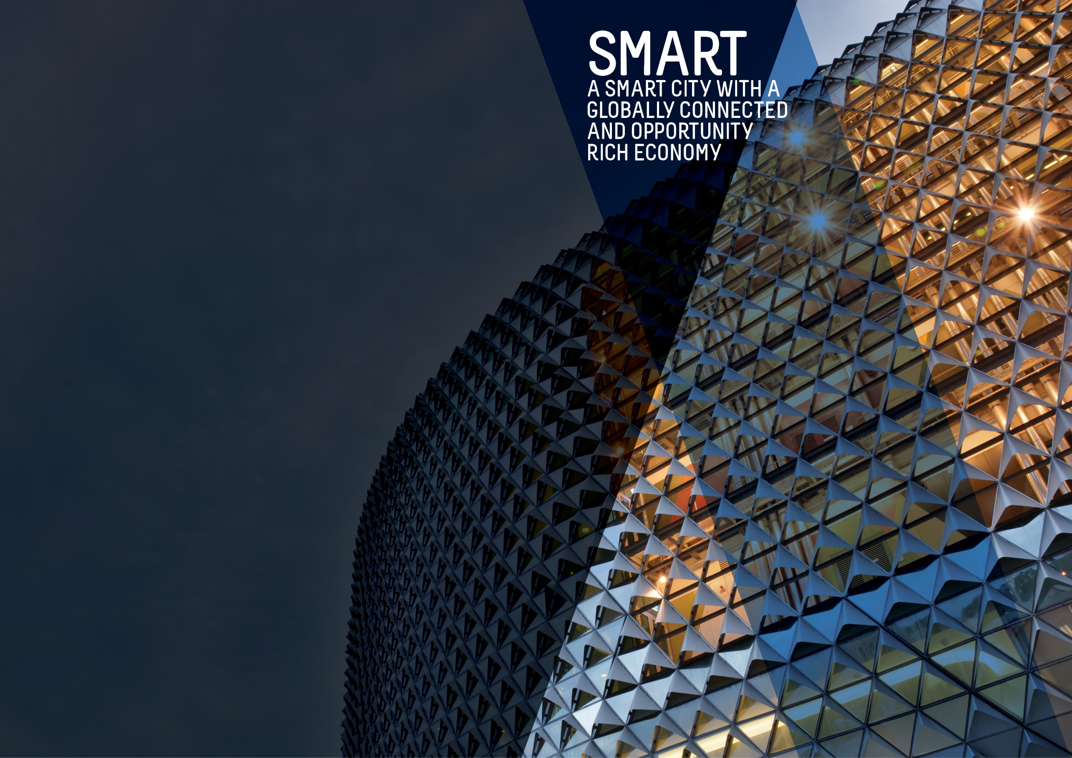
OBJECTIVES SUMMARY
The Smart theme has four objectives. Updated data was not available against any of these objectives in the quarter.
ACTIONS SUMMARY
Of the 26 actions under Smart, 20 were on track, three were on watch and three were off track.

20  ON TRACK |  | 3  ON WATCH |  | 3  OFF TRACK

OBJECTIVE | UPDATE | STATUS
BY 2020, OUR CITY’S ECONOMY WILL BE GROWING FASTER THAN THE AUSTRALIAN ECONOMY | In the year to 30 June 2017, the City's economy grew by 1.4% from $17.8 billion to $18.1 billion. In comparison, South Australia's economic growth was 2.6% over the year while national economic growth was 2%.  For the first time since the introduction of the City of Adelaide's 2016-2020 Strategic Plan, the economic growth of the City was lower than that of South Australia and Australia.  Data source: National Institute of Economic and Industry Research (NIEIR) 2016, presented by economy.id | BASELINE:  GRP growth 2.4% (June 2014)  GDP growth 2.5% (June 2014)  UPDATE ON OBJECTIVE:  GRP growth 1.4% (Jun 2017)  GDP growth 2.0% (Jun 2017)  NEXT UPDATE: May 2019  DIRECTION OF CHANGE: unfavourable variance
TOTAL BUSINESSES IN THE CITY WILL GROW FROM 5,000 TO OVER 5,300 AND WORKERS ON ANY GIVEN DAY FROM 89,000 TO 94,000 BY 2020 | The number of workers in the City has continued to increase from the baseline figure of 89,000 although at a slower pace compared to previous years. In 2018, there are an estimated 91,500 workers in the City on an average weekday.  There has been no updated data for the number of businesses in the City since Quarter One 2017/18.  Data source: City of Adelaide Census of Land Use and Employment (ACCLUE) 2016; City of Adelaide City User Profile (CUP) Survey 2016; ABS, ‘Regional Population Growth, Australia, 2014-15’ (Cat. No. 3218.0) | BASELINE:  89,000 workers daily (2014)  5,055 city businesses (2014)  UPDATE ON OBJECTIVE:  91,500 workers daily (2018)  5,196 city businesses (2016)  NEXT UPDATE: TBA  DIRECTION OF CHANGE: favourable variance
WORKERS IN PROFESSIONAL AND TECHNICAL SERVICES, EDUCATION, FINANCE, TELECOMMUNICATIONS, CREATIVE AND MEDIA SECTORS WILL HAVE GROWN FROM 41,000 TO OVER 49,000 | The number of workers employed by knowledge sector establishments fell by 12% from 40,279 people to 35,650 and is due to a decline in employment across all the knowledge industries. The largest decrease was in the Professional, Scientific and Technical Services sector (-1,968) and the Information, Media and Telecommunications sector (-1,802). This is likely to be due to the reduction in the City based Telstra workforce and the reduction/amalgamation of Internet Service Providers (ISPs) since 2014. (Last updated Q2 2016/17)  Data source: City of Adelaide Census of Land Use and Employment (ACCLUE) 2016 | BASELINE:  40,700 workers in knowledge sectors (2014)  UPDATE ON OBJECTIVE:  35,650 workers in knowledge sectors (2016)  NEXT UPDATE: TBA  DIRECTION OF CHANGE: unfavourable variance
BY 2020, THE NUMBER OF STUDENTS IN THE CITY ON ANY GIVEN DAY OF THE WEEK WILL INCREASE FROM 39,000 TO 41,000 | In 2017, there were approximately 43,000 students in the City on an average weekday. This represents a 7.5% decrease from the number of students in 2016 and could be due to the increasing prevalence of online courses and delivery modes that make it easier for students to study off-site. Nevertheless, the 43,000 continues to be higher than the 39,200 students during the baseline year in 2014 and is in excess to the target of 41,000.  Data source: City of Adelaide City User Profile (CUP) Survey 2018; ABS, ‘Regional Population Growth, Australia, 2016-17’ (Cat. No. 3218.0) | BASELINE:  39,200 students daily (2014)  UPDATE ON OBJECTIVE:  43,400 students daily (2017)  NEXT UPDATE: August 2019  DIRECTION OF CHANGE: favourable variance

ACTION | UPDATE | STATUS
Adopt smart technologies that demonstrate a clear return on investment through new recurring revenue generation models such as; sourcing of external funding, fee for services, data, intellectual property, licensing, proprietary technologies, sharing of services and efficiency dividends | Discussions are being held with City of Playford and City of Salisbury regarding establishing fibre connection to City of Adelaide. City of Onkaparinga has recently commenced a 5-year agreement with City of Adelaide to utilise some of our spare hosting capacity as a result of CoA’s move to Public Cloud Platforms.  A way forward for procurement of way-finding devices will be considered pending outcome of Community Engagement held in July. | on track
Assist businesses and institutions to attract talent by developing and making available collateral promoting Adelaide as a great place to work and live | The City of Adelaide met with several businesses and investment intermediaries to provide collateral and drive visitation to the Invest Adelaide website. News stories and the Economic Insights Dashboard continue to be a valuable resource to drive traffic to the website. Eighteen stories were promoted on the website which covered new investments into Adelaide and the capability of Ten Gigabit Adelaide as a business enabler. These stories have been shared through regular email distributions and via social media such as LinkedIn and Facebook. A revised Investment Prospectus was completed during this quarter. | ON TRACK
Become a world-renowned education City by supporting and partnering with the City’s education sector to attract and retain international, national, regional South Australian and local students, and highly credentialed academic and research staff | During this quarter, CoA collaborated with StudyAdelaide on the Student Ambassador competition. The winners of the competition will be announced in China in July. | on track
Bring together the creative, arts, business, university, education and entrepreneurial sectors to promote unique opportunities for business growth | StudyAdelaide have developed the framework and engaged with City Universities’ employment / career offices. The role of City of Adelaide is to be finalised but will involve promotion and engagement of city businesses. | on track
Build upon the growing laneway and entrepreneurial culture in the City by rejuvenating primary laneways and pedestrian connections. Priorities for completion by 2018 will be the Adelaide Railway Station to Adelaide Central Market link and Rundle Mall laneways, including Gawler Place | Bentham Street underground service modifications are underway. These works will accommodate the new Travel Lodge development and Market to Riverbank (M2R) works. As a result, the M2R works have been rescheduled to commence August 2018. Leigh Street paving and public art works have been programmed to commence in July 2018 and will continue through to February 2019, minimising disruption to businesses and coordinating works with Service Authorities. The co-contribution Shop Front Improvement Grant is currently being implemented. The Pitt Street concept community engagement and consultation has been rescheduled to commence in January 2019 with construction commencing in September 2019. Gawler Place early works commenced with third party authorities APA & NBNco to undertake service relocations and future proofing. | on watch
By June 2018, as part of an improved customer experience we will develop a business plan and implement smart parking technology across the City and North Adelaide to move towards an expiation-free environment | Roll out of Smart Parking technology has commenced, with majority of sensor installation scheduled for completion in July 2018. The roll out has been delayed due to a protracted procurement process to ensure that CoA selects the right solutions while some delays have been due to inclement weather. | off track
By June 2018, develop and promote an international City brand that showcases the smart, liveable, green and cultural advantages of Adelaide | The City of Adelaide brand narrative and creative proposition has been developed and prepared. Preliminary discussions have been held with key stakeholders including Brand SA, SATC and StudyAdelaide. Brand deliverables being scoped including internal communications, brand handbook, media campaign and program support aimed at key consumer segments. | On track
By June 2018, leverage, upgrade and expand our AdelaideFree WiFi network to higher download and upload speeds | Opportunities to expand and improve the AdelaideFree Wi-Fi Network will now be investigated through potentially leveraging the Ten Gigabit Adelaide infrastructure. | off track
By June 2017, review Council’s commercial operations to determine the best management models | A range of reports have been provided to Council relating to each of Council’s businesses identifying both strategic and operational issues and opportunities. Preliminary discussions have occurred regarding options for governance structures with a further report being prepared by external consultants on options and proposed approaches that may also inform legislative changes. | on watch
By June 2018, work with key stakeholders in mainstreets and districts to develop business plans that will provide greater participation at the local level and appropriate governance models, as well as work on projects such as an O’Connell Street enhancement program | Work has been undertaken to achieve North Adelaide Precinct Association's (NAPA) desired enhancements to O'Connell Street. Additional engagement has been undertaken with NAPA on the utilisation of 88 O'Connell Street, events and current planned activations so that businesses can leverage from and maximise these activations.  Precinct groups have acquitted their 2017/18 Mainstreet Development Fund and applications are now open for the 2018/19 funding. The Lord Mayors Precinct Forums (LMPF) were held quarterly and were well attended. Precinct groups have re-established a pre-LMPF meeting to discuss overarching issues to present at the forum as a united voice.  Four Precinct groups received a Mainstreet Advancement Grant in the first half of 2018.  - China Town delivered additional lighting and marketing collateral for the Luna New Year.  - Adelaide West End Association developed ‘Future Hindley’ Place, Branding and Marketing plan to be launched at their AGM in August.  - East End Coordination Group in conjunction with Kukuni Arts will deliver 'East End Eats & Beats' as part of Umbrella Winter City Sounds, Adelaide Guitar Festival - Guitars in Bars and NAIDOC SA Week on the 13 July.  - North Adelaide Precinct Association held a successful car show in Tynte Street.  Applications are now open for the 2018/19 Mainstreet Advancement Grant. | on track
By June 2020, increase the City’s share of the retail and hospitality sectors and deliver ten new high-end stores and 40 start-up businesses by delivering the ‘Experience Adelaide’ Adelaide City Retail Strategy | A Luxury Retail Investment Prospectus has been created and the focus on attracting new retail investment in the city resulted in a trip to Sydney to meet with investors, retail leasing leaders and retail brands.  A Digital Disruption Forum held on 23 May focused on "new retail" trends and opportunities. This was followed up with a stakeholder forum with retailers, technology and service providers taking a close look at the future retail opportunities for Adelaide and the stakeholder expectations of Council. The Colliers Shop Front Vacancy Survey was also conducted, and the report will be available next quarter.  New retail technology providers, Brauz and Passel have brought their services to assist in the promotion of retail offers to shoppers. | on track
Council will continue to liaise and work closely with NBN Co in support of the NBN roll-out across the City | The City of Adelaide is continuing to support NBN Co with their city-wide rollout based on NBN Co's schedules for deployment. | on track
Council will work with key partners to facilitate a 10GB per second capable broadband network across the City and North Adelaide to all premises | Ten Gigabit Adelaide has achieved its project milestone of signing up more than 1000 buildings. TPG are now finalising their technical fibre designs in preparation for commencement of physical construction and roll out. | on track
Each year, increase online open access to meaningful Council-held data and information that empowers residents, visitors, researchers, investors, start-ups and established businesses to make informed, smart decisions | This is the fourth quarter since an electronic system has been in place to track Council's progress against the Strategic Plan. The use of the electronic system is now embedded within the organisation and work is currently underway to gather information to prepare for 2018/19 reporting.  Online access to key data is available through the Economic Insights Dashboard and Development Application Registers showing lodged and completed applications. | on track
Establish single-point-of-contact case managers to support established businesses to grow and attract sustainable businesses, investment and new corporate headquarters to the City | The Case Management process (CM) implemented across relevant Council programs/ activities with an interest in investment attraction. A key feature of CM has been the high level of engagement and relationship building with key external stakeholders to identify investment leads, develop cases and respond to firm investment enquiries and concepts in more formative stages. These include: State Government's Investment Attraction SA agency, the principals and directors of capital transactions within the major commercial property companies, the broader commercial market fund managers, student accommodation managers, property developers, the universities, peak industry and sector groups.  The Ten Gigabit Adelaide initiative has proved to be a major driver of investment interest nationally and off-shore. This has been evidenced through several capital transactions and well as relocations to the City by major firms seeking to significantly enhance their data capability and management costs. that have been greatly enhanced through the Ten Gigabit initiative.  A total of 24 investment initiatives are currently under case management with the City of Adelaide | on track
Facilitate development of the fastest growing sectors, including professional and scientific services, arts and creative industries, by engaging with business leaders to foster collaboration and to assist in identifying and responding to opportunities and challenges | The Adelaide Smart City Studio continues to be a focal point for smart city innovation. Three start-up events were held attended by 112 people during the quarter, focusing on economic priority areas such as Artificial Intelligence, EdTech and Advance Manufacturing.  The Studio’s two smart city start-ups being incubated held their demo day in June. “Peak”, the Festival and Event Tech team, is now investigating City of Adelaide as a potential customer of their Economic Impact Platform. The Water Tech team has signed agreements with commercial partners, including SA Water, and has appointed a developer to code their AI system. Discussions have commenced with a third smart city team from University of Adelaide’s Australian Centre for Robotic Vision for an Urban Mapping project utilising cameras on rubbish trucks.  The tenure of Kirk Drage as Entrepreneur In Residence (EiR) concluded during the quarter with a Program Wrap Up event at ODASA to thank the industry experts who participated on panels for the EiR event series throughout the year. | On track
From 2016 to 2019, increase activity in underutilised premises by providing three years' financial support to Renew Adelaide | KPIs for 2018/19 will be set with Renew Adelaide following receipt of Renew Adelaide’s 2017/18 report quarter one 2018/19. | on track
Promote opportunities and develop projects to showcase the City’s unique heritage and character as a catalyst for sustainable growth and to grow the heritage tourism market | The Visitor Information Services program offered ten experiences in the 2018 History Festival program including Town Hall tours in languages other than English, a self-guided walking trail, and numerous talks session on topics such as ‘Colonel Light Tales’, ‘Portraits and Panels of the Council Chamber’ and ‘The Life Story of Queen Adelaide’.  550 people attended the tours and talks in 2018, this was a 51% increase on the attendees to the 2017 History Festival tours and talks offered by the Visitor Information Services program.  Two City of Adelaide staff attended the National Heritage Tourism Summit in Burra in May.  The City of Adelaide has committed to contribute to the development of a National Heritage Tourism Strategy which the National Trust SA are leading. | on track
Pursue a definitive outcome for the future of the former Royal Adelaide Hospital site as a world class precinct that complements the Park Lands, North Terrace cultural precinct and the East End commercial precinct | This strategic action is now complete and can be closed. East end activations will occur as part of business as usual. | ON TRACK  (COMPLETED)
Showcase the City as the location of choice for international and national trade and investment, especially for the knowledge, arts and cultural sectors, through our sister cities and other partnerships and connections, and align with State Government economic targets for increasing foreign investment, service exports and skilled migration. | City of Adelaide hosted the Indonesian Consul-General, Australia’s Consul-General to Chengdu, and received a delegation from Brittany, France. An invitation from Minister Ridgway was accepted to participate in the State Government Business Mission to China in July 2018. Preparations were underway for the Lord Mayor to visit our Sister City in Penang in July 2018 for the 45th Anniversary of our Sister City relationship.  Improvements have been identified for the dashboard and implemented with options being investigated to make the dashboard more mobile responsive.  Work has commenced with an external partner to scope and plan the next phase of the dashboard to be implemented in 2018/19.  A presentation on the project was given during the Local Government Information and Technology South Australia’s 'Adapt & Thrive' Conference obtaining great feedback from other Councils. | on track
Strengthen relationship with Study Adelaide via continued support from 2016 to 2020 to market Adelaide as an international student destination | KPIs are being formulated to include other International student programs. This will be negotiated and finalised in quarter one 2018/19. | on track
Support development of the clean technology sector through a range of programs, services, initiatives and data, including supporting start-up and growth of new businesses and working with universities to assist with commercialising research and intellectual property for clean-tech applications | Work has continued on a Low Carbon Economy Plan to inform the Low Carbon Council Road Map. The plan is scheduled to be presented to Committee in August and to Council for adoption in late August.  City of Adelaide green credentials were promoted via the creation and promotion of news stories. These covered investments made by businesses and projects Council is undertaking to activate green investment opportunities.  Multiple investment leads were supported which could support the growth of City of Adelaide green economy.  Consideration given to foster the take-up of the Building Upgrade Finance Program (BUF) with the Market Development Plan being developed.  CoA helped raise the awareness of BUF with industry with a hosted Industry Briefing on 29 June, attended by 55 industry representatives. Attendees had the opportunity to learn how this new mechanism could help them and their clients unlock the economic benefits of commercial building upgrades, reduce operating costs and improve environmental and heritage values. | off track
Transform our services and business processes to improve our effectiveness and efficiency and provide improved quality communications, including having all Council forms able to be submitted online by 2018 and all development applications able to be submitted online by 2020 | With the online submission of development applications already completed, the ePlanning project has now successfully completed all dashboards including the launch of external facing interactive development application registers. The implementation of all other online forms has also commenced. All remaining paper-based/non-digital forms will be completed and online by July 2018. | on track
Work with key partners to create a national centre for applied research and education into the digital economy | Support was provided towards the establishment of the Collab4Good coworking space at the former Royal Adelaide Hospital, and a donation was made towards CoworkingSA’s events held during Entrepreneurs Week. Discussions are ongoing about City of Adelaide’s positioning and potential role/contribution to the new State Government’s innovation hub at Lot14 at the former Royal Adelaide Hospital site. | on watch
Work with our local and global partners through a range of projects and initiatives to build on the city-wide culture of entrepreneurship, start-ups and the commercialisation of research and ideas | Financial support was agreed for three major high growth start-up events - Hybrid World Adelaide, Southstart and Entrepreneurs Week.  The 2018/19 strategy for the Smart City Studio and the Entrepreneur Support Programs are currently being reviewed. | On track
Work with partners to develop and implement a range of policies, programs and services to support business start-ups, business growth and business sustainability | A city-wide “Business Support Program” was held with seven events held between April – June. Four ‘Business Support Program Launch’ events were held in various districts across the City in April followed by three themed workshops held centrally in Pilgrim Hall. This was an extension of the successful program rolled out in the East End last year and provided updates on local works and opportunities for business.  188 businesses attended the four ‘launch’ events and of the attendees surveyed, between 75-90% found the presentations highly relevant to their business and its future.  Leading on from the launch events, three themed workshops were delivered with several subject matter experts. These workshops included;  • Leveraging Events and Visual Merchandising - 7 May (40 attendees)  • Digital Disruption and Marketing - 23 May (106 attendees)  • Trading with the Chinese Visitors - 4 June (56 attendees)  Survey results showed 97%+ found the themed workshops informative for their business and highly rated the opportunity to hear from industry experts. 100% of attendees surveyed said they would attend future workshops.  Survey results will inform the delivery and focus of the 2018-19 program to best meet City business needs. | ON TRACK

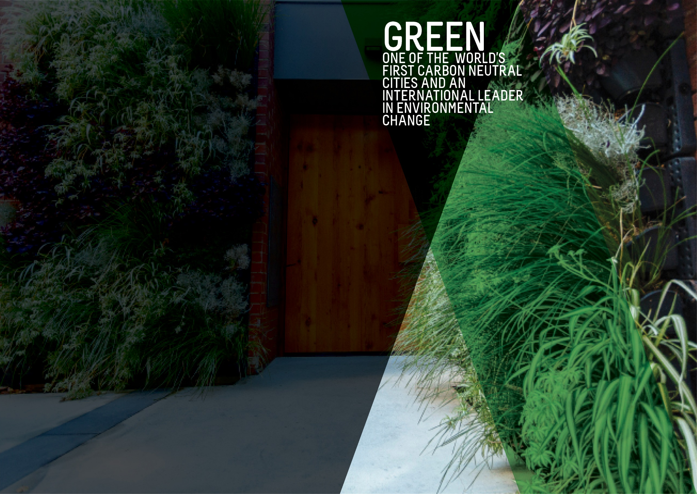
OBJECTIVES SUMMARY
The Green theme has five objectives. Updated data was not available for any of the objectives in the quarter.
ACTIONS SUMMARY
Of the 28 actions under Green, 23 were on track, four were on watch and one was off track.

23  ON TRACK |  | 4  ON WATCH |  | 1  OFF TRACK

OBJECTIVE | UPDATE | STATUS
CITY CARBON EMISSIONS WILL BE REDUCED BY 35% FROM THE 2006-07 BASELINE BY 2020 | The greenhouse gas emissions inventories for the City of Adelaide community were finalised for Financial Years 2016 and 2017 and updated for Financial Years 2007 (base year), 2014 and 2015 to ensure consistency with the latest calculation methodologies and were reported to Council. This has shown a 15% emissions reduction achieved between 2007 and 2017.  The overall reduction in emissions has been driven by a 37% reduction in stationary energy emissions, that is, emissions associated with the consumption of purchased electricity and natural gas. This demonstrates a decoupling of City of Adelaide community GHG emissions from the City of Adelaide Gross Regional Product which has increased by 35% over the same period. (Last updated Q3 2017/18)  Data source: City of Adelaide Community GHG Emissions Inventory | BASELINE:  1,148 kt CO2-e (2006-07)*  UPDATE ON OBJECTIVE:  976 CO2-e (2016-17)  NEXT UPDATE: TBA  DIRECTION OF CHANGE: favourable variance  * Revised from 1,175 kt CO2-e to ensure consistency with the latest calculation methodology
GREEN SPACE AND GREENERY IN THE BUILT-UP AREAS OF THE CITY WILL HAVE INCREASED BY 100,000 METRES BY 2020 | The baseline figure for green space and greenery comes from the Green Infrastructure Benchmark Data and Mapping project undertaken in 2015. Total green coverage is calculated by adding the total pervious area (total area minus total impervious area) to the area of tree canopy cover in built-up areas within the City. The built-up area of the City is the entirety of the City of Adelaide area minus the Park Lands.  Data source: City of Adelaide | BASELINE:  1,241,777.11 (2015)  UPDATE ON OBJECTIVE:  Not available  NEXT UPDATE: 2019  DIRECTION OF CHANGE: not applicable
BY 2020, AQUATIC NATIVE PLANTS ON THE TORRENS LAKE FLOOR WILL HAVE INCREASED FROM ALMOST ZERO TO 7,500 SQUARE METRES | The re-introduction of aquatic native plants to the Torrens Lake floor is an ongoing process with results likely to take some time to achieve and quantify. Nursery propagation over winter has been successful. This year 7,125 aquatic plants have been planted in the Torrens Lake.  Data source: City of Adelaide | BASELINE:  Almost zero (2015)  UPDATE ON OBJECTIVE:  Not available  NEXT UPDATE: 2019  DIRECTION OF CHANGE: not applicable
A DETAILED MEASURE OF REDUCTION IN KERBSIDE AND GENERAL WASTE WILL HAVE BEEN DEVELOPED AND INFLUENCES OUR WORK | Council currently tracks kerbside waste and the proportion of recyclables. The scope of a suitable measure for kerbside and general waste reduction is being considered. Council has seen a small increase in waste going to landfill over the last 12 months because of providing waste services to an increasing number of medium to high density dwellings. | BASELINE:  To be determined  UPDATE ON OBJECTIVE:  Not available  NEXT UPDATE: TBA  DIRECTION OF CHANGE: not applicable
A COMPREHENSIVE INTEGRATED WATER MANAGEMENT MEASURE WILL HAVE BEEN DEVELOPED AND INFLUENCES OUR WORK | Council currently tracks mains water use, recycled water use and the cost of both. The recommendations from the review of the Biodiversity and Water Quality Action Plan have been finalised and will help to inform and develop the Integrated Water Management Plan and Integrated Water Management Measure. | BASELINE:  To be determined  UPDATE ON OBJECTIVE:  Not available  NEXT UPDATE: TBA  DIRECTION OF CHANGE: not applicable

ACTION | UPDATE | STATUS
Achieve adoption of sustainable commercial practices through incentives, purchasing approaches, waste services and regulation | The compostable and re-usable coffee cup pilot was completed. A post-pilot survey was carried out to establish the impact of the Pilot and to seek feedback from participating businesses. | on track
By 2020, Council’s New Year’s Event will send zero-waste to landfill and by 2018, clear guidelines will be developed for organisers of larger community events in Council-operated areas to achieve zero-waste and carbon neutrality | Draft Guidelines have been developed in consultation with waste and events industry and will be presented for adoption to Council in Q2 2018/19. | on track
By 2025, working with City waste collectors, all Council serviced premises will have their landfill, recycling and green waste collection measured and reported to Council, with the data to be available online to the premises' occupant | We are continuing to progress our waste management service approach though COSOL. Committee workshop held on 4/ and we continue work on our revised waste management strategy and policy together with Green Industries SA for consideration by Council in early 2019. | on track
By December 2020, increase our efficient use of recycled water from the GAP scheme in Council-irrigated areas by 25% to an overall level of 80% | Opportunities to extend GAP consumption for irrigation have been identified by the 2016/17 Water Profile Report and will be further investigated to quantify potential contribution to the Strategic Plan target as well as cost benefits. | on track
By December 2017, complete a procurement plan for all Council vehicles to be low or zero emissions | No further update as this Action is completed. | on track (completed)
By June 2017, Council will have developed a Green City Plan detailing Council’s contribution to greening the city and showing activities with aligned annual targets, including an additional 1000 trees in the built-up areas of the city by June 2020 | Development of a city greening plan progresses with a draft to be presented to Council on 11 September 2018. The Waymouth Street Greening Works Project was completed. | on WATCH
By June 2019, our procurement practices will reasonably require the environmental track record and/or credentials of suppliers, and estimates of carbon emissions of products and services | Council is progressing an initiative to embed sustainable procurement practices throughout the Council in accordance with ISO20400 ‘Sustainable procurement – Guidance’. | on track
By June 2020, all Council-owned and maintained public lighting will be converted to LED lights and smart lighting wherever possible | The LED program scope for FY17/18 has been delivered and continuation of the program has been identified and included in the 2018/19 Integrated Business Plan. The procurement exercise, SMART LED is currently out to market as is the new strategic smart lighting program. | on track
By June 2020, the energy requirement for all Council buildings will be sourced from low carbon or renewable energy sources | Energy market consultants have been engaged to provide advice on procurement options for future electricity supply for Council's operations, which are both cost effective and contribute to Council's aim for its operations to be carbon neutral by 2020. | oN track
By the end of 2017, develop and implement a Waste, Recycling and Reuse approach for the City that reflects world’s best practice and the use of smart technology | We are continuing to progress our waste management service approach though Council Solutions. A Committee workshop is to be held on 3 July 2018 and we continue work on our revised Waste Management Strategy and Policy together with Green Industries SA for consideration by Council in early 2019. | on WATCH
Commit through to June 2020 to continue the Sustainable City Incentives Scheme, with annual reviews of incentive funding budget allocations | The Sustainability Incentives Scheme has provided rebates of $430,604 and has supported $2.2M investment in sustainable technologies, with 212 applications approved (168 residential and 44 businesses) in the year to date. Every $1 of incentive funding has leveraged $7.67 investment within the City with energy storage systems increasing by 273% from last Financial Year across the city. A total of 755kW of solar PV installed at 71 residences, 16 businesses and five community organisations in 2017/18. | on track
Continue to work with the State Government and other councils to reduce stormwater and other pollutants into the Torrens River catchment | The Water Quality Monitoring Project has not progressed as budget was not allocated in 2017/18. A review of existing water quality data captured by CoA and external parties (NRM, EPA) will assist in defining the business requirements for monitoring from 2018/19 onwards and provide some long-term trends and analysis upon which key decisions can be made. This review is proposed for Q1 2018/19 as part of general activities and not a discreet project. | off track
Develop international trade, investment and tourism opportunities based on our green and clean reputation | The Visitor Information Services program has continued to provide assistance and advice to City Tree Climb Adventure Park, a new nature-based experience scheduled to open in Blue Gum Park / Kurangga (Park 20) in late September/early October 2018.  The City of Adelaide has provided continued support of nature-based experiences in the City through web, social and the visitor centre and services. | ON TRACK
Enhance biodiversity in the Park Lands and strengthen the role of the Park Lands in achieving a carbon neutral City | The draft Integrated Biodiversity Management Plan has been developed and will be forwarded to Adelaide Park Lands Authority and Council for approval in Q1 2018/19. A request for tender for woody weed removal has been issued and a tenderer has been appointed to undertake woody weed removal in Mistletoe Park / Tainmuntilla (Park 11). | on track
Facilitate the reuse and recycling of equipment, consumables and materials used in festivals and events in the City | This quarter, draft Sustainable Event Guidelines were brought to an industry group event comprising of organisers, waste and recycling industry representatives for discussion and validation. The final Guidelines will be brought to Council for consideration in Q2 2018/19.  A report was also prepared this quarter reviewing the current waste services provided to events in the City and recommending future services to accelerate the transition to sustainable events by 2025. Preparations have progressed for Council's 2018 New Years' Eve event, including the environmentally friendly initiatives that will be put in place for this year's event. | on track
From 2016, collaborate with City-based businesses, interest groups and the education sector through a series of Lord Mayor summits and forums to build partnerships that promote environmental issues and broader innovations | CoA and the Lord Mayor presented at the National Renewable Cities Conference which included a walking tour of the city for delegates (government and industry) highlighting CoA projects. The Lord Mayor was also involved in the Community Leaders Program which had a focus on a variety of sustainability issues. The Low Carbon School Trial, which involved North Adelaide Primary School, Gilles St Primary School and Sturt Street Primary Schools, was completed. | on track
From 2016, Council will commit ongoing funding for powerline undergrounding to assist with greening initiatives | Jeffcott Street Power Line Environment Committee (PLEC) projects will be delivered in 2018/19.  Gouger Street PLEC design will commence as part of the 2018/19 Integrated Business Plan capital works program. | on track
Identify opportunities for building adaptation and re-use that supports heritage aspirations while reducing carbon emissions and waste | The draft Building Upgrade Finance Market Development Plan and promotional video about the first Building Upgrade Agreement in the CoA have been completed. Two industry briefings were held in metropolitan Adelaide in Q4 which over 75 people attended. | on track
Improve energy performance and use of renewable energy in Council and privately-owned buildings, including consideration of solar heating, solar energy generation and battery storage | A feasibility assessment for installing $1.9M of solar PV on council buildings has been completed. Tender Specification Documents were developed for the tender process to install Solar PV in Q1 2018/19. The Solar Savers Adelaide project has been completed and is currently in the monitoring and evaluation stage. | on track
Improve the ecological value of watercourses and biodiversity in the Park Lands | The Torrens Lake Rehabilitation Assessment (feasibility study) is progressing and will be completed in Q1 2018/19.  The subsidiary for the Brown Hill Keswick Creek Storm Water Management project has engaged designers tasked with developing concept plan options for review.  CoA continues scheduled maintenance in the water sensitive urban design areas with managing weeds and regular removal of litter and debris from reed beds. | on track
Partner with the State Government to implement a Carbon Neutral Adelaide Partnership Framework to pursue the shared aspiration for Adelaide to be the world’s first carbon neutral city | Carbon Neutral Adelaide Partners totalled 150 at end of Q4. Three editions of the Carbon Neutral Adelaide e-News were issued promoting incentives, events, news and highlighting partner achievements. City of Adelaide hosted a Carbon Neutral Cities Alliance workshop. The City of Adelaide’s 2016/17 annual community and corporate greenhouse gas inventories were submitted to the Carbon Disclosure Project. | on track
Provide a range of incentives for the use of electric-powered and low-emission vehicles within the City | Ten Electric Vehicle Chargers have been designed and installed within Rundle Street, Wyatt Street and Topham Street UParks. Three Electric Vehicle Chargers have been designed for on-street installation and below ground cabling completed. Technical, electrical, data management and changes to safety legislation have delayed the three on street installations. | oN WATCH
Reduce storm water run-off and pollution into the Torrens River through integrated catchment management and water sensitive urban design | The WSUD program included a number of capital projects to deliver the intended outcome being Gouger Street and Waymouth, both completed during the quarter.  There were several projects that will deliver the design phase being Boulton Street, St Helena and Gawler Places and construction in the following years and are included in the 18/19 Integrated Business Plan Capital Works Program. | on track
Work with all City stakeholders to increase public and private greening with street trees, gardens, community gardens, green walls and roofs providing incentives where appropriate | Research to inform a review of policy to guide decisions around the creation of new open space with development is progressing, informed by recent developments in the CBD. | on track
Work with Federal and State governments to provide appropriate infrastructure and promote sustainable transport options, such as public transport, cycling and walking, to improve the experience of commuters and reduce transport-related carbon emissions | Work continues on delivering the actions outlined in the Smart Move Interim Action Plan 2016-2018. Some of the key projects for 2017/18 included the South Ward Local Area Traffic Management Plan, Smart Traffic Technology and Optimisation, City Connector Enhancements, and motorcycle and scooter parking expansion.  Work is well underway on the North South Bikeway with the sections between Grenfell-Pirie, Wakefield-Angas and Angas-Carrington completed in early 2018. The sections between Rundle-Grenfell, Pirie-Flinders and Flinders-Wakefield will be completed on 24 August 2018. Design, engagement and construction works will continue as a rolling program until the route is complete. | on TRACK
Work with local communities on public greening activities that will beautify streets and parks | CoA continues to deliver core maintenance in line with endorsed service standards. | on track
Work with partners to reduce mains water use through water sensitive urban design and increasing the use of recycled and reused water | The CoA Water Profile Annual Report setting out water consumption data was completed. Key indicators are being drafted to develop an Integrated Water Management Measure. | on watch
Work with private property owners and the State Government to embed better environmental performance into new and existing developments | The Natural Resources and Environment Discussion Paper released as part of the Planning reform process offers Council a great opportunity to influence these outcomes. | on track

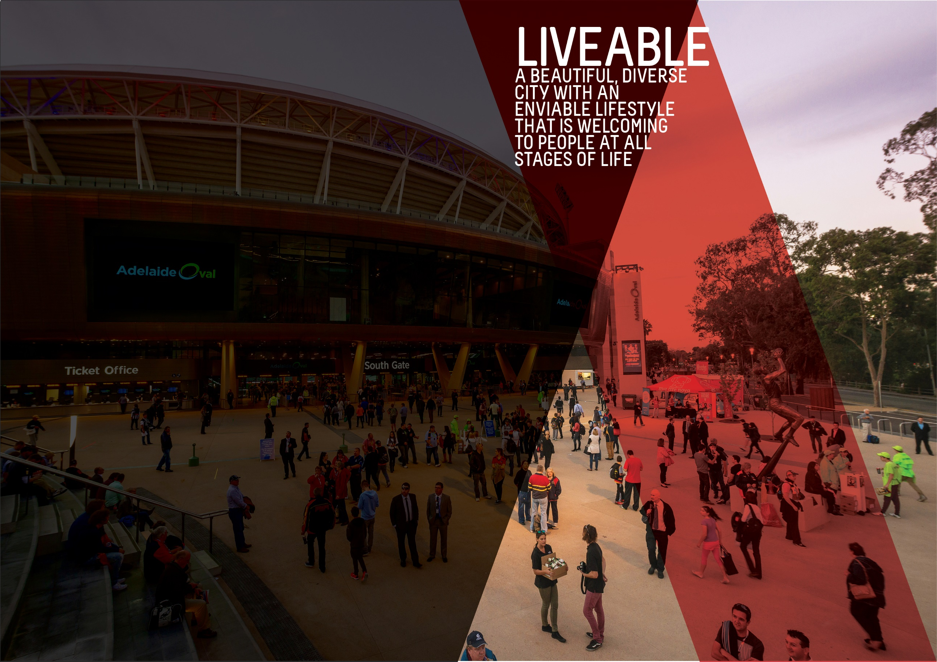

OBJECTIVES SUMMARY
The Liveable theme has three objectives. Updated data was not available for any of the objectives in the quarter.
ACTIONS SUMMARY
Of the 24 actions under Liveable, 19 were on track, five were on watch and none were off track.

19  ON TRACK |  | 5  ON WATCH |  | 0  OFF TRACK

OBJECTIVE | UPDATE | STATUS
THE NUMBER OF PEOPLE LIVING IN THE CITY WILL HAVE GROWN FROM 23,000 TO 28,000 BY 2020 | As at June 2017, the estimated resident population (ERP) of the City was 23,916 persons. This is 2.2% higher than the previous year and 6.1 % higher than the baseline year in 2014. Population growth in the City continues to outpace the State's population growth. Between June 2016 and June 2017, population growth across South Australia increased by 0.6%. (Last updated Q3 2017/18)  Data source: ABS, ‘Regional Population Growth, Australia, 2015-16 (Cat. No. 3218.0) | BASELINE:  22,539 (ERP June 2014)*  UPDATE ON OBJECTIVE:  23,916 (ERP June 2017)  NEXT UPDATE: Early 2019  DIRECTION OF CHANGE: favourable variance  * Baseline figure has been revised due to a change in the methodology the ABS use to estimate regional populations.
ADELAIDE WILL BE LISTED IN THE TOP THREE MOST LIVEABLE CITIES IN THE WORLD BY 2020 | In 2017, Adelaide was once again ranked 5th in the Economist Intelligence Unit's (EIU) Global Liveability rankings. Adelaide has been ranked fifth since 2012. There has generally been little change in the top five rankings over the past few years. The list continues to be topped by Melbourne, Vienna, Vancouver and Toronto.  Of the five categories of liveability assessed by the EIU measure, Adelaide continued to score lowest (94.2/100) in the area of culture and environment, which includes factors such as sporting availability, cultural availability and food and drink, and its highest score (a perfect 100) in the education and healthcare categories. The EIU liveability rankings relate to the entirety of Adelaide and not specifically to the City of Adelaide. (Last updated Q1 2017/18)  Data source: Economist Intelligence Unit, Global Liveability Ranking 2017 | BASELINE:  Ranked 5th (2015)  UPDATE ON OBJECTIVE:  Ranked 5th (2017)  NEXT UPDATE: August 2018  DIRECTION OF CHANGE: no change
CITY OF ADELAIDE RESIDENTS WILL HAVE WELLBEING ABOVE THE GLOBAL AVERAGE | During Quarter 2, Council endorsed a change to the wellbeing objective from “A nation leading wellbeing and resilience measure will be applied and influences our work’ to ‘City of Adelaide residents will have wellbeing above global average”. This wording reflects the outcome of the PERMA+ survey undertaken with South Australian Health & Medial Research Institute (SAHMRI) in 2016 to contribute to the development of a baseline for residents’ wellbeing. It also reflects the focus of Council’s work to maintain resident wellbeing above the global average as articulated in the City of Adelaide’s Wellbeing Roadmap. | BASELINE:  PERMA+ score of 7.2 (September 2016)  UPDATE ON OBJECTIVE:  Not available  NEXT UPDATE: TBA  DIRECTION OF CHANGE: not applicable

ACTION | UPDATE | STATUS
Advocate for an urban growth boundary that limits urban sprawl and promotes the City as the commercial, cultural, residential and social heart of metropolitan Adelaide | No further updates Required - Completed. Commenced with enactment of the Planning, Development and Infrastructure Act 2016, as reflected in the Updated 30 Year Plan for Greater Adelaide. | ON TRACK  (completed)
Advocate to the Federal and State governments for changes in housing taxation and levies to reduce the cost of housing, including an extension of the State government's 'Off-the-Plan Stamp Duty Concession’ for apartments | The State Government’s financial incentive package introduced in the 2017/18 budget for off-the-plan apartments has now expired. This includes partial stamp duty concessions, pre-construction grants and land tax exemptions. Council will need to review its position regarding advocacy for affordable housing and sustainable growth. | ON TRACK
By 2017, endorse a Central Market Arcade redevelopment plan and commence works by 2020 | Request for Detail Proposal submissions have been received and assessed by the Evaluation Panel. Clarification and verification processes are underway with consideration being given to Heads of Agreement structure ahead of Council consideration. Over two-thirds of Arcade traders have signed lease offers and a commercial leasing agent has been appointed to manage existing vacant tenancies with four tenancies under agreement.  Council is currently progressing the centre management options for the Central Market Arcade with building services procurements underway. The Centre management handover is also progressing with current head lessor. | on track
By June 2020, develop an Adelaide 2040 Plan to achieve long-term economic, environmental, social and cultural goals, incorporating a spatial and transport plan for the City and Park Lands | No update required as no activity was planned for the quarter. | on track
Create world class infrastructure by adopting a three year rolling capital works program for the City and Park Lands to ensure all new and existing infrastructure are delivered and maintained to high quality standards, incorporating universal access, technology, heritage, arts and green elements. | The 2017/18 capital work that has been successfully completed includes but is not limited to:  - Josie Agius Park / Wikapartnu Wirra (Park 22) Netball Courts project  - Waymouth Street East Enhancement  - Hutt Street CCTV  - East End (Rundle Street) Festoon Lighting  - Pavilion on the Park Restaurant Renewals  - Marshmallow Park / Pityarilla (Park 19) upgrade  - Hindley St upgrade  - Roads, footpaths, lighting and stormwater upgrade programs  - Sir Donald Bradman Drive entry statement  - Glover East Playspace | on track
Deliver Council’s core services efficiently and with brilliant customer service for a growing and increasingly diverse and multicultural community | This quarter saw the procurement of a new solution that will enhance the value and volume of customer feedback that Council obtains with testing and trials now underway. Existing measures for the organisation will be reviewed in 2018/19 to ensure they shape and drive our desired customer experience culture. | on watch
Deliver sport and recreation activity hubs consistent with the Active City Strategy and Adelaide Park Lands Management Strategy | Construction of the new community sports pavilion in Ellis Park / Tampawardli (Park 24) has commenced with a completion date anticipated of December 2018.  A draft concept plan for enhanced community sports infrastructure in Golden Wattle Park / Mirnu Wirra (Park 21W) has been developed and will be tabled with the Adelaide Park Lands Authority (APLA) and Council in August 2018.  A draft building design for Bundey’s Paddock / Tidlangga (Park 9) has been developed by the lessee but is not to a satisfactory design quality. Council are working with the lessee to improve the design quality before it, along with a draft lease, is tabled with Adelaide Park Lands Authority.  A business case to inform the feasibility of the proposed community sports hub in Josie Agius Park / Wikaparntu Wirra (Park 22) has commenced.  At the end of June 2018, the change room and toilet facility in Victoria Park / Pakapakanthi (Park 16) is planned for completion, with construction of the toilet facility completed during Quarter 4. | ON watch
Develop and celebrate strong and resilient City communities that are welcoming and encourage people of all ages, cultures and means to participate in City life, including through volunteer opportunities | In celebration of National Volunteer Week, volunteers and supervisors participated in the annual parade hosted by Volunteering SA&NT. Volunteers were invited to attend a morning tea and guided tour of the West Terrace Cemetery, with the awarding of years of service certificates from the Lord Mayor; or a twilight meal and guided tour, to attract volunteers who study, work, care or volunteer during working hours.  Refugee Week was delivered between 17-23 June with 238 people attending four events across all three Community Centres. Council hosted the ‘National Journey of the Welcome Scroll’ highlighting CoA Commitment as a Refugee Welcome Zone.  The Access and Inclusion Advisory Panel met on 16 May with a focus on Rymill Park / Murlawirrapurka (Park 14) Play Space, proposed Marketing Standards for Accessibility, an update from the Whitmore Square / Iparrityi focus group, a Market to Riverbank update and discussion about Changing Places. A stakeholder workshop was held on 13 June, with 80 people in attendance to help shape the new Access and Inclusion Strategy.  As part of the History Festival, the Box Factory Community Centre hosted an Aboriginal Cultural History Tour on 25 May. Twenty-five people attended a guided tour learning about the Aboriginal social and political history of the City Squares.  Commonwealth Home Support Program (CHSP) delivered services to 145 older residents between April and June 2018, with 36 new client referrals and 46 new services commencing. A range of social programs to encourage health and social engagement were conducted including cooking sessions and Botanic Garden tours, whilst the Central Market Shopping Bus provided weekly social support and transport to socially isolated residents. Emergency Planning information sessions were successfully completed at three locations in the City and follow-up sessions have been created for residents to learn how to scan their precious documents and photos to USB at City libraries.  The Adelaide Community Leaders in Sustainability program, delivered between February and June 2018, developed 20 individuals active in City communities. Four local neighbourhood projects were completed during the 12-week program.  CoA Community Centres were excited to enable the first Aboriginal Cultural and Political History event as part of SA History Festival and Reconciliation Week. Partnering with the Migration Museum and Kaurna Elders, the event hosted 25 people through a guided tour of key political events and public art pieces in Victoria Square / Tarntanyangga and other city squares. The North Adelaide Community Centre, in partnership with Study Adelaide and Multicultural Communities Council SA, hosted 130 local residents and international students at a Welcome Dinner in June.  Library Out & About popped up in Francis Street and delivered roaming ‘Robots in the Mall’. Living Well Programs at the library service included ‘Superannuation Retirement Planning’, ‘Community Gardening: Autumn’ and ‘Let’s get ethical: no sweat fashion Q&A’ sessions. Smart Experiences at the Library Program delivered regular one-to-one sessions in the Digital Hub Spaces and partnered with the ACH Group to deliver ‘Internet Mythbusting’, the first in a series of programs as part of the ‘Be Connected’ national movement helping older Australians to increase their online confidence and skills. A successful Science Club Program was delivered featuring ‘EveryBody loves science’, ‘Five senses of science’ and ‘May the Science be with you’.  The 2017/18 Community Development Grants program provided funding to a total of 25 Grants (13 Major, eight Minor and four Quick Response) that delivered programs and projects across the year that encouraged people of all ages, cultures and means to participate in City life. | ON TRACK
Encourage City living by understanding the demand drivers and developing a distinctive City living promotion campaign that builds on the Already Home campaign | The Residential Growth Action Plan was presented to Council for endorsement on 12 June 2018 whereby it was resolved to defer endorsement of the Action Plan. Council also resolved to endorse the advocacy items listed in the Plan and requested that administration bring back a further report to Council outlining how the Free Rates for Five Years incentive will be promoted. | ON TRACK
Encourage growth in the full range of residential property development in a mixed use environment in a manner that respects the human scale and different characters of districts in the City | 211 Pirie Street (City Beach) has been identified as an underperforming land holding. Preparation of Guiding Principles is underway along with alternative development scenario and feasibility analysis.  Volleyball SA continue to occupy the site in a holding over capacity, discussions continue in relation to suitable relocation opportunities within the CBD | on watch
Encourage the State Government to improve public transport to promote greater patronage, including continued investment and expansion of the free City Connector Services | Council continues to work in partnership with the State Government on the provision of the free City Connector service and monitor performance and feedback, as well as exploring options to expand the service to other areas of the City. To improve the visibility of service on city streets, three additional buses will be wrapped in the distinctive green free City Connector livery as part of renewal activities. Work continues to discuss the roll out of an expanded audio and visual display system to the remaining City Connector bus fleet with the State Government. A new digital bus stop is planned to be installed on King William Road near North Terrace in Q1 2018/19. An additional three bus shelters will be installed on the free City Connector route in Q1 2018/19. | on track
Enhance the role of the Park Lands in increasing levels of physical activity and wellbeing through formal and informal sport and recreation opportunities | During 2017/18, 76 grant applications were received with 26 approved for funding. Examples of projects that have contributed to achieving the action included an SA Cricket Association (SACA) Social Cricket program, which had over 300 people in attendance; Pashtun Association of SA Cricket League, which attracted 28 teams and 500 participants from Indian backgrounds each week over winter; One Culture Football, which had 70 young people from 15 different nationalities playing regularly each week, and over 300 young people from multicultural backgrounds participating in two school holiday tournaments; Wild Imagination provided nature play opportunities in the Park Lands over the school holiday periods, attracting 4467 participants over the past 12 months.  Progress towards sustainability has occurred in Q4 for the community led initiatives that Council has been involved with in 2017/18. A risk management plan has been put in place to minimise risks associated with the BMX track City Dirt Crew volunteer group and various processes and procedures established, including the installation of bluetooth locks which are operated by the volunteers to access equipment as needed.  Council is also working closely with the SACA to build capacity of various multicultural cricket groups and individuals who are leading these groups. Additionally, meetings with Park Lands lease/licence holders and SACA have been facilitated to increase access to hard wickets and improve their quality to meet the demand for multicultural cricket played during the winter months. | ON TRACK
Explore opportunities in Council’s current property holdings and pursue strategic opportunities to lead or partner in future property developments | A draft Strategic Property Plan (Review) has been prepared. Preparation of Guiding Principles is underway for 211 Pirie Street (City Beach) along with alternative development scenario and feasibility analysis. Volleyball SA continue to occupy the site under holding over lease, however discussions are underway in relation to suitable relocation opportunities. | on watch
In partnership with the State Government, explore the possibility of redeveloping Currie-Grenfell streets as a public transport boulevard to cater for increased demand | Council continues to advocate to the State Government for the complete upgrade of the Currie-Grenfell Street Transport Boulevard. CoA is developing concept options to facilitate discussion on the future upgrade of the corridor. | on track
Increase participation by the broadest range of residents in the community life of their neighbourhood | In response to customer feedback, some improvements were implemented to the eVanced interface in both Rooms and Events. The layout of the room booking forms has been modified to prioritise key information to help customers locate this more easily, changes to the look and feel of the eVanced Events calendar assists customers to read and access this information. | on track
Plan and deliver priority walking and cycling routes throughout and beyond the City and Park Lands, including the provision of East-West and North-South cycleways and connections | Work is well underway on the North South Bikeway with the sections between Grenfell-Pirie, Wakefield-Angas and Angas-Carrington completed in early 2018. The sections between Rundle-Grenfell, Pirie-Flinders and Flinders-Wakefield will be completed on 24 August 2018. Design, engagement and construction works will continue as a rolling program until the route is complete.  Construction in Blenheim Street is complete. Road resurfacing in Blenheim Street and Lowe Street will be undertaken later this year. Designs for Gray Street (Currie Street to Waymouth Street) are progressing for completion in late 2018. | on watch
Plan and seek partnerships for major City infrastructure projects, including cycling corridors, major transport routes and laneways | Discussions with the Federal and State Government are ongoing in regard to future projects within the City and Park Lands. | on track
Promote and protect Adelaide’s built character and heritage through our operations, incentives, policies and direct investment, while working with and advocating to Federal and State governments for an increase in City buildings protected under State or Local Heritage regulations | 2017-18 has been a very successful year of heritage promotions with significant interest from the community oh History Festival and the 30 Year Heritage Incentive Scheme celebrations. This has been demonstrated with ongoing media interest both online and hard copy about Heritage in the city. | on track
Support social entrepreneurs to develop business models that have a positive impact on the City’s wellbeing and resilience | No update as no activity planned for the quarter. | on track
Work with neighbouring councils and the State Government to enhance the facilities, attractions, landscapes and movement networks in the Park Lands to meet the needs and expectations of growing high density communities living in and near the City | The Pelzer Park / Pityarilla (Park 19) Activity Hub is complete with an official opening / launch event held Sunday 29 April 2018. The Rymill Park / Murlawirrapurka (Park 14) Master Plan Final Draft is being completed for the future consideration of Council. Investigations into a new City Skate Park are continuing. A draft City Skate Strategy is being completed. | on track
Work with the community and other stakeholders through a range of initiatives to activate key areas to enable people to use the City safely and seek to reduce crime | CoA has been supporting young people to deliver the Photovoice project, working with other young people to photograph images around the City related to wellbeing. The photos and accompanying narrative will be exhibited as part of SALA in August. Ongoing community engagements with young people has informed the development of The WAY (Wellbeing of Adelaide Youth), a community plan for improving the wellbeing of 18-24 year olds in the City.  Community conversations have supported greater engagement with Neighbourhood Watch programs to increase perceptions of safety. This led to community organisations receiving grant funding in this quarter, including an 8-week physical activity program targeting City residents, skate workshops and sports facility upgrades.  Older people in lower North Adelaide have been consulted about their interest in community-led opportunities; levels of resilience were reasonably high, noting strong local connections. CoA are continuing to meet with members of the Women’s and Children’s Hospital in relation to enhancing Peace Park.  In April 2018, the successful ‘Saving a Life can be Shockingly Easy’ evaluation report was presented to Council and the project was extended to add nine AEDs in 24/7 accessible locations across the City providing an AED almost every 500 metres. | on track
Work with the State and Federal governments and other councils through the Mayors for AdeLINK advocacy group to engage with local communities to progress an integrated light rail network across the City’s key precincts, with key connections to inner city suburbs | Council continues to work with the State Government on the upgrade of the City South tram stop on King William Street.  The North Terrace light rail extension is nearing construction completion, with full operations expected to commence in August 2018. The new State Government has abandoned the AdeLINK proposals. However, Council will continue to discuss and liaise on the light rail projects identified by the new State Government for further consideration including a city loop and a connection to North Adelaide. | on track
Work with the State Government to address housing affordability, including diversity of dwelling stock, and deliver a range of initiatives such as adaptive building re-use and new building technologies | No update required as no activity was planned for the quarter. | on track
Work with the State Government, community leaders and community organisations to support vulnerable members of the community | The Homeless and Vulnerable People project is being delivered as per the State Government funding agreement. The project facilitates communication between people sleeping rough, or who are experiencing homelessness or vulnerability, and social services. | on track

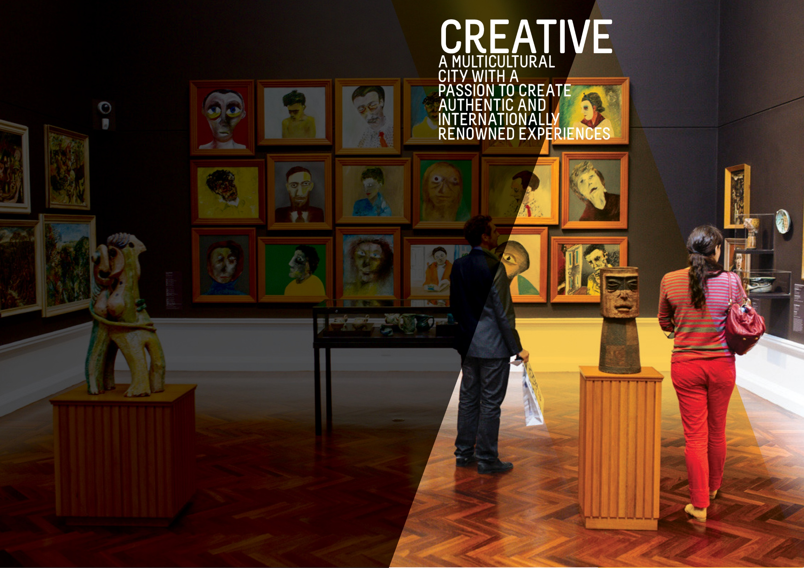
OBJECTIVES SUMMARY
The Creative theme has four objectives. Updated data was available for one of these objectives in the quarter and has been included in this report.
ACTIONS SUMMARY
Of the 32 actions under Creative, 27 were on track, three were on watch and two were off track.

27  ON TRACK |  | 3  ON WATCH |  | 2  OFF TRACK

OBJECTIVE | UPDATE | STATUS
ATTENDANCE AT FESTIVALS AND EVENTS IN THE CITY AND PARK LANDS WILL HAVE GROWN BY 5% BY 2020 | According to the latest event attendance figures available, there were a total of 5.693 million attendances at festivals and events in the City in 2016-17 (averaged over two years). This is an increase of 0.9% or 48,000 attendances from the baseline.  In 2017, the Fringe Festival experienced record-breaking ticket sales, which is reflected in their increased attendance and was the main driver of higher attendances in 2016-17. There were also higher attendances at the Tour Down Under however these have been tempered by slight declines in attendance at other events. (Last updated Q1 2017/18)  Data source: City of Adelaide | BASELINE:  5.62 million attendances  (average of 2013-14 and 2014-15)  UPDATE ON OBJECTIVE:  5.69 million attendances  (average of 2015-16 and 2016-17)  NEXT UPDATE: 2018  DIRECTION OF CHANGE: favourable variance
A DETAILED MEASURE OF THE NUMBER OF PEOPLE CREATING AND ACTIVELY PARTICIPATING IN ARTS AND CULTURAL ACTIVITIES WILL HAVE BEEN DEVELOPED AND INFLUENCES OUR WORK | This measure captures the level of active participation in arts and cultural activities in the City. The data is collected through the City of Adelaide's annual City User Profile (CUP) Survey, which asks City users (people who are in the City on the day of the survey) whether they had actively participated in any of a specified range of activities in the City in the preceding 12 months. These activities include creating music, participating in a theatre/dance/performance/event, parade or show, visual arts and craft and creative writing and is based on the Australian Council of Arts definition of active participation.  The results from the 2018 CUP Survey found that the number of City users who actively participated in arts and cultural activities was 15%, this lower than the level of participation recorded in 2017 (18%) and is also marginally lower than the baseline level of 16% in 2016.  Data source: City of Adelaide City User Profile (CUP) Survey 2018 | BASELINE:  16% (2016)  UPDATE ON OBJECTIVE:  15% (2018)  NEXT UPDATE: August 2019  DIRECTION OF CHANGE: unfavourable variance
BED NIGHTS SPENT IN ADELAIDE BY INTERNATIONAL AND DOMESTIC VISITORS WILL HAVE GROWN FROM 8.1 MILLION TO 9 MILLION BY 2020 | In the year to March 2018, the number of international and domestic visitor nights to the City reached 9.1 million and is 2.2% higher than the same time last year. It is also an increase from the baseline figure of 8.1 million and has met the target of 9 million visitor nights.  The growth over the year has mainly been driven by an increase in the number of domestic visitor nights, which increased by 5.9%, rising from 4.5 million in the year to March 2017 to 4.7 million in the year to March 2018. In comparison, international visitor nights fell slightly by 1.6% during the same period.  Data source: Tourism Research Australia, unpublished data | BASELINE:  8.059 million (June 2014)  UPDATE ON OBJECTIVE:  9.063million (year to March 2018)  NEXT UPDATE: October 2018  DIRECTION OF CHANGE: favourable variance
PEOPLE WHO SAY THE CITY HAS GREAT PLACES TO ENJOY EVENTS, ACTIVITIES, ART AND CULTURE WILL HAVE GROWN FROM 8.4 TO 9 OUT OF 10 BY 2020 | The results of the 2018 City User Profile (CUP) survey show that the rating out of ten for agreement with this statement is 8.3. While this is marginally lower than the 8.4 recorded in 2017, it represents a positive movement from the baseline figure of 8.2 recorded in 2016.  Data source: City of Adelaide City User Profile (CUP) Survey 2018 | BASELINE:  8.4/10 (2015)  UPDATE ON OBJECTIVE:  8.3/10 (2018)  NEXT UPDATE: August 2019  DIRECTION OF CHANGE: No change
THE NUMBER OF PEOPLE THAT ARE VISITING THE CITY EACH DAY FOR SHOPPING, LEISURE OR ENTERTAINMENT WILL HAVE GROWN FROM 111,000 TO 117,000 BY 2020 | The number of people visiting the City each day for these purposes continues to increase and has exceeded the target of 117,000 by 2020. In 2018, there were an estimated 156,900 people in the City for shopping, leisure or entertainment on an average weekday.  Data source: City of Adelaide | BASELINE:  111,141 (2014)  UPDATE ON OBJECTIVE:  156,900 (2017)  NEXT UPDATE: August 2019  DIRECTION OF CHANGE: Favourable

ACTION | UPDATE | STATUS
Advocate for the interstate rail station to be relocated back to the Adelaide Railway Station to capitalise on the iconic Indian Pacific, Ghan and Overland rail services | Liaison continues with the State Government on the return of interstate train services to Adelaide Railway Station. Discussions with the State Government are ongoing regarding the projects within the city and Park Lands. | on track
Attract and support artists and cultural entrepreneurs to develop commercial opportunities | Creative entrepreneurs program ‘The Business of Being Creative’ (TBOBC) participant application process was completed with 101 applications from teams of up to four participants received. 40 participants were shortlisted and 20 participants (15 teams) were selected. Each team was individually matched to a successful creative mentor for the entire duration of the program, with delivery at the City Library including three full-day creative entrepreneurship workshops, one full-day storytelling masterclass, and a Seed Funding ‘Storytelling’ Assessment Panel public event.  CoA in partnership with Carclew delivered “identity.connection.everyday”, three concurrent exhibitions curated by emerging curator Gabrielle Lane and Indigenous artist/curator Carly Dodd across the Adelaide Town Hall, Art Pod, Pirie Street Breezeway and for the first time, Mankurri-api Kuu / Reconciliation Room. The exhibitions present the work of 13 emerging artists across the four venues. The exhibitions formed part of NAIDOC and Reconciliation week celebrations and will be included in SALA Festival 2018. The launch event held at the Town Hall was well attended by over 100 people representing a broad cross section of the community who would not usually attend events at the Town Hall including many young people. | ON TRACK
Attract people from around the world, especially from China and India, to spend more time and experience more hospitality activities in the City | The Australia’s Consul-General to Chengdu to the City of Adelaide and Town Hall Hosted the Indonesian Consul-General and received a delegation from Brittany, France. Council accepted an invitation from Minister Ridgway to participate in the State Government Business Mission to China.  CoA continued to distribute the Qingdao Tourism flyer through the Customer Centre as well as advertised in the official Chinese South Australia guide book, promoting Adelaide as a great place to live, work, visit and study. Council has also committed to advertising in the 2019 International Student Guide - Adelaide edition and IDP edition and online. The IDP edition is predominantly distributed through India to attract students. | ON TRACK
By 2020, develop build and upgrade infrastructure that supports events and is sensitive to the environment within key event spaces in the City and Park Lands | As an input to the Park Land master planning, Council have engaged with several stakeholders who have expressed interest in co-contributing towards event infrastructure in the priority Park Lands for upgrading. Work has also commenced on a Net Profit Value feasibility study on the infrastructure upgrading of the priority Park Lands. Following this assessment, a report will be brought to Council for consideration. | off track
By December 2020, Council will install a network of NBN-enabled interactive wayfinding stations to build on the current roll out | Procurement for wayfinding devices were completed in Q3 with contract negotiations currently underway. | on track
By June 2017, develop an Arts and Culture Strategy | No further updates as this Action is complete. | on track  (completed)
Complete the Rundle Mall Master Plan, including Gawler Place, to link major City attractions | In July 2018 work on the Gawler Place Project was put on hold to allow for alternate design proposals to be prepared more consistent with the original project scope. These will be presented to Council on 11 September with outcomes to be communicated to the Community following this meeting. | ON WATCH
Consider policy de-regulation to allow more interesting temporary opportunities in private buildings | No update required as no activity was planned for the quarter. | on track
Identify opportunities to use specialised lighting to showcase the City’s unique attractions, character and heritage | The East End Creative Lighting Plan is currently ongoing to develop an exciting mix of lighting opportunities to support the evening economy and create an attractive night time destination. The Lighting Master Plan is being developed for Council consideration in 2019. | on track
Increase public art and cultural expression in private development by using planning levers and requirements | No update required as no activity was planned for the quarter. | on track
Partner with cultural institutions to increase visitations in the City and Park Lands | CoA continued to support the Australian Dance Theatre through a strategic partnership for the 2018 inaugural Adelaide Dance Festival to include several outdoor activations. A partnership with Young Adelaide Voices to deliver WATU Youth Choir Festival was supported which includes choristers undertaking an acoustic crawl at iconic Adelaide landmarks and buildings ending in a group sing at Victoria Square / Tarntanyangga. Council also partnered with UniSA in the planning of the opening ceremony of Panpapanpalya which includes a Welcome to Country and Smoking Ceremony in Victoria Square / Tarntanyangga. | on track
Promote and showcase multiculturalism and Aboriginal culture and support local organisations to express this heritage | The City of Adelaide's Stretch Reconciliation Action Plan 2015-2018 has reached the end of its delivery schedule. Of 31 actions, 28 have successfully been delivered. The outstanding actions relate to delivery of the Place of Reflection art work to commemorate the Stolen Generations which has commenced but not yet been delivered.  Preparations for NAIDOC Week in July continue with the range of offerings confirmed to include the Lord Mayor's Flag Raising Ceremony, the Lord Mayor's Morning Tea, NAIDOC in the Mall and a range of community-led grass roots activities in city neighbourhoods. | on track
Promote our UNESCO Live Music accreditation to attract more opportunities for new live music venues | An initiative proposing processes and locations for naming a laneway after an Adelaide music identity was endorsed by Council in June. A partnership was undertaken with the Adelaide Town Hall to re-instate the Pipe Organ Concert Recitals, with the first event on 16 May 2018 very well received to a full house.  Council facilitated and supported a new monthly ‘PubSing’ pub choir event in partnership with Body Song and The Jade live music venue, with 100 in attendance at first event in May 2018.  CoA hosted a Major Choir Events Summit, with 26 participants representing 16 organisations, to discuss scope and develop commitment to a major choir event for Adelaide. The installation of Adelaide UNESCO City of Music street banners was facilitated in June to celebrate Umbrella Winter City Sounds and Guitars in Bars 2018. Effective Case Management assistance was provided to enable a Quick Response grant to be awarded to “Day of Clarity” a free live music festival that enlivened the East End with thousands of music lovers across six venues including an outdoor stage. | on track
Provide support to key festivals and organisations to assist them in offering events and activities that attract visitors to the City | CoA is working with subject expert David Cooke to evaluate the feasibility and economic benefit of hosting the Commonwealth Games in Adelaide in 2026.  Three sponsorship agreements/addendums were executed during the quarter (25 YTD which is 100% complete). $115,000 sponsorship funding was distributed this quarter ($1,610,000 YTD which is 100% of the sponsorship funding component of the budget). Five funding applications for 2018/19 were received and assessed during Q4. Funding recommendations were presented to Council on 26 June were approved.  The Festivals Adelaide Q3 Report was received on 16 April 2018. Key activities and highlights from this report included:  - Expansion of the International Festival City Network to include invitations to Singapore, Austin Texas and Buenos Aries.  - Successful famil program (in partnership with SATC) was held with 12 travel agents from the UK attending and visiting Fringe, Adelaide Festival and Womad for 2 full days.  - Positive feedback received from volunteers regarding the Festival Volunteer Network. Volunteer coordinators across Womad, Fringe and Adelaide Festival worked together for the first time sharing useful information on volunteers and processes KPI's for 2018/19 will be reviewed at the Q4 review meeting to be held on 28 August 2018. | ON TRACK
Pursue completion of the North Terrace Boulevard, focusing on the evolving health and biomedical precinct and the Riverbank precinct | A Final Draft North Terrace West Concept Plan was completed and will be finalised in Q3 2018/19 for consideration by Council. The North Terrace West Concept Plan will be used to explore staging and funding partners following Council and key stakeholder endorsement, including the State Government. | on track
Streamline Council processes for events to be hosted in the City and better enable City businesses to benefit from these events | This quarter the development of the online solution that will provide an end to end booking portal for those interested in holding an event in the City has progressed. Testing and training is occurring with the first phase to be implemented in September 2018. | on watch
Support businesses, community groups and individuals to grow their contribution to the creative, cultural and artistic life of the City | Round 1 Arts and Cultural Grants for 2018-19 featuring Artistic Development, Public Arts and Community Programs and Events categories was administered. Forty applications were received with 18 grant recommendations approved. Draft recommendations for the continuous improvement review of the Arts and Cultural Grants program were finalised with a focus on assessment processes. Quick response grants continue to provide outstanding results with all funds for 2017-18 expended.  In partnership with the National Museum of Australia and the National Archives of Australia, a series of programs were delivered as part of the South Australian History Festival. Programs included a presentation about the history of Australian Song and Dance; a live and interactive video tour of the Gallery of the First Australians; the launch of the Adelaide Ghost and Ghouls Walking Tour and an exhibition commemorating Colonel William Light the first Surveyor-General of South Australia.  The two residencies in Q4 featured Sarah Pearce who ran “Women Write Together” poetry workshops and Suzanne Healey who ran “Recycled Ceramic Mosaics” art workshops. The City Library hosted three exhibitions with partners – “Tooth and Nail: a retrospective”; “Adelaide Contemporary International Design Competition”; “Scott Eames: An Exhibition of Sculpture”. Two Philosophy Café events were delivered in partnership with University of Adelaide under the Library Ideas Space program. SA Writer’s partnership included monthly meetings of the City Writers Group.  Strategic partnerships were developed with Mighty Kingdom to mentor two international city students, assisting them to be industry ready for the creative gaming industry. The partnership with Ace Open established and delivered a mid-career South Australian artist residency to help propel local careers onto the national and international stage. The partnership with The Mill developed and delivered a new ‘Exhibition Space’ program, to incubate culture makers, support sustainable arts practice, grow audiences and facilitate broad cultural engagement.  'ArtWorks' in partnership with Guildhouse, was successfully delivered to provide creative activation of the Minor Works building. Activations included artist in residence Kaspar Schmidt Mumm, writer in residence Rayleen Forester, and Sahr Bashir, who ran two creative workshops for the community to make contemporary paper-based jewellery.  The first Lord Mayor’s Cultural Think Tank was held at The Howling Owl / Urban Cow Studio Gallery with an expert panel of six, plus 25 senior stakeholders from the creative, education and tourism sectors who discussed the challenges and opportunities in galvanising Adelaide’s reputation as a thriving creative and cultural destination. The second quarterly forum (Culture Club) was held at Palace Nova Eastend Cinemas with 60 cross-sectoral representatives attending to hear speakers on the topic of Thinking Big. A Cultural Lens internal forum was attended by 22 representatives across the organisation. | on track
Support the Adelaide Convention Bureau financially and in-kind to encourage longer stays and add value to the visitor experience, especially in areas that support Council’s strategic agenda | No update required as no activity was planned for the quarter | on track
Surprise, delight and attract people by continuing to encourage and support dynamic and changing urban public spaces, heritage, art, laneways, streets, facilities and activities | Building from the direction of the ‘Our Market District’ planning framework, the issues and opportunities for the development of the Chinatown Reinvigoration Project continue to be explored. A draft document and concept plan for Moonta Street have been prepared for further consultation in August.  Gawler Place early works have commenced and Bentham Street detailed service investigations are complete. Planning for 2018 Christmas in the City continues and planning for New Year's Eve 2018 has commenced with a strong focus on crowd management and delivering a low waste event to support the Strategic Plan objective of a low waste NYE event by 2020. | on track
Upgrade and improve amenity to create a higher quality visitor and trader experience by implementing the Our Market District Plan | Chinatown reinvigoration plan scoped. District Reference Group met in the quarter. | on track
Work in partnership with key stakeholders to attract a winter music festival by June 2018. | The City of Adelaide supported Music SA in a successful and well attended program launch of Umbrella Winter City Sounds 2018 where the curated program of free and low-cost events in the City directly supported by Council were announced. Council also assisted with the promotion of the Festival through internal marketing and promotional channels. | ON TRACK
Work with businesses and other partners to bring creativity and smart technology into the everyday experience of our City | Smart watering technology used for irrigation of some Park Lands and squares has been completed. | ON TRACK
Work with existing festivals and events to increase the number and diversity of audiences and visitors | Anzac Day 2018 was implemented successfully this quarter with an estimated 20,000 people in attendance. Following the success of the Glendi Greek Festival in Quarter 3, Council are investigating other opportunities to attract other multicultural events into the City while planning for a number of upcoming multicultural events including NAIDOC Family Fun Day, Panpapanpalya Opening Event and Eid Fitr Prayer.  Across the fourth quarter, CoA also led or supported two major events-focused marketing campaigns. The biggest Winter season campaign to date was developed and launched. This ‘umbrella’ campaign unified a wide variety activities and initiatives led by a number CoA programs, including events, sponsorship and visitor information service. The campaign was targeted at Greater Adelaide residents as well as a select audience of music and culture focused Melbourne residents. The campaign creative aimed to change perceptions of winter in Adelaide being an ‘off season’, to drive awareness and attendance at events, venues, retailers, galleries and more. Work has also begun on developing and executing the 2018 and 2019 CoA Christmas campaigns. | on track
Work with neighbouring councils and the State Government in funding and governance to enhance the role of the Park Lands as a key City asset in supporting artistic and cultural activities | Three new and significant Contemporary Art Acquisitions by nationally recognised artists were sourced from the 2017 Emerging Curator program while the East End Moving Image work New Light was presented at the Special Olympics closing ceremony.  Council have been in ongoing discussions with the new State Government in regard to future projects in the Park Lands and also continues to work in collaboration with the Art Gallery of South Australia to progress the Terrance Plowright sculpture project.  Public art components that have been incorporated into recent developments include Pelzer Park /Pityarilla Activity Hub (Park 19) and a Pakapakanthi log in Victoria Park / Pakapakanthi (Park 17)  The Gawler Place Upgrade Public Art Program has progressed, integrating into the overall works program. The Market to Riverbank (M2R) Art Program has also progressed with one artist selected to undertake design development, fabrication and installation for Stop Motion: Part A, and three artists engaged to undertake concept designs for temporary artwork for Stop Motion Part B. The expression of interest (EOI) was extended to seek submissions from artists for Commotion, a site-specific sound/musical themed installation in the M2R Art Program.  The Cultural Marker Stage 2 upgrade of the artwork’s border has been confirmed in consultation with Reconciliation Committee and the artist. The EOI process for a lighting artwork to be integrated into the Peel Street upgrade was completed during the quarter while the Leigh Street artwork restoration commenced.  Council developed a brief for artwork opportunities that reflect the UNESCO City of Music designation to be integrated into the Union Street upgrade. In this quarter, CoA has continued to work with key internal stakeholders on the Rymill Park / Murlawirrapurka (Park 14) Masterplan to ensure that it best represents the needs and aspirations of event organisers. | on track
Work with partners and key stakeholders to develop Adelaide as the premier international arts market, especially within the Asian region | The Festivals Adelaide Q3 Review meeting was held on 18 April 2018. KPIs for 2018/19 will be reviewed and discussed at the Q4 meeting scheduled for 28 August 2018. | ON TRACK
Work with partners to improve the arrival experience of tourists at Adelaide International Airport and other entry points into the City | The landscape upgrade to Sir Donald Bradman Drive is nearing completion and will enhance the arrival experience into Adelaide from the airport. Wayfinding signage rollout has continued during the quarter. | on track
Work with partners to increase opportunities for live music / performers by developing and implementing a range of policies, programs and services | “Eat Your Greens”, a unique all-ages gig at the Crown and Anchor was delivered in conjunction with Music SA and held on 16 June 2018 to a capacity crowd. The gig showcased professional music acts in a local venue to people under 18, as well as provided an opportunity for high school bands to perform in a professional setting. CoA has worked with the City of Adelaide Concert Band and the City of Adelaide Pipe Band to assist them in delivering live music community events in the City.  The Umbrella Winter City Sounds music festival has helped identify areas for red tape reduction and opportunities for better communicating requirements to partners when obtaining permits, such as for changes in use of buildings and car parking relating to non-traditional live music venues. | on track
Work with partners to promote a comprehensive calendar of events and activities | This last quarter has seen various events and activities in the City, including an ice skating festival, SkatingAt, in Victoria Square / Tarntanyangga and activation at the 88 O'Connell Street site. Council has continued to promote the calendar of events and activities through various channels. | on track
Work with the Federal and State governments and Aboriginal Elders and representatives to establish a national centre for Aboriginal and Torres Strait Islander culture and heritage | CoA continues to work with the Federal and State Governments and Aboriginal Elders and representatives to identify opportunities to establish a national centre for Aboriginal and Torres Strait Islander culture and heritage; however, there is no agreed way forward between governments to achieve this milestone. | off track
Work with the South Australian Tourism Commission and the private sector to develop a visitor experience that maximises visitor spend in the City | All Visitor Information Services programs operated as per business as usual. The Services Agreement report and Quarterly report on Visitor Information Centre statistics have been submitted to the South Australian Tourism Commission (SATC).  During Q4 the Adelaide Visitor Information Centre had 22,274 people through the doors and assisted 7,693 face-to-face enquiries. There was a 9.43% increase in visitors through the door against the same time last year. International visitors accounted for 28% of visitors, 50% were from interstate and 22% were intrastate and locals. Volunteers contributed 2,122 hours to the operation of the centre.  A customised map was provided to StudyAdelaide for international students for the mid-year intake. City of Adelaide maps have also been provided for the Adelaide Concierge map and the Chinese South Australia guide.  In this quarter support (in-kind and financial) was provided for:  - MasterChef filming with two episodes in the City receiving significant national exposure (in collaboration with SATC)  - Tasting Australia - East End Activation  Australian Tourism Exchange (ATE) 2018  - Joymain Incentive Group - 750+ Chinese visitors were rewarded by their employer by being provided a holiday in Adelaide and shopping allowance. | on track
Work with the State Government to facilitate the attraction of an additional major annual international event during the winter months | MasterChef SA was supported and aired from 14 June 2018 achieving an average nightly audience of 1.03 million viewers with a total TV audience reach of 8.1 million across the six episodes equating to 47% of the Australian population.  Digital marketing activity as of 19 June 2018 has generated 7,291 visits to southaustralia.com food and drink campaign page; this included itineraries for the City and MasterChef talent Chef Judge Gary Mehigan videos. As a result, website traffic from the Australian market to southaustralia.com between 13-18 June 2018 increased by 14%.  The involvement with MasterChef was a unique opportunity to showcase Adelaide to a national and international audience of millions. MasterChef Australia is broadcast in over 50 countries internationally, including; Hong Kong, New Zealand, UK, Italy, India, Singapore and Malaysia. | on track
Work with the State Government, to achieve the best outcome for the City in the development of the Riverbank Precinct, including the Festival Plaza upgrade, the Adelaide Convention Centre redevelopment, the South Australian Health and Biomedical Precinct, and planning for the old Royal Adelaide Hospital site redevelopment. | Council continues to work on delivering the actions outlined in the Smart Move Interim Action Plan 2016-2018. The key projects for 2017/18 include the South Ward Local Area Traffic Management Plan, Smart Traffic Technology and Optimisation, City Connector Enhancements and others. CoA also provided advice on transport strategy, design, planning and other matters as required across a range of State Government initiatives and projects. For example, this included the preparation of a North Terrace West Concept Plan (King William Street to West Terrace), currently in Final Draft form, for consideration by Council and State Government in Q3 2018/19. | on watch

