**accbw**

**Waste Management Action Plan 2011-2015**

Approved on: 7 June 2011

**Owner: Program Manager, Sustainable City – 8203 7723**

**Trim Reference: ACC2011/77875**

**Next Review Date: June 2014**

**Executive Summary**

This Waste Management Action Plan has the objective to position the City and the Adelaide City Council to use resources efficiently and increase recycling.

Introduction of the 3 bin system by Council in 2008 has delivered a substantial increase in recycling in the City, with 42% of waste diverted from landfill in 2009/10. Despite this progress, observations of the operational environment and experience in suburban Adelaide indicate that Council will not achieve its target of diverting 60% of waste by 2012.

The Plan sets the following new targets:

* Recycle 50% of kerbside waste by 2015, on the way to 60% by 2020.
* Increase participation in kerbside green organics service to 25% by 2015.

The following strategies are established:

1. Maximise waste diversion from landfill by continuously improving recycling services provided to our community;
2. Prepare the City for the urban form envisaged by the 30 Year Plan for Greater Adelaide;
3. Maximise waste diversion from landfill and efficient use of resources in major public realm projects and City events;
4. Maximise waste diversion from landfill and efficient use of resources in Council’s operations; and
5. Manage risks and opportunities arising from legislative changes, changes to service expectations and rising waste disposal charges

Actions have been developed for each strategy, with particular focus on increasing participation in Council’s kerbside recycling service, undertaking waste stream audits to better understand waste streams and inform service and policy development, and working with partners to ensure efficient and effective waste management and recycling services in the City.

1. **Introduction**

Waste management has rapidly evolved from a singular focus upon protection of public health into a highly mechanised and progressive industry committed to waste minimisation and recycling. Community expectations for environmental sustainability and the efficient use of resources have driven and supported this transformation.

Adelaide City Council, working in close collaboration with the South Australian Government, other metropolitan Councils and industry, has actively supported the development and adoption of enhanced waste management services for residents and businesses.

Council has introduced a kerbside waste bin system for residents and business to maximise recycling, and 87% of trader waste is being recycled from the Central Markets. Additionally, planning is in place to support improved public realm recycling and waste management in apartments.

Waste management practices and obligations of Local Government, business and industry will continue to change as amendments to the Public and Environmental Health Act, the Environment Protection (Waste to Resources) Policy 2010, substantial increases to the Solid Waste Levy from July 2011 and the National Television and Computer Product Stewardship Scheme are progressively implemented.

Further change will be required of waste system designs and service delivery models to ensure the medium and high density urban form envisaged by the 30-yr Plan for Greater Adelaide is effectively and efficiently serviced. This will require consideration of Council’s role as a service provider and ongoing funding requirements for service delivery.

Council’s strategic focus now needs to be on identifying other measures to improve service delivery to a changing urban form, mitigate service cost increases, achieve its strategic target and secure compliance with emerging legislation.

1. **Legislative Requirements**

Changing community expectations has led to the development of a legislative framework that extends the focus and objectives of waste management beyond public health to include environmental protection outcomes.

The progressive definition of roles and responsibilities has materially changed the obligations imposed upon waste generators and service providers.

For Local Government, this includes amendments to the Public and Environmental Health (General) Regulations 2006 and introduction of the Environment Protection (Waste to Resources) Policy 2010, that together require metropolitan Councils to provide residential premises with a weekly kerbside waste and recycling collection service. Notably, prior to this legislation Councils were under no formal obligation to provide waste management services to their community.

The following legislation and related documents are considered most relevant to waste management in the City of Adelaide.

1. *Local Government Act 1999*
2. *Public & Environmental Health Act 1987*

* *Public and Environmental Health (General) Regulations 2006*

1. *Environment Protection Act 1993*

* *Environmental Protection (Waste to Resources) Policy 2010*
* *South Australia’s Waste Strategy 2010-2015 (draft)*

1. *Development Act 1993*

* *Adelaide (City) Development Plan*
* *Building Code of Australia*
* *30-yr Plan for Greater Adelaide, A volume of the Planning Strategy*

1. *Disability Discrimination Act 1992*
2. *Climate Change and Greenhouse Emissions Reduction Act 2007*
3. **Strategic Context**

Council has acknowledged the need to increase waste diversion from landfill and it is actively pursuing the development of Adelaide as an environmentally sustainable city.

An outcome sought in Creating our future, the City of Adelaide Strategic Plan 2008-2012 is the achievement of an ‘Environmentally Sustainable City’.

The Strategic Plan seeks to reduce waste from Council and the City. To this end, Council’s Environmental Sustainability Strategy 2009-2012 sets a target to recycle 60% of material presented at the kerbside by 2012 and for all major events to be zero waste by 2012.

Creating Our Future, City of Adelaide Strategic Plan 2008-2012:

*Outcome 6 – Environmentally Sustainable City*

Strategies:

* Transform the environmental performance of Council’s operations by reducing waste, energy and water use and pursuing carbon neutrality.
* Reduce the City’s carbon emissions, water use and waste through projects with businesses, residents and organisations.

Environmental Sustainability Strategy 2009-2012

*Outcome 4 – A Zero Waste City*

Strategic Directions:

* Reduce waste to landfill from residents and small businesses through Council waste and recycling services.
* Encourage improved resource recovery from medium to high-density developments and hospitality and retail uses.
* Increase waste recovery from the public realm and events.

Key Projects:

* Residential waste bin system that separates general rubbish, recycling, kitchen waste and green waste.
* Greening the Central Market through waste and energy reduction projects.
* Greening commercial buildings through planning requirements and programs that assist businesses to reduce waste and energy and water use.
* Waste and recycling collection services, including public spaces.
* Residential hazardous waste collections, in partnership with the Environmental Protection Authority.

Adelaide Green City Sector Agreement

In April 2010, pursuant to the Climate Change and Greenhouse Emissions Reduction Act 2007, Council and the State Government signed the Adelaide Green City Sector Agreement. The Agreement includes measures to improve resource recovery in the City.

This Action Plan will play an important role in bringing the Agreement to life and delivering programs and projects that will directly contribute toward the achievement of both City and Council waste reduction targets.

1. **Objective**

The Action Plan objective is to position both the City and the Adelaide City Council to use resources efficiently and increase recycling.

The Action Plan focuses on the City of Adelaide as a whole, as well as Council operations, to identify actions that will reduce waste and increase recycling. Implementation of projects will contribute to the achievement of City and Council waste reduction targets and development of the City of Adelaide as a sustainable City.

The Action Plan will ensure Council is well informed and effectively positioned to oversee development and endorsement of future service delivery models that will be implemented when the current kerbside waste collection contract expires in 2015.

1. **Analysis**

**5.1 Current Situation**

Delivery of key projects listed in Creating our Future, the City of Adelaide’s Strategic Plan 2008-2012 and the Environmental Sustainability Strategy 2009-2012 is supporting progress toward achievement of Outcome 6 - Environmentally Sustainable City.

The following progress has been made to achieve targets and deliver key projects:

* **Recycling At City Events -** Target - Major Events to be zero waste by 2012

In 2010, all major events in the City were required to provide a two bin waste and recycling service for patrons and stallholders. For the 2012 event session, major City events will be required to provide a three bin service that includes food waste recycling.

* **Kerbside Waste Collection Service -** Target - 60% Diversion from landfill by 2012

Introduction of the 3 bin system has delivered substantial progress towards Council’s target of diverting 60% of kerbside waste from landfill by 2012 (Figure 1). Recycling rates have increased from less than 25% in 2007/08, to 31% in 2008/09 and 42% in 2009/10 (Figures 2 and 3).

The community’s participation and strong commitment to recycling is reflected in the significant increase in total tonnes of co-mingled recycling collected before and after introduction of the new bin service in November 2009 (Figure 1).

**Figure 1 – Co-mingled Recycling Within The City Of Adelaide From July 2008 To June 2010**



Adelaide City Council replaces weekly 60 litre crate with fortnightly 240 litre co-mingled recycling bin in December 2008.

Other metropolitan Councils have found that, following introduction of the 240 litre co-mingled recycling bin, diversion rates increase rapidly and then stabilise at a higher level. This pattern is evident in Adelaide City Council’s diversion rates (Figure 1). Achieving significant further increases in diversion requires an ongoing commitment to community awareness and service enhancements that target additional waste streams such as food waste.

**Figure 2 – Total Kerbside Waste Diverted From Landfill By Adelaide City Council 2008/09**

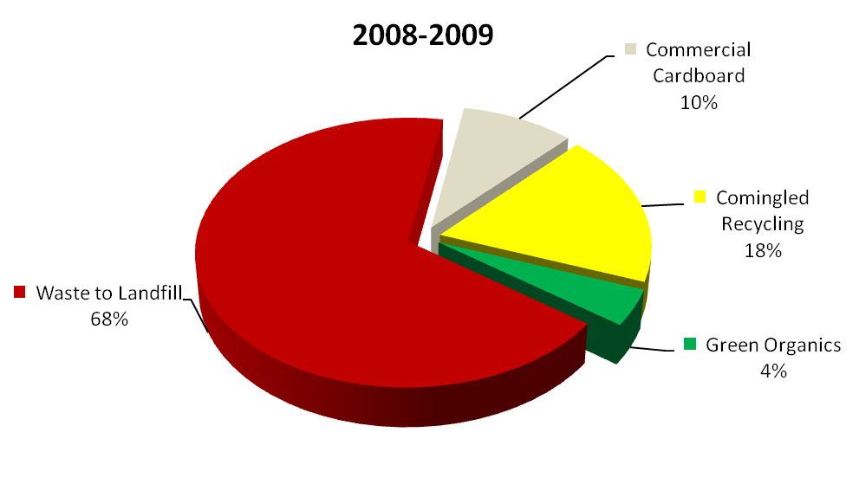

**Figure 3 – Total Kerbside Waste Diverted From Landfill By Adelaide City Council In 2009/10**

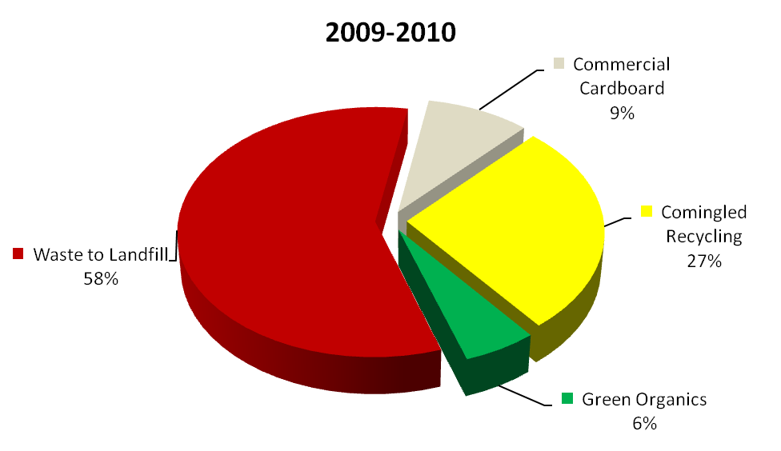

Despite current progress, observations of the operational environment and experience in suburban Adelaide indicate Council will not achieve its target to recycle 60% of material presented at the kerbside by 2012. One of the major obstacles to achieving the target is participation in the kerbside green organics service.

* **Supporting Resource Recovery From Medium And High Density Developments**

A draft Design Guide for Residential Waste Resource is being finalised by Council. Following industry consultation and conclusion of an implementation pilot, this guide will be finalised to inform policy development and adoption by the property development and facility management sectors.

* **Greening Of The Central Markets**

A new waste management and resource recovery system has been introduced at the Adelaide Central Markets. With this system, Central Market stallholders are diverting approximately 90% of all waste from landfill, including 842 tonnes of organic material and 19 tonnes of polystyrene (Figure 4).

**Figure 4 – Projected Waste And Recycling Profile For The Adelaide Central Market In 2011**

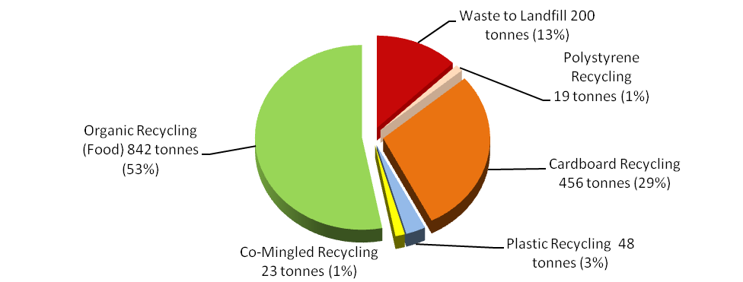

* **Greening City Office Buildings**

Through the CitySwitch Green Office Program, a national initiative of the Council of Capital City Lord Mayors, Council is encouraging office tenants to reduce energy consumption, greenhouse gas emissions and divert waste from landfill. Program participants have a combined net lettable floor area in excess of 120,000m2 or 12% of the total office floor area in the Central Business Area.

* **Public Place Recycling Facilities**

A draft *Public Place Recycling Options Study* is being finalised by Council. This report will guide the design and installation of permanent recycling infrastructure, informing development of the Rundle Mall Master Plan and will assist future collaborations between Adelaide City Council and Zero Waste SA.

* **Hard, Hazardous And E-Waste Collection Services**

Council continues to offer hard, hazardous and e-waste collection services to residents, delivering a quarterly hard waste collection day and collaborating with Zero Waste SA and neighbouring Councils to deliver annual hazardous and e-waste collection days. Council removed approximately 320 tonnes of unwanted or dangerous waste from the City community in 2010.

Including illegal dumping in the City and Adelaide Park Lands, Adelaide City Council safely disposed of approximately 998 tonnes of potentially hazardous waste.

* 1. **Targets And Actions**

**Targets**

As previously indicated, Council will not achieve its target to recycle 60% of material presented at the kerbside by 2012.

Based on these considerations, Council has developed the following waste diversion from landfill and service targets:

* **Recycle 50% of kerbside waste by 2015, on the way to 60% by 2020.**
* **Increase participation in kerbside green organics service to 25% by 2015.**

Although this is lower than the South Australian Government’s ambitious target of diverting 75% of kerbside waste by 2015, this is considered a challenging yet achievable target for Council. As outlined below, there are a number of challenges to achieving such targets that are particular to Adelaide City Council.

The following analysis is provided to determine the strategies and actions required to achieve these targets.

**Analysis**

Each year, Council manages of over 11,824 tonnes of waste and recycling from residents, businesses, Council owned facilities and public areas. This includes over 2,520 tonnes of waste from public bins, street sweeping and illegal dumping in the City and Adelaide Park Lands and approximately 1,471 tonnes from the Adelaide Central Markets (Figure 5).

**Figure 5 – Total Tonnes Of Waste And Recycling Managed By Council Operations In 2010**



Breakdown of waste to landfill from Council’s operations

In South Australia’s Waste Strategy 2010 - 2015 (draft), Zero Waste SA renews the State Government’s commitment to the ambitious target of diverting 75% of kerbside waste from landfill by 2015. The primary mechanism to secure this outcome will be sustained increases to the Solid Waste Levy from $26 per tonne of waste disposed to landfill to $35 per tonne from July 2011 and then at least $50 per tonne in the future (Figure 6).

The higher levy aims to enhance the comparative cost advantage of recycling, particularly food waste recovery, compared to waste disposal to landfill.

Without ongoing improvements to waste diversion from landfill rates, these increases will be a significant cost challenge for Adelaide City Council (Figure 7), which already utilises best practice waste management systems and actively promotes recycling within the community.

The challenges from the increases in the Solid Waste Levy will coincide with other obligations arising from the Public and Environmental Health Act, Environment Protection (Waste to Resources) Policy 2010, and the Australian Government’s National Television and Computer Product Stewardship Scheme. The imposition of greater regulation and costs for waste disposal may also be a contributing factor to an observed trend of increasing illegal dumping.

To mitigate operational risks and escalating costs, Council monitors its role as a waste management service provider and applies this knowledge to ensure legislative obligations are fulfilled and a cost effective service is provided.

**Figure 6 – Projected Cost To Dispose Of Waste To Landfill From Metropolitan Adelaide 2010/11 To 2013/14**

Year

Cost per Tonne

**Figure 7 – Projected Total Cost For Disposal Of Waste To Landfill By Adelaide City Council 2010/11 To 2013/14 (Assumes Stable Waste Volumes)**

Cost per Year

**Priorities**

Council will focus on three areas for improving waste diversion from landfill and resource efficiency: community, Council operations and the role of the Capital City.

1. **Community**

Council’s three bin kerbside system was designed for low density residential housing and is widely considered best practice in suburban local government. This system has enabled metropolitan Adelaide councils to achieve waste diversion from landfill of 55%. Adelaide City Council is currently achieving a waste diversion rate of 42%.

Increasing diversion of waste from landfill will require a sustained focus upon factors that limit the effectiveness of Council’s kerbside waste collection service. Factors that currently inhibit Council achieving more significant waste diversion from landfill include:

1. Council’s waste service profile contains significantly less low density residential development than most metropolitan councils.

1. Compared to low density suburbs, the high density urban form of the City has significantly less space allocated to the storage of waste and recycling bins and less street frontage per dwelling for bin presentation and collection.
2. Thirteen percent (13%) of premises receiving Council’s waste services have taken up the green organics collection service, compared to nearly full participation in other councils, limiting diversion of organic waste, including food waste, from landfill.
3. Service provision to business is substantially higher than other metropolitan councils (approximately sixty percent residential and forty percent business).
4. Mixed use developments with retail outlets or commercial offices often restrict use of street frontage for bin collection, require separate waste systems for each business and engage multiple waste service providers.
5. Provision of a residential kerbside service to small business which may not match service requirements for waste types and generation rates.

Current progress, observations of the operational environment and experience in suburban Adelaide, indicate Council will not achieve its target to recycle 60% of material presented at the kerbside by 2012.

In response to factors limiting diversion of waste from landfill and achievement of the target, Council will pursue a range of strategies, key actions and supporting actions that will enhance:

1. Green organics services and community participation rates;
2. Community awareness and understanding of waste resource recovery in a Sustainable City;
3. Shared knowledge through targeted research and pilot projects; and
4. Capacity of developments and the public realm to facilitate waste resource recovery.
5. **Council Operations**

The Corporation has delivered a modern kerbside waste collection service to residents and small businesses in the City. This service must adapt to changing legislative obligations and pursue increased waste diversion from landfill.

Appropriately designed waste management systems and consolidation of contracts is required to secure greater value for money and higher levels of recycling across all Council facilities and buildings.

Better understanding of the waste profile of Council’s operations is needed to inform development of targets and actions. This will also enable analysis of the potential contribution to achieving the overall target from improving diversion from Council’s operations.

Council will pursue environmental sustainability within its own operations by embedding waste diversion from landfill and resource efficiency considerations into Council’s processes.

To support this, Council will use the waste management hierarchy as a guide for achieving optimal environmental outcomes (Figure 8).

**Figure 8 – Waste Management Hierarchy (Source: Zero Waste SA Website 20 May 2011)**

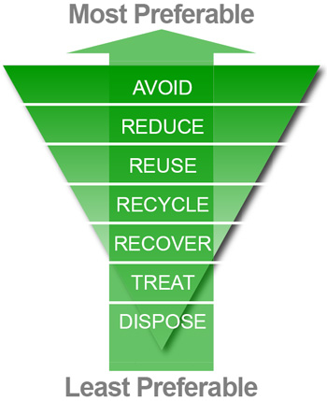

Council will:

1. Use renewable and recycled resources efficiently and conserve non-renewable resources;
2. Reuse and repair equipment and building materials where possible;
3. Divert waste resources from landfill for recycling; and
4. Treat hazardous waste and dispose of residual waste to landfill.

In 2012/13, following waste stream audits and service reviews, Council will set a “waste diversion from landfill” target for Council’s operations. Quantifying this waste stream will enable a better understanding of the contribution that these actions will make to achieving the overall target of 50% diversion by 2015 and 60% diversion by 2020.

1. **Capital City**

Adelaide City has a key role as the State’s hub for retailing, business services, education and entertainment. High rates of recycling and re-use are now standard expectations of modern sustainable cities, yet it is also important that waste services are convenient, efficient and compatible with a City’s character and design.

South Australia is internationally recognised as a leader in waste minimisation and waste diversion from landfill. Since the 1970s, the South Australian Government has pioneered changes to waste management including introduction of container deposit legislation, support for source separation recycling and prohibition of plastic shopping bags.

Building upon the State’s reputation for leadership and the community’s commitment and capacity to recycle, Council is well positioned to deliver an environmentally sustainable City that goes beyond energy and water efficiency.

Council will work to ensure that waste management and resource efficiency considerations are built into the City’s planning, design and character, with particular regard to the new urban form envisaged by the 30 Year Plan for South Australia and major public realm upgrades.

* 1. **Action Plan**

Five strategies have been established:

1. Maximise waste diversion from landfill by continuously improving recycling services provided to our community;
2. Prepare the City for the urban form envisaged by the 30 Year Plan for Greater Adelaide;
3. Maximise waste diversion from landfill and efficient use of resources in major public realm projects and City events;
4. Maximise waste diversion from landfill and efficient use of resources in Council’s operations; and
5. Manage risks and opportunities arising from legislative changes, changes to service expectations and rising waste disposal charges.

Several Key Actions that are necessary for achieving the strategies and targets have been determined (5.3.1 below). In addition, a number of Supporting Actions are listed (5.3.2 below), representing ongoing and additional actions that will contribute to achievement of the strategies and targets.

Actions for which the budget is bracketed are un-budgeted and will require a new budget allocation as part of future Business Plan and Budget proposals.

* + 1. **Key Strategies and Actions**

| **KEY**  **STRATEGIES AND ACTIONS** | **Avoid or Reduce** | **Reuse, Repair or Recycle** | **Treat, Recover or Dispose** | **Budget**  **(*$ ‘000s)*** | **Timeframe** | **Responsibility** |
| --- | --- | --- | --- | --- | --- | --- |
| **Strategy 1: Maximise waste diversion from landfill by continuously improving recycling services provided to our community.** | | | | | | |
| * 1. Undertake waste stream audits of retail, food and hospitality small businesses to inform policy on service delivery. |  |  |  | $10k | 2011-2012 | Sustainable City |
| * 1. Encourage participation in Council’s kerbside green organics service to increase service penetration to 25% by 2015. |  |  |  | ($150k) | Commencing 2013-2014 | Sustainable City  Public Realm |
| * 1. Assist residents in medium and high density developments, serviced by Council’s kerbside service, to use the kerbside green organics bin for food waste recycling. |  |  |  | $10k | Commencing 2012-2013 | Sustainable City |
| * 1. Support the safe removal of hard, electronic and hazardous waste from the community. |  |  |  | $70K | Ongoing | Public Realm |
| * 1. Review service outcomes and pursue opportunities for enhanced service delivery and resource recovery. |  |  |  | TBD | Commencing 2011-2012 | Public Realm |
| **Strategy 2: Prepare the City for the urban form envisaged by the 30 Year Plan for Greater Adelaide.** | | | | | | |
| * 1. Develop waste collection service models that enhance diversion from landfill in high density residential and mixed use developments. |  |  |  | - | 2013-2014 | Public Realm  Sustainable City |
| * 1. Address waste management issues in the Section 30 Review of the Adelaide (City) Development Plan and update the Plan. |  |  |  | - | 2011-2012 | City Design & Character |
| * 1. When assessing developments, seek compliance with the Adelaide (City) Development Plan to ensure waste services are provided to residents and business in new developments without detracting from the amenity, safety, accessibility and character of the City. |  |  |  | **-** | Ongoing | City Design & Character |
| **Strategy 3: Maximise waste diversion from landfill and efficient use of resources in major public realm projects and City events.** | | | | | | |
| * 1. Collaborate with Zero Waste SA to deliver priority public realm recycling projects such as in Rundle Mall. |  |  |  | $48k | 2011-2012 | Sustainable City  Public Realm  City Design & Character |
| * 1. Collaborate with our partners to integrate waste minimisation and recycling into major public realm projects such as Victoria Square, Rundle Mall, North Terrace and the Riverbank, Royal Adelaide Hospital and Adelaide Oval precincts. |  |  |  | TBD | Ongoing | Sustainable City  City Design & Character  Economic Development  Public Realm |
| **Strategy 4: Maximise waste diversion from landfill and efficient use of resources in Council’s operations.** | | | | | | |
| * 1. Audit waste streams and generation rates to inform ongoing service design and procurement practices. |  |  |  | $10k | 2011-2012 | Sustainable City  Public Realm |
| * 1. Set a 2015 and 2020 waste diversion from landfill target for Council operations, including targets for reduction in paper use. |  |  |  | - | 2011-2012 | Sustainable City  Public Realm  Information Management |
| * 1. Embed waste diversion and resource efficiency considerations into Council selection practices for building materials used for major public realm projects. |  |  |  | TBD | Ongoing | City Design & Character  Capital Works |
| * 1. Encourage staff to actively support waste minimisation and recycling in the workplace. |  |  |  |  | Commencing 2011-2012 | Sustainable City  People and Culture  Office of the Lord Mayor and CEO |

* + 1. **Supporting Actions and Projects**

| **SUPPORTING STRATEGIES AND ACTIONS** | **Avoid or Reduce** | **Reuse, Repair or Recycle** | **Treat, Recover or Dispose** | **Budget**  **(*$ ‘000s)*** | **Timeframe** | **Responsibility** |
| --- | --- | --- | --- | --- | --- | --- |
| **Strategy 1: Maximise waste diversion from landfill by continuously improving recycling services provided to residents and small business.** | | | | | | |
| S 1.1 Support and encourage residents and business to use resources efficiently and minimise waste to landfill with information materials such as the annual calendar and waste information guide. |  |  |  | $20k | Ongoing | Public Realm  Economic Development  Sustainable City |
| S 1.2 Deliver public realm projects that increase the capacity of residents to use the kerbside green organics service and reduce obstructions to pedestrians and access to parked cars. |  |  |  | TBD | Ongoing | Sustainable City  Public Realm |
| S 1.3 Monitor participation by residents and business in recycling services to inform service delivery and increase diversion from landfill. |  |  |  | $10k | 2011-2012 | Public Realm |
| S 1.4 Support and encourage Council’s community centres and libraries to use the kerbside 3 bin waste collection service. |  |  |  |  | Ongoing | Sustainable City  City Community  Public Realm  Marketing & Creative Services |

|  |  |  |  |  |  |  |
| --- | --- | --- | --- | --- | --- | --- |
| **Strategy 2: Prepare the City for the urban form envisaged by the 30 Year Plan for Greater Adelaide.** | | | | | | |
| S 2.1 Finalise and encourage use of Council’s Design Guide for Residential Waste Resource Recovery. |  |  |  | - | Ongoing | City Design & Character  Sustainable City  Public Realm |
| **Strategy 3: Maximise waste diversion from landfill and efficient use of resources in major public realm projects and City events.** | | | | | | |
| S 3.1 Assist City events to minimise resource use and maximise waste diversion from landfill through implementation support. |  |  |  | ($20k) | Commencing 2013-2014 | Vibrant City  Sustainable City |
| S 3.2 Undertake waste stream audits of major City events to identify wasted and recoverable resources. |  |  |  | ($30k) | 2012-2013 | Sustainable City  Vibrant City |
| **Strategy 4: Maximise waste diversion from landfill and efficient use of resources in Council’s operations.** | | | | | | |
| S 4.1 Use 100% post consumer non-chlorine bleached recycled paper for all A3 and A4 photocopier printing. |  |  |  | TBD | 2011-2012 | Strategic Procurement  Information Management  Sustainable City |
| S 4.2 Use unbleached 100% post consumer recycled paper envelopes. |  |  |  | TBD | 2011-2012 | Strategic Procurement  Sustainable City |
| S 4.3 Clearly define the roles and responsibilities of waste and cleaning contractors to monitor and report waste diversion from landfill in all Council owned or occupied building and facilities. |  |  |  | N/A | Ongoing | Strategic Procurement |
| S 4.4 Develop an online monitoring and reporting system for waste generation, diversion from landfill and disposal costs. |  |  |  | ($20k) | 2012-2013 | Sustainable City |
| **Strategy 5: Manage risks and opportunities arising from legislative changes, changes to service expectations and rising waste disposal charges.** | | | | | | |
| S 5.1 Advocate for clear definition of Local Government’s role in waste service provision to the community. | **-** | **-** | **-** | - | Ongoing | Office of the Lord Mayor and CEO |
| S 5.2 Collaborate with our partners to advocate for ongoing funding support from the Solid Waste Levy Fund to maintain and enhance service provision to the community and waste diversion from landfill. |  |  |  | - | Ongoing | Office of the Lord Mayor and CEO |
| S 5.3 Undertake a risk assessment of all Council waste management services and functions that includes a review of current and emerging legislation. | **-** | **-** | **-** | **-** | 2011-2012 | Legal and Risk  Public Realm  Sustainable City |
| S 5.4 Collaborate with Zero Waste SA to monitor and quantify the cost of illegal dumping using the Zero Waste User Environment System (ZUES). |  |  |  | $2k | 2011-2012 | Public Realm  Safer City |
| S 5.5 Advocate for a national system of extended producer responsibility for hazardous and e-waste that does not place additional financial burden upon the Council. |  |  |  | **-** | 2011-2012 | Sustainable City  Public Realm |